UNITED STATES
SECURITIES AND EXCHANGE COMMISSION
Washington, D.C. 20549

FORM 10-Q

(Mark One)
☒ QUARTERLY REPORT PURSUANT TO SECTION 13 OR 15(d) OF THE SECURITIES
EXCHANGE ACT OF 1934

For the quarterly period ended March 31, 2023

OR

☐ TRANSITION REPORT PURSUANT TO SECTION 13 OR 15(d) OF THE SECURITIES
EXCHANGE ACT OF 1934

For the transition period from ____________ to ____________

Commission file number 1-12993

ALEXANDRIA REAL ESTATE EQUITIES, INC.
(Exact name of registrant as specified in its charter)
Maryland |  |  |  |  |  | 95-4502084
(State or other jurisdiction of  incorporation or organization) |  |  |  |  |  | (I.R.S. Employer Identification Number)
26 North Euclid Avenue, Pasadena, California 91101
(Address of principal executive offices) (Zip code)

(626) 578-0777
(Registrant’s telephone number, including area code)

N/A
(Former name, former address and former fiscal year, if changed since last report)

Securities registered pursuant to Section 12(b) of the Exchange Act:
Title of each class |  |  | Trading Symbol(s) |  |  | Name of each exchange on which registered
Common Stock, $0.01 par value per share |  |  | ARE |  |  | New York Stock Exchange
Indicate by check mark whether the registrant (1) has filed all reports required to be filed by Section 13 or 15(d) of the Securities Exchange Act of 1934 during the preceding 12 months (or for such shorter period that the registrant was required to file such reports), and (2) has been subject to such filing requirements for the past 90 days. Yes ☒ No ☐

Indicate by check mark whether the registrant has submitted electronically every Interactive Data File required to be submitted and posted pursuant to Rule 405 of Regulation S-T (§ 232.405 of this chapter) during the preceding 12 months (or for such shorter period that the registrant was required to submit and post such files). Yes ☒ No ☐

Indicate by check mark whether the registrant is a large accelerated filer, an accelerated filer, a non-accelerated filer, a smaller reporting company, or an emerging growth company. See the definitions of “large accelerated filer,” “accelerated filer,” “smaller reporting company,” and “emerging growth company” in Rule 12b-2 of the Exchange Act.
Large accelerated filer |  |  | ☒ |  |  |  |  |  | Smaller reporting company |  |  | ☐
Accelerated filer |  |  | ☐ |  |  |  |  |  | Emerging growth company |  |  | ☐
Non-accelerated filer |  |  | ☐
If an emerging growth company, indicate by check mark if the registrant has elected not to use the extended transition period for complying with any new or revised financial accounting standards provided pursuant to Section 13(a) of the Exchange Act. ☐

Indicate by check mark whether the registrant is a shell company (as defined in Rule 12b-2 of the Exchange Act). Yes ☐ No ☒

As of April 14, 2023, 173,013,623 shares of common stock, par value $0.01 per share, were outstanding.

TABLE OF CONTENTS
 |  |  |  |  |  | Page
PART I – FINANCIAL INFORMATION
Item 1. |  |  | FINANCIAL STATEMENTS (UNAUDITED)
 |  |  | Consolidated Balance Sheets as of March 31, 2023 and December 31, 2022 |  |  | 1
 |  |  | Consolidated Financial Statements for the Three Months Ended March 31, 2023 and 2022:
 |  |  | Consolidated Statements of Operations |  |  | 2
 |  |  | Consolidated Statements of Comprehensive Income |  |  | 3
 |  |  | Consolidated Statements of Changes in Stockholders’ Equity and Noncontrolling Interests |  |  | 4
 |  |  | Consolidated Statements of Cash Flows |  |  | 6
 |  |  | Notes to Consolidated Financial Statements |  |  | 8
Item 2. |  |  | MANAGEMENT’S DISCUSSION AND ANALYSIS OF FINANCIAL CONDITION AND RESULTS OF OPERATIONS |  |  | 39
Item 3. |  |  | QUANTITATIVE AND QUALITATIVE DISCLOSURES ABOUT MARKET RISK |  |  | 102
Item 4. |  |  | CONTROLS AND PROCEDURES |  |  | 103
PART II – OTHER INFORMATION
Item 1A. |  |  | RISK FACTORS |  |  | 104
Item 6. |  |  | EXHIBITS |  |  | 107
SIGNATURES |  |  |  |  |  | 108

i

GLOSSARY

The following abbreviations or acronyms that may be used in this document shall have the adjacent meanings set forth below:
ASU |  |  | Accounting Standards Update
ATM |  |  | At the Market
CIP |  |  | Construction in Progress
EPS |  |  | Earnings per Share
ESG |  |  | Environmental, Social & Governance
FASB |  |  | Financial Accounting Standards Board
FDIC |  |  | Federal Deposit Insurance Corporation
FFO |  |  | Funds From Operations
GAAP |  |  | U.S. Generally Accepted Accounting Principles
IRS |  |  | Internal Revenue Service
JV |  |  | Joint Venture
LEED® |  |  | Leadership in Energy and Environmental Design
Nareit |  |  | National Association of Real Estate Investment Trusts
NAV |  |  | Net Asset Value
NYSE |  |  | New York Stock Exchange
REIT |  |  | Real Estate Investment Trust
RSF |  |  | Rentable Square Feet/Foot
SEC |  |  | Securities and Exchange Commission
SF |  |  | Square Feet/Foot
SoDo |  |  | South of Downtown submarket of Seattle
SOFR |  |  | Secured Overnight Financing Rate
SoMa |  |  | South of Market submarket of the San Francisco Bay Area
U.S. |  |  | United States
VIE |  |  | Variable Interest Entity

ii

PART I – FINANCIAL INFORMATION

ITEM 1. FINANCIAL STATEMENTS (UNAUDITED)

Alexandria Real Estate Equities, Inc.
Consolidated Balance Sheets
(In thousands)

 |  |  | March 31, 2023 |  |  |  |  |  | December 31, 2022
 |  |  | (Unaudited)
Assets
Investments in real estate |  |  | $ | 30,889,395 |  |  |  |  | $ | 29,945,440
Investments in unconsolidated real estate joint ventures |  |  | 38,355 |  |  |  |  |  | 38,435
Cash and cash equivalents |  |  | 1,263,452 |  |  |  |  |  | 825,193
Restricted cash |  |  | 34,932 |  |  |  |  |  | 32,782
Tenant receivables |  |  | 8,197 |  |  |  |  |  | 7,614
Deferred rent |  |  | 974,865 |  |  |  |  |  | 942,646
Deferred leasing costs |  |  | 527,848 |  |  |  |  |  | 516,275
Investments |  |  | 1,573,018 |  |  |  |  |  | 1,615,074
Other assets |  |  | 1,602,403 |  |  |  |  |  | 1,599,940
Total assets |  |  | $ | 36,912,465 |  |  |  |  | $ | 35,523,399
Liabilities, Noncontrolling Interests, and Equity
Secured notes payable |  |  | $ | 73,645 |  |  |  |  | $ | 59,045
Unsecured senior notes payable |  |  | 11,089,124 |  |  |  |  |  | 10,100,717
Unsecured senior line of credit and commercial paper |  |  | 374,536 |  |  |  |  |  | —
Accounts payable, accrued expenses, and other liabilities |  |  | 2,479,047 |  |  |  |  |  | 2,471,259
Dividends payable |  |  | 209,346 |  |  |  |  |  | 209,131
Total liabilities |  |  | 14,225,698 |  |  |  |  |  | 12,840,152
Commitments and contingencies
Redeemable noncontrolling interests |  |  | 44,862 |  |  |  |  |  | 9,612
Alexandria Real Estate Equities, Inc.’s stockholders’ equity:
Common stock |  |  | 1,709 |  |  |  |  |  | 1,707
Additional paid-in capital |  |  | 18,902,821 |  |  |  |  |  | 18,991,492
Accumulated other comprehensive loss |  |  | (20,536) |  |  |  |  |  | (20,812)
Alexandria Real Estate Equities, Inc.’s stockholders’ equity |  |  | 18,883,994 |  |  |  |  |  | 18,972,387
Noncontrolling interests |  |  | 3,757,911 |  |  |  |  |  | 3,701,248
Total equity |  |  | 22,641,905 |  |  |  |  |  | 22,673,635
Total liabilities, noncontrolling interests, and equity |  |  | $ | 36,912,465 |  |  |  |  | $ | 35,523,399

The accompanying notes are an integral part of these consolidated financial statements.

1

Alexandria Real Estate Equities, Inc.
Consolidated Statements of Operations
(In thousands, except per share amounts)
(Unaudited)

 |  |  | Three Months Ended March 31,
 |  |  | 2023 |  |  |  |  |  | 2022
Revenues:
Income from rentals |  |  | $ | 687,949 |  |  |  |  | $ | 612,554
Other income |  |  | 12,846 |  |  |  |  |  | 2,511
Total revenues |  |  | 700,795 |  |  |  |  |  | 615,065
Expenses:
Rental operations |  |  | 206,933 |  |  |  |  |  | 181,328
General and administrative |  |  | 48,196 |  |  |  |  |  | 40,931
Interest |  |  | 13,754 |  |  |  |  |  | 29,440
Depreciation and amortization |  |  | 265,302 |  |  |  |  |  | 240,659
Total expenses |  |  | 534,185 |  |  |  |  |  | 492,358
Equity in earnings of unconsolidated real estate joint ventures |  |  | 194 |  |  |  |  |  | 220
Investment loss |  |  | (45,111) |  |  |  |  |  | (240,319)
Net income (loss) |  |  | 121,693 |  |  |  |  |  | (117,392)
Net income attributable to noncontrolling interests |  |  | (43,831) |  |  |  |  |  | (32,177)
Net income (loss) attributable to Alexandria Real Estate Equities, Inc.’s stockholders |  |  | 77,862 |  |  |  |  |  | (149,569)
Net income attributable to unvested restricted stock awards |  |  | (2,606) |  |  |  |  |  | (2,081)
Net income (loss) attributable to Alexandria Real Estate Equities, Inc.’s common stockholders |  |  | $ | 75,256 |  |  |  |  | $ | (151,650)
Net income (loss) per share attributable to Alexandria Real Estate Equities, Inc.’s common stockholders:
Basic |  |  | $ | 0.44 |  |  |  |  | $ | (0.96)
Diluted |  |  | $ | 0.44 |  |  |  |  | $ | (0.96)

The accompanying notes are an integral part of these consolidated financial statements.

2

Alexandria Real Estate Equities, Inc.
Consolidated Statements of Comprehensive Income
(In thousands)
(Unaudited)

 |  |  | Three Months Ended March 31,
 |  |  | 2023 |  |  |  |  |  | 2022
Net income (loss) |  |  | $ | 121,693 |  |  |  |  | $ | (117,392)
Other comprehensive income
Unrealized gains on foreign currency translation:
Unrealized foreign currency translation gains arising during the period |  |  | 276 |  |  |  |  |  | 1,567
Unrealized gains on foreign currency translation, net |  |  | 276 |  |  |  |  |  | 1,567
Total other comprehensive income |  |  | 276 |  |  |  |  |  | 1,567
Comprehensive income (loss) |  |  | 121,969 |  |  |  |  |  | (115,825)
Less: comprehensive income attributable to noncontrolling interests |  |  | (43,831) |  |  |  |  |  | (32,177)
Comprehensive income (loss) attributable to Alexandria Real Estate Equities, Inc.’s stockholders |  |  | $ | 78,138 |  |  |  |  | $ | (148,002)

The accompanying notes are an integral part of these consolidated financial statements.

3

Alexandria Real Estate Equities, Inc.
Consolidated Statement of Changes in Stockholders’ Equity and Noncontrolling Interests
(Dollars in thousands)
(Unaudited)
 |  |  |  |  |  | Alexandria Real Estate Equities, Inc.’s Stockholders’ Equity
 |  |  |  |  |  | Number of  Common  Shares |  |  |  |  |  | Common  Stock |  |  |  |  |  | Additional  Paid-In Capital |  |  |  |  |  | Retained  Earnings |  |  |  |  |  | Accumulated Other Comprehensive Loss |  |  |  |  |  | Noncontrolling  Interests |  |  |  |  |  | Total  Equity |  |  |  |  |  | Redeemable  Noncontrolling  Interests
Balance as of December 31, 2022 |  |  |  |  |  | 170,748,395 |  |  |  |  |  | $ | 1,707 |  |  |  |  | $ | 18,991,492 |  |  |  |  | $ | — |  |  |  |  | $ | (20,812) |  |  |  |  | $ | 3,701,248 |  |  |  |  | $ | 22,673,635 |  |  |  |  | $ | 9,612
Net income |  |  |  |  |  | — |  |  |  |  |  | — |  |  |  |  |  | — |  |  |  |  |  | 77,862 |  |  |  |  |  | — |  |  |  |  |  | 43,630 |  |  |  |  |  | 121,492 |  |  |  |  |  | 201
Total other comprehensive income |  |  |  |  |  | — |  |  |  |  |  | — |  |  |  |  |  | — |  |  |  |  |  | — |  |  |  |  |  | 276 |  |  |  |  |  | — |  |  |  |  |  | 276 |  |  |  |  |  | —
Contributions from and sales of noncontrolling interests |  |  |  |  |  | — |  |  |  |  |  | — |  |  |  |  |  | 18,999 |  |  |  |  |  | — |  |  |  |  |  | — |  |  |  |  |  | 76,018 |  |  |  |  |  | 95,017 |  |  |  |  |  | 35,250
Distributions to and redemption of noncontrolling interests |  |  |  |  |  | — |  |  |  |  |  | — |  |  |  |  |  | — |  |  |  |  |  | — |  |  |  |  |  | — |  |  |  |  |  | (62,985) |  |  |  |  |  | (62,985) |  |  |  |  |  | (201)
Issuance pursuant to stock plan |  |  |  |  |  | 194,586 |  |  |  |  |  | 2 |  |  |  |  |  | 35,782 |  |  |  |  |  | — |  |  |  |  |  | — |  |  |  |  |  | — |  |  |  |  |  | 35,784 |  |  |  |  |  | —
Taxes related to net settlement of equity awards |  |  |  |  |  | (83,277) |  |  |  |  |  | — |  |  |  |  |  | (11,968) |  |  |  |  |  | — |  |  |  |  |  | — |  |  |  |  |  | — |  |  |  |  |  | (11,968) |  |  |  |  |  | —
Dividends declared on common stock ($1.21 per share) |  |  |  |  |  | — |  |  |  |  |  | — |  |  |  |  |  | — |  |  |  |  |  | (209,346) |  |  |  |  |  | — |  |  |  |  |  | — |  |  |  |  |  | (209,346) |  |  |  |  |  | —
Reclassification of distributions in excess of earnings |  |  |  |  |  | — |  |  |  |  |  | — |  |  |  |  |  | (131,484) |  |  |  |  |  | 131,484 |  |  |  |  |  | — |  |  |  |  |  | — |  |  |  |  |  | — |  |  |  |  |  | —
Balance as of March 31, 2023 |  |  |  |  |  | 170,859,704 |  |  |  |  |  | $ | 1,709 |  |  |  |  | $ | 18,902,821 |  |  |  |  | $ | — |  |  |  |  | $ | (20,536) |  |  |  |  | $ | 3,757,911 |  |  |  |  | $ | 22,641,905 |  |  |  |  | $ | 44,862

The accompanying notes are an integral part of these consolidated financial statements.

4

Alexandria Real Estate Equities, Inc.
Consolidated Statement of Changes in Stockholders’ Equity and Noncontrolling Interests
(Dollars in thousands)
(Unaudited)
 |  |  |  |  |  | Alexandria Real Estate Equities, Inc.’s Stockholders’ Equity
 |  |  |  |  |  | Number of  Common  Shares |  |  |  |  |  | Common  Stock |  |  |  |  |  | Additional  Paid-In Capital |  |  |  |  |  | Retained  Earnings |  |  |  |  |  | Accumulated Other Comprehensive Loss |  |  |  |  |  | Noncontrolling  Interests |  |  |  |  |  | Total  Equity |  |  |  |  |  | Redeemable  Noncontrolling  Interests
Balance as of December 31, 2021 |  |  |  |  |  | 158,043,880 |  |  |  |  |  | $ | 1,580 |  |  |  |  | $ | 16,195,256 |  |  |  |  | $ | — |  |  |  |  | $ | (7,294) |  |  |  |  | $ | 2,834,096 |  |  |  |  | $ | 19,023,638 |  |  |  |  | $ | 9,612
Net (loss) income |  |  |  |  |  | — |  |  |  |  |  | — |  |  |  |  |  | — |  |  |  |  |  | (149,569) |  |  |  |  |  | — |  |  |  |  |  | 31,976 |  |  |  |  |  | (117,593) |  |  |  |  |  | 201
Total other comprehensive income |  |  |  |  |  | — |  |  |  |  |  | — |  |  |  |  |  | — |  |  |  |  |  | — |  |  |  |  |  | 1,567 |  |  |  |  |  | — |  |  |  |  |  | 1,567 |  |  |  |  |  | —
Contributions from and sales of noncontrolling interests |  |  |  |  |  | — |  |  |  |  |  | — |  |  |  |  |  | 413,615 |  |  |  |  |  | — |  |  |  |  |  | — |  |  |  |  |  | 405,251 |  |  |  |  |  | 818,866 |  |  |  |  |  | —
Distributions to and redemption of noncontrolling interests |  |  |  |  |  | — |  |  |  |  |  | — |  |  |  |  |  | — |  |  |  |  |  | — |  |  |  |  |  | — |  |  |  |  |  | (30,300) |  |  |  |  |  | (30,300) |  |  |  |  |  | (201)
Issuance of common stock |  |  |  |  |  | 3,220,000 |  |  |  |  |  | 32 |  |  |  |  |  | 646,284 |  |  |  |  |  | — |  |  |  |  |  | — |  |  |  |  |  | — |  |  |  |  |  | 646,316 |  |  |  |  |  | —
Issuance pursuant to stock plan |  |  |  |  |  | 219,905 |  |  |  |  |  | 2 |  |  |  |  |  | 30,857 |  |  |  |  |  | — |  |  |  |  |  | — |  |  |  |  |  | — |  |  |  |  |  | 30,859 |  |  |  |  |  | —
Taxes related to net settlement of equity awards |  |  |  |  |  | (75,489) |  |  |  |  |  | — |  |  |  |  |  | (14,648) |  |  |  |  |  | — |  |  |  |  |  | — |  |  |  |  |  | — |  |  |  |  |  | (14,648) |  |  |  |  |  | —
Dividends declared on common stock ($1.15 per share) |  |  |  |  |  | — |  |  |  |  |  | — |  |  |  |  |  | — |  |  |  |  |  | (187,701) |  |  |  |  |  | — |  |  |  |  |  | — |  |  |  |  |  | (187,701) |  |  |  |  |  | —
Reclassification of distributions and net loss |  |  |  |  |  | — |  |  |  |  |  | — |  |  |  |  |  | (337,270) |  |  |  |  |  | 337,270 |  |  |  |  |  | — |  |  |  |  |  | — |  |  |  |  |  | — |  |  |  |  |  | —
Balance as of March 31, 2022 |  |  |  |  |  | 161,408,296 |  |  |  |  |  | $ | 1,614 |  |  |  |  | $ | 16,934,094 |  |  |  |  | $ | — |  |  |  |  | $ | (5,727) |  |  |  |  | $ | 3,241,023 |  |  |  |  | $ | 20,171,004 |  |  |  |  | $ | 9,612

The accompanying notes are an integral part of these consolidated financial statements.

5

Alexandria Real Estate Equities, Inc.
Consolidated Statements of Cash Flows
(In thousands)
(Unaudited)

 |  |  | Three Months Ended March 31,
 |  |  | 2023 |  |  |  |  |  | 2022
Operating Activities:
Net income (loss) |  |  | $ | 121,693 |  |  |  |  | $ | (117,392)
Adjustments to reconcile net income (loss) to net cash provided by operating activities:
Depreciation and amortization |  |  | 265,302 |  |  |  |  |  | 240,659
Equity in earnings of unconsolidated real estate joint ventures |  |  | (194) |  |  |  |  |  | (220)
Distributions of earnings from unconsolidated real estate joint ventures |  |  | 285 |  |  |  |  |  | 975
Amortization of loan fees |  |  | 3,639 |  |  |  |  |  | 3,103
Amortization of debt discounts (premiums) |  |  | 288 |  |  |  |  |  | (424)
Amortization of acquired above- and below-market leases |  |  | (21,636) |  |  |  |  |  | (13,915)
Deferred rent |  |  | (33,191) |  |  |  |  |  | (42,025)
Stock compensation expense |  |  | 16,486 |  |  |  |  |  | 14,028
Investment loss |  |  | 45,111 |  |  |  |  |  | 240,319
Changes in operating assets and liabilities:
Tenant receivables |  |  | (582) |  |  |  |  |  | (191)
Deferred leasing costs |  |  | (33,469) |  |  |  |  |  | (75,162)
Other assets |  |  | (25,422) |  |  |  |  |  | (22,618)
Accounts payable, accrued expenses, and other liabilities |  |  | (32,740) |  |  |  |  |  | (36,051)
Net cash provided by operating activities |  |  | 305,570 |  |  |  |  |  | 191,086
Investing Activities:
Additions to real estate |  |  | (873,366) |  |  |  |  |  | (666,364)
Purchases of real estate |  |  | (177,543) |  |  |  |  |  | (1,903,800)
Change in escrow deposits |  |  | 9,366 |  |  |  |  |  | 100,635
Investments in unconsolidated real estate joint ventures |  |  | (106) |  |  |  |  |  | (335)
Return of capital from unconsolidated real estate joint ventures |  |  | — |  |  |  |  |  | 471
Additions to non-real estate investments |  |  | (47,401) |  |  |  |  |  | (64,247)
Sales of and distributions from non-real estate investments |  |  | 49,385 |  |  |  |  |  | 44,842
Net cash used in investing activities |  |  | $ | (1,039,665) |  |  |  |  | $ | (2,488,798)

6

Alexandria Real Estate Equities, Inc.
Consolidated Statements of Cash Flows
(In thousands)
(Unaudited)

 |  |  | Three Months Ended March 31,
 |  |  | 2023 |  |  |  |  |  | 2022
Financing Activities:
Borrowings from secured notes payable |  |  | $ | 14,428 |  |  |  |  | $ | 5,082
Repayments of borrowings from secured notes payable |  |  | — |  |  |  |  |  | (906)
Proceeds from issuance of unsecured senior notes payable |  |  | 996,205 |  |  |  |  |  | 1,793,318
Borrowings from unsecured senior line of credit |  |  | 375,000 |  |  |  |  |  | 1,180,000
Repayments of borrowings from unsecured senior line of credit |  |  | (375,000) |  |  |  |  |  | (1,180,000)
Proceeds from issuances under commercial paper program |  |  | 775,000 |  |  |  |  |  | 6,120,000
Repayments of borrowings under commercial paper program |  |  | (400,000) |  |  |  |  |  | (6,390,000)
Payments of loan fees |  |  | (9,989) |  |  |  |  |  | (17,596)
Taxes paid related to net settlement of equity awards |  |  | (7,854) |  |  |  |  |  | (8,906)
Proceeds from issuance of common stock |  |  | — |  |  |  |  |  | 646,316
Dividends on common stock |  |  | (209,131) |  |  |  |  |  | (183,847)
Contributions from and sales of noncontrolling interests |  |  | 79,337 |  |  |  |  |  | 819,610
Distributions to and purchases of noncontrolling interests |  |  | (63,186) |  |  |  |  |  | (30,501)
Net cash provided by financing activities |  |  | 1,174,810 |  |  |  |  |  | 2,752,570
Effect of foreign exchange rate changes on cash and cash equivalents |  |  | (306) |  |  |  |  |  | 81
Net increase in cash, cash equivalents, and restricted cash |  |  | 440,409 |  |  |  |  |  | 454,939
Cash, cash equivalents, and restricted cash as of the beginning of period |  |  | 857,975 |  |  |  |  |  | 415,227
Cash, cash equivalents, and restricted cash as of the end of period |  |  | $ | 1,298,384 |  |  |  |  | $ | 870,166
Supplemental Disclosure and Non-Cash Investing and Financing Activities:
Cash paid during the period for interest, net of interest capitalized |  |  | $ | 21,519 |  |  |  |  | $ | 22,550
Accrued construction for current-period additions to real estate |  |  | $ | 419,029 |  |  |  |  | $ | 300,713
Contribution of assets from real estate joint venture partner |  |  | $ | 33,250 |  |  |  |  | $ | —
Issuance of noncontrolling interest to joint venture partner |  |  | $ | (33,250) |  |  |  |  | $ | —
Right-of-use asset |  |  | $ | — |  |  |  |  | $ | 10,127
Lease liability |  |  | $ | — |  |  |  |  | $ | (10,127)

The accompanying notes are an integral part of these consolidated financial statements.

7

Alexandria Real Estate Equities, Inc.
Notes to Consolidated Financial Statements
(Unaudited)

1. ORGANIZATION AND BASIS OF PRESENTATION

Alexandria Real Estate Equities, Inc. (NYSE:ARE), an S&P 500® life science REIT, is the pioneer of the life science real estate niche since its founding in 1994. Alexandria is the preeminent and longest-tenured owner, operator, and developer of collaborative life science, agtech, and advanced technology campuses in AAA innovation cluster locations, including Greater Boston, the San Francisco Bay Area, New York City, San Diego, Seattle, Maryland, and Research Triangle. With over 850 tenants, Alexandria has a total market capitalization of $33.0 billion and an asset base in North America of 75.6 million SF as of March 31, 2023. As used in this quarterly report on Form 10-Q, references to the “Company,” “Alexandria,” “ARE,” “we,” “us,” and “our” refer to Alexandria Real Estate Equities, Inc. and its consolidated subsidiaries. The accompanying unaudited consolidated financial statements include the accounts of Alexandria Real Estate Equities, Inc. and its consolidated subsidiaries. All significant intercompany balances and transactions have been eliminated.

We have prepared the accompanying interim consolidated financial statements in accordance with GAAP and in conformity with the rules and regulations of the SEC. In our opinion, these interim consolidated financial statements presented herein reflect all adjustments, of a normal recurring nature, that are necessary to fairly present the interim consolidated financial statements. The results of operations for the interim period are not necessarily indicative of the results that may be expected for the year ending December 31, 2023. These unaudited consolidated financial statements should be read in conjunction with the audited consolidated financial statements and the notes thereto included in our annual report on Form 10-K for the year ended December 31, 2022. Any references to our market capitalization, number or quality of buildings or tenants, quality of location, square footage, number of leases, or occupancy percentage, and any amounts derived from these values in these notes to consolidated financial statements are outside the scope of our independent registered public accounting firm’s review.

2. SUMMARY OF SIGNIFICANT ACCOUNTING POLICIES

Consolidation

On an ongoing basis, as circumstances indicate the need for reconsideration, we evaluate each legal entity that is not wholly owned by us in accordance with the consolidation accounting guidance. Our evaluation considers all of our variable interests, including equity ownership, as well as fees paid to us for our involvement in the management of each partially owned entity. To fall within the scope of the consolidation guidance, an entity must meet both of the following criteria:

•The entity has a legal structure that has been established to conduct business activities and to hold assets; such entity can be in the form of a partnership, limited liability company, or corporation, among others; and
•We have a variable interest in the legal entity — i.e., variable interests that are contractual, such as equity ownership, or other financial interests that change with changes in the fair value of the entity’s net assets.

If an entity does not meet both criteria above, we apply other accounting literature, such as the cost or equity method of accounting. If an entity does meet both criteria above, we evaluate such entity for consolidation under either the variable interest model if the legal entity meets any of the following characteristics to qualify as a VIE, or under the voting model for all other legal entities that are not VIEs.

A legal entity is determined to be a VIE if it has any of the following three characteristics:

1)The entity does not have sufficient equity to finance its activities without additional subordinated financial support;
2)The entity is established with non-substantive voting rights (i.e., the entity deprives the majority economic interest holder(s) of voting rights); or
3)The equity holders, as a group, lack the characteristics of a controlling financial interest. Equity holders meet this criterion if they lack any of the following:
•The power, through voting rights or similar rights, to direct the activities of the entity that most significantly influence the entity’s economic performance, as evidenced by:
•Substantive participating rights in day-to-day management of the entity’s activities; or
•Substantive kick-out rights over the party responsible for significant decisions;
•The obligation to absorb the entity’s expected losses; or
•The right to receive the entity’s expected residual returns.

8

2. SUMMARY OF SIGNIFICANT ACCOUNTING POLICIES (continued)

Our real estate joint ventures consist of limited partnerships or limited liability companies. For an entity structured as a limited partnership or a limited liability company, our evaluation of whether the equity holders (equity partners other than the general partner or the managing member of a joint venture) lack the characteristics of a controlling financial interest includes the evaluation of whether the limited partners or non-managing members (the noncontrolling equity holders) lack both substantive participating rights and substantive kick-out rights, defined as follows:

•Participating rights provide the noncontrolling equity holders the ability to direct significant financial and operating decisions made in the ordinary course of business that most significantly influence the entity’s economic performance.
•Kick-out rights allow the noncontrolling equity holders to remove the general partner or managing member without cause.

If we conclude that any of the three characteristics of a VIE are met, including that the equity holders lack the characteristics of a controlling financial interest because they lack both substantive participating rights and substantive kick-out rights, we conclude that the entity is a VIE and evaluate it for consolidation under the variable interest model.

Variable interest model

If an entity is determined to be a VIE, we evaluate whether we are the primary beneficiary. The primary beneficiary analysis is a qualitative analysis based on power and benefits. We consolidate a VIE if we have both power and benefits — that is, (i) we have the power to direct the activities of a VIE that most significantly influence the VIE’s economic performance (power) and (ii) we have the obligation to absorb losses of or the right to receive benefits from the VIE that could potentially be significant to the VIE (benefits). We consolidate VIEs whenever we determine that we are the primary beneficiary. Refer to Note 4 – “Consolidated and unconsolidated real estate joint ventures” to our unaudited consolidated financial statements for information on specific joint ventures that qualify as VIEs. If we have a variable interest in a VIE but are not the primary beneficiary, we account for our investment using the equity method of accounting.

Voting model

If a legal entity fails to meet any of the three characteristics of a VIE (i.e., insufficiency of equity, existence of non-substantive voting rights, or lack of a controlling financial interest), we then evaluate such entity under the voting model. Under the voting model, we consolidate the entity if we determine that we, directly or indirectly, have greater than 50% of the voting shares and that other equity holders do not have substantive participating rights. Refer to Note 4 – “Consolidated and unconsolidated real estate joint ventures” to our unaudited consolidated financial statements for information on specific joint ventures that qualify for evaluation under the voting model.

Use of estimates

The preparation of consolidated financial statements in conformity with GAAP requires us to make estimates and assumptions that affect the reported amounts of assets, liabilities, and equity; the disclosure of contingent assets and liabilities as of the date of the consolidated financial statements; and the amounts of revenues and expenses during the reporting period. Actual results could materially differ from those estimates.

Investments in real estate

Evaluation of business combination or asset acquisition

We evaluate each acquisition of real estate or in-substance real estate (including equity interests in entities that predominantly hold real estate assets) to determine whether the integrated set of assets and activities acquired meets the definition of a business and needs to be accounted for as a business combination. An acquisition of an integrated set of assets and activities that does not meet the definition of a business is accounted for as an asset acquisition. If either of the following criteria is met, the integrated set of assets and activities acquired would not qualify as a business:

•Substantially all of the fair value of the gross assets acquired is concentrated in either a single identifiable asset or a group of similar identifiable assets; or
•The integrated set of assets and activities is lacking, at a minimum, an input and a substantive process that together significantly contribute to the ability to create outputs (i.e., revenue generated before and after the transaction).

An acquired process is considered substantive if:

•The process includes an organized workforce (or includes an acquired contract that provides access to an organized workforce) that is skilled, knowledgeable, and experienced in performing the process;
•The process cannot be replaced without significant cost, effort, or delay; or
•The process is considered unique or scarce.

9

2. SUMMARY OF SIGNIFICANT ACCOUNTING POLICIES (continued)

Generally, our acquisitions of real estate or in-substance real estate do not meet the definition of a business because substantially all of the fair value is concentrated in a single identifiable asset or group of similar identifiable assets (i.e., land, buildings, and related intangible assets) or because the acquisition does not include a substantive process in the form of an acquired workforce or an acquired contract that cannot be replaced without significant cost, effort, or delay. When evaluating acquired service or management contracts, we consider the nature of the services performed, the terms of the contract relative to similar arm’s-length contracts, and the availability of comparable vendors in evaluating whether the acquired contract constitutes a substantive process.

Recognition of real estate acquired

We evaluate each acquisition of real estate or in-substance real estate (including equity interests in entities that predominantly hold real estate assets) to determine whether the integrated set of assets and activities acquired meets the definition of a business and needs to be accounted for as a business combination. An acquisition of an integrated set of assets and activities that does not meet the definition of a business is accounted for as an asset acquisition.

For acquisitions of real estate or in-substance real estate that are accounted for as business combinations, we allocate the acquisition consideration (excluding acquisition costs) to the assets acquired, liabilities assumed, noncontrolling interests, and previously existing ownership interests at fair value as of the acquisition date. Assets include intangible assets such as tenant relationships, acquired in-place leases, and favorable intangibles associated with in-place leases in which we are the lessor. Liabilities include unfavorable intangibles associated with in-place leases in which we are the lessor. In addition, for acquired in-place finance or operating leases in which we are the lessee, acquisition consideration is allocated to lease liabilities and related right-of-use assets, adjusted to reflect favorable or unfavorable terms of the lease when compared with market terms. Any excess (deficit) of the consideration transferred relative to the fair value of the net assets acquired is accounted for as goodwill (bargain purchase gain). Acquisition costs related to business combinations are expensed as incurred.

Generally, we expect that acquisitions of real estate or in-substance real estate will not meet the definition of a business because substantially all of the fair value is concentrated in a single identifiable asset or group of similar identifiable assets (i.e., land, buildings, and related intangible assets). The accounting model for asset acquisitions is similar to the accounting model for business combinations, except that the acquisition consideration (including acquisition costs) is allocated to the individual assets acquired and liabilities assumed on a relative fair value basis. Any excess (deficit) of the consideration transferred relative to the sum of the fair value of the assets acquired and liabilities assumed is allocated to the individual assets and liabilities based on their relative fair values. As a result, asset acquisitions do not result in the recognition of goodwill or a bargain purchase gain. Incremental and external direct acquisition costs related to acquisitions of real estate or in-substance real estate (such as legal and other third-party services) are capitalized.

We exercise judgment to determine the key assumptions used to allocate the purchase price of real estate acquired among its components. The allocation of the consideration to the various components of properties acquired during the year can have an effect on our net income due to the useful depreciable and amortizable lives applicable to each component and the recognition of the related depreciation and amortization expense in our consolidated statements of operations. We apply judgment in utilizing available comparable market information to assess relative fair value. We assess the relative fair values of tangible and intangible assets and liabilities based on available comparable market information, including estimated replacement costs, rental rates, and recent market transactions. In addition, we may use estimated cash flow projections that utilize appropriate discount and capitalization rates. Estimates of future cash flows are based on a number of factors, including the historical operating results, known and anticipated trends, and market/economic conditions that may affect the property.

The value of tangible assets acquired is based upon our estimation of fair value on an “as if vacant” basis. The value of acquired in-place leases includes the estimated costs during the hypothetical lease-up period and other costs that would have been incurred in the execution of similar leases under the market conditions at the acquisition date of the acquired in-place lease. If there is a bargain fixed-rate renewal option for the period beyond the noncancelable lease term of an in-place lease, we evaluate intangible factors, such as the business conditions in the industry in which the lessee operates, the economic conditions in the area in which the property is located, and the ability of the lessee to sublease the property during the renewal term, in order to determine the likelihood that the lessee will renew. When we determine that there is reasonable assurance that such bargain purchase option will be exercised, we consider the option in determining the intangible value of such lease and its related amortization period. We also recognize the relative fair values of assets acquired, the liabilities assumed, and any noncontrolling interest in acquisitions of less than a 100% interest when the acquisition constitutes a change in control of the acquired entity.

Depreciation and amortization

The values allocated to buildings and building improvements, land improvements, tenant improvements, and equipment are depreciated on a straight-line basis. For buildings and building improvements, we depreciate using the shorter of the respective ground lease terms or their estimated useful lives, not to exceed 40 years. Land improvements are depreciated over their estimated useful lives, not to exceed 20 years. Tenant improvements are depreciated over their respective lease terms or estimated useful lives, and equipment is depreciated over the shorter of the lease term or its estimated useful life. The values of the right-of-use assets are amortized on a straight-line basis over the remaining terms of each related lease. The values of acquired in-place leases and

10

2. SUMMARY OF SIGNIFICANT ACCOUNTING POLICIES (continued)

associated favorable intangibles (i.e., acquired above-market leases) are classified in other assets in our consolidated balance sheets and are amortized over the remaining terms of the related leases as a reduction of income from rentals in our consolidated statements of operations. The values of unfavorable intangibles (i.e., acquired below-market leases) associated with acquired in-place leases are classified in accounts payable, accrued expenses, and other liabilities in our consolidated balance sheets and are amortized over the remaining terms of the related leases as an increase in income from rentals in our consolidated statements of operations.

Capitalized project costs

We capitalize project costs, including pre-construction costs, interest, property taxes, insurance, and other costs directly related and essential to the development, redevelopment, pre-construction, or construction of a project. Capitalization of development, redevelopment, pre-construction, and construction costs is required while activities are ongoing to prepare an asset for its intended use. Fluctuations in our development, redevelopment, pre-construction, and construction activities could result in significant changes to total expenses and net income. Costs incurred after a project is substantially complete and ready for its intended use are expensed as incurred. Should development, redevelopment, pre-construction, or construction activity cease, interest, property taxes, insurance, and certain other costs would no longer be eligible for capitalization and would be expensed as incurred. Expenditures for repairs and maintenance are expensed as incurred.

Real estate sales

A property is classified as held for sale when all of the following criteria for a plan of sale have been met: (i) management, having the authority to approve the action, commits to a plan to sell the property; (ii) the property is available for immediate sale in its present condition, subject only to terms that are usual and customary; (iii) an active program to locate a buyer and other actions required to complete the plan to sell have been initiated; (iv) the sale of the property is probable and is expected to be completed within one year; (v) the property is being actively marketed for sale at a price that is reasonable in relation to its current fair value; and (vi) actions necessary to complete the plan of sale indicate that it is unlikely that significant changes to the plan will be made or that the plan will be withdrawn. Depreciation of assets ceases upon designation of a property as held for sale. For additional details, refer to Note 15 – “Assets classified as held for sale” to our unaudited consolidated financial statements.

If the disposal of a property represents a strategic shift that has (or will have) a major effect on our operations or financial results, such as (i) a major line of business, (ii) a major geographic area, (iii) a major equity method investment, or (iv) other major parts of an entity, then the operations of the property, including any interest expense directly attributable to it, are classified as discontinued operations in our consolidated statements of operations, and amounts for all prior periods presented are reclassified from continuing operations to discontinued operations. The disposal of an individual property generally will not represent a strategic shift and therefore will typically not meet the criteria for classification as a discontinued operation.

We recognize gains or losses on real estate sales in accordance with the accounting standard on the derecognition of nonfinancial assets arising from contracts with noncustomers. Our ordinary output activities consist of the leasing of space to our tenants in our operating properties, not the sales of real estate. Therefore, sales of real estate (in which we are the seller) qualify as contracts with noncustomers. In our transactions with noncustomers, we apply certain recognition and measurement principles consistent with our method of recognizing revenue arising from contracts with customers. Derecognition of the asset is based on the transfer of control. If a real estate sales contract includes our ongoing involvement with the property, then we evaluate each promised good or service under the contract to determine whether it represents a separate performance obligation, constitutes a guarantee, or prevents the transfer of control. If a good or service is considered a separate performance obligation, an allocated portion of the transaction price is recognized as revenue as we transfer the related good or service to the buyer.

The recognition of gain or loss on the sale of a partial interest also depends on whether we retain a controlling or noncontrolling interest in the property. If we retain a controlling interest in the property upon completion of the sale, we continue to reflect the asset at its book value, record a noncontrolling interest for the book value of the partial interest sold, and recognize additional paid-in capital for the difference between the consideration received and the partial interest at book value. Conversely, if we retain a noncontrolling interest upon completion of the sale of a partial interest of real estate, we recognize a gain or loss as if 100% of the asset were sold.

11

2. SUMMARY OF SIGNIFICANT ACCOUNTING POLICIES (continued)

Impairment of long-lived assets

Prior to and subsequent to the end of each quarter, we review current activities and changes in the business conditions of all of our long-lived assets to determine the existence of any triggering events or impairment indicators requiring an impairment analysis. If triggering events or impairment indicators are identified, we review an estimate of the future undiscounted cash flows, including, if necessary, a probability-weighted approach if multiple outcomes are under consideration.

Long-lived assets to be held and used, including our rental properties, CIP, land held for development, right-of-use assets related to operating leases in which we are the lessee, and intangibles, are individually evaluated for impairment when conditions exist that may indicate that the carrying amount of a long-lived asset may not be recoverable. The carrying amount of a long-lived asset to be held and used is not recoverable if it exceeds the sum of the undiscounted cash flows expected to result from the use and eventual disposition of the asset. Triggering events or impairment indicators for long-lived assets to be held and used are assessed by project and include significant fluctuations in estimated net operating income, occupancy changes, significant near-term lease expirations, current and historical operating and/or cash flow losses, construction costs, estimated completion dates, rental rates, and other market factors. We assess the expected undiscounted cash flows based upon numerous factors, including, but not limited to, construction costs, available market information, current and historical operating results, known trends, current market/economic conditions that may affect the asset, and our assumptions about the use of the asset, including, if necessary, a probability-weighted approach if multiple outcomes are under consideration.

Upon determination that an impairment has occurred, a write-down is recognized to reduce the carrying amount of the asset to its estimated fair value. If an impairment charge is not required to be recognized, the recognition of depreciation or amortization is adjusted prospectively, as necessary, to reduce the carrying amount of the asset to its estimated disposition value over the remaining period that the asset is expected to be held and used. We may adjust depreciation of properties that are expected to be disposed of or redeveloped prior to the end of their useful lives.

We use the held for sale impairment model for our properties classified as held for sale, which is different from the held and used impairment model. Under the held for sale impairment model, an impairment charge is recognized if the carrying amount of the long-lived asset classified as held for sale exceeds its fair value less cost to sell. Because of these two different models, it is possible for a long-lived asset previously classified as held and used to require the recognition of an impairment charge upon classification as held for sale.

International operations

In addition to operating properties in the U.S., we have 11 properties in Canada and one operating property in China. The functional currency for our subsidiaries operating in the U.S. is the U.S. dollar. The functional currencies for our foreign subsidiaries are the local currencies in each respective country. The assets and liabilities of our foreign subsidiaries are translated into U.S. dollars at the exchange rate in effect as of the financial statement date. Revenue and expense accounts of our foreign subsidiaries are translated using the weighted-average exchange rate for the periods presented. Gains or losses resulting from the translation are classified in accumulated other comprehensive income (loss) as a separate component of total equity and are excluded from net income (loss).

Whenever a foreign investment meets the criteria for classification as held for sale, we evaluate the recoverability of the investment under the held for sale impairment model. We may recognize an impairment charge if the carrying amount of the investment exceeds its fair value less cost to sell. In determining an investment’s carrying amount, we consider its net book value and any cumulative unrealized foreign currency translation adjustment related to the investment.

The appropriate amounts of foreign exchange rate gains or losses classified in accumulated other comprehensive income (loss) are reclassified to net income (loss) when realized upon the sale of our investment or upon the complete or substantially complete liquidation of our investment.

Investments

We hold investments in publicly traded companies and privately held entities primarily involved in the life science, agtech, and technology industries. As a REIT, we generally limit our ownership of each individual entity’s voting stock to less than 10%. We evaluate each investment to determine whether we have the ability to exercise significant influence, but not control, over an investee. We evaluate investments in which our ownership is equal to or greater than 20%, but less than or equal to 50%, of an investee’s voting stock with a presumption that we have this ability. For our investments in limited partnerships that maintain specific ownership accounts, we presume that such ability exists when our ownership interest exceeds 3% to 5%. In addition to our ownership interest, we consider whether we have a board seat or whether we participate in the policy-making process, among other criteria, to determine if we have the ability to exert significant influence, but not control, over an investee. If we determine that we have such ability, we account for the investment under the equity method of accounting, as described below.

12

2. SUMMARY OF SIGNIFICANT ACCOUNTING POLICIES (continued)

Investments accounted for under the equity method

Under the equity method of accounting, we initially recognize our investment at cost and subsequently adjust the carrying amount of the investment for our share of earnings or losses reported by the investee, distributions received, and other-than-temporary impairments. For more information about our investments accounted for under the equity method, refer to Note 7 – “Investments” to our unaudited consolidated financial statements.

Investments that do not qualify for the equity method of accounting

For investees over which we determine that we do not have the ability to exercise significant influence or control, we account for each investment depending on whether it is an investment in a (i) publicly traded company, (ii) privately held entity that reports NAV per share, or (iii) privately held entity that does not report NAV per share, as described below.

Investments in publicly traded companies

Our investments in publicly traded companies are classified as investments with readily determinable fair values and are presented at fair value in our consolidated balance sheets, with changes in fair value classified in investment income (loss) in our consolidated statements of operations. The fair values for our investments in publicly traded companies are determined based on sales prices or quotes available on securities exchanges.

Investments in privately held companies

Our investments in privately held entities without readily determinable fair values consist of (i) investments in privately held entities that report NAV per share and (ii) investments in privately held entities that do not report NAV per share. These investments are accounted for as follows:

Investments in privately held entities that report NAV per share

Investments in privately held entities that report NAV per share, such as our privately held investments in limited partnerships, are presented at fair value using NAV as a practical expedient, with changes in fair value classified in investment income (loss) in our consolidated statements of operations. We use NAV per share reported by limited partnerships generally without adjustment, unless we are aware of information indicating that the NAV reported by a limited partnership does not accurately reflect the fair value of the investment at our reporting date.

Investments in privately held entities that do not report NAV per share

Investments in privately held entities that do not report NAV per share are accounted for using a measurement alternative, under which these investments are measured at cost, adjusted for observable price changes and impairments, with changes classified in investment income (loss) in our consolidated statements of operations.

An observable price arises from an orderly transaction for an identical or similar investment of the same issuer, which is observed by an investor without expending undue cost and effort. Observable price changes result from, among other things, equity transactions of the same issuer executed during the reporting period, including subsequent equity offerings or other reported equity transactions related to the same issuer. To determine whether these transactions are indicative of an observable price change, we evaluate, among other factors, whether these transactions have similar rights and obligations, including voting rights, distribution preferences, and conversion rights to the investments we hold.

Impairment evaluation of equity method investments and investments in privately held entities that do not report NAV per share

We monitor equity method investments and investments in privately held entities that do not report NAV per share for new developments, including operating results, prospects and results of clinical trials, new product initiatives, new collaborative agreements, capital-raising events, and merger and acquisition activities. These investments are evaluated on the basis of a qualitative assessment for indicators of impairment by monitoring the presence of the following triggering events or impairment indicators:

13

2. SUMMARY OF SIGNIFICANT ACCOUNTING POLICIES (continued)

(i)a significant deterioration in the earnings performance, credit rating, asset quality, or business prospects of the investee;
(ii)a significant adverse change in the regulatory, economic, or technological environment of the investee;
(iii)a significant adverse change in the general market condition, including the research and development of technology and products that the investee is bringing or attempting to bring to the market;
(iv)significant concerns about the investee’s ability to continue as a going concern; and/or
(v)a decision by investors to cease providing support or reduce their financial commitment to the investee.

If such indicators are present, we are required to estimate the investment’s fair value and immediately recognize an impairment charge in an amount equal to the investment’s carrying value in excess of its estimated fair value.

Investment income/loss recognition and classification

We recognize both realized and unrealized gains and losses in our consolidated statements of operations, classified in investment income (loss) in our consolidated statements of operations. Unrealized gains and losses represent:

(i)changes in fair value for investments in publicly traded companies;
(ii)changes in NAV for investments in privately held entities that report NAV per share;
(iii)observable price changes for investments in privately held entities that do not report NAV per share; and
(iv)our share of unrealized gains or losses reported by our equity method investees.

Realized gains and losses on our investments represent the difference between proceeds received upon disposition of investments and their historical or adjusted cost basis. For our equity method investments, realized gains and losses represent our share of realized gains or losses reported by the investee. Impairments are realized losses, which result in an adjusted cost basis, and represent charges to reduce the carrying values of investments in privately held entities that do not report NAV per share and equity method investments, if impairments are deemed other than temporary, to their estimated fair value.

Revenues

The table below provides details of our consolidated total revenues for the three months ended March 31, 2023 and 2022 (in thousands):
 |  |  |  |  |  | Three Months Ended March 31,
 |  |  |  |  |  | 2023 |  |  |  |  |  | 2022
Income from rentals:
Revenues subject to the lease accounting standard:
Operating leases |  |  |  |  |  | $ | 677,422 |  |  |  |  | $ | 603,513
Direct financing and sales-type leases(1) |  |  |  |  |  | 648 |  |  |  |  |  | 1,020
Revenues subject to the lease accounting standard |  |  |  |  |  | 678,070 |  |  |  |  |  | 604,533
Revenues subject to the revenue recognition accounting standard |  |  |  |  |  | 9,879 |  |  |  |  |  | 8,021
Income from rentals |  |  |  |  |  | 687,949 |  |  |  |  |  | 612,554
Other income |  |  |  |  |  | 12,846 |  |  |  |  |  | 2,511
Total revenues |  |  |  |  |  | $ | 700,795 |  |  |  |  | $ | 615,065
(1)We completed the sale of our real estate assets subject to sales-type leases in May 2022 and have had no sales-type leases since then. Refer to Note 5 – “Leases” to these unaudited consolidated financial statements for additional information.

During the three months ended March 31, 2023, revenues that were subject to the lease accounting standard aggregated $678.1 million, or represented 96.8% of our total revenues. During the three months ended March 31, 2023, our total revenues also included $22.7 million, or 3.2%, subject to other accounting guidance. Our other income consisted primarily of management fees and interest income earned during the three months ended March 31, 2023. For a detailed discussion related to our revenue streams, refer to the “Lease accounting” subsection and the “Recognition of revenue arising from contracts with customers” section within this Note 2 to our unaudited consolidated financial statements.

14

2. SUMMARY OF SIGNIFICANT ACCOUNTING POLICIES (continued)

Lease accounting

Definition and classification of a lease

When we enter into a contract or amend an existing contract, we evaluate whether the contract meets the definition of a lease. To meet the definition of a lease, the contract must meet all three criteria:

(i)One party (lessor) must hold an identified asset;
(ii)The counterparty (lessee) must have the right to obtain substantially all of the economic benefits from the use of the asset throughout the period of the contract; and
(iii)The counterparty (lessee) must have the right to direct the use of the identified asset throughout the period of the contract.

We classify our leases as either finance leases or operating leases if we are the lessee, or sales-type, direct financing, or operating leases if we are the lessor. We use the following criteria to determine if a lease is a finance lease (as a lessee) or sales-type or direct financing lease (as a lessor):

(i)Ownership is transferred from lessor to lessee by the end of the lease term;
(ii)An option to purchase is reasonably certain to be exercised;
(iii)The lease term is for the major part of the underlying asset’s remaining economic life;
(iv)The present value of lease payments equals or exceeds substantially all of the fair value of the underlying asset; or
(v)The underlying asset is specialized and is expected to have no alternative use at the end of the lease term.

If we meet any of the above criteria, we account for the lease as a finance, a sales-type, or a direct financing lease. If we do not meet any of the criteria, we account for the lease as an operating lease.

A lease is accounted for as a sales-type lease if it is considered to transfer control of the underlying asset to the lessee. A lease is accounted for as a direct financing lease if risks and rewards are conveyed without the transfer of control, which is normally indicated by the existence of a residual value guarantee from an unrelated third party other than the lessee.

This classification will determine the method of recognition of the lease:

•For an operating lease, we recognize income from rentals if we are the lessor, or rental operations expense if we are the lessee, over the term of the lease on a straight-line basis.
•For a sales-type lease or a direct financing lease, we recognize the income from rentals, or for a finance lease, we recognize rental operations expense, over the term of the lease using the effective interest method.
•At inception of a sales-type lease or a direct financing lease, if we determine the fair value of the leased property is lower than its carrying amount, we recognize a selling loss immediately at lease commencement. If fair value exceeds the carrying amount of a lease, a gain is recognized at lease commencement on a sales-type lease. For a direct financing lease, a gain is deferred at lease commencement and amortized over the lease term.

Lessor accounting

Costs to execute leases

We capitalize initial direct costs, which represent only incremental costs of a lease that would not have been incurred if the lease had not been obtained. Costs that we incur to negotiate or arrange a lease, regardless of its outcome, such as for fixed employee compensation, tax or legal advice to negotiate lease terms, and other costs, are expensed as incurred.

Operating leases

We account for the revenue from our lease contracts by utilizing the single component accounting policy. This policy requires us to account for, by class of underlying asset, the lease component and nonlease component(s) associated with each lease as a single component if two criteria are met:

(i)The timing and pattern of transfer of the lease component and the nonlease component(s) are the same; and
(ii)The lease component would be classified as an operating lease if it were accounted for separately.

Lease components consist primarily of fixed rental payments, which represent scheduled rental amounts due under our leases, and contingent rental payments. Nonlease components consist primarily of tenant recoveries representing reimbursements of rental operating expenses under our triple net lease structure, including recoveries for property taxes, insurance, utilities, repairs and maintenance, and common area expenses.

15

2. SUMMARY OF SIGNIFICANT ACCOUNTING POLICIES (continued)

If the lease component is the predominant component, we account for all revenues under such lease as a single component in accordance with the lease accounting standard. Conversely, if the nonlease component is the predominant component, all revenues under such lease are accounted for in accordance with the revenue recognition accounting standard. Our operating leases qualify for the single component accounting, and the lease component in each of our leases is predominant. Therefore, we account for all revenues from our operating leases under the lease accounting standard and classify these revenues as income from rentals in our consolidated statements of operations.

We commence recognition of income from rentals related to the operating leases at the date the property is ready for its intended use by the tenant and the tenant takes possession or controls the physical use of the leased asset. Income from rentals related to fixed rental payments under operating leases is recognized on a straight-line basis over the respective operating lease terms. We classify amounts expected to be received in later periods as deferred rent in our consolidated balance sheets. Amounts received currently but recognized as revenue in future periods are classified in accounts payable, accrued expenses, and other liabilities in our consolidated balance sheets.

Income from rentals related to variable payments includes tenant recoveries and contingent rental payments. Tenant recoveries, including reimbursements of utilities, repairs and maintenance, common area expenses, real estate taxes and insurance, and other operating expenses, are recognized as revenue in the period during which the applicable expenses are incurred and the tenant’s obligation to reimburse us arises. Income from rentals related to other variable payments is recognized when associated contingencies are removed.

We assess collectibility from our tenants of future lease payments for each of our operating leases. If we determine that collectibility is probable, we recognize income from rentals based on the methodology described above. If we determine that collectibility is not probable, we recognize an adjustment to lower our income from rentals. Furthermore, we may recognize a general allowance at a portfolio level (not the individual level) if we do not expect to collect future lease payments in full.

For each lease for which we determine that collectibility of future lease payments is not probable, we cease the recognition of income from rentals on a straight-line basis, and limit the recognition of income to the payments collected from the lessee. We do not resume straight-line recognition of income from rentals for these leases until we determine that the collectibility of future payments related to these leases is probable.

We also record a general allowance related to the deferred rent balances that at the portfolio level (not the individual level) are not expected to be collected in full through the lease term. During the three months ended March 31, 2023, we recorded no adjustments to the general allowance balance. As of March 31, 2023, our general allowance balance aggregated $20.4 million.

Direct financing and sales-type leases

Income from rentals related to direct financing and sales-type leases is recognized over the lease term using the effective interest rate method. At lease commencement, we record an asset within other assets in our consolidated balance sheets, which represents our net investment in the lease. This initial net investment is determined by aggregating the present values of the total future lease payments attributable to the lease and the estimated residual value of the property, less any unearned income related to our direct financing lease. Over the lease term, the investment in the lease accretes in value, producing a constant periodic rate of return on the net investment in the lease. Income from these leases is classified in income from rentals in our consolidated statements of operations. Our net investment is reduced over time as lease payments are received.

We evaluate our net investment in direct financing and sales-type leases for impairment under the current expected credit loss standard. For more information, refer to the “Allowance for credit losses” section within this Note 2 to our unaudited consolidated financial statements.

As a lessor, we classify a lease with variable lease payments that do not depend on an index or a rate as an operating lease on the commencement date of the lease if both of the following criteria are met:

(i)The lease would have been classified as a sales-type lease or direct financing lease under the current lease standard; and
(ii)The sales-type lease or direct financing lease classification would have resulted in a selling loss at lease commencement.

We do not derecognize the underlying asset and do not recognize a loss upon lease commencement but continue to depreciate the underlying asset over its useful life.

16

2. SUMMARY OF SIGNIFICANT ACCOUNTING POLICIES (continued)

Lessee accounting

We have operating lease agreements in which we are the lessee consisting of ground and office leases. At the lease commencement date (or at the acquisition date if the lease is acquired as part of a real estate acquisition), we are required to recognize a liability to account for our future obligations under these operating leases, and a corresponding right-of-use asset.

The lease liability is measured based on the present value of the future lease payments, including payments during the term under our extension options that we are reasonably certain to exercise. The present value of the future lease payments is calculated for each operating lease using each respective remaining lease term and a corresponding estimated incremental borrowing rate, which is the interest rate that we estimate we would have to pay to borrow on a collateralized basis over a similar term for an amount equal to the lease payments. Subsequently, the lease liability is accreted by applying a discount rate established at the lease commencement date to the lease liability balance as of the beginning of the period and is reduced by the payments made during the period. We classify the operating lease liability in accounts payable, accrued expenses, and other liabilities in our consolidated balance sheets.

The right-of-use asset is measured based on the corresponding lease liability, adjusted for initial direct leasing costs and any other consideration exchanged with the landlord prior to the commencement of the lease, as well as adjustments to reflect favorable or unfavorable terms of an acquired lease when compared with market terms at the time of acquisition. Subsequently, the right-of-use asset is amortized on a straight-line basis during the lease term. We classify the right-of-use asset in other assets in our consolidated balance sheets.

Recognition of revenue arising from contracts with customers

We recognize revenues associated with transactions arising from contracts with customers, excluding revenues subject to the lease accounting standard discussed in the “Lease accounting” section above, in accordance with the revenue recognition accounting standard. A customer is distinguished from a noncustomer by the nature of the goods or services that are transferred. Customers are provided with goods or services that are generated by a company’s ordinary output activities, whereas noncustomers are provided with nonfinancial assets that are outside of a company’s ordinary output activities.

We generally recognize revenue representing the transfer of goods and services to customers in an amount that reflects the consideration to which we expect to be entitled in the exchange. In order to determine the recognition of revenue from customer contracts, we use a five-step model to (i) identify the contract with the customer, (ii) identify the performance obligations in the contract, (iii) determine the transaction price, including variable consideration to the extent that it is probable that a significant future reversal will not occur, (iv) allocate the transaction price to the performance obligations in the contract, and (v) recognize revenue when (or as) we satisfy the performance obligation.

We identify contractual performance obligations and determine whether revenue should be recognized at a point in time or over time, based on when control of goods and services transfers to a customer. We consider whether we control the goods or services prior to the transfer to the customer in order to determine whether we should account for the arrangement as a principal or agent. If we determine that we control the goods or services provided to the customer, then we are the principal to the transaction, and we recognize the gross amount of consideration expected in the exchange. If we simply arrange but do not control the goods or services being transferred to the customer, then we are considered to be an agent to the transaction, and we recognize the net amount of consideration we are entitled to retain in the exchange.

Total revenues subject to the revenue recognition accounting standard and classified within income from rentals in our consolidated statements of operations for the three months ended March 31, 2023 included $9.9 million, primarily related to short-term parking revenues associated with long-term lease agreements. Short-term parking revenues do not qualify for the single component accounting policy, as discussed in the “Lessor accounting” subsection of the “Lease accounting” section within this Note 2, due to the difference in the timing and pattern of transfer of our parking service obligations and associated lease components within the same lease agreement. We recognize short-term parking revenues in accordance with the revenue recognition accounting standard when the service is provided and the performance obligation is satisfied, which normally occurs at a point in time.

Monitoring of tenant credit quality

During the term of each lease, we monitor the credit quality and any related material changes of our tenants by (i) monitoring the credit rating of tenants that are rated by a nationally recognized credit rating agency, (ii) reviewing financial statements of the tenants that are publicly available or that are required to be delivered to us pursuant to the applicable lease, (iii) monitoring news reports regarding our tenants and their respective businesses, and (iv) monitoring the timeliness of lease payments.

17

2. SUMMARY OF SIGNIFICANT ACCOUNTING POLICIES (continued)

Allowance for credit losses

We are required to estimate and recognize lifetime expected losses, rather than incurred losses, for most of our financial assets measured at amortized cost and certain other instruments, including trade and other receivables (excluding receivables arising from operating leases), loans, held-to-maturity debt securities, net investments in leases arising from sales-type and direct financing leases, and off-balance-sheet credit exposures (e.g., loan commitments). The recognition of such expected losses, even if the expected risk of credit loss is remote, typically results in earlier recognition of credit losses. An assessment of the collectibility of operating lease payments and the recognition of an adjustment to lease income based on this assessment is governed by the lease accounting standard discussed in the “Lease accounting” section earlier within this Note 2 to our unaudited consolidated financial statements.

At each reporting date, we reassess our credit loss allowances on the aggregate net investment of our direct financing and sales-type leases and our trade receivables. If necessary, we recognize a credit loss adjustment for our current estimate of expected credit losses, which is classified within rental operations in our consolidated statements of operations. For further details, refer to Note 5 – “Leases” to our unaudited consolidated financial statements.

Income taxes

We are organized and operate as a REIT pursuant to the Internal Revenue Code (the “Code”). Under the Code, a REIT that distributes at least 90% of its REIT taxable income to its stockholders annually (excluding net capital gains) and meets certain other conditions is not subject to federal income tax on its distributed taxable income, but could be subject to certain federal, foreign, state, and local taxes. We distribute 100% of our taxable income annually; therefore, a provision for federal income taxes is not required. In addition to our REIT returns, we file federal, foreign, state, and local tax returns for our subsidiaries. We file with jurisdictions located in the U.S., Canada, China, and other international locations. Our tax returns are subject to routine examination in various jurisdictions for the 2017 through 2022 calendar years.

Employee and non-employee share-based payments

We have implemented an entity-wide accounting policy to account for forfeitures of share-based awards granted to employees and non-employees when they occur. As a result of this policy, we recognize expense on share-based awards with time-based vesting conditions without reductions for an estimate of forfeitures. This accounting policy only applies to service condition awards. For performance condition awards, we continue to assess the probability that such conditions will be achieved. Expenses related to forfeited awards are reversed as forfeitures occur. All nonforfeitable dividends paid on share-based payment awards are initially classified in retained earnings and reclassified to compensation cost only if forfeitures of the underlying awards occur. Our employee and non-employee share-based awards are measured at fair value on the grant date and recognized over the recipient’s required service period.

Forward equity sales agreements

We account for our forward equity sales agreements in accordance with the accounting guidance governing financial instruments and derivatives. As of March 31, 2023, none of our forward equity sales agreements were deemed to be liabilities as they did not embody obligations to repurchase our shares, nor did they embody obligations to issue a variable number of shares for which the monetary value was predominantly fixed, varied with something other than the fair value of our shares, or varied inversely in relation to our shares. We also evaluated whether the agreements met the derivatives and hedging guidance scope exception to be accounted for as equity instruments and concluded that the agreements can be classified as equity contracts based on the following assessment: (i) none of the agreements’ exercise contingencies were based on observable markets or indices besides those related to the market for our own stock price and operations; and (ii) none of the settlement provisions precluded the agreements from being indexed to our own stock.

Issuer and guarantor subsidiaries of guaranteed securities

Generally, a parent entity must provide separate subsidiary issuer or guarantor financial statements, unless it qualifies for disclosure exceptions. A parent entity may be eligible for disclosure exceptions if it meets the following criteria:

(i)The subsidiary issuer or guarantor is a consolidated subsidiary of the parent company, and
(ii)The subsidiary issues a registered security that is:
•Issued jointly and severally with the parent company, or
•Fully and unconditionally guaranteed by the parent company.

A parent entity that meets the above criteria may instead present summarized financial information (“alternative disclosures”) either within the consolidated financial statements or within the “Management’s discussion and analysis of financial condition and results of operations” section in Item 2. We evaluated the criteria and determined that we are eligible for the disclosure exceptions, which allow us to provide alternative disclosures; as such, we present alternative disclosures within the “Management’s discussion and analysis of financial condition and results of operations” section in Item 2.

18

2. SUMMARY OF SIGNIFICANT ACCOUNTING POLICIES (continued)

Distributions from equity method investments

We use the “nature of the distribution” approach to determine the classification within our consolidated statements of cash flows of cash distributions received from equity method investments, including our unconsolidated real estate joint ventures and equity method non-real estate investments. Under this approach, distributions are classified based on the nature of the underlying activity that generated the cash distributions. If we lack the information necessary to apply this approach in the future, we will be required to apply the “cumulative earnings” approach as an accounting change on a retrospective basis. Under the cumulative earnings approach, distributions up to the amount of cumulative equity in earnings recognized are classified as cash inflows from operating activities, and those in excess of that amount are classified as cash inflows from investing activities.

Restricted cash

We present cash and cash equivalents separately from restricted cash within our consolidated balance sheets. However, we include restricted cash with cash and cash equivalents when reconciling the beginning-of-period and end-of-period total amounts shown in the consolidated statements of cash flows. We provide a reconciliation between the consolidated balance sheets and the consolidated statements of cash flows, as required, when the balance includes more than one line item for cash, cash equivalents, and restricted cash. We also provide a disclosure of the nature of the restrictions related to material restricted cash balances.

Recent accounting pronouncement

On June 30, 2022, the FASB issued an ASU to clarify the guidance on fair value measurement of an equity security that is subject to a contractual sale restriction. Currently, some entities apply a discount to the price of their equity security investments subject to a contractual sale restriction, whereas others do not. This update eliminates the diversity in practice by clarifying that a recognition of a discount related to a contractual sale restriction is not permitted. We hold certain equity investments in publicly held entities that are subject to contractual sale restrictions. We do not recognize such discounts; therefore, the adoption of this standard will have no impact on our consolidated financial statements. This update does not change the application of existing measurement guidance on share-based compensation. Pursuant to the disclosure requirements of this new standard, the footnotes to our consolidated financial statements will contain incremental disclosures related to equity securities that are subject to contractual sale restrictions, including (i) the fair value of such equity securities reflected in the balance sheet, (ii) the nature and remaining duration of the corresponding restrictions, and (iii) any circumstances that could cause a lapse in the restrictions. The accounting standard will become effective for us on January 1, 2024, with early adoption permitted.

19

3. INVESTMENTS IN REAL ESTATE
Our consolidated investments in real estate, including real estate assets classified as held for sale as described in Note 15 – “Assets classified as held for sale” to our unaudited consolidated financial statements, consisted of the following as of March 31, 2023 and December 31, 2022 (in thousands):

 |  |  |  |  |  | March 31, 2023 |  |  |  |  |  | December 31, 2022
Rental properties:
Land (related to rental properties) |  |  |  |  |  | $ | 4,358,226 |  |  |  |  | $ | 4,284,731
Buildings and building improvements |  |  |  |  |  | 18,758,941 |  |  |  |  |  | 18,605,627
Other improvements |  |  |  |  |  | 2,814,476 |  |  |  |  |  | 2,677,763
Rental properties |  |  |  |  |  | 25,931,643 |  |  |  |  |  | 25,568,121
Development and redevelopment projects |  |  |  |  |  | 9,503,420 |  |  |  |  |  | 8,715,335
Gross investments in real estate – North America |  |  |  |  |  | 35,435,063 |  |  |  |  |  | 34,283,456
Less: accumulated depreciation – North America |  |  |  |  |  | (4,557,560) |  |  |  |  |  | (4,349,780)
Net investments in real estate – North America |  |  |  |  |  | 30,877,503 |  |  |  |  |  | 29,933,676
Net investments in real estate – Asia |  |  |  |  |  | 11,892 |  |  |  |  |  | 11,764
Investments in real estate |  |  |  |  |  | $ | 30,889,395 |  |  |  |  | $ | 29,945,440

Acquisitions

Our real estate asset acquisitions during the three months ended March 31, 2023 consisted of the following (dollars in thousands):
 |  |  |  |  |  |  |  |  |  |  |  | Square Footage
Market |  |  |  |  |  | Number of Properties |  |  |  |  |  | Future Development |  |  |  |  |  | Active Development/Redevelopment |  |  |  |  |  | Operating With Future Development/Redevelopment |  |  |  |  |  |  |  | Purchase Price(1)
Canada |  |  |  |  |  | 1 |  |  |  |  |  | — |  |  |  |  |  | — |  |  |  |  |  | 247,743 |  |  |  |  |  |  |  | $ | 100,837
Other |  |  |  |  |  | 2 |  |  |  |  |  | 715,000 |  |  |  |  |  | 110,717 |  |  |  |  |  | 10,000 |  |  |  |  |  |  |  | 71,103
Three months ended March 31, 2023 |  |  |  |  |  | 3 |  |  |  |  |  | 715,000 |  |  |  |  |  | 110,717 |  |  |  |  |  | 257,743 |  |  |  |  |  |  |  | $ | 171,940

(1)Represents the aggregate contractual purchase price of our acquisitions, which differs from purchases of real estate in our unaudited consolidated statements of cash flows due to the timing of payment, closing costs, and other acquisition adjustments such as prorations of rents and expenses.

Based upon our evaluation of each acquisition, we determined that substantially all of the fair value related to each acquisition was concentrated in a single identifiable asset or a group of similar identifiable assets or was associated with a land parcel with no operations. Accordingly, each transaction did not meet the definition of a business and therefore was accounted for as an asset acquisition. In each of these transactions, we allocated the total consideration for each acquisition to the individual assets and liabilities acquired on a relative fair value basis.

During the three months ended March 31, 2023, we acquired three properties for an aggregate purchase price of $171.9 million. In connection with our acquisitions, we recorded in-place lease assets aggregating $11.1 million and below-market lease liabilities in which we are the lessor aggregating $5.9 million. As of March 31, 2023, the total and weighted-average amortization period remaining on our in-place leases and below-market leases acquired during the three months ended March 31, 2023 was 2.8 years.

20

4. CONSOLIDATED AND UNCONSOLIDATED REAL ESTATE JOINT VENTURES
From time to time, we enter into joint venture agreements through which we own a partial interest in real estate entities that own, develop, and operate real estate properties. As of March 31, 2023, our real estate joint ventures held the following properties:
 |  |  | Property |  |  |  |  |  | Market |  |  |  |  |  | Submarket |  |  |  |  |  | Our Ownership Interest(1)
Consolidated real estate joint ventures(2):
 |  |  | 50 and 60 Binney Street |  |  |  |  |  | Greater Boston |  |  |  |  |  | Cambridge/Inner Suburbs |  |  |  |  |  |  |  |  | 34.0 |  | %
 |  |  | 75/125 Binney Street |  |  |  |  |  | Greater Boston |  |  |  |  |  | Cambridge/Inner Suburbs |  |  |  |  |  |  |  |  | 40.0 |  | %
 |  |  | 100 and 225 Binney Street and 300 Third Street |  |  |  |  |  | Greater Boston |  |  |  |  |  | Cambridge/Inner Suburbs |  |  |  |  |  |  |  |  | 30.0 |  | %
 |  |  | 99 Coolidge Avenue |  |  |  |  |  | Greater Boston |  |  |  |  |  | Cambridge/Inner Suburbs |  |  |  |  |  |  |  |  | 75.0 |  | %
 |  |  | 15 Necco Street |  |  |  |  |  | Greater Boston |  |  |  |  |  | Seaport Innovation District |  |  |  |  |  |  |  |  | 90.0 |  | % | (3)
 |  |  | Other Greater Boston joint venture |  |  |  |  |  | Greater Boston |  |  |  |  |  | – |  |  |  |  |  |  |  |  | 60.7 |  | %
 |  |  | Alexandria Center® for Science and Technology – Mission Bay(4) |  |  |  |  |  | San Francisco Bay Area |  |  |  |  |  | Mission Bay |  |  |  |  |  |  |  |  | 25.0 |  | %
 |  |  | 1450 Owens Street |  |  |  |  |  | San Francisco Bay Area |  |  |  |  |  | Mission Bay |  |  |  |  |  |  |  |  | 54.0 |  | % | (5)
 |  |  | 601, 611, 651, 681, 685, and 701 Gateway Boulevard |  |  |  |  |  | San Francisco Bay Area |  |  |  |  |  | South San Francisco |  |  |  |  |  |  |  |  | 50.0 |  | %
 |  |  | 751 Gateway Boulevard |  |  |  |  |  | San Francisco Bay Area |  |  |  |  |  | South San Francisco |  |  |  |  |  |  |  |  | 51.0 |  | %
 |  |  | 211 and 213 East Grand Avenue |  |  |  |  |  | San Francisco Bay Area |  |  |  |  |  | South San Francisco |  |  |  |  |  |  |  |  | 30.0 |  | %
 |  |  | 500 Forbes Boulevard |  |  |  |  |  | San Francisco Bay Area |  |  |  |  |  | South San Francisco |  |  |  |  |  |  |  |  | 10.0 |  | %
 |  |  | Alexandria Center® for Life Science – Millbrae |  |  |  |  |  | San Francisco Bay Area |  |  |  |  |  | South San Francisco |  |  |  |  |  |  |  |  | 45.8 |  | %
 |  |  | 3215 Merryfield Row |  |  |  |  |  | San Diego |  |  |  |  |  | Torrey Pines |  |  |  |  |  |  |  |  | 30.0 |  | %
 |  |  | Campus Point by Alexandria(6) |  |  |  |  |  | San Diego |  |  |  |  |  | University Town Center |  |  |  |  |  |  |  |  | 55.0 |  | %
 |  |  | 5200 Illumina Way |  |  |  |  |  | San Diego |  |  |  |  |  | University Town Center |  |  |  |  |  |  |  |  | 51.0 |  | %
 |  |  | 9625 Towne Centre Drive |  |  |  |  |  | San Diego |  |  |  |  |  | University Town Center |  |  |  |  |  |  |  |  | 50.1 |  | %
 |  |  | SD Tech by Alexandria(7) |  |  |  |  |  | San Diego |  |  |  |  |  | Sorrento Mesa |  |  |  |  |  |  |  |  | 50.0 |  | %
 |  |  | Pacific Technology Park |  |  |  |  |  | San Diego |  |  |  |  |  | Sorrento Mesa |  |  |  |  |  |  |  |  | 50.0 |  | %
 |  |  | Summers Ridge Science Park(8) |  |  |  |  |  | San Diego |  |  |  |  |  | Sorrento Mesa |  |  |  |  |  |  |  |  | 30.0 |  | %
 |  |  | 1201 and 1208 Eastlake Avenue East and 199 East Blaine Street |  |  |  |  |  | Seattle |  |  |  |  |  | Lake Union |  |  |  |  |  |  |  |  | 30.0 |  | %
 |  |  | 400 Dexter Avenue North |  |  |  |  |  | Seattle |  |  |  |  |  | Lake Union |  |  |  |  |  |  |  |  | 30.0 |  | %
 |  |  | 800 Mercer Street |  |  |  |  |  | Seattle |  |  |  |  |  | Lake Union |  |  |  |  |  |  |  |  | 60.0 |  | %
Unconsolidated real estate joint ventures(2):
 |  |  | 1655 and 1725 Third Street |  |  |  |  |  | San Francisco Bay Area |  |  |  |  |  | Mission Bay |  |  |  |  |  |  |  |  | 10.0 |  | %
 |  |  | 1401/1413 Research Boulevard |  |  |  |  |  | Maryland |  |  |  |  |  | Rockville |  |  |  |  |  |  |  |  | 65.0 |  | % | (9)
 |  |  | 1450 Research Boulevard |  |  |  |  |  | Maryland |  |  |  |  |  | Rockville |  |  |  |  |  |  |  |  | 73.2 |  | % | (9)
 |  |  | 101 West Dickman Street |  |  |  |  |  | Maryland |  |  |  |  |  | Beltsville |  |  |  |  |  |  |  |  | 57.9 |  | % | (9)
(1)Refer to the table on the next page that shows the categorization of our joint ventures under the consolidation framework.
(2)In addition to the real estate joint ventures listed, various partners hold insignificant noncontrolling interests in two other consolidated real estate joint ventures in North America and we hold an interest in one other insignificant unconsolidated real estate joint venture in North America.
(3)Refer to Note 16 – “Subsequent events” to our unaudited consolidated financial statements for additional information.
(4)Includes 409 and 499 Illinois Street, 1500 and 1700 Owens Street, and 455 Mission Bay Boulevard South.
(5)The noncontrolling interest share of our joint venture partner is anticipated to increase to 75% as our partner contributes the remaining cost to complete the project over time.
(6)Includes 10210, 10260, 10290, and 10300 Campus Point Drive and 4110, 4135, 4155, 4161, 4224, and 4242 Campus Point Court.
(7)Includes 9605, 9645, 9675, 9685, 9725, 9735, 9808, 9855, and 9868 Scranton Road and 10055, 10065, and 10075 Barnes Canyon Road.
(8)Includes 9965, 9975, 9985, and 9995 Summers Ridge Road.
(9)Represents a joint venture with a local real estate operator in which our partner manages the day-to-day activities that significantly affect the economic performance of the joint venture.

Our consolidation policy is described under the “Consolidation” section in Note 2 – “Summary of significant accounting policies” to our unaudited consolidated financial statements. Consolidation accounting is highly technical, but its framework is primarily based on the controlling financial interests and benefits of the joint ventures. We generally consolidate a joint venture that is a legal entity that we control (i.e., we have the power to direct the activities of the joint venture that most significantly affect its economic performance) through contractual rights, regardless of our ownership interest, and where we determine that we have benefits through the allocation of earnings or losses and fees paid to us that could be significant to the joint venture (the “VIE model”).
21

4. CONSOLIDATED AND UNCONSOLIDATED REAL ESTATE JOINT VENTURES (continued)
We also generally consolidate joint ventures when we have a controlling financial interest through voting rights and where our voting interest is greater than 50% (the “voting model”). Voting interest differs from ownership interest for some joint ventures. We account for joint ventures that do not meet the consolidation criteria under the equity method of accounting by recognizing our share of income and losses.

The table below shows the categorization of our real estate joint ventures under the consolidation framework:
Property(1) |  |  |  |  |  | Consolidation Model |  |  |  |  |  | Voting Interest |  |  |  |  |  | Consolidation Analysis |  |  |  |  |  |  |  |  | Conclusion
50 and 60 Binney Street |  |  |  |  |  | VIE model |  |  |  |  |  | Not applicable under VIE model |  |  |  |  |  |  |  |  |  |  |  |  |  |  | Consolidated
75/125 Binney Street |  |  |  |  |  |  |  |  |  |  |  |  |  |  |  |  |  | We have:
100 and 225 Binney Street and 300 Third Street
99 Coolidge Avenue |  |  |  |  |  |  |  |  |  |  |  |  |  |  |  |  |  | (i) |  |  | The power to direct the activities of the joint venture that most significantly affect its economic performance; and
15 Necco Street
Other Greater Boston joint venture
Alexandria Center® for Science and Technology – Mission Bay
1450 Owens Street
601, 611, 651, 681, 685, and 701 Gateway Boulevard
751 Gateway Boulevard
211 and 213 East Grand Avenue |  |  |  |  |  |  |  |  |  |  |  |  |  |  |  |  |  | (ii) |  |  | Benefits that can be significant to the joint venture.
500 Forbes Boulevard
Alexandria Center® for Life Science – Millbrae
3215 Merryfield Row
Campus Point by Alexandria
5200 Illumina Way |  |  |  |  |  |  |  |  |  |  |  |  |  |  |  |  |  | Therefore, we are the primary beneficiary of each VIE
9625 Towne Centre Drive
SD Tech by Alexandria
Pacific Technology Park
Summers Ridge Science Park
1201 and 1208 Eastlake Avenue East and 199 East Blaine Street
400 Dexter Avenue North
800 Mercer Street
1401/1413 Research Boulevard |  |  |  |  |  |  |  |  |  |  |  |  |  |  |  |  |  | We do not control the joint venture and are therefore not the primary beneficiary. |  |  |  |  |  |  |  |  | Equity method of accounting
1450 Research Boulevard
101 West Dickman Street
1655 and 1725 Third Street |  |  |  |  |  | Voting model |  |  |  |  |  | Does not exceed 50% |  |  |  |  |  | Our voting interest is 50% or less.
(1)In addition to the real estate joint ventures listed, various partners hold insignificant noncontrolling interests in two other consolidated real estate joint ventures in North America and we hold an interest in one other insignificant unconsolidated real estate joint venture in North America.

During the three months ended March 31, 2023, we acquired two properties and entitlements aggregating 515,000 RSF with development opportunities in Greater Boston for a purchase price aggregating $58.9 million. Upon completion of these acquisitions, we formed a real estate joint venture with a local real estate operator that acquired a 39.3% interest in this joint venture in exchange for the contribution of additional entitlements and other pre-construction assets for a total contribution of $37.6 million, including a non-cash contribution aggregating $33.3 million. The entitlements contributed by our partner increased the joint venture’s aggregate development opportunities to 715,000 RSF. Our partner has the option to require of us the redemption of $35.3 million of its ownership interest at its contributed value beginning in January 2024. As a result, this portion of our partner’s ownership interest is classified in the redeemable noncontrolling interest section of our consolidated balance sheet as of March 31, 2023.

Our joint venture partner lacks kick-out rights over our role as property manager and does not have substantive participating rights. Therefore, we determined that the joint venture should be accounted for as a VIE. We also determined that we are the primary beneficiary of this joint venture because we are responsible for activities that most significantly impact its economic performance, and also have the obligation to absorb losses of, or the right to receive benefits from, the joint venture that could potentially be significant to the joint venture. Accordingly, we consolidate this real estate joint venture under the variable interest model.

22

4. CONSOLIDATED AND UNCONSOLIDATED REAL ESTATE JOINT VENTURES (continued)
Consolidated VIEs’ balance sheet information

We, together with joint venture partners, hold interests in real estate joint ventures that we consolidate in our financial statements. These existing joint ventures provide significant equity capital to fund a portion of our future construction spend, and our joint venture partners may also contribute equity into these entities for financing-related activities.

The table below aggregates the balance sheet information of our consolidated VIEs as of March 31, 2023 and December 31, 2022 (in thousands):
 |  |  |  |  |  | March 31, 2023 |  |  |  |  |  | December 31, 2022
Investments in real estate |  |  |  |  |  | $ | 7,082,094 |  |  |  |  | $ | 6,771,842
Cash and cash equivalents |  |  |  |  |  | 240,184 |  |  |  |  |  | 246,931
Other assets |  |  |  |  |  | 695,037 |  |  |  |  |  | 684,487
Total assets |  |  |  |  |  | $ | 8,017,315 |  |  |  |  | $ | 7,703,260
Secured notes payable |  |  |  |  |  | $ | 72,996 |  |  |  |  | $ | 58,396
Other liabilities |  |  |  |  |  | 485,668 |  |  |  |  |  | 430,615
Total liabilities |  |  |  |  |  | 558,664 |  |  |  |  |  | 489,011
Redeemable noncontrolling interests |  |  |  |  |  | 35,250 |  |  |  |  |  | —
Alexandria Real Estate Equities, Inc.’s share of equity |  |  |  |  |  | 3,665,490 |  |  |  |  |  | 3,513,001
Noncontrolling interests’ share of equity |  |  |  |  |  | 3,757,911 |  |  |  |  |  | 3,701,248
Total liabilities and equity |  |  |  |  |  | $ | 8,017,315 |  |  |  |  | $ | 7,703,260

In determining whether to aggregate the balance sheet information of consolidated VIEs, we considered the similarity of each VIE, including the primary purpose of these entities to own, manage, operate, and lease real estate properties owned by the VIEs, and the similar nature of our involvement in each VIE as a managing member. Due to the similarity of the characteristics, we present the balance sheet information of these entities on an aggregated basis. None of our consolidated VIEs’ assets have restrictions that limit their use to settle specific obligations of the VIE. There are no creditors or other partners of our consolidated VIEs that have recourse to our general credit, and our maximum exposure to our consolidated VIEs is limited to our variable interests in each VIE, except for our 99 Coolidge Avenue real estate joint venture in which the VIE’s secured construction loan is guaranteed by us. For additional information, refer to Note 10 – “Secured and unsecured senior debt” to our unaudited consolidated financial statements.

Unconsolidated real estate joint ventures

Our maximum exposure to our unconsolidated VIEs is limited to our investment in each VIE. Our investments in unconsolidated real estate joint ventures, accounted for under the equity method of accounting presented in our consolidated balance sheets as of March 31, 2023 and December 31, 2022, consisted of the following (in thousands):
Property |  |  |  |  |  | March 31, 2023 |  |  |  |  |  | December 31, 2022
1655 and 1725 Third Street |  |  |  |  |  | $ | 12,878 |  |  |  |  | $ | 12,996
1450 Research Boulevard |  |  |  |  |  | 5,708 |  |  |  |  |  | 5,625
101 West Dickman Street |  |  |  |  |  | 8,725 |  |  |  |  |  | 8,678
Other |  |  |  |  |  | 11,044 |  |  |  |  |  | 11,136
 |  |  |  |  |  | $ | 38,355 |  |  |  |  | $ | 38,435

The following table presents key terms related to our unconsolidated real estate joint ventures’ secured loans as of March 31, 2023 (dollars in thousands):
 |  |  |  |  |  |  |  |  |  |  |  |  |  |  |  |  |  |  |  |  |  |  |  | Interest Rate(1) |  |  |  |  |  | At 100% |  |  |  |  |  |  |  |  |  |  |  | Our Share
Unconsolidated Joint Venture |  |  |  |  |  | Maturity Date |  |  |  |  |  |  |  |  |  |  |  | Stated Rate |  |  |  |  |  |  |  |  |  |  |  | Aggregate Commitment |  |  |  |  |  | Debt Balance(2)
1401/1413 Research Boulevard |  |  |  |  |  |  |  |  | 12/23/24 |  |  |  |  |  |  |  |  | 2.70% |  |  |  |  |  | 3.31% |  |  |  |  |  | $ | 28,500 |  |  |  |  | $ | 28,201 |  |  |  |  | 65.0%
1655 and 1725 Third Street |  |  |  |  |  |  |  |  | 3/10/25 |  |  |  |  |  |  |  |  | 4.50% |  |  |  |  |  | 4.57% |  |  |  |  |  | 600,000 |  |  |  |  |  | 599,187 |  |  |  |  |  | 10.0%
101 West Dickman Street |  |  |  |  |  |  |  |  | 11/10/26 |  |  |  |  |  |  |  |  | SOFR+1.95% |  |  | (3) |  |  | 6.61% |  |  |  |  |  | 26,750 |  |  |  |  |  | 12,648 |  |  |  |  |  | 57.9%
1450 Research Boulevard |  |  |  |  |  |  |  |  | 12/10/26 |  |  |  |  |  |  |  |  | SOFR+1.95% |  |  | (3) |  |  | 6.67% |  |  |  |  |  | 13,000 |  |  |  |  |  | 5,245 |  |  |  |  |  | 73.2%
 |  |  |  |  |  |  |  |  |  |  |  |  |  |  |  |  |  |  |  |  |  |  |  |  |  |  |  |  |  | $ | 668,250 |  |  |  |  | $ | 645,281
(1)Includes interest expense and amortization of loan fees.
(2)Represents outstanding principal, net of unamortized deferred financing costs, as of March 31, 2023.
(3)This loan is subject to a fixed SOFR floor rate of 0.75%.

23

5. LEASES
Refer to the “Lease accounting” section in Note 2 – “Summary of significant accounting policies” to our unaudited consolidated financial statements for information about lease accounting standards that set principles for the recognition, measurement, presentation, and disclosure of leases for both parties to a lease agreement (i.e., lessees and lessors).

Leases in which we are the lessor

As of March 31, 2023, we had 433 properties aggregating 41.9 million operating RSF located in key clusters, including Greater Boston, the San Francisco Bay Area, New York City, San Diego, Seattle, Maryland, and Research Triangle. We focus on developing Class A properties in AAA innovation cluster locations, which we consider to be highly desirable for tenancy by life science, agtech, and technology entities. Such locations are generally characterized by high barriers to entry for new landlords, high barriers to exit for tenants, and a limited supply of available space. As of March 31, 2023, all leases in which we are the lessor were classified as operating leases, with the exception of one direct financing lease. Our leases are described below.

Operating leases

As of March 31, 2023, our 433 properties were subject to operating lease agreements. Two of these properties, representing two land parcels, are subject to lease agreements that each contain an option for the lessee to purchase the underlying asset from us at fair market value during each of the 30-day periods commencing on the dates that are 15 years, 30 years, and 74.5 years after the rent commencement date of October 1, 2017. The remaining lease term related to each of the two land parcels is 69.7 years. Our leases generally contain options to extend lease terms at prevailing market rates at the time of expiration. Certain operating leases contain early termination options that require advance notification and payment of a penalty, which in most cases is substantial enough to be deemed economically disadvantageous by a tenant to exercise. Future lease payments to be received under the terms of our operating lease agreements, excluding expense reimbursements, in effect as of March 31, 2023 are outlined in the table below (in thousands):
Year |  |  |  |  |  | Amount
2023 |  |  |  |  |  | $ | 1,334,277
2024 |  |  |  |  |  | 1,917,110
2025 |  |  |  |  |  | 1,908,850
2026 |  |  |  |  |  | 1,857,081
2027 |  |  |  |  |  | 1,763,042
Thereafter |  |  |  |  |  | 11,877,113
Total |  |  |  |  |  | $ | 20,657,473

Refer to Note 3 – “Investments in real estate” to our unaudited consolidated financial statements for additional information about our owned real estate assets, which are the underlying assets under our operating leases.

Direct financing lease

As of March 31, 2023, we had one direct financing lease agreement, with a net investment balance of $39.5 million, for a parking structure with a remaining lease term of 69.7 years. The lessee has an option to purchase the underlying asset at fair market value during each of the 30-day periods commencing on the dates that are 15 years, 30 years, and 74.5 years after the rent commencement date of October 1, 2017.

The components of our aggregate net investment in our direct financing lease as of March 31, 2023 and December 31, 2022 are summarized in the table below (in thousands):
 |  |  | March 31, 2023 |  |  |  |  |  | December 31, 2022
Gross investment in direct financing lease |  |  | $ | 254,726 |  |  |  |  | $ | 255,186
Less: unearned income on direct financing lease |  |  | (212,347) |  |  |  |  |  | (212,995)
Less: allowance for credit losses |  |  | (2,839) |  |  |  |  |  | (2,839)
Net investment in direct financing lease |  |  | $ | 39,540 |  |  |  |  | $ | 39,352

As of March 31, 2023, our estimated credit loss related to our direct financing lease was $2.8 million. No adjustment to the estimated credit loss balance was required during the three months ended March 31, 2023. For further details, refer to the “Allowance for credit losses” section in Note 2 – “Summary of significant accounting policies” to our unaudited consolidated financial statements.

24

5. LEASES (continued)
Future lease payments to be received under the terms of our direct financing lease as of March 31, 2023 are outlined in the table below (in thousands):
Year |  |  |  |  |  | Total
2023 |  |  |  |  |  | $ | 1,403
2024 |  |  |  |  |  | 1,919
2025 |  |  |  |  |  | 1,976
2026 |  |  |  |  |  | 2,036
2027 |  |  |  |  |  | 2,097
Thereafter |  |  |  |  |  | 245,295
Total |  |  |  |  |  | $ | 254,726

Income from rentals

Our income from rentals includes revenue related to agreements for the rental of our real estate, which primarily includes revenues subject to the lease accounting standard and the revenue recognition accounting standard as shown below (in thousands):
 |  |  |  |  |  | Three Months Ended March 31,
 |  |  |  |  |  | 2023 |  |  |  |  |  | 2022
Income from rentals:
Revenues subject to the lease accounting standard:
Operating leases |  |  |  |  |  | $ | 677,422 |  |  |  |  | $ | 603,513
Direct financing and sales-type leases(1) |  |  |  |  |  | 648 |  |  |  |  |  | 1,020
Revenues subject to the lease accounting standard |  |  |  |  |  | 678,070 |  |  |  |  |  | 604,533
Revenues subject to the revenue recognition accounting standard |  |  |  |  |  | 9,879 |  |  |  |  |  | 8,021
Income from rentals |  |  |  |  |  | $ | 687,949 |  |  |  |  | $ | 612,554
(1)We completed the sale of our real estate assets subject to sales-type leases in May 2022 and have had no sales-type leases since then.

Our revenues that are subject to the revenue recognition accounting standard and are classified in income from rentals consist primarily of short-term parking revenues that are not considered lease revenues under the lease accounting standard. Refer to the “Revenues” and “Recognition of revenue arising from contracts with customers” sections in Note 2 – “Summary of significant accounting policies” to our unaudited consolidated financial statements for additional information.

Residual value risk management strategy

Our leases do not have guarantees of residual value on the underlying assets. We manage risk associated with the residual value of our leased assets by (i) evaluating each potential acquisition of real estate to determine whether it meets our business objective to invest primarily in high-demand markets with limited supply of available space, (ii) directly managing our leased properties, conducting frequent property inspections, proactively addressing potential maintenance issues before they arise, and timely resolving any occurring issues, and (iii) carefully selecting our tenants and monitoring their credit quality throughout their respective lease terms.

Leases in which we are the lessee

Operating lease agreements

We have operating lease agreements in which we are the lessee consisting of ground and office leases. Certain of these leases have options to extend or terminate the contract terms upon meeting certain criteria. There are no notable restrictions or covenants imposed by the leases, nor guarantees of residual value.

We recognize a right-of-use asset, which is classified within other assets in our consolidated balance sheets, and a related liability, which is classified within accounts payable, accrued expenses, and other liabilities in our consolidated balance sheets, to account for our future obligations under ground and office lease arrangements in which we are the lessee. Refer to the “Lessee accounting” subsection of the “Lease accounting” section in Note 2 – “Summary of significant accounting policies” to our unaudited consolidated financial statements.

As of March 31, 2023, the present value of the remaining contractual payments aggregating $898.5 million under our operating lease agreements, including our extension options that we are reasonably certain to exercise, was $405.2 million. Our corresponding operating lease right-of-use assets, adjusted for initial direct leasing costs and other consideration exchanged with the landlord prior to the commencement of the lease, aggregated $554.9 million. As of March 31, 2023, the weighted-average remaining lease term of

25

5. LEASES (continued)
operating leases in which we are the lessee was approximately 42 years, and the weighted-average discount rate was 4.6%. The weighted-average discount rate is based on the incremental borrowing rate estimated for each lease, which is the interest rate that we estimate we would have to pay to borrow on a collateralized basis over a similar term for an amount equal to the lease payments.

Ground lease obligations as of March 31, 2023, included leases for 41 of our properties, which accounted for approximately 9% of our total number of properties. Excluding one ground lease that expires in 2036 related to one operating property with a net book value of $6.2 million as of March 31, 2023, our ground lease obligations have remaining lease terms ranging from approximately 31 years to 99 years, including extension options that we are reasonably certain to exercise.

The reconciliation of future lease payments under noncancelable operating leases in which we are the lessee to the operating lease liability reflected in our unaudited consolidated balance sheet as of March 31, 2023 is presented in the table below (in thousands):
Year |  |  |  |  |  | Total
2023 |  |  |  |  |  | $ | 18,316
2024 |  |  |  |  |  | 24,389
2025 |  |  |  |  |  | 24,475
2026 |  |  |  |  |  | 24,543
2027 |  |  |  |  |  | 22,866
Thereafter |  |  |  |  |  | 783,888
Total future payments under our operating leases in which we are the lessee |  |  |  |  |  | 898,477
Effect of discounting |  |  |  |  |  | (493,287)
Operating lease liability |  |  |  |  |  | $ | 405,190

Lessee operating costs

Operating lease costs relate to our ground and office leases in which we are the lessee. Ground leases generally require fixed annual rent payments and may also include escalation clauses and renewal options. Our operating lease obligations related to our office leases have remaining terms of up to 13 years, exclusive of extension options. For the three months ended March 31, 2023 and 2022, our costs for operating leases in which we are the lessee were as follows (in thousands):
 |  |  |  |  |  | Three Months Ended March 31,
 |  |  |  |  |  | 2023 |  |  |  |  |  | 2022
Gross operating lease costs |  |  |  |  |  | $ | 9,457 |  |  |  |  | $ | 8,648
Capitalized lease costs |  |  |  |  |  | (921) |  |  |  |  |  | (930)
Expenses for operating leases in which we are the lessee |  |  |  |  |  | $ | 8,536 |  |  |  |  | $ | 7,718

For the three months ended March 31, 2023 and 2022, amounts paid and classified as operating activities in our unaudited consolidated statements of cash flows for leases in which we are the lessee were $7.3 million and $33.0 million, respectively. The decrease primarily relates to a $26.3 million payment made during the three months ended March 31, 2022 in connection with the execution of ground lease extensions at two properties in our Greater Stanford submarket.

6. CASH, CASH EQUIVALENTS, AND RESTRICTED CASH
Cash, cash equivalents, and restricted cash consisted of the following as of March 31, 2023 and December 31, 2022 (in thousands):
 |  |  | March 31, 2023 |  |  |  |  |  | December 31, 2022
Cash and cash equivalents |  |  | $ | 1,263,452 |  |  |  |  | $ | 825,193
Restricted cash:
Funds held in escrow for real estate acquisitions |  |  | 30,002 |  |  |  |  |  | 30,112
Other |  |  | 4,930 |  |  |  |  |  | 2,670
 |  |  | 34,932 |  |  |  |  |  | 32,782
Total |  |  | $ | 1,298,384 |  |  |  |  | $ | 857,975

26

7. INVESTMENTS

We hold investments in publicly traded companies and privately held entities primarily involved in the life science, agtech, and technology industries. As a REIT, we generally limit our ownership of each individual entity’s voting stock to less than 10%. We evaluate each investment to determine whether we have the ability to exercise significant influence, but not control, over an investee. We evaluate investments in which our ownership is equal to or greater than 20%, but less than or equal to 50%, of an investee’s voting stock with a presumption that we have this ability. For our investments in limited partnerships that maintain specific ownership accounts, we presume that such ability exists when our ownership interest exceeds 3% to 5%. In addition to our ownership interest, we consider whether we have a board seat or whether we participate in the policy-making process, among other criteria, to determine if we have the ability to exert significant influence, but not control, over an investee. If we determine that we have such ability, we account for the investment under the equity method of accounting, as described below.

Investments accounted for under the equity method

Under the equity method of accounting, we initially recognize our investment at cost and subsequently adjust the carrying amount of the investment for our share of earnings or losses reported by the investee, distributions received, and other-than-temporary impairments.

As of March 31, 2023, we had eight investments in limited partnerships aggregating $62.5 million that maintain specific ownership accounts for each investor, which were accounted for under the equity method. Our ownership interest in each of these eight investments was greater than 5%.

Investments that do not qualify for the equity method of accounting

For investees over which we determine that we do not have the ability to exercise significant influence or control, we account for each investment depending on whether it is an investment in a (i) publicly traded company, (ii) privately held entity that reports NAV per share, or (iii) privately held entity that does not report NAV per share, as described below.

Investments in publicly traded companies

Our investments in publicly traded companies are classified as investments with readily determinable fair values and are presented at fair value in our consolidated balance sheets, with changes in fair value classified in investment income (loss) in our consolidated statements of operations. The fair values for our investments in publicly traded companies are determined based on sales prices or quotes available on securities exchanges.

Investments in privately held companies

Our investments in privately held entities without readily determinable fair values consist of (i) investments in privately held entities that report NAV per share and (ii) investments in privately held entities that do not report NAV per share. These investments are accounted for as follows:

Investments in privately held entities that report NAV per share

Investments in privately held entities that report NAV per share, such as our privately held investments in limited partnerships, are presented at fair value using NAV as a practical expedient, with changes in fair value classified in investment income (loss) in our consolidated statements of operations. We use NAV per share reported by limited partnerships generally without adjustment, unless we are aware of information indicating that the NAV reported by a limited partnership does not accurately reflect the fair value of the investment at our reporting date.

Investments in privately held entities that do not report NAV per share

Investments in privately held entities that do not report NAV per share are accounted for using a measurement alternative, under which these investments are measured at cost, adjusted for observable price changes and impairments, with changes classified in investment income (loss) in our consolidated statements of operations.

An observable price arises from an orderly transaction for an identical or similar investment of the same issuer, which is observed by an investor without expending undue cost and effort. Observable price changes result from, among other things, equity transactions of the same issuer executed during the reporting period, including subsequent equity offerings or other reported equity transactions related to the same issuer. To determine whether these transactions are indicative of an observable price change, we evaluate, among other factors, whether these transactions have similar rights and obligations, including voting rights, distribution preferences, and conversion rights to the investments we hold.

27

7. INVESTMENTS (continued)
Impairment evaluation of equity method investments and investments in privately held entities that do not report NAV per share

We monitor equity method investments and investments in privately held entities that do not report NAV per share for new developments, including operating results, prospects and results of clinical trials, new product initiatives, new collaborative agreements, capital-raising events, and merger and acquisition activities. These investments are evaluated on the basis of a qualitative assessment for indicators of impairment by monitoring the presence of the following triggering events or impairment indicators:
(i)a significant deterioration in the earnings performance, credit rating, asset quality, or business prospects of the investee;
(ii)a significant adverse change in the regulatory, economic, or technological environment of the investee;
(iii)a significant adverse change in the general market condition, including the research and development of technology and products that the investee is bringing or attempting to bring to the market;
(iv)significant concerns about the investee’s ability to continue as a going concern; and/or
(v)a decision by investors to cease providing support or reduce their financial commitment to the investee.

If such indicators are present, we are required to estimate the investment’s fair value and immediately recognize an impairment charge in an amount equal to the investment’s carrying value in excess of its estimated fair value.

Investment income/loss recognition and classification

We recognize both realized and unrealized gains and losses in our consolidated statements of operations, classified in investment income (loss) in our consolidated statements of operations. Unrealized gains and losses represent:

(i)changes in fair value for investments in publicly traded companies;
(ii)changes in NAV for investments in privately held entities that report NAV per share;
(iii)observable price changes for investments in privately held entities that do not report NAV per share; and
(iv)our share of unrealized gains or losses reported by our equity method investees.

Realized gains and losses on our investments represent the difference between proceeds received upon disposition of investments and their historical or adjusted cost basis. For our equity method investments, realized gains and losses represent our share of realized gains or losses reported by the investee. Impairments are realized losses, which result in an adjusted cost basis, and represent charges to reduce the carrying values of investments in privately held entities that do not report NAV per share and equity method investments, if impairments are deemed other than temporary, to their estimated fair value.

Funding commitments to investments in privately held entities that report NAV

We are committed to funding approximately $378.7 million for our investments in privately held entities that report NAV. Our funding commitments expire at various dates over the next 12 years with a weighted-average expiration of 8.5 years as of March 31, 2023. These investments are not redeemable by us, but we may receive distributions from these investments throughout their terms. Our investments in privately held entities that report NAV generally have expected initial terms in excess of 10 years. The weighted-average remaining term during which these investments are expected to be liquidated was 5.3 years as of March 31, 2023.

28

7. INVESTMENTS (continued)
The following tables summarize our investments as of March 31, 2023 and December 31, 2022 (in thousands):
 |  |  | March 31, 2023
 |  |  | Cost |  |  |  |  |  | Unrealized Gains |  |  |  |  |  | Unrealized  Losses |  |  |  |  |  | Carrying Amount
Publicly traded companies |  |  | $ | 200,833 |  |  |  |  | $ | 63,308 |  |  |  |  | $ | (110,800) |  |  |  |  | $ | 153,341
Entities that report NAV |  |  | 469,863 |  |  |  |  |  | 299,235 |  |  |  |  |  | (10,144) |  |  |  |  |  | 758,954
Entities that do not report NAV:
Entities with observable price changes |  |  | 101,703 |  |  |  |  |  | 96,728 |  |  |  |  |  | (1,574) |  |  |  |  |  | 196,857
Entities without observable price changes |  |  | 401,350 |  |  |  |  |  | — |  |  |  |  |  | — |  |  |  |  |  | 401,350
Investments accounted for under the equity method |  |  | N/A |  |  |  |  |  | N/A |  |  |  |  |  | N/A |  |  |  |  |  | 62,516
Total investments |  |  | $ | 1,173,749 |  |  |  |  | $ | 459,271 |  |  |  |  | $ | (122,518) |  |  |  |  | $ | 1,573,018

 |  |  | December 31, 2022
 |  |  | Cost |  |  |  |  |  | Unrealized Gains |  |  |  |  |  | Unrealized  Losses |  |  |  |  |  | Carrying Amount
Publicly traded companies |  |  | $ | 210,986 |  |  |  |  | $ | 96,271 |  |  |  |  | $ | (100,118) |  |  |  |  | $ | 207,139
Entities that report NAV |  |  | 452,391 |  |  |  |  |  | 315,071 |  |  |  |  |  | (7,710) |  |  |  |  |  | 759,752
Entities that do not report NAV:
Entities with observable price changes |  |  | 100,296 |  |  |  |  |  | 95,062 |  |  |  |  |  | (1,574) |  |  |  |  |  | 193,784
Entities without observable price changes |  |  | 388,940 |  |  |  |  |  | — |  |  |  |  |  | — |  |  |  |  |  | 388,940
Investments accounted for under the equity method |  |  | N/A |  |  |  |  |  | N/A |  |  |  |  |  | N/A |  |  |  |  |  | 65,459
Total investments |  |  | $ | 1,152,613 |  |  |  |  | $ | 506,404 |  |  |  |  | $ | (109,402) |  |  |  |  | $ | 1,615,074

Cumulative gains and losses (realized and unrealized) on investments in privately held entities that do not report NAV still held as of March 31, 2023 aggregated to a gain of $26.9 million, which consisted of upward adjustments aggregating $96.7 million, downward adjustments aggregating $1.6 million, and impairments aggregating $68.3 million.

Our investment loss for the three months ended March 31, 2023 and 2022 consisted of the following (in thousands):
 |  |  |  |  |  | Three Months Ended March 31,
 |  |  |  |  |  | 2023 |  |  |  |  |  | 2022
Realized gains |  |  |  |  |  | $ | 20,744 |  |  |  |  | $ | 23,114
Unrealized losses |  |  |  |  |  | (65,855) |  |  |  |  |  | (263,433)
Investment loss |  |  |  |  |  | $ | (45,111) |  |  |  |  | $ | (240,319)

During the three months ended March 31, 2023, gains and losses on investments in privately held entities that do not report NAV still held as of March 31, 2023 aggregated to a loss of $510 thousand, which consisted of upward adjustments aggregating $1.8 million and downward adjustments and impairments aggregating $2.3 million.

During the three months ended March 31, 2022, gains and losses on investments in privately held entities that do not report NAV still held as of March 31, 2022 aggregated to a gain of $642 thousand, which consisted of upward adjustments aggregating $6.8 million and downward adjustments and impairments aggregating $6.2 million.

Unrealized losses related to investments still held (excluding investments accounted for under the equity method of accounting) as of March 31, 2023 and 2022 aggregated to losses of $38.3 million and $224.4 million during the three months ended March 31, 2023 and 2022, respectively.

Our investment loss for the three months ended March 31, 2023 also included $6.2 million of equity in losses of our equity method investments.

Refer to the “Investments” section in Note 2 – “Summary of significant accounting policies” to our unaudited consolidated financial statements for additional information.

29

8. OTHER ASSETS
The following table summarizes the components of other assets as of March 31, 2023 and December 31, 2022 (in thousands):

 |  |  | March 31, 2023 |  |  |  |  |  | December 31, 2022
Acquired in-place leases |  |  | $ | 589,807 |  |  |  |  | $ | 615,638
Deferred compensation plan |  |  | 35,286 |  |  |  |  |  | 33,534
Deferred financing costs – unsecured senior line of credit |  |  | 30,183 |  |  |  |  |  | 31,747
Deposits |  |  | 11,321 |  |  |  |  |  | 20,805
Furniture, fixtures, and equipment |  |  | 22,788 |  |  |  |  |  | 23,186
Net investment in direct financing lease |  |  | 39,540 |  |  |  |  |  | 39,352
Notes receivable |  |  | 22,093 |  |  |  |  |  | 19,875
Operating lease right-of-use assets |  |  | 554,872 |  |  |  |  |  | 558,255
Other assets |  |  | 96,495 |  |  |  |  |  | 80,724
Prepaid expenses |  |  | 52,135 |  |  |  |  |  | 28,294
Property, plant, and equipment |  |  | 147,883 |  |  |  |  |  | 148,530
Total |  |  | $ | 1,602,403 |  |  |  |  | $ | 1,599,940

9. FAIR VALUE MEASUREMENTS

We provide fair value information about all financial instruments for which it is practicable to estimate fair value. We measure and disclose the estimated fair value of financial assets and liabilities by utilizing a fair value hierarchy that distinguishes between data obtained from sources independent of the reporting entity and the reporting entity’s own assumptions about market participant assumptions. This hierarchy consists of three broad levels, as follows: (i) quoted prices in active markets for identical assets or liabilities (Level 1), (ii) significant other observable inputs (Level 2), and (iii) significant unobservable inputs (Level 3). Significant other observable inputs can include quoted prices for similar assets or liabilities in active markets, as well as inputs that are observable for the asset or liability, such as interest rates, foreign exchange rates, and yield curves. Significant unobservable inputs are typically based on an entity’s own assumptions, since there is little, if any, related market activity. In instances in which the determination of the fair value measurement is based on inputs from different levels of the fair value hierarchy, the level in the fair value hierarchy within which the entire fair value measurement falls is based on the lowest level of input that is significant to the fair value measurement in its entirety. Our assessment of the significance of a particular input to the fair value measurement in its entirety requires judgment and considers factors specific to the asset or liability.

Assets and liabilities measured at fair value on a recurring basis

The following table sets forth the assets that we measure at fair value on a recurring basis by level in the fair value hierarchy (in thousands). There were no liabilities measured at fair value on a recurring basis as of March 31, 2023 and December 31, 2022. In addition, there were no transfers of assets measured at fair value on a recurring basis to or from Level 3 in the fair value hierarchy during the three months ended March 31, 2023.

 |  |  |  |  |  |  |  |  |  |  |  | Fair Value Measurement Using
Description |  |  |  |  |  | Total |  |  |  |  |  | Quoted Prices in  Active Markets  for Identical Assets  (Level 1) |  |  |  |  |  | Significant  Other  Observable Inputs  (Level 2) |  |  |  |  |  | Significant  Unobservable  Inputs  (Level 3)
Investments in publicly traded companies:
As of March 31, 2023 |  |  |  |  |  | $ | 153,341 |  |  |  |  | $ | 153,341 |  |  |  |  | $ | — |  |  |  |  | $ | —
As of December 31, 2022 |  |  |  |  |  | $ | 207,139 |  |  |  |  | $ | 207,139 |  |  |  |  | $ | — |  |  |  |  | $ | —

Our investments in publicly traded companies represent investments with readily determinable fair values, and are carried at fair value, with changes in fair value classified in investment income in our consolidated financial statements. We also hold investments in privately held entities, which consist of (i) investments that report NAV and (ii) investments that do not report NAV, as further described below.

30

9. FAIR VALUE MEASUREMENTS (continued)
Our investments in privately held entities that report NAV, such as our privately held investments in limited partnerships, are carried at fair value using NAV as a practical expedient, with changes in fair value classified in net income. As of March 31, 2023 and December 31, 2022, the carrying values of investments in privately held entities that report NAV aggregated $759.0 million and $759.8 million, respectively. These investments are excluded from the fair value hierarchy above as required by the fair value accounting standards. We estimate the fair value of each of our investments in limited partnerships based on the most recent NAV reported by each limited partnership. As a result, the determination of fair values of our investments in privately held entities that report NAV generally does not involve significant estimates, assumptions, or judgments.

Assets and liabilities measured at fair value on a nonrecurring basis

The following table sets forth the assets measured at fair value on a nonrecurring basis by level within the fair value hierarchy as of March 31, 2023 and December 31, 2022 (in thousands). These investments were measured at various times during the period from January 1, 2018 to March 31, 2023.
 |  |  |  |  |  |  |  |  |  |  |  | Fair Value Measurement Using
Description |  |  |  |  |  | Total |  |  |  |  |  | Quoted Prices in  Active Markets  for Identical Assets  (Level 1) |  |  |  |  |  | Significant  Other  Observable Inputs  (Level 2)(1) |  |  |  |  |  |  |  |  | Significant  Unobservable  Inputs  (Level 3)(2)
Investments in privately held entities that do not report NAV
As of March 31, 2023 |  |  |  |  |  | $ | 214,610 |  |  |  |  | $ | — |  |  |  |  | $ | 196,857 |  |  |  |  |  |  |  | $ | 17,753
As of December 31, 2022 |  |  |  |  |  | $ | 212,262 |  |  |  |  | $ | — |  |  |  |  | $ | 193,784 |  |  |  |  |  |  |  | $ | 18,478
(1)These amounts represent the total carrying amounts of our equity investments in privately held entities with observable price changes, which are included in the investments balance of $1.6 billion in our unaudited consolidated balance sheets as of each March 31, 2023 and December 31, 2022. For more information, refer to Note 7 – “Investments” to our unaudited consolidated financial statements.
(2)These amounts are included in the investments in privately held entities without observable price changes balances aggregating $401.4 million and $388.9 million as of March 31, 2023 and December 31, 2022, respectively, disclosed in Note 7 – “Investments” to our unaudited consolidated financial statements. The aforementioned balances represent the carrying amounts of investments in privately held entities that do not report NAV for which impairments have been recognized in accordance with the measurement alternative guidance described in the “Investments” section in Note 2 – “Summary of significant accounting policies” to our unaudited consolidated financial statements.

Our investments in privately held entities that do not report NAV are measured at cost, adjusted for observable price changes and impairments, with changes recognized in net income. These investments are adjusted based on the observable price changes in orderly transactions for the identical or similar investment of the same issuer. Further adjustments are not made until another observable transaction occurs. Therefore, the determination of fair values of our investments in privately held entities that do not report NAV does not involve significant estimates and assumptions or subjective and complex judgments.

We also subject our investments in privately held entities that do not report NAV to a qualitative assessment for indicators of impairment. If indicators of impairment are present, we are required to estimate the investment’s fair value and immediately recognize an impairment charge in an amount equal to the investment’s carrying value in excess of its estimated fair value.

The estimates of fair value typically incorporate valuation techniques that include an income approach reflecting a discounted cash flow analysis, and a market approach that includes a comparative analysis of acquisition multiples and pricing multiples generated by market participants. In certain instances, we may use multiple valuation techniques for a particular investment and estimate its fair value based on an average of multiple valuation results.

Our real estate assets classified as held for sale are measured at fair value less cost to sell, with changes recognized in net income. We evaluate these assets utilizing an agreed-upon contractual sales price and available comparable market information. If this information is not available, we use estimated replacement costs or estimated cash flow projections that utilize appropriate discount and capitalization rates.

As of March 31, 2023, the carrying amounts of our real estate investments classified as held for sale aggregated $116.7 million, which is included in the investments in real estate balance in our unaudited consolidated balance sheet. For our assets classified as held for sale, the estimated fair values were primarily based on unobservable inputs categorized within Level 3 of the fair value hierarchy. Refer to Note 15 – “Assets classified as held for sale” to our unaudited consolidated financial statements for additional information.

The carrying values of cash and cash equivalents, restricted cash, tenant receivables, deposits, notes receivable, accounts payable, accrued expenses, and other short-term liabilities approximate their fair value.

31

9. FAIR VALUE MEASUREMENTS (continued)

The fair values of our secured notes payable and unsecured senior notes payable and the amounts outstanding on our unsecured senior line of credit and commercial paper program were estimated using widely accepted valuation techniques, including discounted cash flow analyses using significant other observable inputs such as available market information on discount and borrowing rates with similar terms, maturities, and credit ratings. Because the valuations of our financial instruments are based on these types of estimates, the actual fair value of our financial instruments may differ materially if our estimates do not prove to be accurate. Additionally, the use of different market assumptions or estimation methods may have a material effect on the estimated fair value amounts.

As of March 31, 2023 and December 31, 2022, the book and estimated fair values of our secured notes payable and unsecured senior notes payable and the amounts outstanding under our unsecured senior line of credit and commercial paper program, including the level within the fair value hierarchy for which the estimates were derived, were as follows (in thousands):
 |  |  | March 31, 2023
 |  |  | Book Value |  |  |  |  |  | Fair Value Hierarchy |  |  |  |  |  |  |  |  |  |  |  |  |  |  |  |  |  | Estimated Fair Value
 |  |  |  |  |  |  |  |  | Quoted Prices in  Active Markets  for Identical Assets  (Level 1) |  |  |  |  |  | Significant  Other  Observable Inputs  (Level 2) |  |  |  |  |  | Significant  Unobservable  Inputs  (Level 3)
Liabilities:
Secured notes payable |  |  | $ | 73,645 |  |  |  |  | $ | — |  |  |  |  | $ | 72,990 |  |  |  |  | $ | — |  |  |  |  | $ | 72,990
Unsecured senior notes payable |  |  | $ | 11,089,124 |  |  |  |  | $ | — |  |  |  |  | $ | 9,406,058 |  |  |  |  | $ | — |  |  |  |  | $ | 9,406,058
Unsecured senior line of credit |  |  | $ | — |  |  |  |  | $ | — |  |  |  |  | $ | — |  |  |  |  | $ | — |  |  |  |  | $ | —
Commercial paper program |  |  | $ | 374,536 |  |  |  |  | $ | — |  |  |  |  | $ | 374,874 |  |  |  |  | $ | — |  |  |  |  | $ | 374,874

 |  |  | December 31, 2022
 |  |  | Book Value |  |  |  |  |  | Fair Value Hierarchy |  |  |  |  |  |  |  |  |  |  |  |  |  |  |  |  |  | Estimated Fair Value
 |  |  |  |  |  |  |  |  | Quoted Prices in  Active Markets  for Identical Assets  (Level 1) |  |  |  |  |  | Significant  Other  Observable Inputs  (Level 2) |  |  |  |  |  | Significant  Unobservable  Inputs  (Level 3)
Liabilities:
Secured notes payable |  |  | $ | 59,045 |  |  |  |  | $ | — |  |  |  |  | $ | 58,811 |  |  |  |  | $ | — |  |  |  |  | $ | 58,811
Unsecured senior notes payable |  |  | $ | 10,100,717 |  |  |  |  | $ | — |  |  |  |  | $ | 8,539,015 |  |  |  |  | $ | — |  |  |  |  | $ | 8,539,015
Unsecured senior line of credit |  |  | $ | — |  |  |  |  | $ | — |  |  |  |  | $ | — |  |  |  |  | $ | — |  |  |  |  | $ | —
Commercial paper program |  |  | $ | — |  |  |  |  | $ | — |  |  |  |  | $ | — |  |  |  |  | $ | — |  |  |  |  | $ | —

32

10. SECURED AND UNSECURED SENIOR DEBT

The following table summarizes our outstanding indebtedness and respective principal payments remaining as of March 31, 2023 (dollars in thousands):
 |  |  |  |  |  | Stated  Rate |  |  |  |  |  | Interest Rate(1) |  |  |  |  |  | Maturity Date(2) |  |  |  |  |  | Principal Payments Remaining for the Periods Ending December 31, |  |  |  |  |  |  |  |  |  |  |  |  |  |  |  |  |  |  |  |  |  |  |  |  |  |  |  |  |  |  |  |  |  |  |  |  |  |  |  |  |  | Unamortized (Deferred Financing Cost), (Discount)/ Premium
Debt |  |  |  |  |  |  |  |  |  |  |  |  |  |  |  |  |  |  |  |  |  |  |  | 2023 |  |  |  |  |  | 2024 |  |  |  |  |  | 2025 |  |  |  |  |  | 2026 |  |  |  |  |  | 2027 |  |  |  |  |  | Thereafter |  |  |  |  |  | Principal |  |  |  |  |  |  |  |  |  |  |  | Total
Secured notes payable
Greater Boston(3) |  |  |  |  |  | SOFR+2.70 |  | % |  |  |  | 7.57 |  | % |  |  |  | 11/19/26 |  |  |  |  |  | $ | — |  |  |  |  | $ | — |  |  |  |  | $ | — |  |  |  |  | $ | 74,144 |  |  |  |  | $ | — |  |  |  |  | $ | — |  |  |  |  | $ | 74,144 |  |  |  |  | $ | (1,148) |  |  |  |  | $ | 72,996
San Francisco Bay Area |  |  |  |  |  | 6.50 |  | % |  |  |  | 6.50 |  |  |  |  |  | 7/1/36 |  |  |  |  |  | 30 |  |  |  |  |  | 32 |  |  |  |  |  | 34 |  |  |  |  |  | 36 |  |  |  |  |  | 38 |  |  |  |  |  | 479 |  |  |  |  |  | 649 |  |  |  |  |  | — |  |  |  |  |  | 649
Secured debt weighted average interest rate/subtotal |  |  |  |  |  |  |  |  |  |  |  | 7.56 |  |  |  |  |  |  |  |  |  |  |  | 30 |  |  |  |  |  | 32 |  |  |  |  |  | 34 |  |  |  |  |  | 74,180 |  |  |  |  |  | 38 |  |  |  |  |  | 479 |  |  |  |  |  | 74,793 |  |  |  |  |  | (1,148) |  |  |  |  |  | 73,645
Unsecured senior line of credit and commercial paper program(4) |  |  |  |  |  | (4) |  |  |  |  |  | 5.38 |  |  | (4) |  |  | 1/22/28 |  |  | (4) |  |  | (4) |  |  |  |  |  | — |  |  |  |  |  | — |  |  |  |  |  | — |  |  |  |  |  | — |  |  |  |  |  | 375,000 |  |  | (4) |  |  | 375,000 |  |  |  |  |  | (464) |  |  |  |  |  | 374,536
Unsecured senior notes payable |  |  |  |  |  | 3.45 |  | % |  |  |  | 3.62 |  |  |  |  |  | 4/30/25 |  |  |  |  |  | — |  |  |  |  |  | — |  |  |  |  |  | 600,000 |  |  |  |  |  | — |  |  |  |  |  | — |  |  |  |  |  | — |  |  |  |  |  | 600,000 |  |  |  |  |  | (1,841) |  |  |  |  |  | 598,159
Unsecured senior notes payable |  |  |  |  |  | 4.30 |  | % |  |  |  | 4.50 |  |  |  |  |  | 1/15/26 |  |  |  |  |  | — |  |  |  |  |  | — |  |  |  |  |  | — |  |  |  |  |  | 300,000 |  |  |  |  |  | — |  |  |  |  |  | — |  |  |  |  |  | 300,000 |  |  |  |  |  | (1,387) |  |  |  |  |  | 298,613
Unsecured senior notes payable – green bond |  |  |  |  |  | 3.80 |  | % |  |  |  | 3.96 |  |  |  |  |  | 4/15/26 |  |  |  |  |  | — |  |  |  |  |  | — |  |  |  |  |  | — |  |  |  |  |  | 350,000 |  |  |  |  |  | — |  |  |  |  |  | — |  |  |  |  |  | 350,000 |  |  |  |  |  | (1,509) |  |  |  |  |  | 348,491
Unsecured senior notes payable |  |  |  |  |  | 3.95 |  | % |  |  |  | 4.13 |  |  |  |  |  | 1/15/27 |  |  |  |  |  | — |  |  |  |  |  | — |  |  |  |  |  | — |  |  |  |  |  | — |  |  |  |  |  | 350,000 |  |  |  |  |  | — |  |  |  |  |  | 350,000 |  |  |  |  |  | (1,950) |  |  |  |  |  | 348,050
Unsecured senior notes payable |  |  |  |  |  | 3.95 |  | % |  |  |  | 4.07 |  |  |  |  |  | 1/15/28 |  |  |  |  |  | — |  |  |  |  |  | — |  |  |  |  |  | — |  |  |  |  |  | — |  |  |  |  |  | — |  |  |  |  |  | 425,000 |  |  |  |  |  | 425,000 |  |  |  |  |  | (2,048) |  |  |  |  |  | 422,952
Unsecured senior notes payable |  |  |  |  |  | 4.50 |  | % |  |  |  | 4.60 |  |  |  |  |  | 7/30/29 |  |  |  |  |  | — |  |  |  |  |  | — |  |  |  |  |  | — |  |  |  |  |  | — |  |  |  |  |  | — |  |  |  |  |  | 300,000 |  |  |  |  |  | 300,000 |  |  |  |  |  | (1,414) |  |  |  |  |  | 298,586
Unsecured senior notes payable |  |  |  |  |  | 2.75 |  | % |  |  |  | 2.87 |  |  |  |  |  | 12/15/29 |  |  |  |  |  | — |  |  |  |  |  | — |  |  |  |  |  | — |  |  |  |  |  | — |  |  |  |  |  | — |  |  |  |  |  | 400,000 |  |  |  |  |  | 400,000 |  |  |  |  |  | (2,778) |  |  |  |  |  | 397,222
Unsecured senior notes payable |  |  |  |  |  | 4.70 |  | % |  |  |  | 4.81 |  |  |  |  |  | 7/1/30 |  |  |  |  |  | — |  |  |  |  |  | — |  |  |  |  |  | — |  |  |  |  |  | — |  |  |  |  |  | — |  |  |  |  |  | 450,000 |  |  |  |  |  | 450,000 |  |  |  |  |  | (2,704) |  |  |  |  |  | 447,296
Unsecured senior notes payable |  |  |  |  |  | 4.90 |  | % |  |  |  | 5.05 |  |  |  |  |  | 12/15/30 |  |  |  |  |  | — |  |  |  |  |  | — |  |  |  |  |  | — |  |  |  |  |  | — |  |  |  |  |  | — |  |  |  |  |  | 700,000 |  |  |  |  |  | 700,000 |  |  |  |  |  | (6,096) |  |  |  |  |  | 693,904
Unsecured senior notes payable |  |  |  |  |  | 3.375 |  | % |  |  |  | 3.48 |  |  |  |  |  | 8/15/31 |  |  |  |  |  | — |  |  |  |  |  | — |  |  |  |  |  | — |  |  |  |  |  | — |  |  |  |  |  | — |  |  |  |  |  | 750,000 |  |  |  |  |  | 750,000 |  |  |  |  |  | (5,469) |  |  |  |  |  | 744,531
Unsecured senior notes payable – green bond |  |  |  |  |  | 2.00 |  | % |  |  |  | 2.12 |  |  |  |  |  | 5/18/32 |  |  |  |  |  | — |  |  |  |  |  | — |  |  |  |  |  | — |  |  |  |  |  | — |  |  |  |  |  | — |  |  |  |  |  | 900,000 |  |  |  |  |  | 900,000 |  |  |  |  |  | (8,573) |  |  |  |  |  | 891,427
Unsecured senior notes payable |  |  |  |  |  | 1.875 |  | % |  |  |  | 1.97 |  |  |  |  |  | 2/1/33 |  |  |  |  |  | — |  |  |  |  |  | — |  |  |  |  |  | — |  |  |  |  |  | — |  |  |  |  |  | — |  |  |  |  |  | 1,000,000 |  |  |  |  |  | 1,000,000 |  |  |  |  |  | (8,624) |  |  |  |  |  | 991,376
Unsecured senior notes payable – green bond |  |  |  |  |  | 2.95 |  | % |  |  |  | 3.07 |  |  |  |  |  | 3/15/34 |  |  |  |  |  | — |  |  |  |  |  | — |  |  |  |  |  | — |  |  |  |  |  | — |  |  |  |  |  | — |  |  |  |  |  | 800,000 |  |  |  |  |  | 800,000 |  |  |  |  |  | (8,551) |  |  |  |  |  | 791,449
Unsecured senior notes payable – green bond |  |  |  |  |  | 4.75 |  | % |  |  |  | 4.88 |  |  |  |  |  | 4/15/35 |  |  |  |  |  | — |  |  |  |  |  | — |  |  |  |  |  | — |  |  |  |  |  | — |  |  |  |  |  | — |  |  |  |  |  | 500,000 |  |  |  |  |  | 500,000 |  |  |  |  |  | (5,748) |  |  |  |  |  | 494,252
Unsecured senior notes payable |  |  |  |  |  | 4.85 |  | % |  |  |  | 4.93 |  |  |  |  |  | 4/15/49 |  |  |  |  |  | — |  |  |  |  |  | — |  |  |  |  |  | — |  |  |  |  |  | — |  |  |  |  |  | — |  |  |  |  |  | 300,000 |  |  |  |  |  | 300,000 |  |  |  |  |  | (3,073) |  |  |  |  |  | 296,927
Unsecured senior notes payable |  |  |  |  |  | 4.00 |  | % |  |  |  | 3.91 |  |  |  |  |  | 2/1/50 |  |  |  |  |  | — |  |  |  |  |  | — |  |  |  |  |  | — |  |  |  |  |  | — |  |  |  |  |  | — |  |  |  |  |  | 700,000 |  |  |  |  |  | 700,000 |  |  |  |  |  | 10,196 |  |  |  |  |  | 710,196
Unsecured senior notes payable |  |  |  |  |  | 3.00 |  | % |  |  |  | 3.08 |  |  |  |  |  | 5/18/51 |  |  |  |  |  | — |  |  |  |  |  | — |  |  |  |  |  | — |  |  |  |  |  | — |  |  |  |  |  | — |  |  |  |  |  | 850,000 |  |  |  |  |  | 850,000 |  |  |  |  |  | (11,893) |  |  |  |  |  | 838,107
Unsecured senior notes payable |  |  |  |  |  | 3.55 |  | % |  |  |  | 3.63 |  |  |  |  |  | 3/15/52 |  |  |  |  |  | — |  |  |  |  |  | — |  |  |  |  |  | — |  |  |  |  |  | — |  |  |  |  |  | — |  |  |  |  |  | 1,000,000 |  |  |  |  |  | 1,000,000 |  |  |  |  |  | (14,440) |  |  |  |  |  | 985,560
Unsecured senior notes payable |  |  |  |  |  | 5.15 |  | % |  |  |  | 5.26 |  |  |  |  |  | 4/15/53 |  |  |  |  |  | — |  |  |  |  |  | — |  |  |  |  |  | — |  |  |  |  |  | — |  |  |  |  |  | — |  |  |  |  |  | 500,000 |  |  |  |  |  | 500,000 |  |  |  |  |  | (7,974) |  |  |  |  |  | 492,026
Unsecured debt weighted average interest rate/subtotal |  |  |  |  |  |  |  |  |  |  |  | 3.71 |  |  |  |  |  |  |  |  |  |  |  | — |  |  |  |  |  | — |  |  |  |  |  | 600,000 |  |  |  |  |  | 650,000 |  |  |  |  |  | 350,000 |  |  |  |  |  | 9,950,000 |  |  |  |  |  | 11,550,000 |  |  |  |  |  | (86,340) |  |  |  |  |  | 11,463,660
Weighted-average interest rate/total |  |  |  |  |  |  |  |  |  |  |  | 3.73 |  | % |  |  |  |  |  |  |  |  |  | $ | 30 |  |  |  |  | $ | 32 |  |  |  |  | $ | 600,034 |  |  |  |  | $ | 724,180 |  |  |  |  | $ | 350,038 |  |  |  |  | $ | 9,950,479 |  |  |  |  | $ | 11,624,793 |  |  |  |  | $ | (87,488) |  |  |  |  | $ | 11,537,305
(1)Represents the weighted-average interest rate as of the end of the applicable period, including amortization of loan fees, amortization of debt premiums (discounts), and other bank fees.
(2)Reflects any extension options that we control.
(3)Represents a secured construction loan held by our consolidated real estate joint venture at 99 Coolidge Avenue, of which we have a 75.0% interest. As of March 31, 2023, this joint venture has $121.2 million available under existing lender commitments. The interest rate shall be reduced from SOFR+2.70% to SOFR+2.10% over time upon the completion of certain leasing, construction, and financial covenant milestones.
(4)Refer to “$4.0 billion unsecured senior line of credit” and “$2.0 billion commercial paper program” on the next page.

33

10. SECURED AND UNSECURED SENIOR DEBT (continued)
The following table summarizes our secured and unsecured senior debt and amounts outstanding under our unsecured senior line of credit and commercial paper program as of March 31, 2023 (dollars in thousands):
 |  |  | Fixed-Rate Debt |  |  |  |  |  | Variable-Rate Debt |  |  |  |  |  |  |  |  |  |  |  |  |  |  |  |  |  | Weighted-Average
 |  |  |  |  |  |  |  |  |  |  |  |  |  |  |  |  |  |  |  |  |  |  |  |  |  |  | Interest |  |  |  |  |  | Remaining Term  (in years)
 |  |  |  |  |  |  |  |  |  |  |  |  |  |  | Total |  |  |  |  |  | Percentage |  |  |  |  |  | Rate(1)
Secured notes payable |  |  | $ | 649 |  |  |  |  | $ | 72,996 |  |  |  |  | $ | 73,645 |  |  |  |  | 0.6 |  | % |  |  |  | 7.56 |  | % |  |  |  | 3.7
Unsecured senior notes payable |  |  | 11,089,124 |  |  |  |  |  | — |  |  |  |  |  | 11,089,124 |  |  |  |  |  | 96.2 |  |  |  |  |  | 3.65 |  |  |  |  |  | 13.7
Unsecured senior line of credit and commercial paper program |  |  | — |  |  |  |  |  | 374,536 |  |  |  |  |  | 374,536 |  |  | (2) |  |  | 3.2 |  |  |  |  |  | 5.38 |  |  | (2) |  |  | 4.8 |  |  | (3)
Total/weighted average |  |  | $ | 11,089,773 |  |  |  |  | $ | 447,532 |  |  |  |  | $ | 11,537,305 |  |  |  |  | 100.0 |  | % |  |  |  | 3.73 |  | % |  |  |  | 13.4 |  |  | (3)
Percentage of total debt |  |  | 96.1 |  | % |  |  |  | 3.9 |  | % |  |  |  | 100 |  | %
(1)Represents the weighted-average interest rate as of the end of the applicable period, including expense/income related to the amortization of loan fees, amortization of debt premiums (discounts), and other bank fees.
(2)As of March 31, 2023, we had no outstanding balance on our unsecured senior line of credit and a $374.5 million outstanding balance on our commercial paper notes.
(3)We calculate the weighted-average remaining term of our commercial paper notes by using the maturity date of our unsecured senior line of credit. Using the maturity date of our outstanding commercial paper notes, the consolidated weighted-average maturity of our debt is 13.2 years. The commercial paper notes sold during the three months ended March 31, 2023 were issued at a weighted-average yield to maturity of 5.08% and had a weighted-average maturity term of 11 days.

Unsecured senior notes payable

In February 2023, we opportunistically issued $1.0 billion of unsecured senior notes payable with a weighted-average interest rate of 4.95% and a weighted-average maturity of 21.2 years. The unsecured senior notes consisted of $500.0 million of 4.75% green unsecured senior notes due 2035 and $500.0 million of 5.15% unsecured senior notes due 2053.

$4.0 billion unsecured senior line of credit

Our unsecured senior line of credit has aggregate commitments of $4.0 billion and bears an interest rate of SOFR plus 0.835%. In addition to the cost of borrowing, the unsecured senior line of credit is subject to an annual facility fee of 0.14% based on the aggregate commitments outstanding. Based upon our ability to achieve certain annual sustainability targets, the interest rate and facility fee rate are also subject to upward or downward adjustments of up to four basis points with respect to the interest rate and up to one basis point with respect to the facility fee rate.

During the three months ended March 31, 2023, we achieved certain annual sustainability targets, as described in our unsecured senior line of credit agreement, which reduced the borrowing rate by four basis points for a one-year period to SOFR plus 0.835%, from SOFR plus 0.875%, and reduced the facility fee by one basis point to 0.14% from 0.15%. As of March 31, 2023, we had no outstanding balance on our unsecured senior line of credit.

$2.0 billion commercial paper program

Our commercial paper program provides us with the ability to issue up to $2.0 billion of commercial paper notes that bear interest at short-term fixed rates with a maturity of generally 30 days or less and a maximum maturity of 397 days from the date of issuance. Our commercial paper program is backed by our unsecured senior line of credit, and at all times we expect to retain a minimum undrawn amount of borrowing capacity under our unsecured senior line of credit equal to any outstanding notes issued under our commercial paper program. We use the net proceeds from the issuances of the notes for general working capital and other general corporate purposes. General corporate purposes may include, but are not limited to, the repayment of other debt and selective development, redevelopment, or acquisition of properties. The commercial paper notes sold during the three months ended March 31, 2023 were issued at a weighted-average yield to maturity of 5.08% and had a weighted-average maturity term of 11 days. As of March 31, 2023, we had $374.5 million of commercial paper notes outstanding.

Interest expense

The following table summarizes interest expense for the three months ended March 31, 2023 and 2022 (in thousands):
 |  |  | Three Months Ended March 31,
 |  |  | 2023 |  |  |  |  |  | 2022
Interest incurred |  |  | $ | 100,824 |  |  |  |  | $ | 87,203
Capitalized interest |  |  | (87,070) |  |  |  |  |  | (57,763)
Interest expense |  |  | $ | 13,754 |  |  |  |  | $ | 29,440

34

11. ACCOUNTS PAYABLE, ACCRUED EXPENSES, AND OTHER LIABILITIES

The following table summarizes the components of accounts payable, accrued expenses, and other liabilities as of March 31, 2023 and December 31, 2022 (in thousands):
 |  |  | March 31, 2023 |  |  |  |  |  | December 31, 2022
Accounts payable and accrued expenses |  |  | $ | 354,870 |  |  |  |  | $ | 389,741
Accrued construction |  |  | 680,587 |  |  |  |  |  | 624,440
Acquired below-market leases |  |  | 401,003 |  |  |  |  |  | 417,656
Conditional asset retirement obligations |  |  | 56,280 |  |  |  |  |  | 52,723
Deferred rent liabilities |  |  | 19,128 |  |  |  |  |  | 18,321
Operating lease liability |  |  | 405,190 |  |  |  |  |  | 406,700
Unearned rent and tenant security deposits |  |  | 461,787 |  |  |  |  |  | 449,622
Other liabilities |  |  | 100,202 |  |  |  |  |  | 112,056
Total |  |  | $ | 2,479,047 |  |  |  |  | $ | 2,471,259

As of March 31, 2023 and December 31, 2022, our conditional asset retirement obligations liability primarily consisted of the soil and groundwater remediation liabilities associated with certain of our properties. Some of our properties may contain asbestos or may be subjected to other hazardous or toxic substances, which, under certain conditions, requires remediation. We engage independent environmental consultants to conduct Phase I or similar environmental assessments at our properties. This type of assessment generally includes a site inspection, interviews, and a public records review; asbestos, lead-based paint, and mold surveys; subsurface sampling; and other testing. We recognize a liability for the fair value of a conditional asset retirement obligation (including asbestos) when the fair value of the liability can be reasonably estimated. In addition, environmental laws and regulations subject our tenants, and potentially us, to liability that may result from our tenants’ routine handling of hazardous substances and wastes as part of their operations at our properties. These assessments and investigations of our properties have not to date revealed any additional environmental liability we believe would have a material adverse effect on our business and financial statements or that would require additional disclosures or recognition in our consolidated financial statements.

35

12. EARNINGS PER SHARE
From time to time, we enter into forward equity sales agreements, which are discussed in Note 13 – “Stockholders’ equity” to our unaudited consolidated financial statements. We consider the potential dilution resulting from the forward equity sales agreements on the EPS calculations. At inception, the agreements do not have an effect on the computation of basic EPS as no shares are delivered until settlement. The common shares issued upon the settlement of the forward equity sales agreements, weighted for the period these common shares were outstanding, are included in the denominator of basic EPS. To determine the dilution resulting from the forward equity sales agreements during the period of time prior to settlement, we calculate the number of weighted-average shares outstanding – diluted using the treasury stock method.

We account for unvested restricted stock awards that contain nonforfeitable rights to dividends as participating securities and include these securities in the computation of EPS using the two-class method. Our forward equity sales agreements are not participating securities and are therefore not included in the computation of EPS using the two-class method. Under the two-class method, we allocate net income (after amounts attributable to noncontrolling interests) to common stockholders and unvested restricted stock awards by using the weighted-average shares of each class outstanding for quarter-to-date and year-to-date periods independently, based on their respective participation rights to dividends declared (or accumulated) and undistributed earnings.

The table below reconciles the numerators and denominators of the basic and diluted EPS computations for the three months ended March 31, 2023 and 2022 (in thousands, except per share amounts):
 |  |  | Three Months Ended March 31,
 |  |  | 2023 |  |  |  |  |  | 2022
Net income (loss) |  |  | $ | 121,693 |  |  |  |  | $ | (117,392)
Net income attributable to noncontrolling interests |  |  | (43,831) |  |  |  |  |  | (32,177)
Net income attributable to unvested restricted stock awards |  |  | (2,606) |  |  |  |  |  | (2,081)
Numerator for basic and diluted EPS – net income (loss) attributable to Alexandria Real Estate Equities, Inc.’s common stockholders |  |  | $ | 75,256 |  |  |  |  | $ | (151,650)
Denominator for basic EPS – weighted-average shares of common stock outstanding |  |  | 170,784 |  |  |  |  |  | 158,198
Dilutive effect of forward equity sales agreements |  |  | — |  |  |  |  |  | —
Denominator for diluted EPS – weighted-average shares of common stock outstanding |  |  | 170,784 |  |  |  |  |  | 158,198
Net income (loss) per share attributable to Alexandria Real Estate Equities, Inc.’s common stockholders:
Basic |  |  | $ | 0.44 |  |  |  |  | $ | (0.96)
Diluted |  |  | $ | 0.44 |  |  |  |  | $ | (0.96)

36

13. STOCKHOLDERS’ EQUITY
Common equity transactions

During the three months ended March 31, 2023, we did not issue any new equity under our ATM program, including any shares to settle our forward equity agreements outstanding as of December 31, 2022. As of March 31, 2023, we expect to issue an aggregate of 699 thousand shares of common stock to settle all our outstanding forward equity sales agreements, and to receive net proceeds of $102.5 million. In addition, the remaining amount available under our ATM program for future sales of common stock aggregated $141.9 million as of March 31, 2023.

Dividends

During the three months ended March 31, 2023, we declared cash dividends on our common stock aggregating $209.3 million, or $1.21 per share. In April 2023, we paid the cash dividends on our common stock declared for the three months ended March 31, 2023.

Accumulated other comprehensive loss

The change in accumulated other comprehensive loss attributable to Alexandria Real Estate Equities, Inc.’s stockholders during the three months ended March 31, 2023 was entirely due to net unrealized gains of $276 thousand on foreign currency translation related to our operations in Canada and China.

Common stock, preferred stock, and excess stock authorizations

Our charter authorizes the issuance of 400.0 million shares of common stock, of which 170.9 million shares were issued and outstanding as of March 31, 2023. Our charter also authorizes the issuance of up to 100.0 million shares of preferred stock, none of which were issued and outstanding as of March 31, 2023. In addition, 200.0 million shares of “excess stock” (as defined in our charter) are authorized, none of which were issued and outstanding as of March 31, 2023.

14. NONCONTROLLING INTERESTS

Noncontrolling interests represent the third-party interests in certain entities in which we have a controlling interest. As of March 31, 2023, these entities owned 64 properties, which are included in our consolidated financial statements. Noncontrolling interests are adjusted for additional contributions and distributions, the proportionate share of the net earnings or losses, and other comprehensive income or loss. Distributions, profits, and losses related to these entities are allocated in accordance with the respective operating agreements. During the three months ended March 31, 2023 and 2022, we distributed $63.2 million and $30.5 million, respectively, to our consolidated real estate joint venture partners.

Certain of our noncontrolling interests have the right to require us to redeem their ownership interests in the respective entities. We classify these ownership interests in the entities as redeemable noncontrolling interests outside of total equity in our consolidated balance sheets. Redeemable noncontrolling interests are adjusted for additional contributions and distributions, the proportionate share of the net earnings or losses, and other comprehensive income or loss. If the amount of a redeemable noncontrolling interest is less than the maximum redemption value at the balance sheet date, such amount is adjusted to the maximum redemption value. Subsequent declines in the redemption value are recognized only to the extent that previous increases have been recognized.

Refer to Note 4 – “Consolidated and unconsolidated real estate joint ventures” to our unaudited consolidated financial statements for additional information.

37

15. ASSETS CLASSIFIED AS HELD FOR SALE

As of March 31, 2023, we had 10 properties and a land parcel in North America aggregating 297,284 RSF, including eight contiguous properties aggregating 128,870 RSF in a non-core submarket, and one property in Asia aggregating 334,144 RSF, which were classified as held for sale in our consolidated financial statements.

The disposal of properties classified as held for sale does not represent a strategic shift that has (or will have) a major effect on our operations or financial results and therefore does not meet the criteria for classification as a discontinued operation. We cease depreciation of our properties upon their classification as held for sale. Refer to the “Real estate sales” subsection of the “Investments in real estate” section in Note 2 – “Summary of significant accounting policies” for additional information.
The following is a summary of net assets as of March 31, 2023 and December 31, 2022 for our real estate investments that were classified as held for sale as of each respective date (in thousands):

 |  |  | March 31, 2023 |  |  |  |  |  | December 31, 2022
Total assets |  |  | $ | 117,598 |  |  |  |  | $ | 117,197
Total liabilities |  |  | (1,688) |  |  |  |  |  | (2,034)
Total accumulated other comprehensive income |  |  | 761 |  |  |  |  |  | 898
Net assets classified as held for sale |  |  | $ | 116,671 |  |  |  |  | $ | 116,061

16. SUBSEQUENT EVENTS

Sale of partial interest in consolidated real estate joint venture

As of March 31, 2023, our investment in 15 Necco Street, a development project aggregating 345,995 RSF located in our Seaport Innovation District submarket was held in a consolidated real estate joint venture in which 90% was owned by us and 10% was owned by our existing joint venture partner.

In April 2023, an investor acquired a 20% interest in this joint venture, which consists of an 18% interest sold by us and a 2% interest sold by our existing partner. The sales price of the 18% interest sold by us was $66.1 million. Upon completion of the sale, our ownership interest in the consolidated real estate joint venture is 72% and our existing and new partners’ noncontrolling interests are 8% and 20%, respectively. We retained control over this real estate joint venture and therefore continue to consolidate it.

Asset held for sale

In January 2020, we acquired a three-building office campus aggregating 509,702 RSF in our Route 128 submarket. At the time of our acquisition, the campus was fully occupied with a weighted-average remaining lease term of 6.1 years. We had intended to convert the campus into office/laboratory space through redevelopment upon the expirations of the acquired in-place leases.

Since our acquisition, the macroeconomic environment and demand for office space have deteriorated considerably. In April 2023, upon meeting the criteria for classification as held for sale, we recognized a real estate impairment charge of approximately $139 million to reduce our investment in this campus to its current fair value less costs to sell from the book value of $259 million. These buildings represent our only pure operating office campus in the Greater Boston market, and we expect to complete the sale in mid-2023.

38

ITEM 2. MANAGEMENT’S DISCUSSION AND ANALYSIS OF FINANCIAL CONDITION AND RESULTS OF OPERATIONS

Forward-looking statements

Certain information and statements included in this quarterly report on Form 10-Q, including, without limitation, statements containing the words “forecast,” “guidance,” “goals,” “projects,” “estimates,” “anticipates,” “believes,” “expects,” “intends,” “may,” “plans,” “seeks,” “should,” “targets,” or “will,” or the negative of those words or similar words, constitute “forward-looking statements” within the meaning of Section 27A of the Securities Act of 1933, as amended, and Section 21E of the Securities Exchange Act of 1934, as amended. Forward-looking statements involve inherent risks and uncertainties regarding events, conditions, and financial trends that may affect our future plans of operations, business strategy, results of operations, and financial position. A number of important factors could cause actual results to differ materially from those included within or contemplated by the forward-looking statements, including, but not limited to, the following:

•Operating factors, such as a failure to operate our business successfully in comparison to market expectations or in comparison to our competitors, our inability to obtain capital when desired or refinance debt maturities when desired, and/or a failure to maintain our status as a REIT for federal tax purposes;
•Market and industry factors, such as adverse developments concerning the life science, agtech, and technology industries and/or our tenants;
•Government factors, such as any unfavorable effects resulting from federal, state, local, and/or foreign government policies, laws, and/or funding levels;
•Global factors, such as negative economic, social, political, financial, credit market, and/or banking conditions;
•Uncertain global, national, and local impacts of the ongoing COVID-19 pandemic; and
•Other factors, such as climate change, cyber intrusions, and/or changes in laws, regulations, and financial accounting standards.

This list of risks and uncertainties is not exhaustive. Additional information regarding risk factors that may affect us is included under “Item 1A. Risk factors” and “Item 7. Management’s discussion and analysis of financial condition and results of operations” of our annual report on Form 10-K for the year ended December 31, 2022 and under respective sections within this quarterly report on Form 10-Q. Readers of this quarterly report on Form 10-Q should also read our other documents filed publicly with the SEC for further discussion regarding such factors.

39

Overview

We are a Maryland corporation formed in October 1994 that has elected to be taxed as a REIT for federal income tax purposes. Alexandria Real Estate Equities, Inc. (NYSE: ARE), an S&P 500® company, is a best-in-class, mission-driven life science REIT making a positive and lasting impact on the world. As the pioneer of the life science real estate niche since its founding in 1994, Alexandria is the preeminent and longest-tenured owner, operator, and developer of collaborative life science, agtech, and advanced technology campuses in AAA innovation cluster locations, including Greater Boston, the San Francisco Bay Area, New York City, San Diego, Seattle, Maryland, and Research Triangle. The trusted partner to over 850 tenants, Alexandria has a total market capitalization of $33.0 billion and an asset base in North America of 75.6 million SF as of March 31, 2023, which includes 41.9 million RSF of operating properties and 5.5 million RSF of Class A properties undergoing construction, 9.7 million RSF of near-term and intermediate-term development and redevelopment projects, and 18.5 million SF of future development projects. Alexandria has a longstanding and proven track record of developing Class A properties clustered in life science, agtech, and advanced technology campuses that provide our innovative tenants with highly dynamic and collaborative environments that enhance their ability to successfully recruit and retain world-class talent and inspire productivity, efficiency, creativity, and success. Alexandria also provides strategic capital to transformative life science, agrifoodtech, climate innovation, and technology companies through our venture capital platform. We believe our unique business model and diligent underwriting allow us to attract a high-quality and diverse tenant base that results in higher occupancy levels, longer lease terms, higher rental income, higher returns, and greater long-term asset value.

As of March 31, 2023:

•Investment-grade or publicly traded large cap tenants represented 49% of our total annual rental revenue;
•Approximately 95% of our leases (on an annual rental revenue basis) contained effective annual rent escalations approximating 3.0% that were either fixed or indexed based on a consumer price index or other index;
•Approximately 93% of our leases (on an annual rental revenue basis) were triple net leases, which require tenants to pay substantially all real estate taxes, insurance, utilities, repairs and maintenance, common area expenses, and other operating expenses (including increases thereto) in addition to base rent; and
•Approximately 93% of our leases (on an annual rental revenue basis) provided for the recapture of capital expenditures (such as HVAC maintenance and/or replacement, roof replacement, and parking lot resurfacing) that we believe would typically be borne by the landlord in traditional office leases.

Our primary business objective is to maximize long-term asset value and stockholder returns based on a multifaceted platform of internal and external growth. A key element of our strategy is our unique focus on Class A properties located in collaborative life science, agtech, and advanced technology campuses in AAA innovation clusters. These key campus locations are generally characterized by high barriers to entry for new landlords, high barriers to exit for tenants, and a limited supply of available space. They generally represent highly desirable locations for tenancy by life science, agtech, and technology entities because of their close proximity to concentrations of specialized skills, knowledge, institutions, and related businesses. Our strategy also includes drawing upon our deep and broad real estate, life science, agtech, and technology relationships in order to identify and attract new and leading tenants and to source additional value-creation real estate.

Executive summary

Operating results
 |  |  | Three Months Ended March 31,
 |  |  | 2023 |  |  |  |  |  | 2022
Net income (loss) attributable to Alexandria’s common stockholders – diluted:
In millions |  |  | $ | 75.3 |  |  |  |  | $ | (151.7)
Per share |  |  | $ | 0.44 |  |  |  |  | $ | (0.96)
Funds from operations attributable to Alexandria’s common stockholders – diluted, as adjusted:
In millions |  |  | $ | 373.7 |  |  |  |  | $ | 324.6
Per share |  |  | $ | 2.19 |  |  |  |  | $ | 2.05

For additional information, refer to “Funds from operations and funds from operations, as adjusted, attributable to Alexandria Real Estate Equities, Inc.’s common stockholders” in the “Non-GAAP measures and definitions” section within this Item 2.

40

An operationally excellent, industry-leading REIT with a high-quality and diverse client base of over 850 tenants supporting high-quality revenues, stable cash flows, and strong margins

Percentage of total annual rental revenue in effect from investment-grade or publicly traded large cap tenants |  |  |  |  |  |  |  |  | 49 |  | %
Sustained strength in tenant collections:
Tenant receivables as of March 31, 2023 |  |  |  |  |  |  |  |  | $ | 8.2 |  | million
April 2023 tenant rent and receivables collected as of the date of this report |  |  |  |  |  |  |  |  | 99.7 |  | %
Tenant rent and receivables for the three months ended March 31, 2023 collected as of the date of this report |  |  |  |  |  |  |  |  | 99.9 |  | %
On March 10, 2023, we held $108.3 million in letters of credit originally issued by Silicon Valley Bank, now a division of First Citizens Bank. As of April 24, 2023, our tenants have transitioned $26.0 million to new banks or new forms of lease security, $64.7 million are in the process of transitioning to new banks acceptable to us, and $17.6 million remain to be transitioned.
Occupancy of operating properties in North America |  |  |  |  |  |  |  |  | 93.6 |  | %
Operating margin |  |  |  |  |  |  |  |  | 70 |  | % | (1)
Adjusted EBITDA margin |  |  |  |  |  |  |  |  | 69 |  | % | (1)
Weighted-average remaining lease term:
All tenants |  |  |  |  |  |  |  |  | 7.2 |  |  | years
Top 20 tenants |  |  |  |  |  |  |  |  | 9.5 |  |  | years
(1)For the three months ended March 31, 2023.

Continued strong leasing volume and rental rate increases

•During the three months ended March 31, 2023, rental rate increase of 48.3% represents the highest quarterly rental rate growth in Company history.
•Strong leasing activity continued during the three months ended March 31, 2023 with leasing volume aggregating 1.2 million RSF, exceeding the 1.1 million RSF average in quarterly leasing for the five-year period prior to 2021, with 85% generated from our client base of over 850 tenants.
 |  |  |  |  |  | Three Months Ended March 31, 2023
Total leasing activity – RSF |  |  |  |  |  | 1,223,427
Lease renewals and re-leasing of space:
RSF (included in total leasing activity above) |  |  |  |  |  | 1,120,038
Rental rate increase |  |  |  |  |  | 48.3%
Rental rate increase (cash basis) |  |  |  |  |  | 24.2%

Continued strong net operating income and internal growth

•Total revenues of $700.8 million, up 13.9%, for the three months ended March 31, 2023, compared to $615.1 million for the three months ended March 31, 2022.
•Net operating income (cash basis) of $1.8 billion for the three months ended March 31, 2023 annualized, increased by $245.0 million, or 16.2%, compared to the three months ended March 31, 2022 annualized. Refer to “Net operating income, net operating income (cash basis), and operating margin” in the “Non-GAAP measures and definitions” section within this Item 2 for a reconciliation of our net income to net operating income (cash basis).
•Same property net operating income growth:
•3.7% and 9.0% (cash basis) for the three months ended March 31, 2023, compared to the three months ended March 31, 2022.
•Our same property growth for the three months ended March 31, 2023 outperformed our 10-year averages of 3.6% and 6.6% (cash basis).
•95% of our leases contain contractual annual rent escalations approximating 3%.

41

Significant reductions to 2023 construction, acquisitions, and equity-type capital

Key updates to our 2023 guidance include the following changes to our 2023 sources and uses:

•$325 million reduction in total uses of capital to $2.95 billion.
•$325 million reduction in sources of capital to $2.95 billion.
•$950 million in net incremental debt for 2023 ($1.0 billion of unsecured senior notes payable issued in February 2023).
•$375 million in net cash provided by operating activities after dividends.
•$1.625 billion in dispositions, sales of partial interests, and future settlement of forward equity sales agreements that were outstanding as of December 31, 2022.
•$965.4 million, or 59%, completed or subject to executed letters of intent or purchase and sale agreements, including $865.4 million from dispositions and sales of partial interests and approximately $100 million from forward equity sales agreements that were outstanding as of December 31, 2022.
•$659.6 million of targeted dispositions and sales of partial interests.
•$275 million of excess bond offering proceeds to reduce debt capital for 2024.

Continued strong and flexible balance sheet with 13.4 years of remaining term of debt

•Investment-grade credit ratings ranked in the top 10% among all publicly traded U.S. REITs.
•$5.3 billion of liquidity.
•No debt maturities prior to 2025.
•13.4 years weighted-average remaining term of debt.
•96.1% of our debt has a fixed rate.
•Net debt and preferred stock to Adjusted EBITDA of 5.3x and fixed-charge coverage ratio of 5.0x for the three months ended March 31, 2023 annualized.
•Total debt and preferred stock to gross assets of 28%.
•In February 2023, we issued unsecured senior notes payable aggregating $1.0 billion at 4.95% for average term of 21.2 years.
•$1.4 billion of expected capital contributions from existing real estate joint venture partners from the three months ended June 30, 2023 through 2026 to fund construction.

Continued strong and increasing dividends with a focus on retaining significant net cash flows from operating activities after dividends for reinvestment

•Common stock dividend declared for the three months ended March 31, 2023 was $1.21 per common share, aggregating $4.78 per common share for the twelve months ended March 31, 2023, up 24 cents, or 5%, over the twelve months ended March 31, 2022.
•Dividend yield of 3.9% as of March 31, 2023.
•Dividend payout ratio of 55% for the three months ended March 31, 2023.
•Average annual dividend per-share growth of 5.4% from 2019 to the three months ended March 31, 2023 annualized.

Strong balance sheet management

Key metrics as of March 31, 2023

•$33.0 billion in total market capitalization.
•$21.5 billion in total equity capitalization, which ranks in the top 10% among all publicly traded U.S. REITs.
 |  |  |  |  |  | March 31, 2023 |  |  |  |  |  |  |  |  |  |  |  |  |  |  | Goal for Fourth Quarter of 2023 Annualized
 |  |  |  |  |  | Quarter Annualized |  |  |  |  |  |  |  |  | Trailing 12 Months
Net debt and preferred stock to Adjusted EBITDA |  |  |  |  |  | 5.3x |  |  |  |  |  |  |  |  | 5.6x |  |  |  |  |  | Less than or equal to 5.1x
Fixed-charge coverage ratio |  |  |  |  |  | 5.0x |  |  |  |  |  |  |  |  | 5.0x |  |  |  |  |  | 4.5x to 5.0x

Key capital events

•In February 2023, we opportunistically issued $1.0 billion of unsecured senior notes payable with a weighted-average interest rate of 4.95% and a weighted-average maturity of 21.2 years. The unsecured senior notes include:
•$500.0 million of 4.75% green unsecured senior notes due 2035; and
•$500.0 million of 5.15% unsecured senior notes due 2053.

42

Investments

•As of March 31, 2023:
•Our non-real estate investments aggregated $1.6 billion.
•Unrealized gains presented in our consolidated balance sheets were $336.8 million, comprising gross unrealized gains and losses aggregating $459.3 million and $122.5 million, respectively.
•For the three months ended March 31, 2023, investment loss of $45.1 million presented in our consolidated statements of operations consisted of $20.7 million of realized gains and $65.9 million of unrealized losses/changes in fair value.

External growth and investments in real estate

Alexandria’s value-creation pipeline drives visibility for future growth aggregating over $610 million of incremental net operating income

•Highly leased value-creation pipeline of current and four near-term projects expected to generate greater than $610 million of incremental net operating income, primarily commencing from the second quarter of 2023 through the first quarter of 2026.
•6.7 million RSF of value-creation projects, 74% of which is leased/negotiating.
•79% of the leased RSF of our value-creation projects was generated from our client base of over 850 tenants.
•During the three months ended March 31, 2023, we placed into service development and redevelopment projects aggregating 453,511 RSF across multiple submarkets, resulting in $23 million of incremental net operating income.
•Annual net operating income (cash basis) is expected to increase by $41 million upon the burn-off of initial free rent from recently delivered projects.

Industry and ESG leadership: catalyzing and leading the way for positive change to benefit human health and society

•In March 2023, Alexandria was named one of Newsweek’s Most Trustworthy Companies in America. The Company was one of only six S&P 500 REITs recognized based on three main public touchpoints of trust: customer trust, investor trust and employee trust.
•During the three months ended March 31, 2023, Alexandria earned several awards in recognition of excellence in operations, asset management, development, and leasing across our regions:
•In our Greater Boston market, Alexandria received two 2023 BOMA Mid-Atlantic TOBY (The Outstanding Building of the Year) awards — Corporate Facility of the Year for 225 Binney Street on our Alexandria Center® at Kendall Square mega campus and Building Under 100,000 SF for 700 Technology Square on our Alexandria Technology Square® mega campus. The TOBY Awards honor and recognize quality in commercial buildings and reward excellence in building management.
•In our San Diego market, Alexandria was selected for two 2023 CoStar Impact Awards: Commercial Development of the Year for 10055 Barnes Canyon Road on our SD Tech by Alexandria mega campus; and Lease of the Year for a near-term development project on our Campus Point by Alexandria mega campus. The CoStar Impact Awards recognize exemplary commercial real estate transactions and projects completed in 2022 that have significantly influenced their communities.
•In our Research Triangle market, Alexandria earned three awards in the Triangle Business Journal’s 2023 SPACE Awards — Top Office Development for 8 Davis Drive on our Alexandria Center® for Advanced Technologies mega campus, Top Life Science/Laboratory Lease at 7 Triangle Drive, and Top Flex Lease at our Alexandria Center® for Life Science – Durham mega campus. The annual SPACE Awards recognize the Research Triangle’s top real estate developments and transactions.
•In January 2023, Alexandria became a founding sponsor of the International Institute for Sustainable Laboratories (I2SL) new Labs2Zero program. As a founding sponsor, we help drive the development of I2SL’s new roadmap, which aims to improve the energy and emissions performance of existing and future laboratory buildings.

43

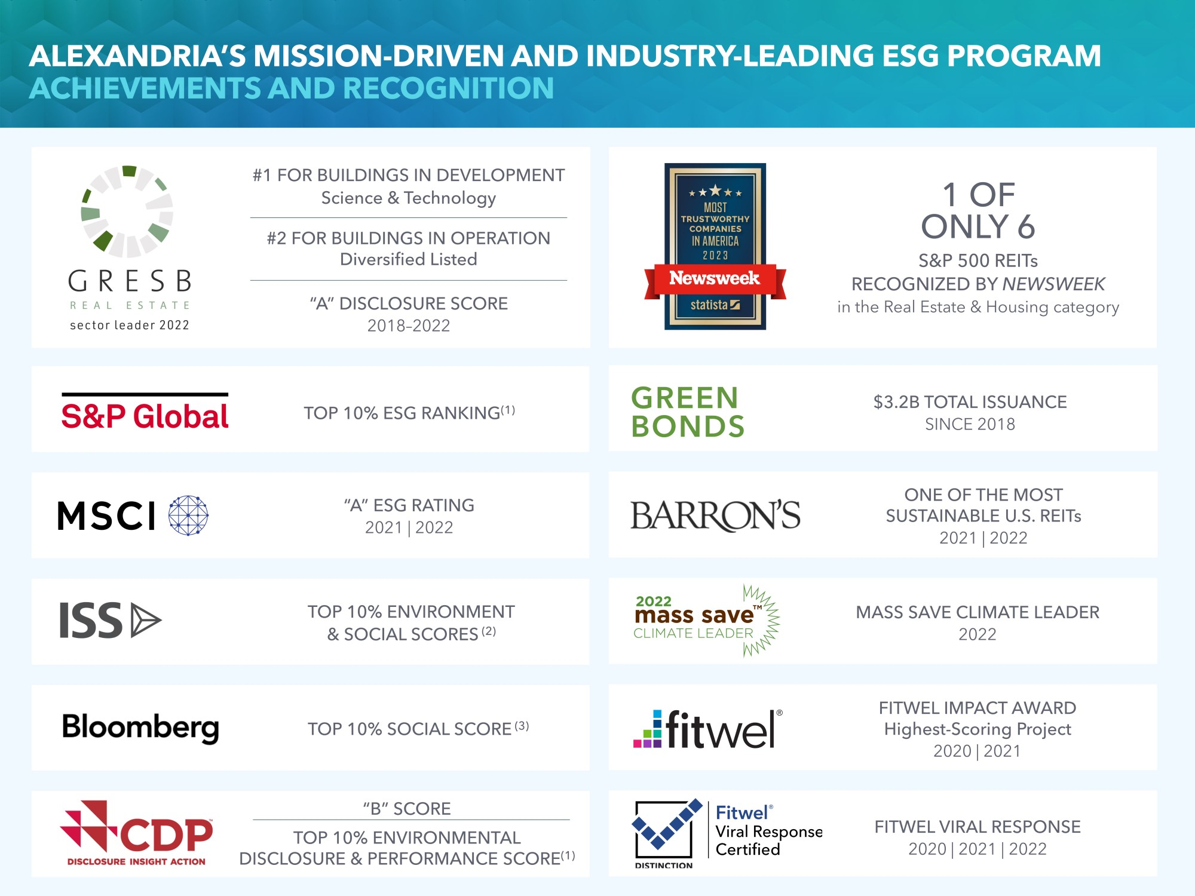
(1)Reflects current score for Alexandria and latest scores available for the FTSE Nareit All REITs Index companies from Bloomberg Professional Services as of March 31, 2023.
(2)Reflects current scores for Alexandria and latest scores available for the FTSE Nareit All REITs Index companies on ISS’s website as of March 31, 2023.
(3)Top 10% ranking among FTSE Nareit All REITs Index companies, based on information available from Bloomberg Professional Services as of March 31, 2023.

44

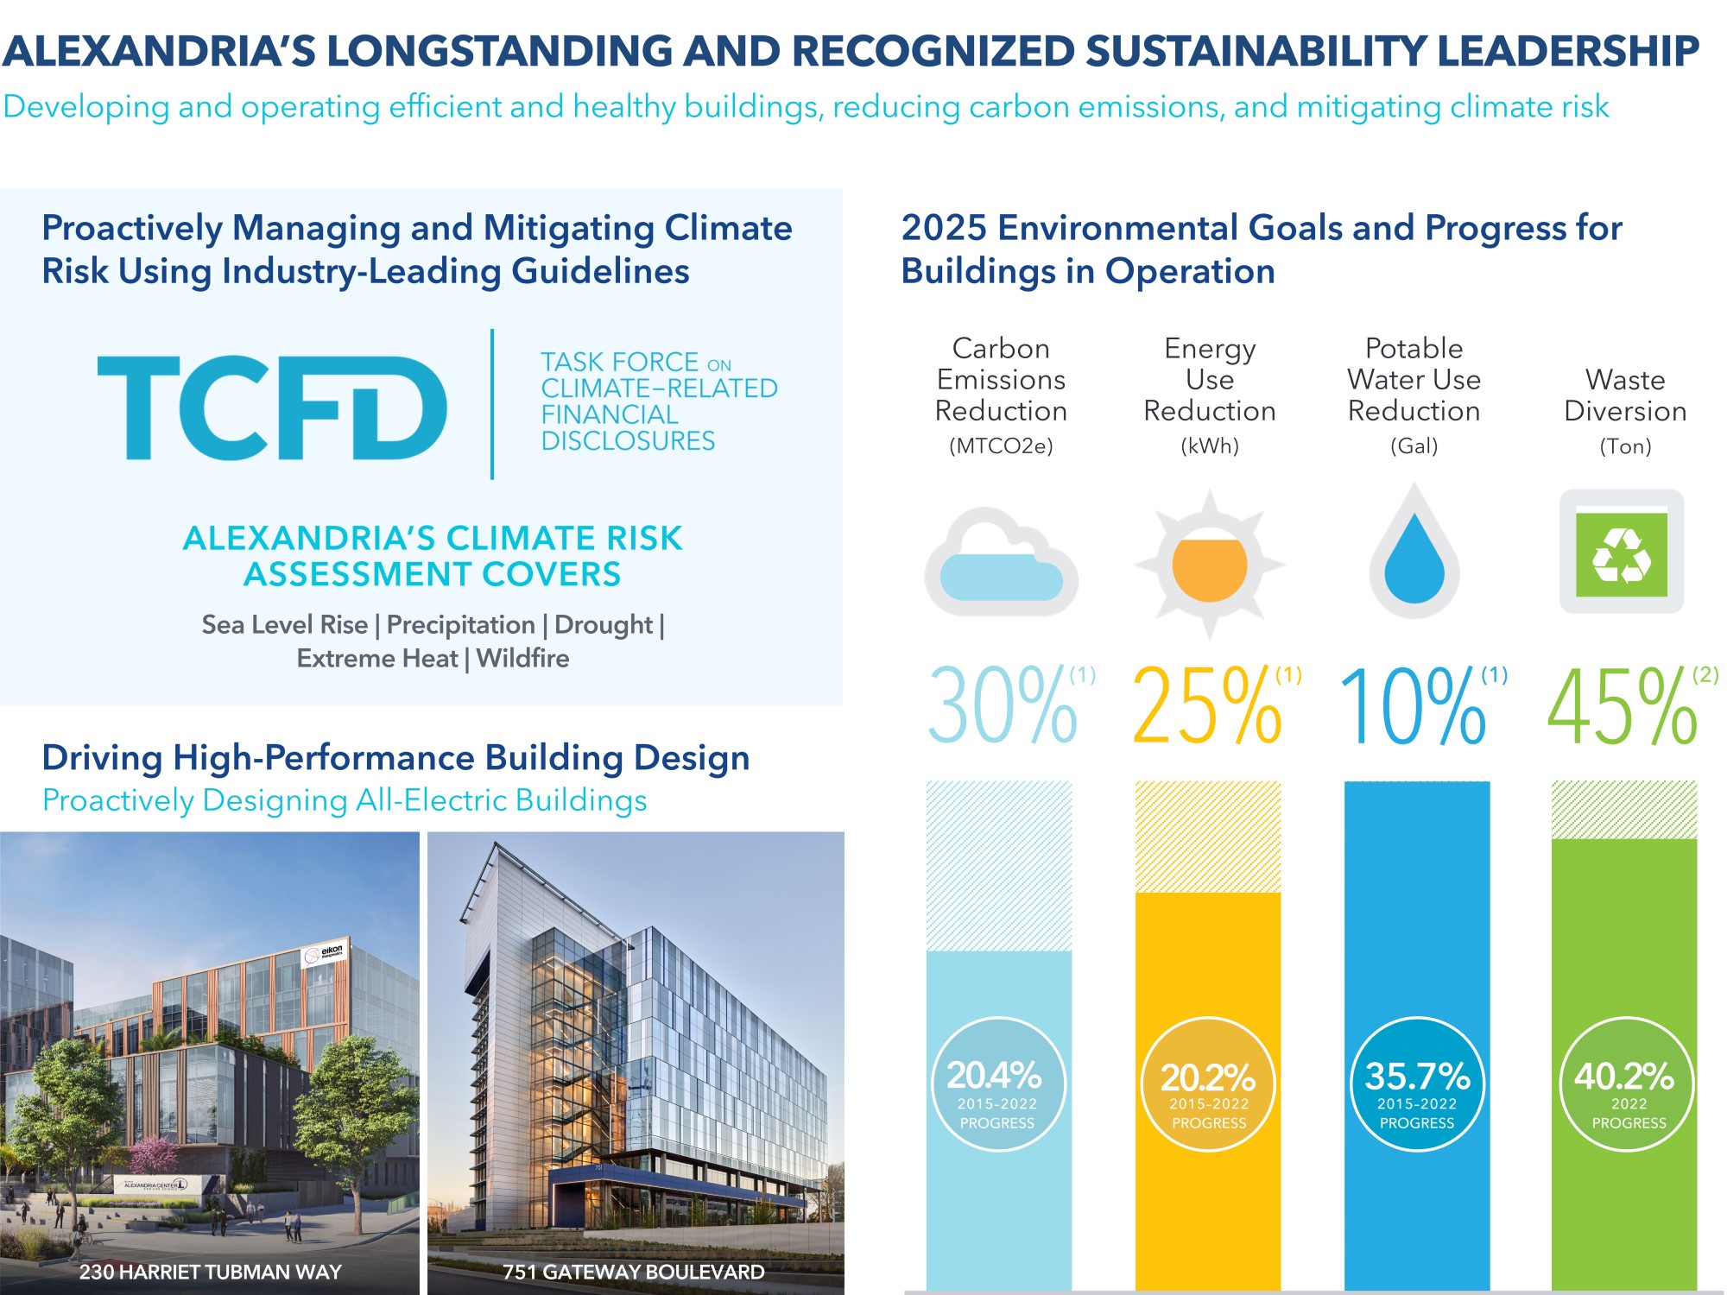
Environmental data for 2022 reflected in the chart above received independent limited assurance from DNV. The Independent Assurance Statement from DNV is available at www.are.com/esg.html.
(1)2025 environmental goals relative to a 2015 baseline on a like-for-like basis for buildings in operation that Alexandria directly manages. The carbon emissions reduction goal relates to our Scope 1 and Scope 2 emissions.
(2)2025 environmental goal for buildings in operation that Alexandria indirectly and directly manages.

45

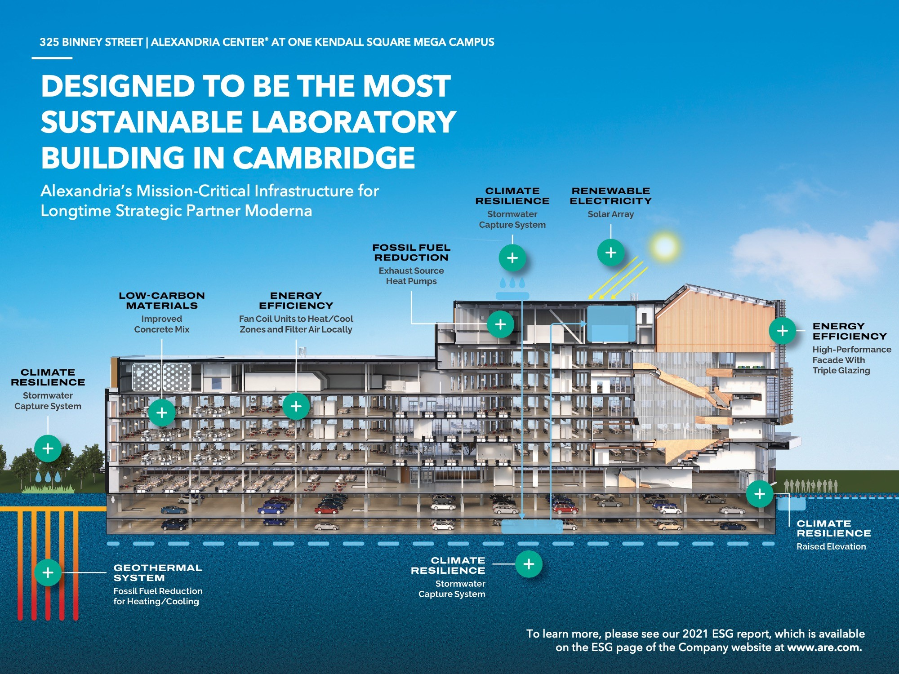

46

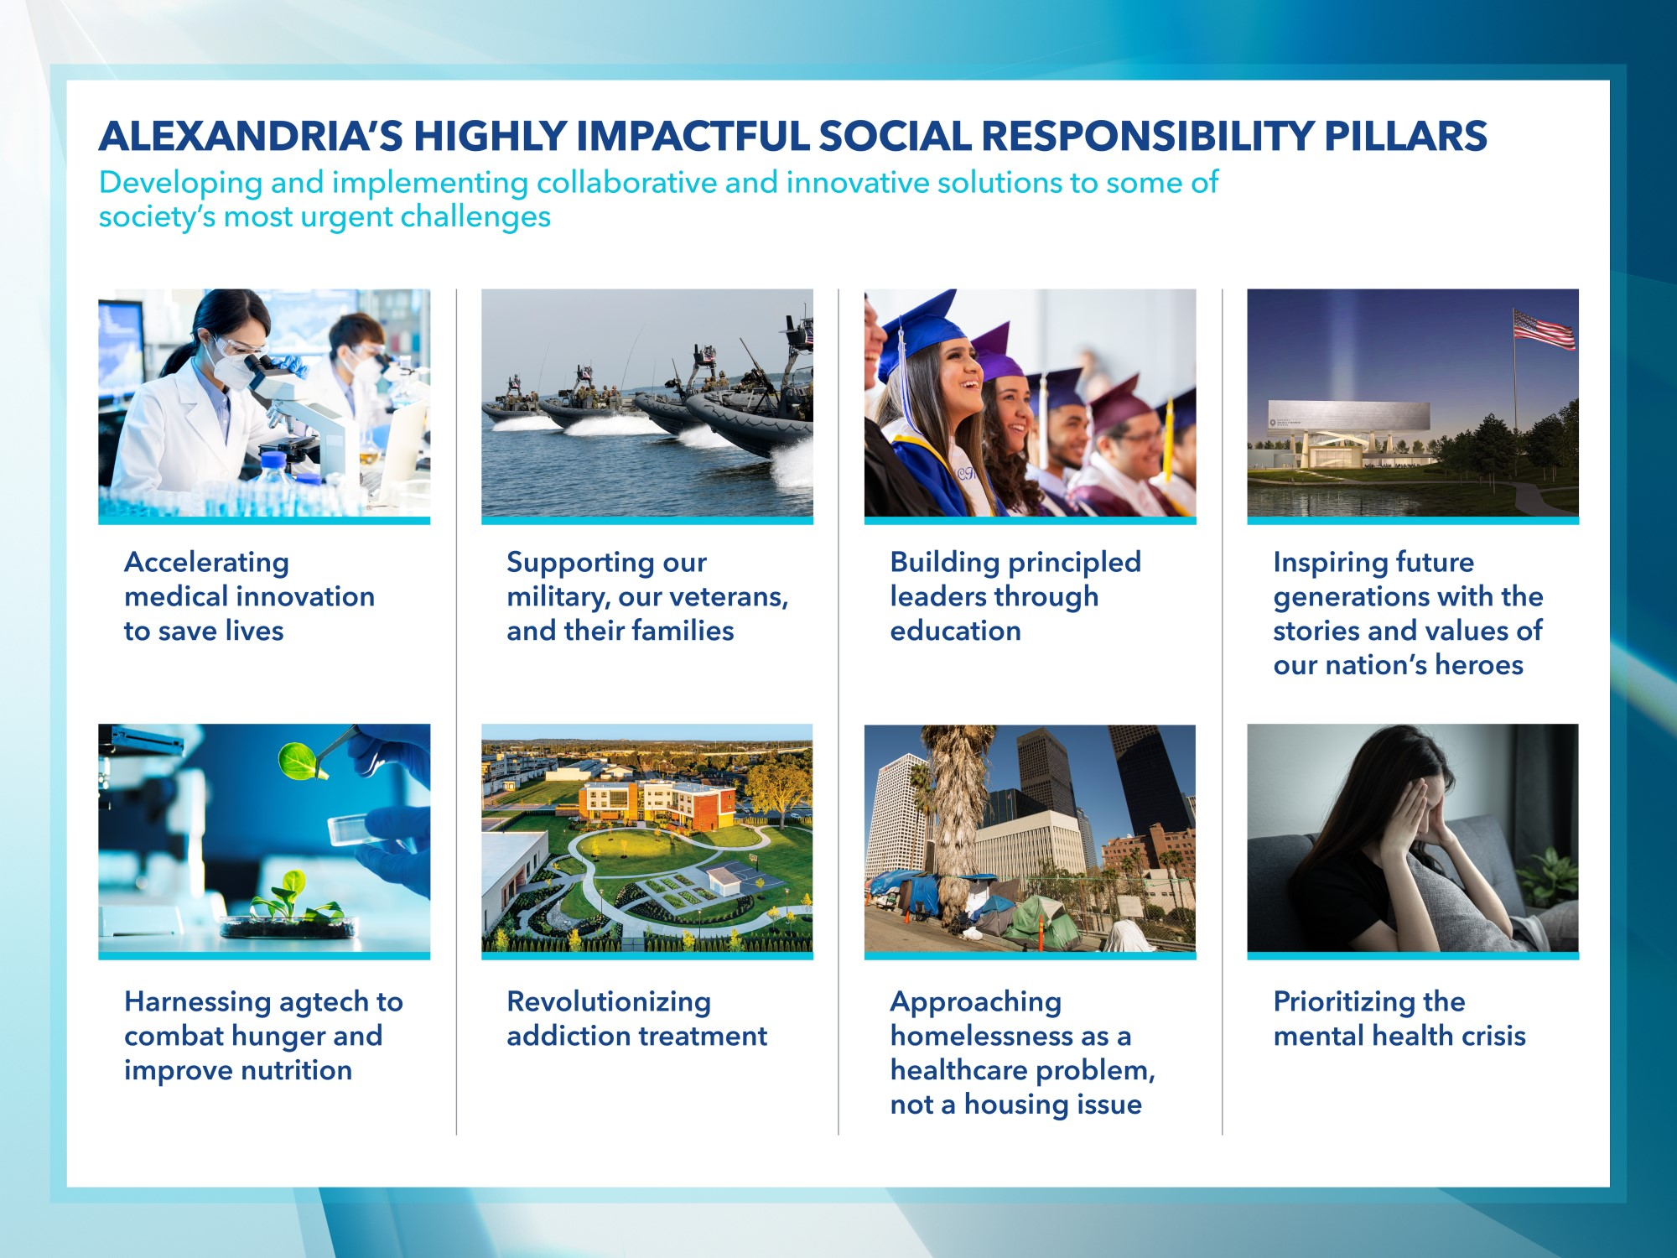

47

Operating summary

Historical Same Property  Net Operating Income Growth |  |  |  |  |  |  |  |  | Favorable Lease Structure(1)
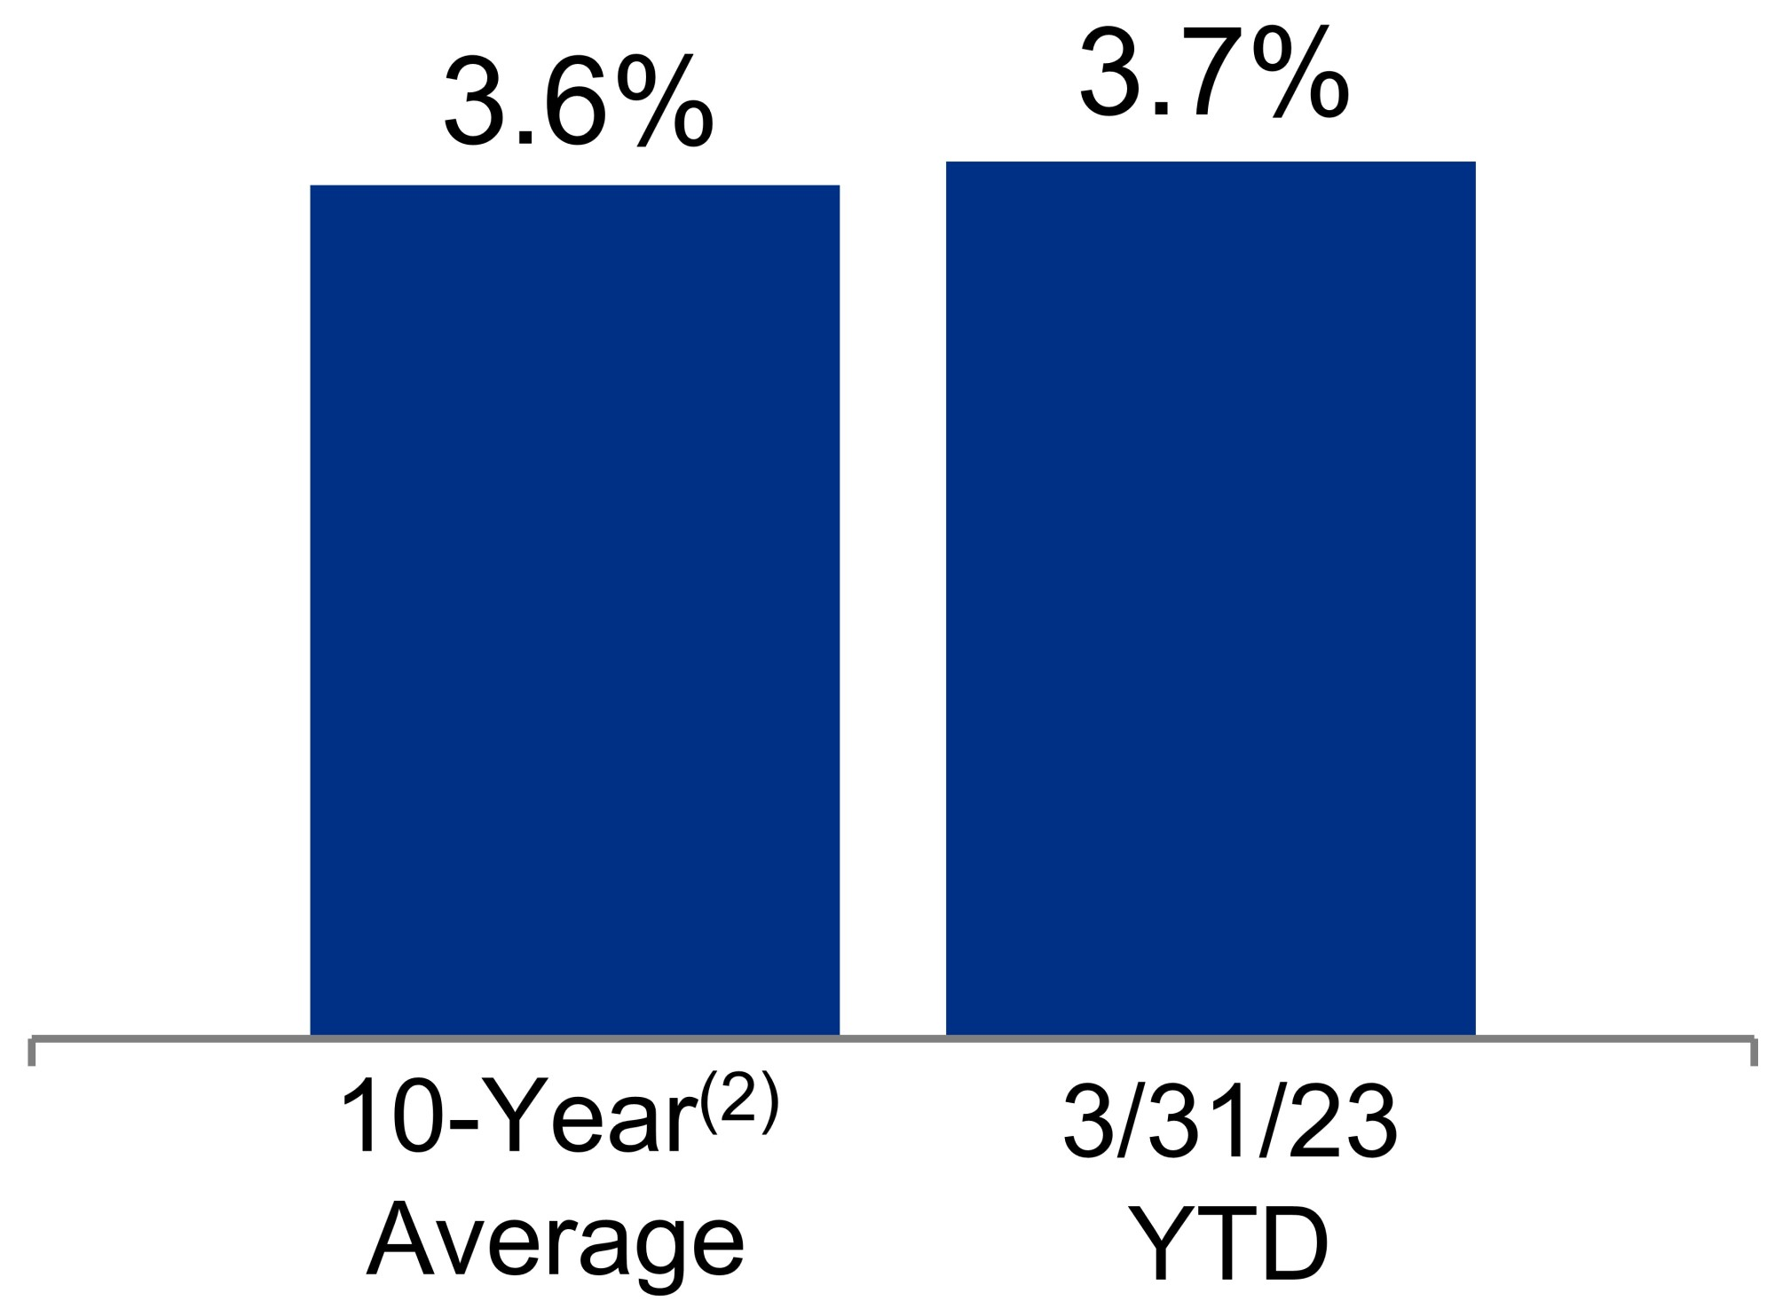 |  |  | 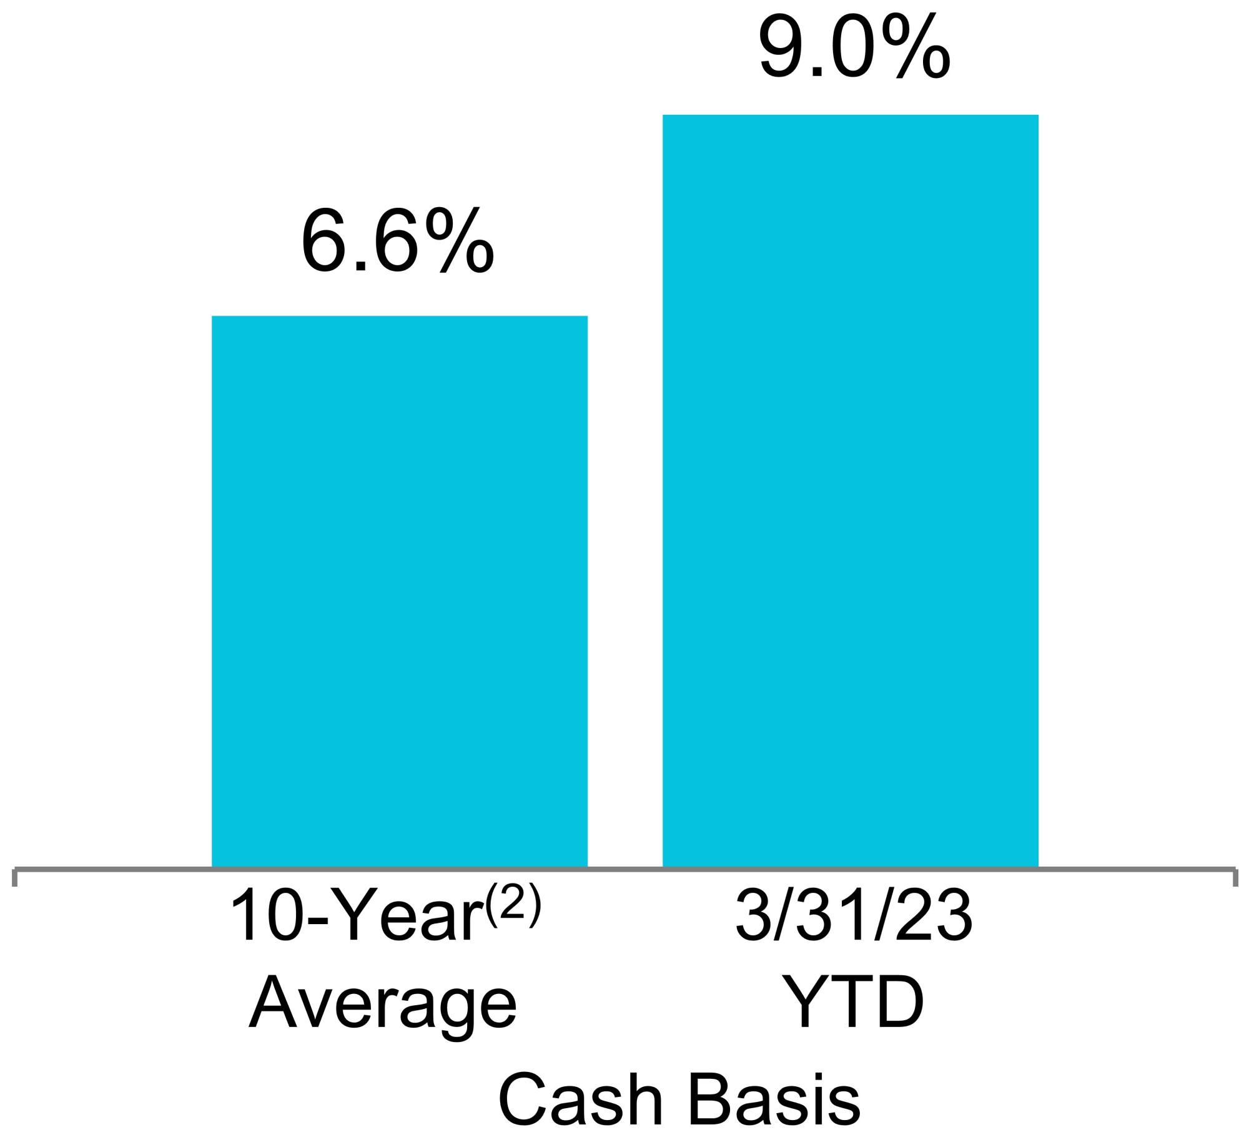 |  |  |  |  |  | Strategic Lease Structure by Owner and Operator of Collaborative Life Science, Agtech, and Advanced Technology Campuses
 |  |  |  |  |  |  |  |  | Increasing cash flows
 |  |  |  |  |  |  |  |  | Percentage of leases containing annual rent escalations |  |  |  |  |  |  |  |  |  |  |  |  |  |  |  |  |  | 95%
 |  |  |  |  |  |  |  |  | Stable cash flows
 |  |  |  |  |  |  |  |  | Percentage of triple  net leases |  |  |  |  |  |  |  |  |  |  |  |  |  |  |  |  |  | 93%
 |  |  |  |  |  |  |  |  | Lower capex burden
 |  |  |  |  |  |  |  |  | Percentage of leases providing for the recapture of capital expenditures |  |  |  |  |  |  |  |  |  |  |  |  |  |  |  |  |  | 93%
Historical Rental Rate Growth:  Renewed/Re-Leased Space |  |  |  |  |  |  |  |  | Margins(3)
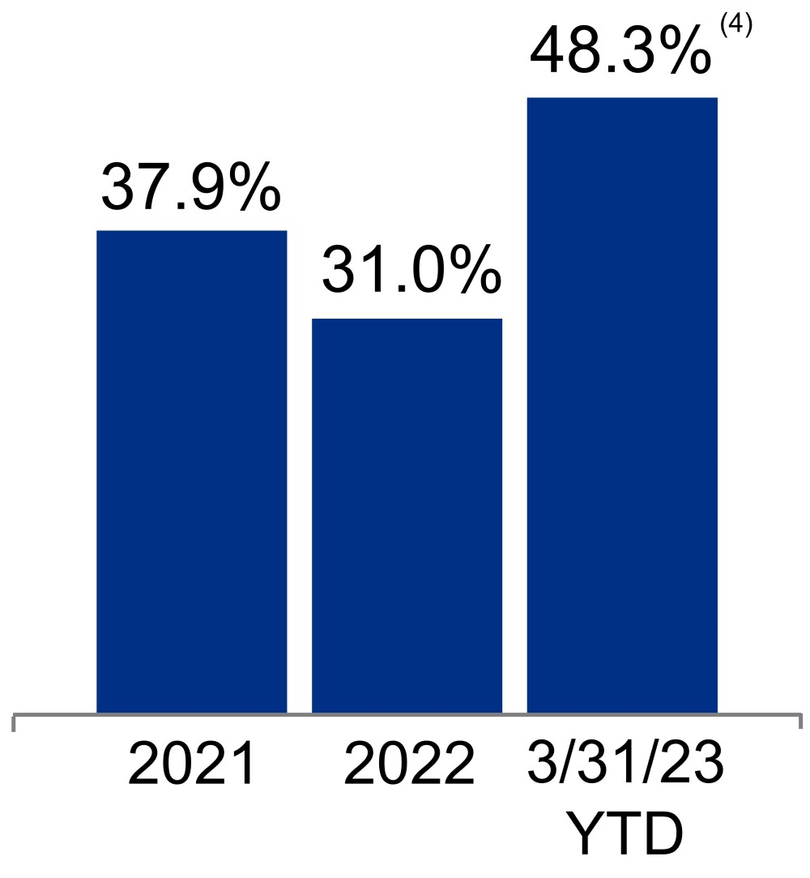 |  |  | 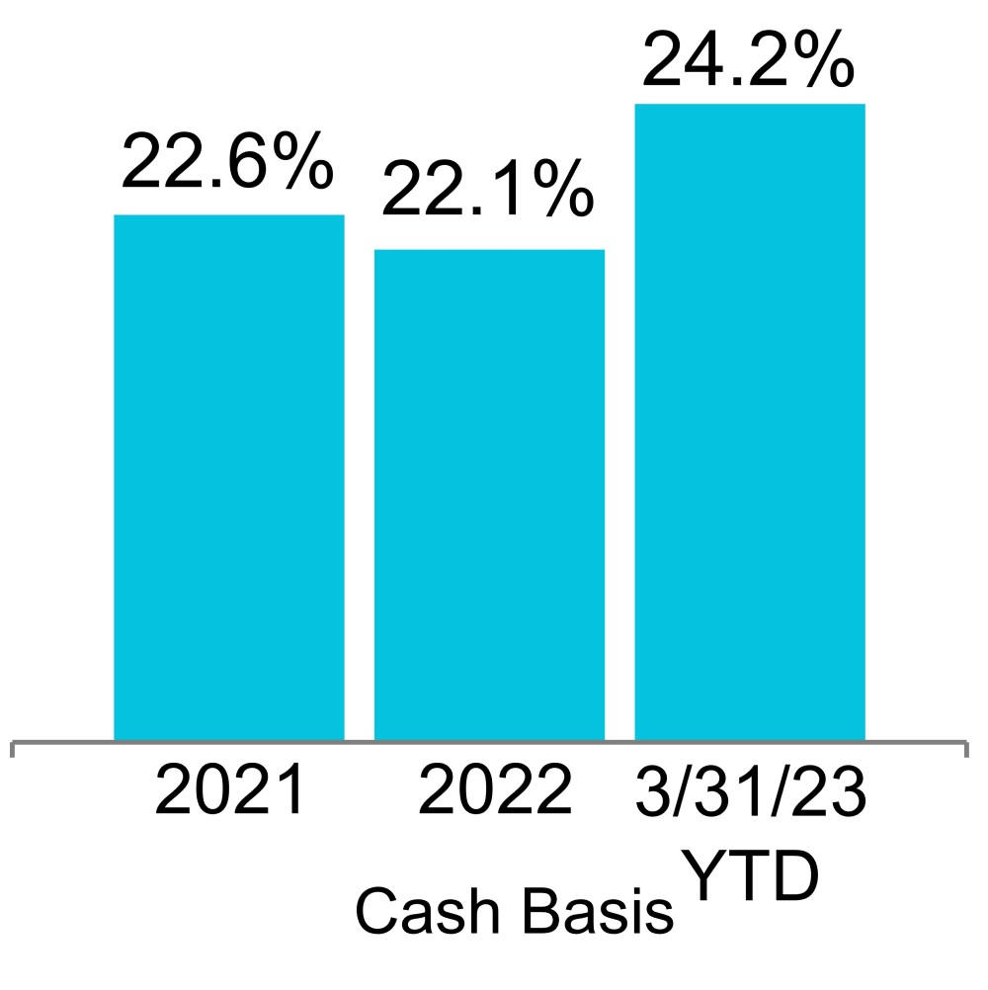
 |  |  |  |  |  |  |  |  | Operating |  |  |  |  |  |  |  |  |  |  |  |  |  |  | Adjusted EBITDA
 |  |  |  |  |  |  |  |  | 70% |  |  |  |  |  |  |  |  |  |  |  |  |  |  | 69%
Net Debt and Preferred Stock  to Adjusted EBITDA(5) |  |  |  |  |  |  |  |  | Fixed-Charge Coverage Ratio(5)
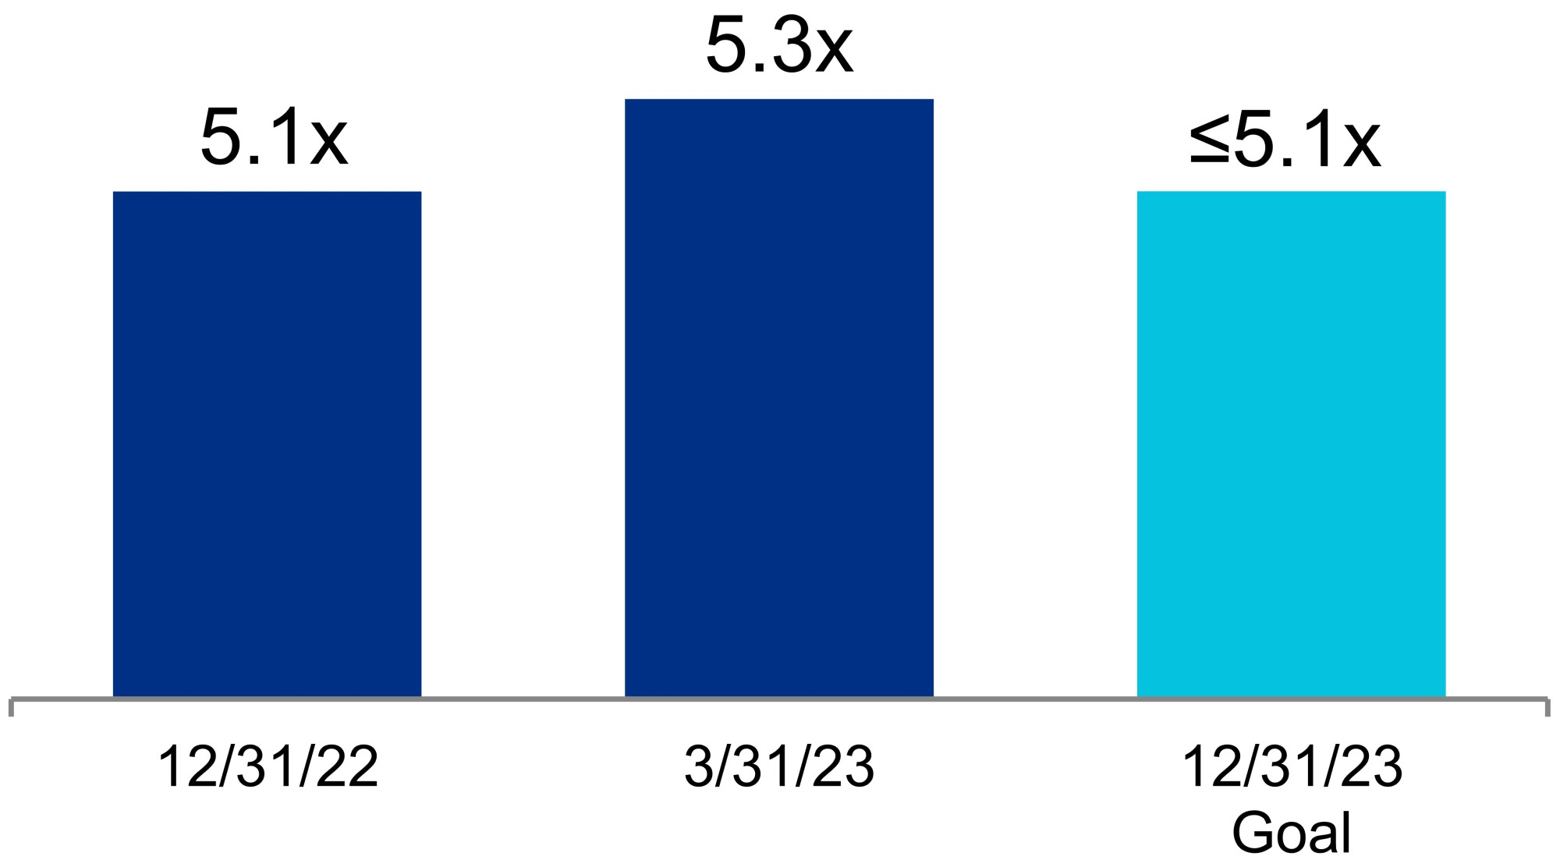 |  |  |  |  |  |  |  |  | 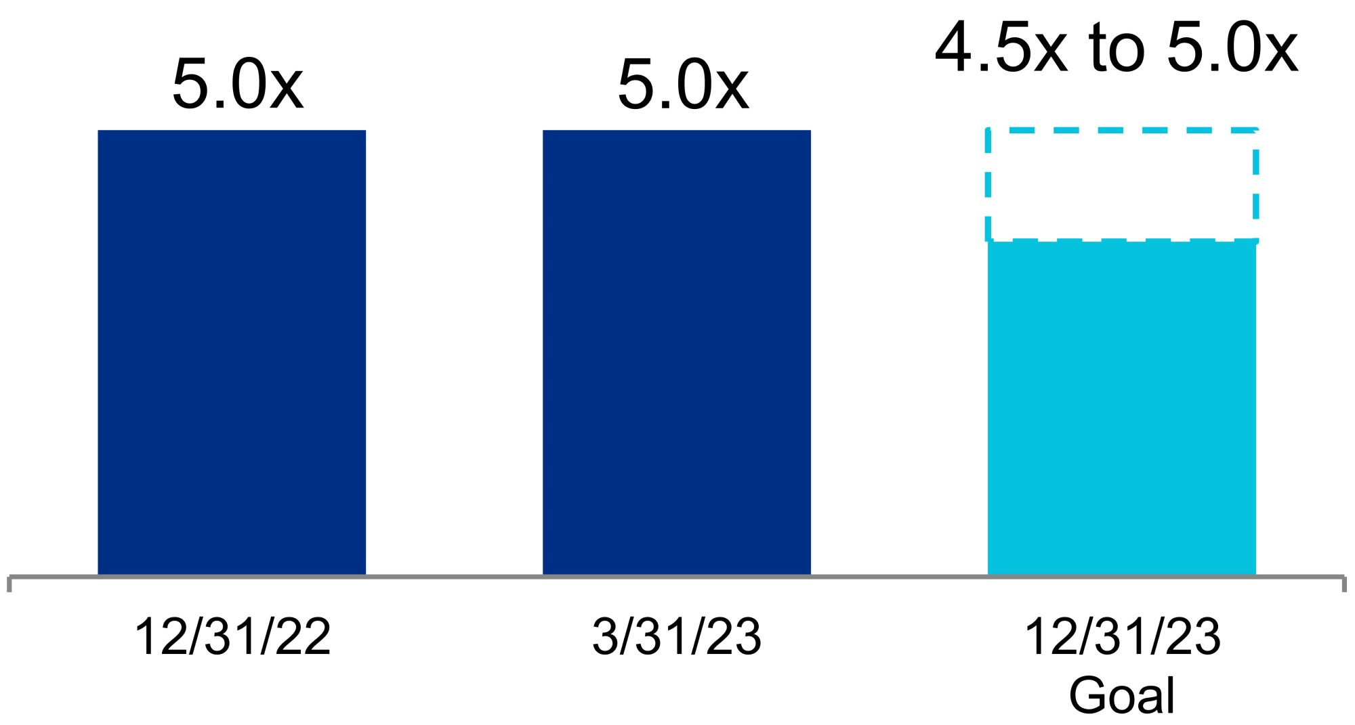
Refer to “Same properties” and “Non-GAAP measures and definitions” within this Item 2 for additional details. “Non-GAAP measures and definitions” contains the definition of “Net operating income” and its reconciliation from the most directly comparable financial measure presented in accordance with GAAP.

(1)Percentages calculated based on annual rental revenue in effect as of March 31, 2023.
(2)The 10-year average represents the average for the years ended December 31, 2013 through December 31, 2022.
(3)Represents percentages for the three months ended March 31, 2023.
(4)Represents the highest quarterly rental rate growth in Company history.
(5)Quarter annualized. Refer to the definitions of “Net debt and preferred stock to Adjusted EBITDA” and “Fixed-charge coverage ratio” in the “Non-GAAP measures and definitions” section within this Item 2 for additional details.

48

Long-Duration and Stable Cash Flows From
High-Quality and Diverse Tenants
Investment-Grade or  Publicly Traded Large Cap Tenants |  |  |  |  |  | REIT Industry-Leading  Tenant Client Base
49% |  |  |  |  |  | 90%
of ARE’s Total  Annual Rental Revenue(1) |  |  |  |  |  | of ARE’s Top 20 Tenants Annual Rental Revenue(1) Is From Investment-Grade or Publicly Traded Large Cap Tenants
Long-Duration Lease Terms
7.2 Years
Weighted-Average
Remaining Term(2)

Sustained Strength in Tenant Collections(3)
99.9%
For the Three Months Ended
March 31, 2023
99.7%
April 2023
Represents annual rental revenue in effect as of March 31, 2023. Refer to the “Non-GAAP measures and definitions” section within this Item 2 for additional information.

(1)Represents annual rental revenue in effect as of March 31, 2023.
(2)Based on total annual rental revenue in effect as of March 31, 2023.
(3)Represents the portion of total receivables billed for each indicated period collected through the date of this report. .

49

High-Quality and Diverse Client Base in AAA Locations
Industry Mix of  Over 850 Tenants(1) |  |  |  |  |  |  |  |  |  |  |  | AAA Locations
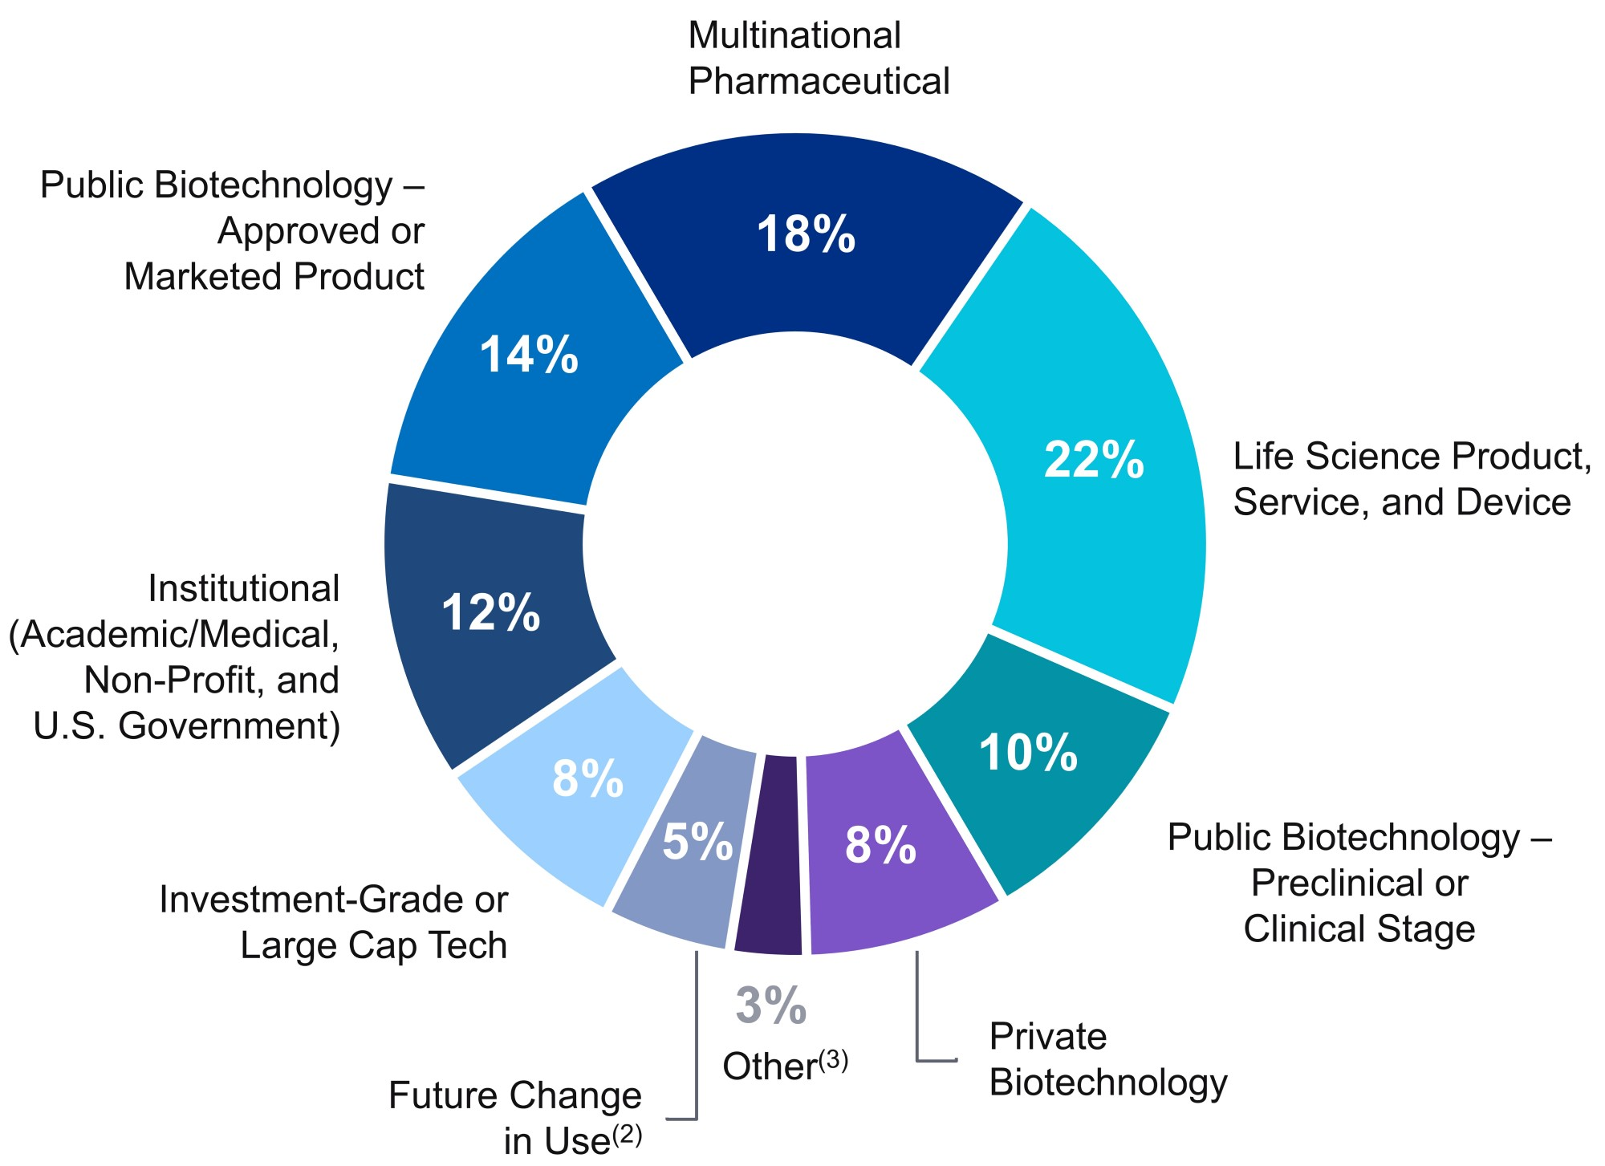 |  |  |  |  |  |  |  |  |  |  |  | 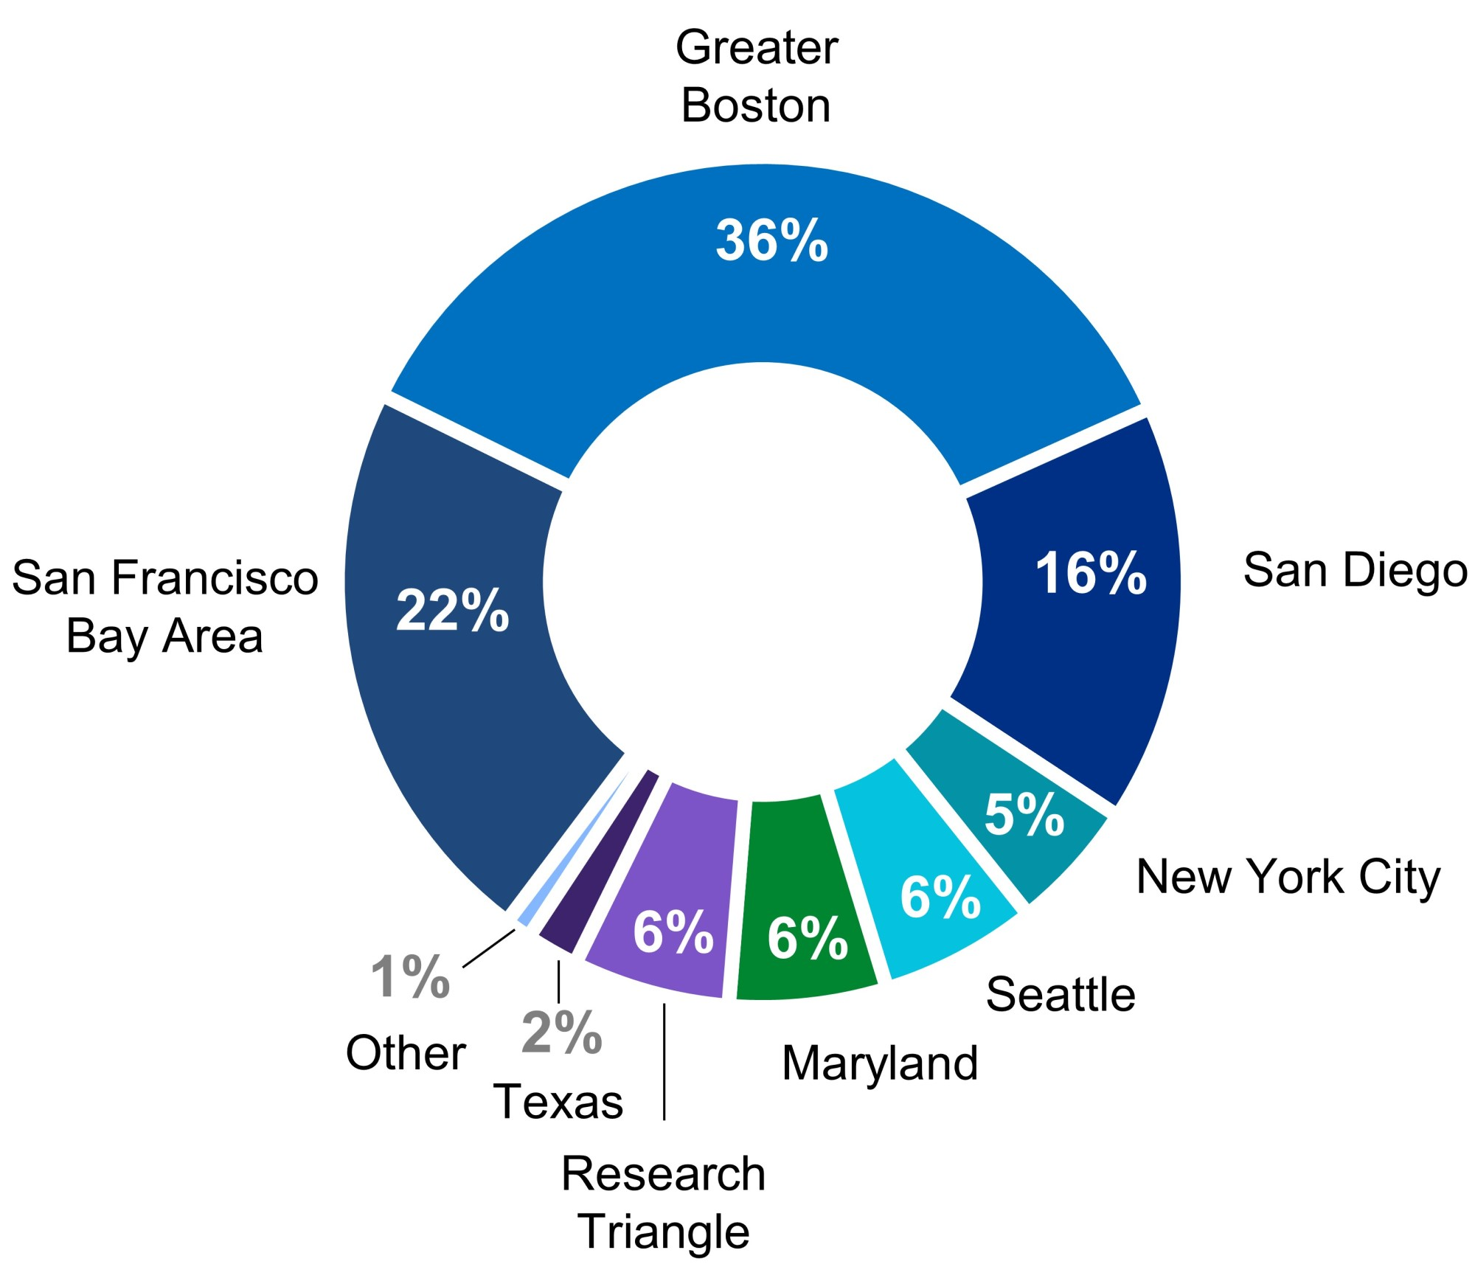
Percentage of ARE’s Annual Rental Revenue(4)
Solid Occupancy From Historically Strong Demand
for Class A Properties in AAA Locations
Solid Historical  Occupancy(5) |  |  |  |  |  | Occupancy Across Key Locations
 |  |  |  |  |  | 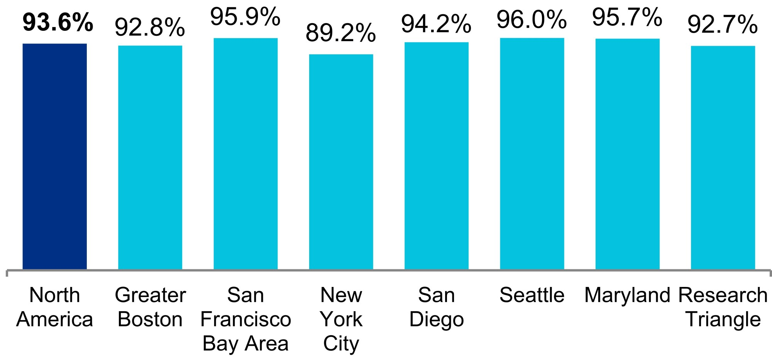
96%
Over 10 Years
Represents annual rental revenue in effect as of March 31, 2023. Refer to the “Non-GAAP measures and definitions” section within this Item 2 for additional information.

(1)Tenant count declined from approximately 1,000 tenants during the three months ended March 31, 2023 due to the planned move-outs at our recently acquired retail property, The Shops at Tanforan, representing a future multi-building development project.
(2)Represents annual rental revenue currently generated from space that is targeted for a future change in use, including 1.1% of total annual rental revenue that is generated from covered land play projects. The weighted-average remaining term of these leases is 5.3 years.
(3)Our other tenants, which represent an aggregate of 3.0% of our annual rental revenue, comprise technology, professional services, finance, telecommunications, and construction/real estate companies and less than 1.0% of retail-related tenants by annual rental revenue.
(4)Represents annual rental revenue in effect as of March 31, 2023.
(5)Represents average occupancy of operating properties in North America as of each December 31 for the last 10 years and as of March 31, 2023.

50

Leasing

The following table summarizes our leasing activity at our properties:
 |  |  |  |  |  | Three Months Ended |  |  |  |  |  |  |  |  |  |  |  |  |  |  |  |  |  | Year Ended
 |  |  |  |  |  | March 31, 2023 |  |  |  |  |  |  |  |  |  |  |  |  |  |  |  |  |  | December 31, 2022
 |  |  |  |  |  | Including  Straight-Line Rent |  |  |  |  |  |  |  |  | Cash Basis |  |  |  |  |  |  |  |  |  |  | Including  Straight-Line Rent |  |  |  | Cash Basis
(Dollars per RSF)
Leasing activity:
Renewed/re-leased space(1)
Rental rate changes |  |  |  |  |  | 48.3% |  |  | (2) |  |  |  |  |  | 24.2% |  |  |  |  |  |  |  |  |  |  |  | 31.0% |  |  |  |  |  | 22.1%
New rates |  |  |  |  |  | $62.75 |  |  |  |  |  |  |  |  | $59.87 |  |  |  |  |  |  |  |  |  |  |  | $50.37 |  |  |  |  |  | $48.48
Expiring rates |  |  |  |  |  | $42.31 |  |  |  |  |  |  |  |  | $48.21 |  |  |  |  |  |  |  |  |  |  |  | $38.44 |  |  |  |  |  | $39.69
RSF |  |  |  |  |  | 1,120,038 |  |  |  |  |  |  |  |  |  |  |  |  |  |  |  |  |  |  |  |  | 4,540,325
Tenant improvements/leasing commissions |  |  |  |  |  | $16.59 |  |  |  |  |  |  |  |  |  |  |  |  |  |  |  |  |  |  |  |  | $27.83
Weighted-average lease term |  |  |  |  |  | 5.3 years |  |  |  |  |  |  |  |  |  |  |  |  |  |  |  |  |  |  |  |  | 5.0 years
Developed/redeveloped/ previously vacant space leased(3)
New rates |  |  |  |  |  | $39.54 |  |  |  |  |  |  |  |  | $38.29 |  |  |  |  |  |  |  |  |  |  |  | $73.46 |  |  |  |  |  | $64.04
RSF |  |  |  |  |  | 103,389 |  |  |  |  |  |  |  |  |  |  |  |  |  |  |  |  |  |  |  |  | 3,865,262
Weighted-average lease term |  |  |  |  |  | 7.5 years |  |  |  |  |  |  |  |  |  |  |  |  |  |  |  |  |  |  |  |  | 11.8 years
Leasing activity summary (totals):
New rates |  |  |  |  |  | $60.79 |  |  |  |  |  |  |  |  | $58.05 |  |  |  |  |  |  |  |  |  |  |  | $60.98 |  |  |  |  |  | $55.64
RSF |  |  |  |  |  | 1,223,427 |  |  |  |  |  |  |  |  |  |  |  |  |  |  |  |  |  |  |  |  | 8,405,587
Weighted-average lease term |  |  |  |  |  | 5.5 years |  |  |  |  |  |  |  |  |  |  |  |  |  |  |  |  |  |  |  |  | 8.1 years
Lease expirations(1)
Expiring rates |  |  |  |  |  | $43.47 |  |  |  |  |  |  |  |  | $47.45 |  |  |  |  |  |  |  |  |  |  |  | $37.41 |  |  |  |  |  | $38.06
RSF |  |  |  |  |  | 2,012,525 |  |  |  |  |  |  |  |  |  |  |  |  |  |  |  |  |  |  |  |  | 6,572,286

Leasing activity includes 100% of results for properties in which we have an investment in North America.

(1)Excludes month-to-month leases aggregating 115,520 RSF and 266,292 RSF as of March 31, 2023 and December 31, 2022, respectively.
(2)Represents the highest quarterly rental rate growth in Company history.
(3)Refer to the “New Class A development and redevelopment properties: summary of pipeline” section within this Item 2 for additional information on total project costs.

51

Summary of contractual lease expirations

The following table summarizes information with respect to the contractual lease expirations at our properties as of March 31, 2023:
Year |  |  |  |  |  |  |  |  |  |  |  | RSF |  |  |  |  |  |  |  |  |  |  |  | Percentage of  Occupied RSF |  |  |  |  |  |  |  |  |  |  |  | Annual Rental Revenue  (per RSF)(1) |  |  |  |  |  |  |  |  |  |  |  | Percentage of Total  Annual Rental Revenue
 |  |  | 2023 |  |  | (2) |  |  |  |  |  |  |  |  | 1,700,031 |  |  |  |  |  |  |  |  |  |  |  | 4.4 |  | % |  |  |  |  |  |  |  |  |  | $ | 46.10 |  |  |  |  |  |  |  |  |  |  | 3.9 |  | %
 |  |  | 2024 |  |  |  |  |  |  |  |  |  |  |  | 3,739,274 |  |  |  |  |  |  |  |  |  |  |  | 9.6 |  | % |  |  |  |  |  |  |  |  |  | $ | 49.15 |  |  |  |  |  |  |  |  |  |  | 9.2 |  | %
 |  |  | 2025 |  |  |  |  |  |  |  |  |  |  |  | 3,369,852 |  |  |  |  |  |  |  |  |  |  |  | 8.6 |  | % |  |  |  |  |  |  |  |  |  | $ | 48.66 |  |  |  |  |  |  |  |  |  |  | 8.2 |  | %
 |  |  | 2026 |  |  |  |  |  |  |  |  |  |  |  | 2,787,746 |  |  |  |  |  |  |  |  |  |  |  | 7.2 |  | % |  |  |  |  |  |  |  |  |  | $ | 49.08 |  |  |  |  |  |  |  |  |  |  | 6.8 |  | %
 |  |  | 2027 |  |  |  |  |  |  |  |  |  |  |  | 2,729,791 |  |  |  |  |  |  |  |  |  |  |  | 7.0 |  | % |  |  |  |  |  |  |  |  |  | $ | 55.00 |  |  |  |  |  |  |  |  |  |  | 7.5 |  | %
 |  |  | 2028 |  |  |  |  |  |  |  |  |  |  |  | 4,608,140 |  |  |  |  |  |  |  |  |  |  |  | 11.8 |  | % |  |  |  |  |  |  |  |  |  | $ | 51.98 |  |  |  |  |  |  |  |  |  |  | 12.0 |  | %
 |  |  | 2029 |  |  |  |  |  |  |  |  |  |  |  | 2,398,269 |  |  |  |  |  |  |  |  |  |  |  | 6.2 |  | % |  |  |  |  |  |  |  |  |  | $ | 54.31 |  |  |  |  |  |  |  |  |  |  | 6.5 |  | %
 |  |  | 2030 |  |  |  |  |  |  |  |  |  |  |  | 2,830,567 |  |  |  |  |  |  |  |  |  |  |  | 7.3 |  | % |  |  |  |  |  |  |  |  |  | $ | 57.36 |  |  |  |  |  |  |  |  |  |  | 8.1 |  | %
 |  |  | 2031 |  |  |  |  |  |  |  |  |  |  |  | 3,086,116 |  |  |  |  |  |  |  |  |  |  |  | 7.9 |  | % |  |  |  |  |  |  |  |  |  | $ | 54.15 |  |  |  |  |  |  |  |  |  |  | 8.3 |  | %
 |  |  | 2032 |  |  |  |  |  |  |  |  |  |  |  | 1,298,945 |  |  |  |  |  |  |  |  |  |  |  | 3.3 |  | % |  |  |  |  |  |  |  |  |  | $ | 56.91 |  |  |  |  |  |  |  |  |  |  | 3.7 |  | %
Thereafter |  |  |  |  |  |  |  |  |  |  |  |  |  |  | 10,413,780 |  |  |  |  |  |  |  |  |  |  |  | 26.7 |  | % |  |  |  |  |  |  |  |  |  | $ | 49.67 |  |  |  |  |  |  |  |  |  |  | 25.8 |  | %
(1)Represents amounts in effect as of March 31, 2023.
(2)Excludes month-to-month leases aggregating 115,520 RSF as of March 31, 2023.

The following tables present information by market with respect to our lease expirations in North America as of March 31, 2023, for the remainder of 2023, and for all of 2024:
 |  |  |  |  |  | 2023 Contractual Lease Expirations (in RSF) |  |  |  |  |  |  |  |  |  |  |  |  |  |  |  |  |  |  |  |  |  |  |  |  |  |  |  |  |  | Annual Rental Revenue  (per RSF)(4)
Market |  |  |  |  |  | Leased |  |  |  |  |  | Negotiating/  Anticipating |  |  |  |  |  | Targeted for Future  Development/  Redevelopment(1) |  |  |  |  |  | Remaining  Expiring Leases(2) |  |  |  |  |  | Total(3)
Greater Boston |  |  |  |  |  | 37,017 |  |  |  |  |  | 21,675 |  |  |  |  |  | 10,265 |  |  | (5) |  |  | 283,576 |  |  |  |  |  | 352,533 |  |  |  |  |  | $ | 62.34
San Francisco Bay Area |  |  |  |  |  | 56,253 |  |  |  |  |  | 41,381 |  |  |  |  |  | — |  |  |  |  |  | 182,743 |  |  |  |  |  | 280,377 |  |  |  |  |  | 57.96
New York City |  |  |  |  |  | — |  |  |  |  |  | — |  |  |  |  |  | — |  |  |  |  |  | 20,790 |  |  |  |  |  | 20,790 |  |  |  |  |  | N/A
San Diego |  |  |  |  |  | 199,402 |  |  |  |  |  | 72,292 |  |  |  |  |  | — |  |  |  |  |  | 229,740 |  |  |  |  |  | 501,434 |  |  |  |  |  | 31.62
Seattle |  |  |  |  |  | — |  |  |  |  |  | — |  |  |  |  |  | — |  |  |  |  |  | 255,460 |  |  |  |  |  | 255,460 |  |  |  |  |  | 31.87
Maryland |  |  |  |  |  | — |  |  |  |  |  | 89,831 |  |  |  |  |  | — |  |  |  |  |  | 116,938 |  |  |  |  |  | 206,769 |  |  |  |  |  | 32.26
Research Triangle |  |  |  |  |  | — |  |  |  |  |  | — |  |  |  |  |  | — |  |  |  |  |  | 59,398 |  |  |  |  |  | 59,398 |  |  |  |  |  | 46.88
Texas |  |  |  |  |  | — |  |  |  |  |  | — |  |  |  |  |  | — |  |  |  |  |  | — |  |  |  |  |  | — |  |  |  |  |  | —
Canada |  |  |  |  |  | 13,321 |  |  |  |  |  | — |  |  |  |  |  | — |  |  |  |  |  | 2,484 |  |  |  |  |  | 15,805 |  |  |  |  |  | 28.07
Non-cluster/other markets |  |  |  |  |  | — |  |  |  |  |  | 4,354 |  |  |  |  |  | — |  |  |  |  |  | 3,111 |  |  |  |  |  | 7,465 |  |  |  |  |  | 58.48
Total |  |  |  |  |  | 305,993 |  |  |  |  |  | 229,533 |  |  |  |  |  | 10,265 |  |  |  |  |  | 1,154,240 |  |  |  |  |  | 1,700,031 |  |  |  |  |  | $ | 46.10
Percentage of expiring leases |  |  |  |  |  | 18 |  | % |  |  |  | 14 |  | % |  |  |  | 1 |  | % |  |  |  | 67 |  | % |  |  |  | 100 |  | %
 |  |  |  |  |  | 2024 Contractual Lease Expirations (in RSF) |  |  |  |  |  |  |  |  |  |  |  |  |  |  |  |  |  |  |  |  |  |  |  |  |  |  |  |  |  | Annual Rental Revenue  (per RSF)(4)
Market |  |  |  |  |  | Leased |  |  |  |  |  | Negotiating/  Anticipating |  |  |  |  |  | Targeted for Future  Development/  Redevelopment(1) |  |  |  |  |  | Remaining  Expiring Leases(2) |  |  |  |  |  | Total
Greater Boston |  |  |  |  |  | 51,564 |  |  |  |  |  | — |  |  |  |  |  | 122,465 |  |  |  |  |  | 535,690 |  |  |  |  |  | 709,719 |  |  |  |  |  | $ | 75.28
San Francisco Bay Area |  |  |  |  |  | 35,798 |  |  |  |  |  | — |  |  |  |  |  | 107,250 |  |  |  |  |  | 555,209 |  |  |  |  |  | 698,257 |  |  |  |  |  | 61.98
New York City |  |  |  |  |  | — |  |  |  |  |  | — |  |  |  |  |  | 349,947 |  |  |  |  |  | 8,227 |  |  |  |  |  | 358,174 |  |  |  |  |  | N/A
San Diego |  |  |  |  |  | 28,698 |  |  |  |  |  | 28,264 |  |  |  |  |  | 580,021 |  |  |  |  |  | 345,518 |  |  |  |  |  | 982,501 |  |  |  |  |  | 31.60
Seattle |  |  |  |  |  | — |  |  |  |  |  | 186,923 |  |  |  |  |  | 50,552 |  |  |  |  |  | 220,425 |  |  |  |  |  | 457,900 |  |  |  |  |  | 23.44
Maryland |  |  |  |  |  | — |  |  |  |  |  | 26,627 |  |  |  |  |  | — |  |  |  |  |  | 44,919 |  |  |  |  |  | 71,546 |  |  |  |  |  | 23.04
Research Triangle |  |  |  |  |  | 15,519 |  |  |  |  |  | 103,171 |  |  |  |  |  | — |  |  |  |  |  | 106,254 |  |  |  |  |  | 224,944 |  |  |  |  |  | 65.25
Texas |  |  |  |  |  | — |  |  |  |  |  | — |  |  |  |  |  | 126,034 |  |  |  |  |  | 72,938 |  |  |  |  |  | 198,972 |  |  |  |  |  | 33.91
Canada |  |  |  |  |  | — |  |  |  |  |  | — |  |  |  |  |  | — |  |  |  |  |  | 6,786 |  |  |  |  |  | 6,786 |  |  |  |  |  | 23.45
Non-cluster/other markets |  |  |  |  |  | — |  |  |  |  |  | — |  |  |  |  |  | — |  |  |  |  |  | 30,475 |  |  |  |  |  | 30,475 |  |  |  |  |  | 65.94
Total |  |  |  |  |  | 131,579 |  |  |  |  |  | 344,985 |  |  |  |  |  | 1,336,269 |  |  |  |  |  | 1,926,441 |  |  |  |  |  | 3,739,274 |  |  |  |  |  | $ | 49.15
Percentage of expiring leases |  |  |  |  |  | 4 |  | % |  |  |  | 9 |  | % |  |  |  | 36 |  | % |  |  |  | 51 |  | % |  |  |  | 100 |  | %
(1)Represents RSF targeted for future development or redevelopment, subject to market conditions, upon expiration of existing in-place leases primarily related to recently acquired properties with an average contractual lease expiration dates of August 31, 2023 and July 20, 2024 for 2023 and 2024, respectively, weighted by annual rental revenue. Refer to “Investments in real estate – value-creation square footage currently in rental properties” in the “Non-GAAP measures and definitions” section within this Item 2 for additional details on value-creation square feet currently included in rental properties.
(2)The largest remaining contractual expirations for 2023 and 2024 are 108,020 RSF in our Bothell submarket and 97,702 RSF in our Mission Bay submarket.
(3)Excludes month-to-month leases aggregating 115,520 RSF as of March 31, 2023.
(4)Represents amounts in effect as of March 31, 2023.
(5)Represents one lease at 840 Winter Street in our Route 128 submarket. 840 Winter Street is a 168,214 RSF property undergoing redevelopment and is 100% leased.

52

Top 20 tenants

90% of Top 20 Tenants Annual Rental Revenue Is From Investment-Grade
or Publicly Traded Large Cap Tenants(1)

Our properties are leased to a high-quality and diverse group of tenants, with no individual tenant accounting for more than 3.6% of our annual rental revenue in effect as of March 31, 2023. The following table sets forth information regarding leases with our 20 largest tenants in North America based upon annual rental revenue in effect as of March 31, 2023 (dollars in thousands, except average market cap amounts):
 |  |  |  |  |  |  |  |  |  |  |  | Remaining Lease Term(1)  (in Years) |  |  |  |  |  |  |  |  |  |  |  |  |  |  | Aggregate  RSF |  |  |  |  |  |  |  |  | Annual  Rental  Revenue(1) |  |  |  |  |  |  |  |  |  |  |  | Percentage of Aggregate Annual Rental Revenue (1) |  |  |  |  |  |  |  |  | Investment-Grade Credit Ratings |  |  |  |  |  |  |  |  |  |  |  | Average Market Cap(1)  (in billions)
 |  |  |  |  |  | Tenant |  |  |  |  |  |  |  |  |  |  |  |  |  |  |  |  |  |  |  |  |  |  |  |  |  |  |  |  |  |  |  |  |  |  |  |  |  |  |  |  |  |  |  |  |  |  |  |  |  |  | Moody’s |  |  |  |  |  | S&P
1 |  |  |  |  |  | Bristol-Myers Squibb Company |  |  |  |  |  |  |  |  | 6.2 |  |  |  |  |  |  |  |  |  |  |  | 969,852 |  |  |  |  |  |  |  |  | $ |  |  | 73,073 |  |  |  |  |  |  |  |  | 3.6 |  | % |  |  |  |  |  |  | A2 |  |  |  |  |  | A+ |  |  |  |  |  | $ | 157.0
2 |  |  |  |  |  | Moderna, Inc. |  |  |  |  |  |  |  |  | 13.6 |  |  |  |  |  |  |  |  |  |  |  | 908,436 |  |  |  |  |  |  |  |  |  |  |  | 51,934 |  |  |  |  |  |  |  |  | 2.6 |  |  |  |  |  |  |  |  | — |  |  |  |  |  | — |  |  |  |  |  | $ | 61.1
3 |  |  |  |  |  | Eli Lilly and Company |  |  |  |  |  |  |  |  | 6.0 |  |  |  |  |  |  |  |  |  |  |  | 743,267 |  |  |  |  |  |  |  |  |  |  |  | 49,896 |  |  |  |  |  |  |  |  | 2.5 |  |  |  |  |  |  |  |  | A2 |  |  |  |  |  | A+ |  |  |  |  |  | $ | 310.9
4 |  |  |  |  |  | Takeda Pharmaceutical Company Limited |  |  |  |  |  |  |  |  | 6.8 |  |  |  |  |  |  |  |  |  |  |  | 549,760 |  |  |  |  |  |  |  |  |  |  |  | 37,399 |  |  |  |  |  |  |  |  | 1.9 |  |  |  |  |  |  |  |  | Baa2 |  |  |  |  |  | BBB+ |  |  |  |  |  | $ | 45.8
5 |  |  |  |  |  | Alphabet Inc. |  |  |  |  |  |  |  |  | 3.7 |  |  |  |  |  |  |  |  |  |  |  | 654,423 |  |  |  |  |  |  |  |  |  |  |  | 36,809 |  |  |  |  |  |  |  |  | 1.8 |  |  |  |  |  |  |  |  | Aa2 |  |  |  |  |  | AA+ |  |  |  |  |  | $ | 1,371.1
6 |  |  |  |  |  | Illumina, Inc. |  |  |  |  |  |  |  |  | 7.4 |  |  |  |  |  |  |  |  |  |  |  | 890,389 |  |  |  |  |  |  |  |  |  |  |  | 36,204 |  |  |  |  |  |  |  |  | 1.8 |  |  |  |  |  |  |  |  | Baa3 |  |  |  |  |  | BBB |  |  |  |  |  | $ | 34.9
7 |  |  |  |  |  | 2seventy bio, Inc.(2) |  |  |  |  |  |  |  |  | 10.4 |  |  |  |  |  |  |  |  |  |  |  | 312,805 |  |  |  |  |  |  |  |  |  |  |  | 33,617 |  |  |  |  |  |  |  |  | 1.7 |  |  |  |  |  |  |  |  | — |  |  |  |  |  | — |  |  |  |  |  | $ | 0.5
8 |  |  |  |  |  | Harvard University |  |  |  |  |  |  |  |  | 6.8 |  |  |  |  |  |  |  |  |  |  |  | 391,625 |  |  |  |  |  |  |  |  |  |  |  | 31,889 |  |  |  |  |  |  |  |  | 1.6 |  |  |  |  |  |  |  |  | Aaa |  |  |  |  |  | AAA |  |  |  |  |  | $ | —
9 |  |  |  |  |  | Novartis AG |  |  |  |  |  |  |  |  | 5.4 |  |  |  |  |  |  |  |  |  |  |  | 447,831 |  |  |  |  |  |  |  |  |  |  |  | 30,749 |  |  |  |  |  |  |  |  | 1.5 |  |  |  |  |  |  |  |  | A1 |  |  |  |  |  | AA- |  |  |  |  |  | $ | 205.7
10 |  |  |  |  |  | Sanofi |  |  |  |  |  |  |  |  | 8.5 |  |  |  |  |  |  |  |  |  |  |  | 393,278 |  |  |  |  |  |  |  |  |  |  |  | 29,350 |  |  |  |  |  |  |  |  | 1.5 |  |  |  |  |  |  |  |  | A1 |  |  |  |  |  | AA |  |  |  |  |  | $ | 119.9
11 |  |  |  |  |  | Cloud Software Group, Inc. |  |  |  |  |  |  |  |  | 3.9 |  |  | (3) |  |  |  |  |  |  |  |  | 292,013 |  |  |  |  |  |  |  |  |  |  |  | 28,537 |  |  |  |  |  |  |  |  | 1.4 |  |  |  |  |  |  |  |  | — |  |  |  |  |  | — |  |  |  |  |  | $ | —
12 |  |  |  |  |  | Uber Technologies, Inc. |  |  |  |  |  |  |  |  | 59.5 |  |  | (4) |  |  |  |  |  |  |  |  | 1,009,188 |  |  |  |  |  |  |  |  |  |  |  | 27,716 |  |  |  |  |  |  |  |  | 1.4 |  |  |  |  |  |  |  |  | — |  |  |  |  |  | — |  |  |  |  |  | $ | 55.8
13 |  |  |  |  |  | Roche |  |  |  |  |  |  |  |  | 6.3 |  |  |  |  |  |  |  |  |  |  |  | 416,417 |  |  |  |  |  |  |  |  |  |  |  | 27,026 |  |  |  |  |  |  |  |  | 1.3 |  |  |  |  |  |  |  |  | Aa2 |  |  |  |  |  | AA |  |  |  |  |  | $ | 272.3
14 |  |  |  |  |  | Pfizer Inc. |  |  |  |  |  |  |  |  | 1.5 |  |  |  |  |  |  |  |  |  |  |  | 405,165 |  |  |  |  |  |  |  |  |  |  |  | 21,461 |  |  |  |  |  |  |  |  | 1.1 |  |  |  |  |  |  |  |  | A1 |  |  |  |  |  | A+ |  |  |  |  |  | $ | 269.4
15 |  |  |  |  |  | Massachusetts Institute of Technology |  |  |  |  |  |  |  |  | 5.8 |  |  |  |  |  |  |  |  |  |  |  | 257,626 |  |  |  |  |  |  |  |  |  |  |  | 21,438 |  |  |  |  |  |  |  |  | 1.1 |  |  |  |  |  |  |  |  | Aaa |  |  |  |  |  | AAA |  |  |  |  |  | $ | —
16 |  |  |  |  |  | Boston Children's Hospital |  |  |  |  |  |  |  |  | 13.6 |  |  |  |  |  |  |  |  |  |  |  | 269,816 |  |  |  |  |  |  |  |  |  |  |  | 20,066 |  |  |  |  |  |  |  |  | 1.0 |  |  |  |  |  |  |  |  | Aa2 |  |  |  |  |  | AA |  |  |  |  |  | $ | —
17 |  |  |  |  |  | AstraZeneca PLC |  |  |  |  |  |  |  |  | 4.3 |  |  |  |  |  |  |  |  |  |  |  | 360,450 |  |  |  |  |  |  |  |  |  |  |  | 19,616 |  |  |  |  |  |  |  |  | 1.0 |  |  |  |  |  |  |  |  | A3 |  |  |  |  |  | A |  |  |  |  |  | $ | 200.5
18 |  |  |  |  |  | United States Government |  |  |  |  |  |  |  |  | 7.1 |  |  |  |  |  |  |  |  |  |  |  | 313,778 |  |  |  |  |  |  |  |  |  |  |  | 19,527 |  |  |  |  |  |  |  |  | 1.0 |  |  |  |  |  |  |  |  | Aaa |  |  |  |  |  | AA+ |  |  |  |  |  | $ | —
19 |  |  |  |  |  | New York University |  |  |  |  |  |  |  |  | 8.6 |  |  |  |  |  |  |  |  |  |  |  | 203,500 |  |  |  |  |  |  |  |  |  |  |  | 19,241 |  |  |  |  |  |  |  |  | 1.0 |  |  |  |  |  |  |  |  | Aa2 |  |  |  |  |  | AA- |  |  |  |  |  | $ | —
20 |  |  |  |  |  | Merck & Co., Inc. |  |  |  |  |  |  |  |  | 11.1 |  |  |  |  |  |  |  |  |  |  |  | 300,930 |  |  |  |  |  |  |  |  |  |  |  | 18,913 |  |  |  |  |  |  |  |  | 0.9 |  |  |  |  |  |  |  |  | A1 |  |  |  |  |  | A+ |  |  |  |  |  | $ | 245.3
 |  |  |  |  |  | Total/weighted-average |  |  |  |  |  |  |  |  | 9.5 |  |  | (4) |  |  |  |  |  |  |  |  | 10,090,549 |  |  |  |  |  |  |  |  | $ |  |  | 634,461 |  |  |  |  |  |  |  |  | 31.7 |  | %

Annual rental revenue and RSF include 100% of each property managed by us in North America.

(1)Based on total annual rental revenue in effect as of March 31, 2023. Represents the percentage of our annual rental revenue generated by our top 20 tenants that are also investment-grade or publicly traded large cap tenants. Refer to the definitions of “Annual rental revenue” and “Investment-grade or publicly traded large cap tenants” in the “Non-GAAP measures and definitions” section within this Item 2 for our methodologies of calculating annual rental revenue from unconsolidated real estate joint ventures and average market capitalization, respectively.
(2)As of December 31, 2022, 2seventy bio, Inc. held $266.3 million of cash, cash equivalents, and marketable securities, and during the first quarter of 2023, the company raised an additional $117 million in net proceeds in an underwritten follow-on public offering.
(3)Includes leases at recently acquired properties with future development and redevelopment opportunities. These leases with Cloud Software Group, Inc. (formerly known as TIBCO Software, Inc.) were in place when we acquired the properties.
(4)Includes (i) ground leases for land at 1455 and 1515 Third Street (two buildings aggregating 422,980 RSF) and (ii) leases at 1655 and 1725 Third Street (two buildings aggregating 586,208 RSF) owned by our unconsolidated real estate joint venture in which we have an ownership interest of 10%. Annual rental revenue is presented using 100% of the annual rental revenue from our consolidated properties and our share of annual rental revenue from our unconsolidated real estate joint ventures. Refer to footnote 1 for additional details. Excluding the ground leases, the weighted-average remaining lease term for our top 20 tenants was 7.3 years as of March 31, 2023.

53

Locations of properties

The locations of our properties are diversified among a number of life science, agtech, and technology cluster markets. The following table sets forth the total RSF, number of properties, and annual rental revenue in effect as of March 31, 2023 in each of our markets in North America (dollars in thousands, except per RSF amounts):
 |  |  |  |  |  | RSF |  |  |  |  |  |  |  |  |  |  |  |  |  |  |  |  |  |  |  |  |  |  |  |  |  |  |  |  |  | Number of Properties |  |  |  |  |  | Annual Rental Revenue
Market |  |  |  |  |  | Operating |  |  |  |  |  | Development |  |  |  |  |  | Redevelopment |  |  |  |  |  | Total |  |  |  |  |  | % of Total |  |  |  |  |  |  |  |  |  |  |  | Total |  |  |  |  |  | % of Total |  |  |  |  |  | Per RSF
Greater Boston |  |  |  |  |  | 11,245,830 |  |  |  |  |  | 1,439,791 |  |  |  |  |  | 1,513,018 |  |  |  |  |  | 14,198,639 |  |  |  |  |  | 30 |  | % |  |  |  | 84 |  |  |  |  |  | $ | 718,876 |  |  |  |  | 36 |  | % |  |  |  | $ | 68.91
San Francisco Bay Area |  |  |  |  |  | 7,820,195 |  |  |  |  |  | 728,734 |  |  |  |  |  | 300,010 |  |  |  |  |  | 8,848,939 |  |  |  |  |  | 19 |  |  |  |  |  | 68 |  |  |  |  |  | 451,960 |  |  |  |  |  | 22 |  |  |  |  |  | 64.85
New York City |  |  |  |  |  | 1,270,019 |  |  |  |  |  | — |  |  |  |  |  | — |  |  |  |  |  | 1,270,019 |  |  |  |  |  | 3 |  |  |  |  |  | 5 |  |  |  |  |  | 95,160 |  |  |  |  |  | 5 |  |  |  |  |  | 83.98
San Diego |  |  |  |  |  | 8,099,957 |  |  |  |  |  | — |  |  |  |  |  | — |  |  |  |  |  | 8,099,957 |  |  |  |  |  | 16 |  |  |  |  |  | 93 |  |  |  |  |  | 328,647 |  |  |  |  |  | 16 |  |  |  |  |  | 43.07
Seattle |  |  |  |  |  | 2,831,613 |  |  |  |  |  | 311,631 |  |  |  |  |  | 178,129 |  |  |  |  |  | 3,321,373 |  |  |  |  |  | 7 |  |  |  |  |  | 45 |  |  |  |  |  | 112,156 |  |  |  |  |  | 6 |  |  |  |  |  | 41.24
Maryland |  |  |  |  |  | 3,493,094 |  |  |  |  |  | 532,000 |  |  |  |  |  | 57,515 |  |  |  |  |  | 4,082,609 |  |  |  |  |  | 9 |  |  |  |  |  | 51 |  |  |  |  |  | 115,883 |  |  |  |  |  | 6 |  |  |  |  |  | 34.94
Research Triangle |  |  |  |  |  | 3,874,491 |  |  |  |  |  | 88,038 |  |  |  |  |  | — |  |  |  |  |  | 3,962,529 |  |  |  |  |  | 8 |  |  |  |  |  | 40 |  |  |  |  |  | 114,389 |  |  |  |  |  | 6 |  |  |  |  |  | 31.85
Texas |  |  |  |  |  | 1,795,353 |  |  |  |  |  | — |  |  |  |  |  | 130,765 |  |  |  |  |  | 1,926,118 |  |  |  |  |  | 4 |  |  |  |  |  | 15 |  |  |  |  |  | 46,990 |  |  |  |  |  | 2 |  |  |  |  |  | 29.15
Canada |  |  |  |  |  | 834,968 |  |  |  |  |  | — |  |  |  |  |  | 217,798 |  |  |  |  |  | 1,052,766 |  |  |  |  |  | 2 |  |  |  |  |  | 11 |  |  |  |  |  | 16,358 |  |  |  |  |  | 1 |  |  |  |  |  | 22.58
Non-cluster/other markets |  |  |  |  |  | 382,961 |  |  |  |  |  | — |  |  |  |  |  | — |  |  |  |  |  | 382,961 |  |  |  |  |  | 1 |  |  |  |  |  | 11 |  |  |  |  |  | 15,973 |  |  |  |  |  | — |  |  |  |  |  | 52.36
Properties held for sale |  |  |  |  |  | 297,284 |  |  |  |  |  | — |  |  |  |  |  | — |  |  |  |  |  | 297,284 |  |  |  |  |  | 1 |  |  |  |  |  | 10 |  |  | (1) |  |  | 2,041 |  |  |  |  |  | — |  |  |  |  |  | N/A
North America |  |  |  |  |  | 41,945,765 |  |  |  |  |  | 3,100,194 |  |  |  |  |  | 2,397,235 |  |  |  |  |  | 47,443,194 |  |  |  |  |  | 100 |  | % |  |  |  | 433 |  |  |  |  |  | $ | 2,018,433 |  |  |  |  | 100 |  | % |  |  |  | $ | 52.46
 |  |  |  |  |  |  |  |  |  |  |  | 5,497,429
(1)Represents properties classified as held for sale in three submarkets, including eight contiguous properties aggregating 128,870 RSF in a non-core submarket.

Summary of occupancy percentages in North America

The following table sets forth the occupancy percentages for our operating properties and our operating and redevelopment properties in each of our North America markets, excluding properties held for sale, as of the following dates:

 |  |  |  |  |  | Operating Properties |  |  |  |  |  |  |  |  |  |  |  |  |  |  |  |  |  | Operating and Redevelopment Properties
Market |  |  |  |  |  | 3/31/23 |  |  |  |  |  | 12/31/22 |  |  |  |  |  | 3/31/22 |  |  |  |  |  | 3/31/23 |  |  |  |  |  | 12/31/22 |  |  |  |  |  | 3/31/22
Greater Boston |  |  |  |  |  | 92.8 |  | % |  |  |  | 94.5 |  | % |  |  |  | 95.4 |  | % |  |  |  | 81.8 |  | % |  |  |  | 85.5 |  | % |  |  |  | 85.0 |  | %
San Francisco Bay Area |  |  |  |  |  | 95.9 |  |  |  |  |  | 96.7 |  |  |  |  |  | 95.6 |  |  |  |  |  | 92.3 |  |  |  |  |  | 93.3 |  |  |  |  |  | 92.4
New York City |  |  |  |  |  | 89.2 |  |  |  |  |  | 92.3 |  |  |  |  |  | 98.4 |  |  |  |  |  | 89.2 |  |  |  |  |  | 92.3 |  |  |  |  |  | 91.9
San Diego |  |  |  |  |  | 94.2 |  |  |  |  |  | 95.4 |  |  |  |  |  | 94.2 |  |  |  |  |  | 94.2 |  |  |  |  |  | 95.4 |  |  |  |  |  | 92.7
Seattle |  |  |  |  |  | 96.0 |  |  |  |  |  | 97.0 |  |  |  |  |  | 97.9 |  |  |  |  |  | 90.4 |  |  |  |  |  | 90.1 |  |  |  |  |  | 91.0
Maryland |  |  |  |  |  | 95.7 |  |  |  |  |  | 95.8 |  |  |  |  |  | 100.0 |  |  |  |  |  | 94.2 |  |  |  |  |  | 93.3 |  |  |  |  |  | 96.4
Research Triangle |  |  |  |  |  | 92.7 |  |  |  |  |  | 94.0 |  |  |  |  |  | 93.6 |  |  |  |  |  | 92.7 |  |  |  |  |  | 85.0 |  |  |  |  |  | 85.5
Texas |  |  |  |  |  | 89.8 |  |  |  |  |  | 91.2 |  |  |  |  |  | N/A |  |  |  |  |  | 83.7 |  |  |  |  |  | 81.6 |  |  |  |  |  | N/A
Subtotal |  |  |  |  |  | 93.9 |  |  |  |  |  | 95.1 |  |  |  |  |  | 95.7 |  |  |  |  |  | 89.1 |  |  |  |  |  | 89.9 |  |  |  |  |  | 89.8
Canada |  |  |  |  |  | 86.8 |  |  |  |  |  | 80.8 |  |  |  |  |  | 76.5 |  |  |  |  |  | 68.8 |  |  |  |  |  | 68.2 |  |  |  |  |  | 76.5
Non-cluster/other markets |  |  |  |  |  | 79.7 |  |  |  |  |  | 75.0 |  |  |  |  |  | 80.4 |  |  |  |  |  | 79.7 |  |  |  |  |  | 75.0 |  |  |  |  |  | 75.7
North America |  |  |  |  |  | 93.6 |  | % | (1) |  |  | 94.8 |  | % |  |  |  | 94.7 |  | % |  |  |  | 88.5 |  | % |  |  |  | 89.4 |  | % |  |  |  | 88.9 |  | %

(1)Decline in occupancy primarily relates to: (i) seven lease expirations spread across four markets, which aggregate 370,797 RSF at properties that are expected to have rental rate increases of 109.7% and 115.1% (cash basis) and for which we have successfully re-leased an aggregate 28.9% with occupancy expected to commence on a portion of the RSF as early as the third quarter of 2023, and (ii) in connection with our strategic review of projected 2023 construction spending, our temporary pause of construction work at one building aggregating 70,734 RSF, which was undergoing redevelopment in our Greater Houston submarket, until further lease-up of the building. As of March 31, 2023, the vacant asset was classified as an operating property.

54

Investments in real estate

A key component of our business model is our disciplined allocation of capital to the development and redevelopment of new Class A properties, and property enhancements identified during the underwriting of certain acquired properties, located in collaborative life science, agtech, and advanced technology campuses in AAA innovation clusters. These projects are focused on providing high-quality, generic, and reusable spaces that meet the real estate requirements of, and are reusable by, a wide range of tenants. Upon completion, each value-creation project is expected to generate increases in rental income, net operating income, and cash flows. Our development and redevelopment projects are generally in locations that are highly desirable to high-quality entities, which we believe results in higher occupancy levels, longer lease terms, higher rental income, higher returns, and greater long-term asset value. Our pre-construction activities are undertaken in order to prepare the property for its intended use and include entitlements, permitting, design, site work, and other activities preceding commencement of construction of aboveground building improvements.

Our investments in real estate consisted of the following as of March 31, 2023 (dollars in thousands):
 |  |  |  |  |  |  |  |  |  |  |  | Development and Redevelopment
 |  |  |  |  |  |  |  |  |  |  |  | Active and Near-Term Construction |  |  |  |  |  |  |  |  |  |  |  | Future Opportunities Subject to  Market Conditions and Leasing
 |  |  |  |  |  | Operating |  |  |  |  |  | Under Construction 69% Leased/Negotiating |  |  |  |  |  | Committed Near Term 100% Leased(1) |  |  |  |  |  | Near Term |  |  |  |  |  | Intermediate  Term |  |  |  |  |  | Future |  |  |  |  |  | Subtotal |  |  |  |  |  | Total
Square footage
Operating |  |  |  |  |  | 41,945,765 |  |  |  |  |  | — |  |  |  |  |  | — |  |  |  |  |  | — |  |  |  |  |  | — |  |  |  |  |  | — |  |  |  |  |  | — |  |  |  |  |  | 41,945,765
New Class A development and redevelopment properties |  |  |  |  |  | — |  |  |  |  |  | 5,497,429 |  |  |  |  |  | 1,206,281 |  |  |  |  |  | 3,354,990 |  |  |  |  |  | 5,864,406 |  |  |  |  |  | 21,966,051 |  |  |  |  |  | 37,889,157 |  |  |  |  |  | 37,889,157
Value-creation square feet currently included in rental properties(2) |  |  |  |  |  | — |  |  |  |  |  | — |  |  |  |  |  | — |  |  |  |  |  | (290,532) |  |  |  |  |  | (434,776) |  |  |  |  |  | (3,502,022) |  |  |  |  |  | (4,227,330) |  |  |  |  |  | (4,227,330)
Total square footage |  |  |  |  |  | 41,945,765 |  |  |  |  |  | 5,497,429 |  |  |  |  |  | 1,206,281 |  |  |  |  |  | 3,064,458 |  |  |  |  |  | 5,429,630 |  |  |  |  |  | 18,464,029 |  |  |  |  |  | 33,661,827 |  |  |  |  |  | 75,607,592
Investments in real estate
Gross book value as of March 31, 2023(3) |  |  |  |  |  | $ | 25,931,643 |  |  |  |  | $ | 4,574,701 |  |  |  |  | $ | 346,278 |  |  |  |  | $ | 1,013,145 |  |  |  |  | $ | 1,281,930 |  |  |  |  | $ | 2,287,366 |  |  |  |  | $ | 9,503,420 |  |  |  |  | $ | 35,435,063

(1)Represents near-term projects expected to commence construction during the next four quarters after March 31, 2023.
(2)Refer to “Investments in real estate – value-creation square footage currently in rental properties” in the “Non-GAAP measures and definitions” section within this Item 2 for additional details on value-creation square feet currently included in rental properties.
(3)Balances exclude accumulated depreciation and our share of the cost basis associated with our properties held by our unconsolidated real estate joint ventures, which is classified as investments in unconsolidated real estate joint ventures in our consolidated balance sheets.

55

Acquisitions

Our real estate asset acquisitions for the three months ended March 31, 2023 consisted of the following (dollars in thousands):
Property |  |  |  |  |  | Submarket/Market |  |  |  |  |  | Date of Purchase |  |  |  |  |  | Number of Properties |  |  |  |  |  | Operating  Occupancy |  |  |  |  |  |  |  |  | Square Footage |  |  |  |  |  |  |  |  |  |  |  |  |  |  |  |  |  |  |  | Purchase Price
 |  |  |  |  |  |  |  |  |  |  |  |  |  |  |  |  |  |  |  |  |  |  |  |  |  |  |  |  |  |  |  |  | Acquisitions With Development and Redevelopment Opportunities(1)
 |  |  |  |  |  |  |  |  |  |  |  |  |  |  |  |  |  |  |  |  |  |  |  |  |  |  |  |  |  |  |  |  | Future Development |  |  |  |  |  | Active Development/Redevelopment |  |  |  |  |  | Operating With Future Development/ Redevelopment |  |  |  |  |  |  |  |  |  |  |  |  |  |  |  |  |  |  | Total(2)
Three months ended March 31, 2023:
Canada |  |  |  |  |  | Canada |  |  |  |  |  | 1/30/23 |  |  |  |  |  | 1 |  |  |  |  |  | 100 |  | % |  |  |  |  |  |  | — |  |  |  |  |  | — |  |  |  |  |  | 247,743 |  |  |  |  |  |  |  |  |  | 247,743 |  |  |  |  |  | $ |  |  | 100,837
Other |  |  |  |  |  | Various |  |  |  |  |  |  |  |  |  |  |  | 2 |  |  |  |  |  | 100 |  |  |  |  |  |  |  |  | 715,000 |  |  |  |  |  | 110,717 |  |  |  |  |  | 10,000 |  |  |  |  |  |  |  |  |  | 835,717 |  |  |  |  |  |  |  |  | 71,103
 |  |  |  |  |  |  |  |  |  |  |  |  |  |  |  |  |  | 3 |  |  |  |  |  | 100 |  | % |  |  |  |  |  |  | 715,000 |  |  |  |  |  | 110,717 |  |  |  |  |  | 257,743 |  |  |  |  |  |  |  |  |  | 1,083,460 |  |  |  |  |  | $ |  |  | 171,940

(1)We expect to provide total estimated costs and related yields for development and redevelopment projects in the future, subsequent to the commencement of construction.
(2)Represents total square footage upon completion of development or redevelopment of one or more new Class A properties. Square footage presented includes RSF of buildings currently in operations with future development or redevelopment opportunities. Refer to the definition of “Investments in real estate – value-creation square footage currently in rental properties” in the “Non-GAAP measures and definitions” section within this Item 2 for additional information.

56

New Class A development and redevelopment properties
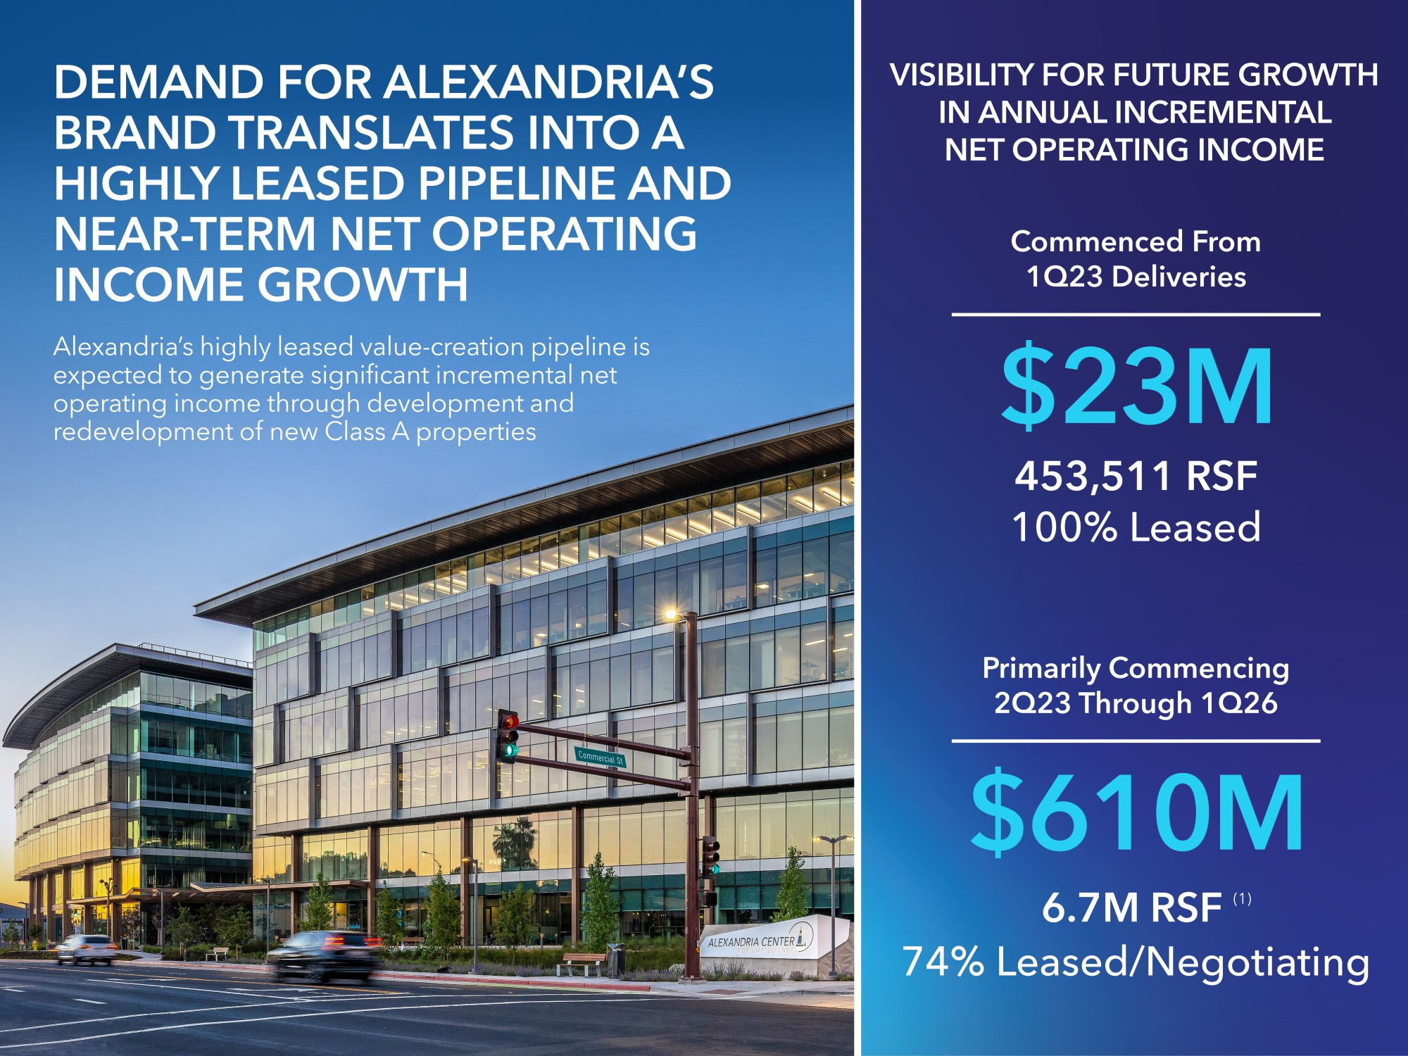
Refer to “Net operating income” in the “Non-GAAP measures and definitions” section within this Item 2 for additional details and its reconciliation from the most directly comparable financial measures presented in accordance with GAAP.
(1)As of March 31, 2023 Represents projects under construction aggregating 5.5 million RSF and four near term projects, aggregating 1.2 million RSF, expected to commence construction during the next four quarters after March 31, 2023.

57

New Class A development and redevelopment properties: recent deliveries
The following table presents value-creation development and redevelopment of new Class A properties placed into service during the three months ended March 31, 2023 (dollars in thousands):
Deliveries in 1Q23 commenced $23 million in annual incremental net operating income
201 Brookline Avenue |  |  |  |  |  | Alexandria Center® for Advanced  Technologies – Monte Villa Parkway |  |  |  |  |  | 9601 and 9603 Medical Center Drive |  |  |  |  |  | 2400 Ellis Road, 40 Moore Drive, and  14 TW Alexander Drive(1)
Greater Boston/Fenway |  |  |  |  |  | Seattle/Bothell |  |  |  |  |  | Maryland/Rockville |  |  |  |  |  | Research Triangle/Research Triangle
447,247 RSF |  |  |  |  |  | 35,847 RSF |  |  |  |  |  | 48,516 RSF |  |  |  |  |  | 603,316 RSF
100% Occupancy |  |  |  |  |  | 100% Occupancy |  |  |  |  |  | 100% Occupancy |  |  |  |  |  | 100% Occupancy
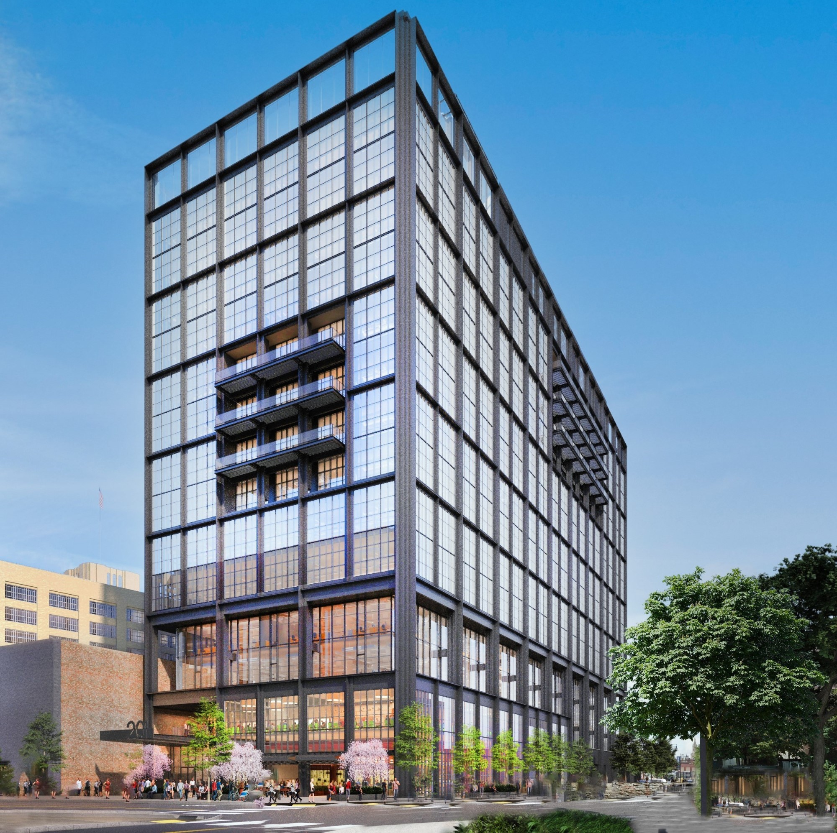 |  |  |  |  |  | 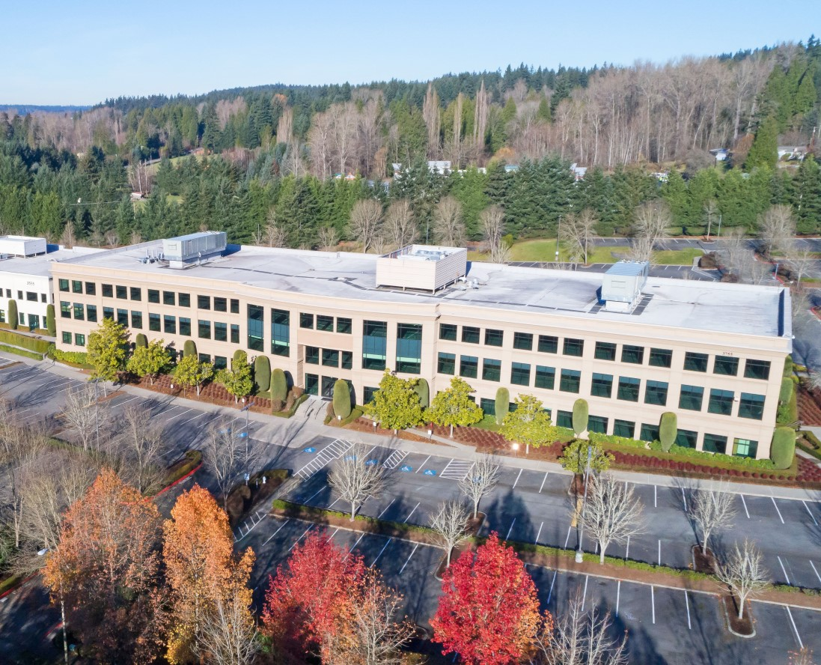 |  |  |  |  |  | 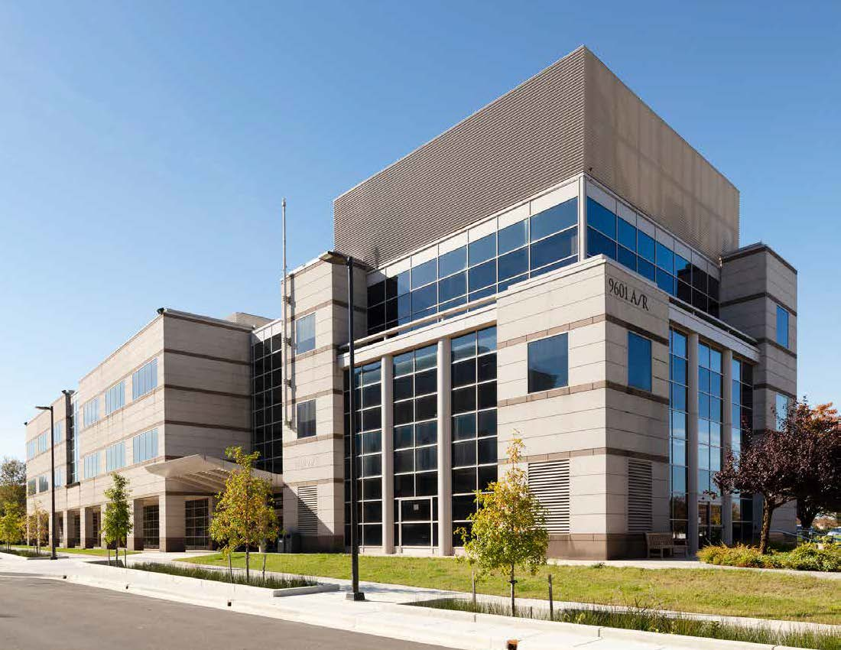 |  |  |  |  |  | 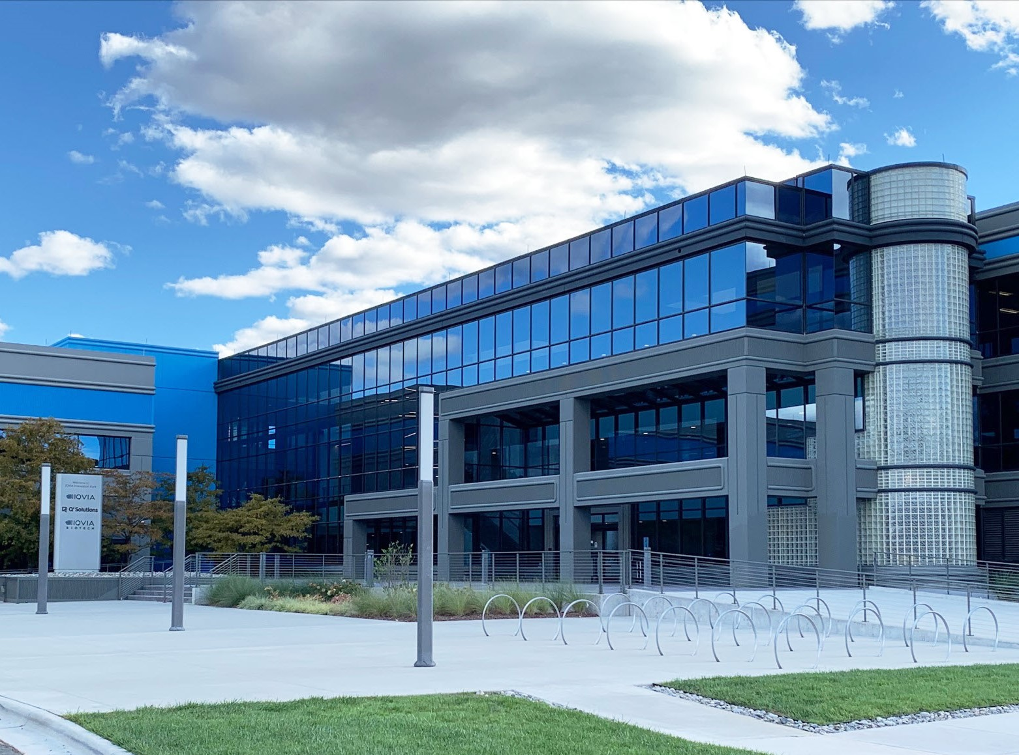
Property/Market/Submarket |  |  |  |  |  | 1Q23  Delivery Date(2) |  |  |  |  |  | Our Ownership Interest |  |  |  |  |  | RSF Placed in Service |  |  |  |  |  |  |  |  |  |  |  |  |  | Occupancy Percentage(3) |  |  |  | Total Project |  |  |  |  |  |  |  |  |  |  |  | Unlevered Yields
 |  |  |  |  |  |  |  |  |  |  |  |  |  |  |  |  |  | Prior to 1/1/23 |  |  |  |  |  | 1Q23 |  |  |  |  |  |  |  |  |  |  |  |  |  |  |  |  |  |  |  |  |  |  |  |  |  |  |  |  |  | Total |  |  |  |  |  |  |  |  |  |  |  | Initial Stabilized |  |  |  |  |  |  |  |  |  |  |  | Initial Stabilized (Cash Basis)
 |  |  |  |  |  |  |  |  |  |  |  |  |  |  |  |  |  |  |  |  |  |  |  |  |  |  |  |  |  |  |  |  |  |  |  |  |  |  |  |  |  | RSF |  |  |  |  |  | Investment
Development projects
201 Brookline Avenue/Greater Boston/Fenway |  |  |  |  |  | 3/15/23 |  |  |  |  |  | 98.8% |  |  |  |  |  | 340,073 |  |  |  |  |  | 107,174 |  |  |  |  |  |  |  |  |  |  |  | 447,247 |  |  |  |  |  |  |  |  | 100% |  |  |  |  |  |  |  |  | 510,116 |  |  |  |  |  | $ | 775,000 |  |  |  |  |  |  |  | 7.2 |  | % |  |  |  |  |  |  |  |  |  | 6.5 |  | %
Redevelopment projects
Alexandria Center® for Advanced Technologies – Monte Villa Parkway/Seattle/Bothell |  |  |  |  |  | 1/19/23 |  |  |  |  |  | 100% |  |  |  |  |  | — |  |  |  |  |  | 35,847 |  |  |  |  |  |  |  |  |  |  |  | 35,847 |  |  |  |  |  |  |  |  | 100% |  |  |  |  |  |  |  |  | 460,623 |  |  |  |  |  | 229,000 |  |  |  |  |  |  |  |  | 6.3 |  |  |  |  |  |  |  |  |  |  |  | 6.2
9601 and 9603 Medical Center Drive/Maryland/Rockville |  |  |  |  |  | 1/9/23 |  |  |  |  |  | 100% |  |  |  |  |  | 34,589 |  |  |  |  |  | 13,927 |  |  |  |  |  |  |  |  |  |  |  | 48,516 |  |  |  |  |  |  |  |  | 100% |  |  |  |  |  |  |  |  | 95,911 |  |  |  |  |  | 54,000 |  |  |  |  |  |  |  |  | 8.4 |  |  |  |  |  |  |  |  |  |  |  | 7.1
20400 Century Boulevard/Maryland/Gaithersburg |  |  |  |  |  | 3/1/23 |  |  |  |  |  | 100% |  |  |  |  |  | 50,738 |  |  |  |  |  | 19,692 |  |  |  |  |  |  |  |  |  |  |  | 70,430 |  |  |  |  |  |  |  |  | 100% |  |  |  |  |  |  |  |  | 80,550 |  |  |  |  |  | 35,000 |  |  |  |  |  |  |  |  | 8.5 |  |  |  |  |  |  |  |  |  |  |  | 8.6
2400 Ellis Road, 40 Moore Drive, and 14 TW Alexander Drive/Research Triangle/Research Triangle(4) |  |  |  |  |  | 2/17/23 |  |  |  |  |  | 100% |  |  |  |  |  | 326,445 |  |  |  |  |  | 276,871 |  |  |  |  |  |  |  |  |  |  |  | 603,316 |  |  |  |  |  |  |  |  | 100% |  |  |  |  |  |  |  |  | 603,316 |  |  |  |  |  | 241,000 |  |  |  |  |  |  |  |  | 8.1 |  |  |  |  |  |  |  |  |  |  |  | 6.8
Weighted average/total |  |  |  |  |  | 2/27/23 |  |  |  |  |  |  |  |  |  |  |  | 751,845 |  |  |  |  |  | 453,511 |  |  |  |  |  |  |  |  |  |  |  | 1,205,356 |  |  |  |  |  |  |  |  |  |  |  |  |  |  |  |  |  | 1,750,516 |  |  |  |  |  | $ | 1,334,000 |  |  |  |  |  |  |  | 7.3 |  | % |  |  |  |  |  |  |  |  |  | 6.6 |  | %
(1)Image represents 2400 Ellis Road on our Alexandria Center® for Life Science – Durham mega campus.
(2)Represents the average delivery date for deliveries that occurred during the three months ended March 31, 2023, weighted by annual rental revenue.
(3)Relates to total operating RSF placed in service as of the most recent delivery.
(4)During the three months ended March 31, 2023, we delivered 276,871 RSF of our 14 TW Alexander Drive and 40 Moore Drive redevelopment project. Due to current market conditions and in connection with our strategic review of projected 2023 construction spending, we updated our plans for our redevelopment project aggregating 100,000 SF at 41 Moore Drive. As of March 31, 2023, this project was classified as a future development project, rather than a redevelopment, which will allow us to upzone this project to a larger building to meet future market demand.

58

New Class A development and redevelopment properties: current projects
325 Binney Street |  |  |  |  |  | 140 First Street |  |  |  |  |  | 99 Coolidge Avenue |  |  |  |  |  | 500 North Beacon Street and  4 Kingsbury Avenue(1) |  |  |  |  |  | 201 Brookline Avenue
Greater Boston/  Cambridge/Inner Suburbs |  |  |  |  |  | Greater Boston/  Cambridge/Inner Suburbs |  |  |  |  |  | Greater Boston/  Cambridge/Inner Suburbs |  |  |  |  |  | Greater Boston/  Cambridge/Inner Suburbs |  |  |  |  |  | Greater Boston/Fenway
462,100 RSF |  |  |  |  |  | 403,892 RSF |  |  |  |  |  | 320,809 RSF |  |  |  |  |  | 248,018 RSF |  |  |  |  |  | 62,869 RSF
100% Leased |  |  |  |  |  | 100% Leased |  |  |  |  |  | 36% Leased/Negotiating |  |  |  |  |  | 85% Leased/Negotiating |  |  |  |  |  | 98% Leased/Negotiating
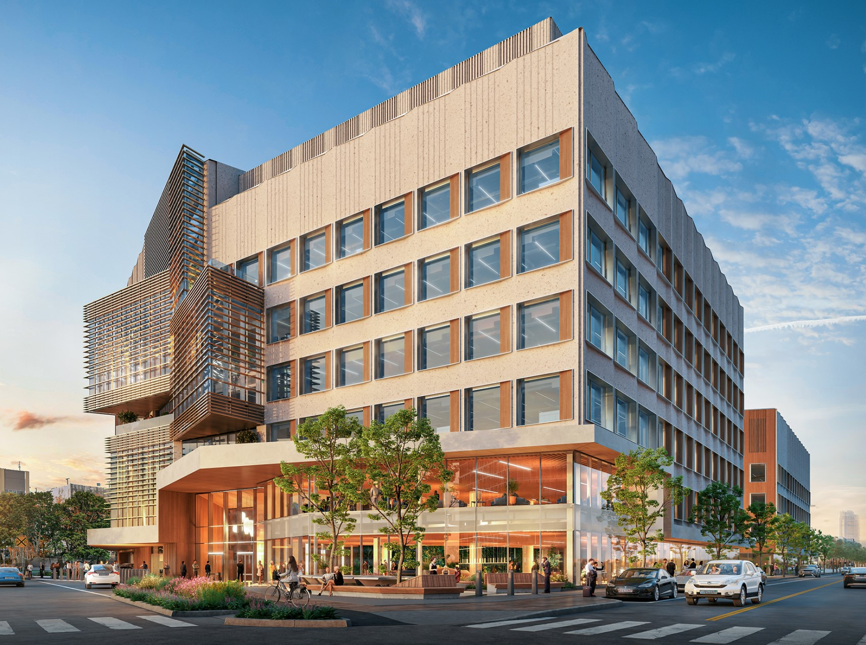 |  |  |  |  |  | 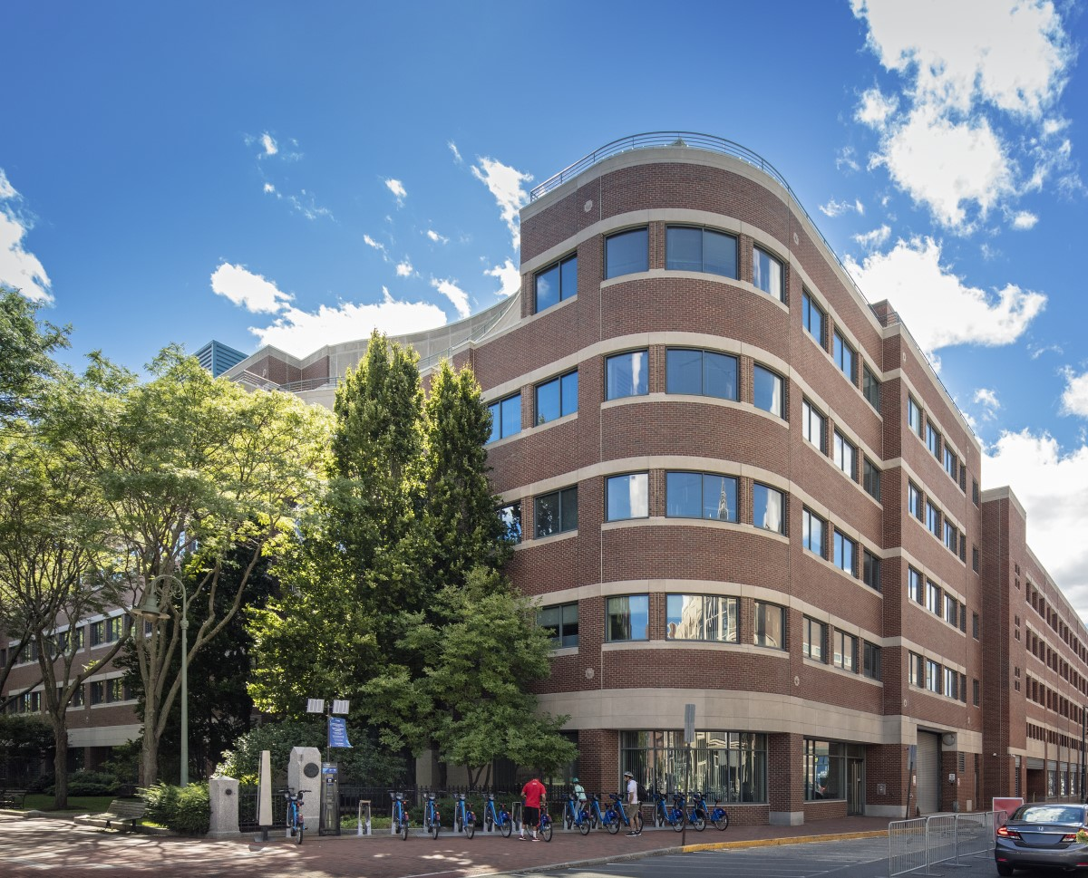 |  |  |  |  |  | 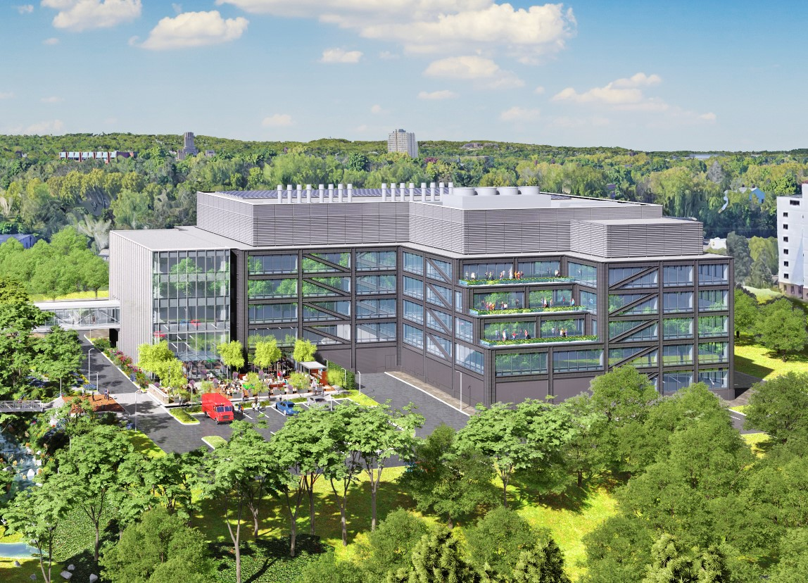 |  |  |  |  |  | 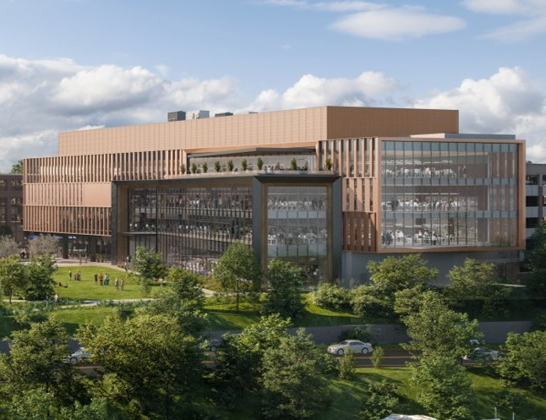

 |  |  | 15 Necco Street |  |  |  |  |  | 40, 50, and 60 Sylvan Road(2) |  |  |  |  |  | 1450 Owens Street |  |  |  |  |  | 651 Gateway Boulevard |  |  |  |  |  | 230 Harriet Tubman Way
 |  |  | Greater Boston/  Seaport Innovation District |  |  |  |  |  | Greater Boston/Route 128 |  |  |  |  |  | San Francisco Bay Area/  Mission Bay |  |  |  |  |  | San Francisco Bay Area/  South San Francisco |  |  |  |  |  | San Francisco Bay Area/  South San Francisco
 |  |  | 345,995 RSF |  |  |  |  |  | 515,273 RSF |  |  |  |  |  | 212,796 RSF |  |  |  |  |  | 300,010 RSF |  |  |  |  |  | 285,346 RSF
 |  |  | 97% Leased/Negotiating |  |  |  |  |  | —% Leased/Negotiating |  |  |  |  |  | —% Leased/Negotiating |  |  |  |  |  | 22% Leased/Negotiating |  |  |  |  |  | 100% Leased
 |  |  | 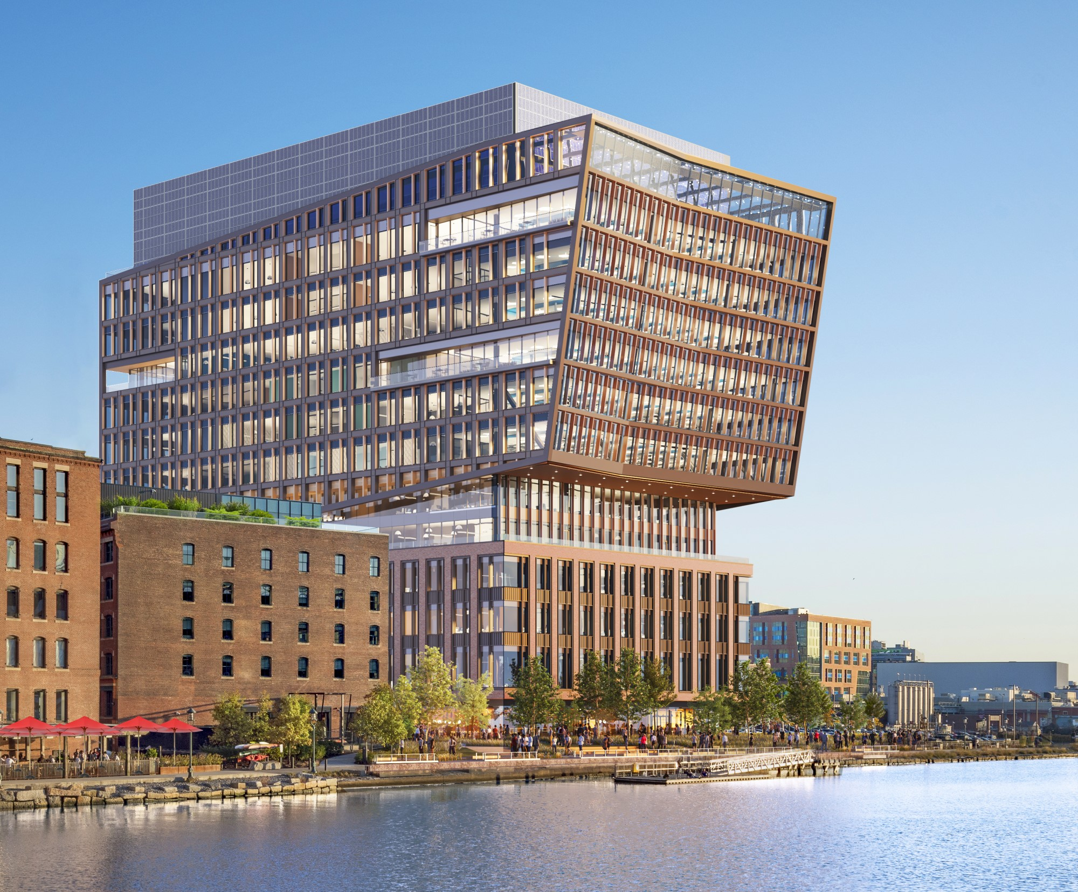 |  |  |  |  |  | 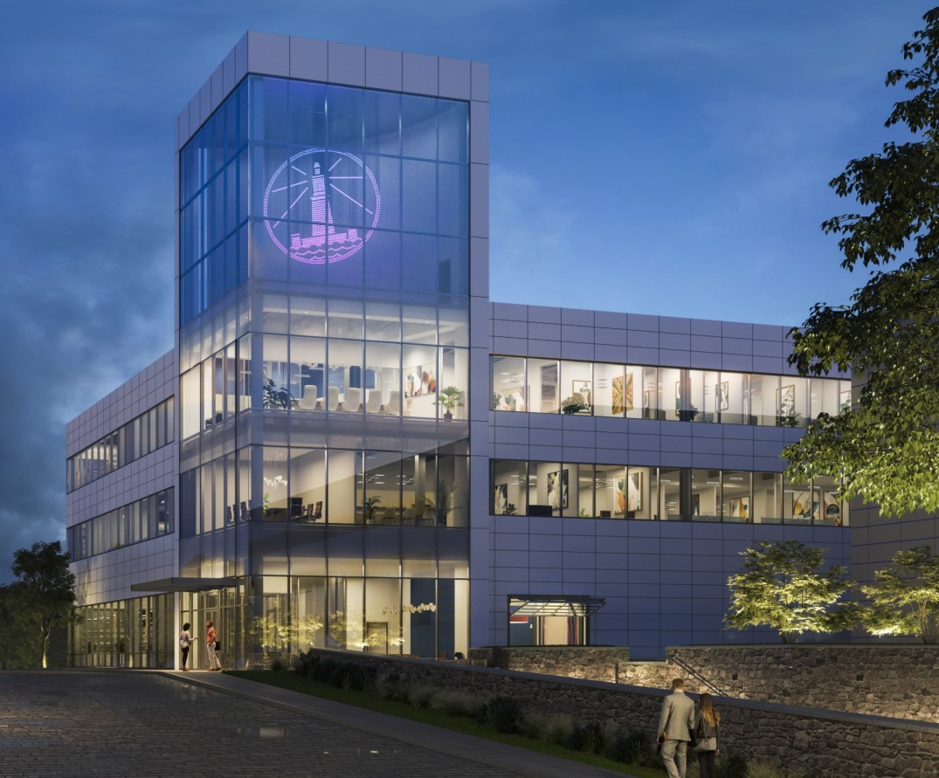 |  |  |  |  |  | 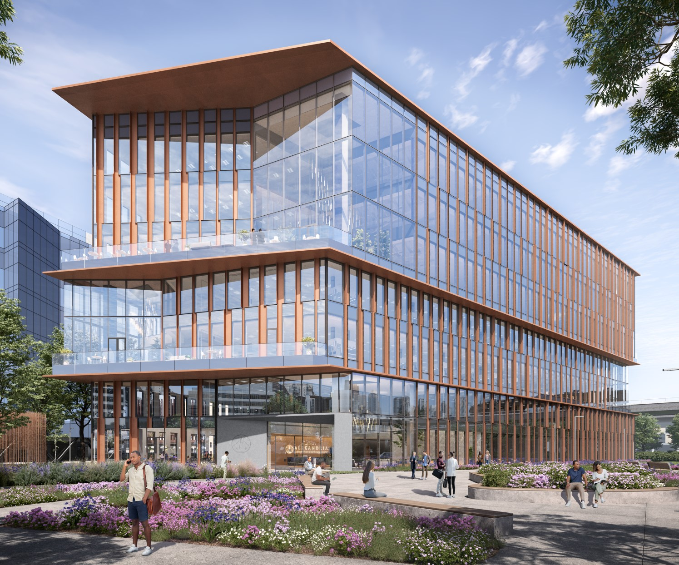 |  |  |  |  |  | 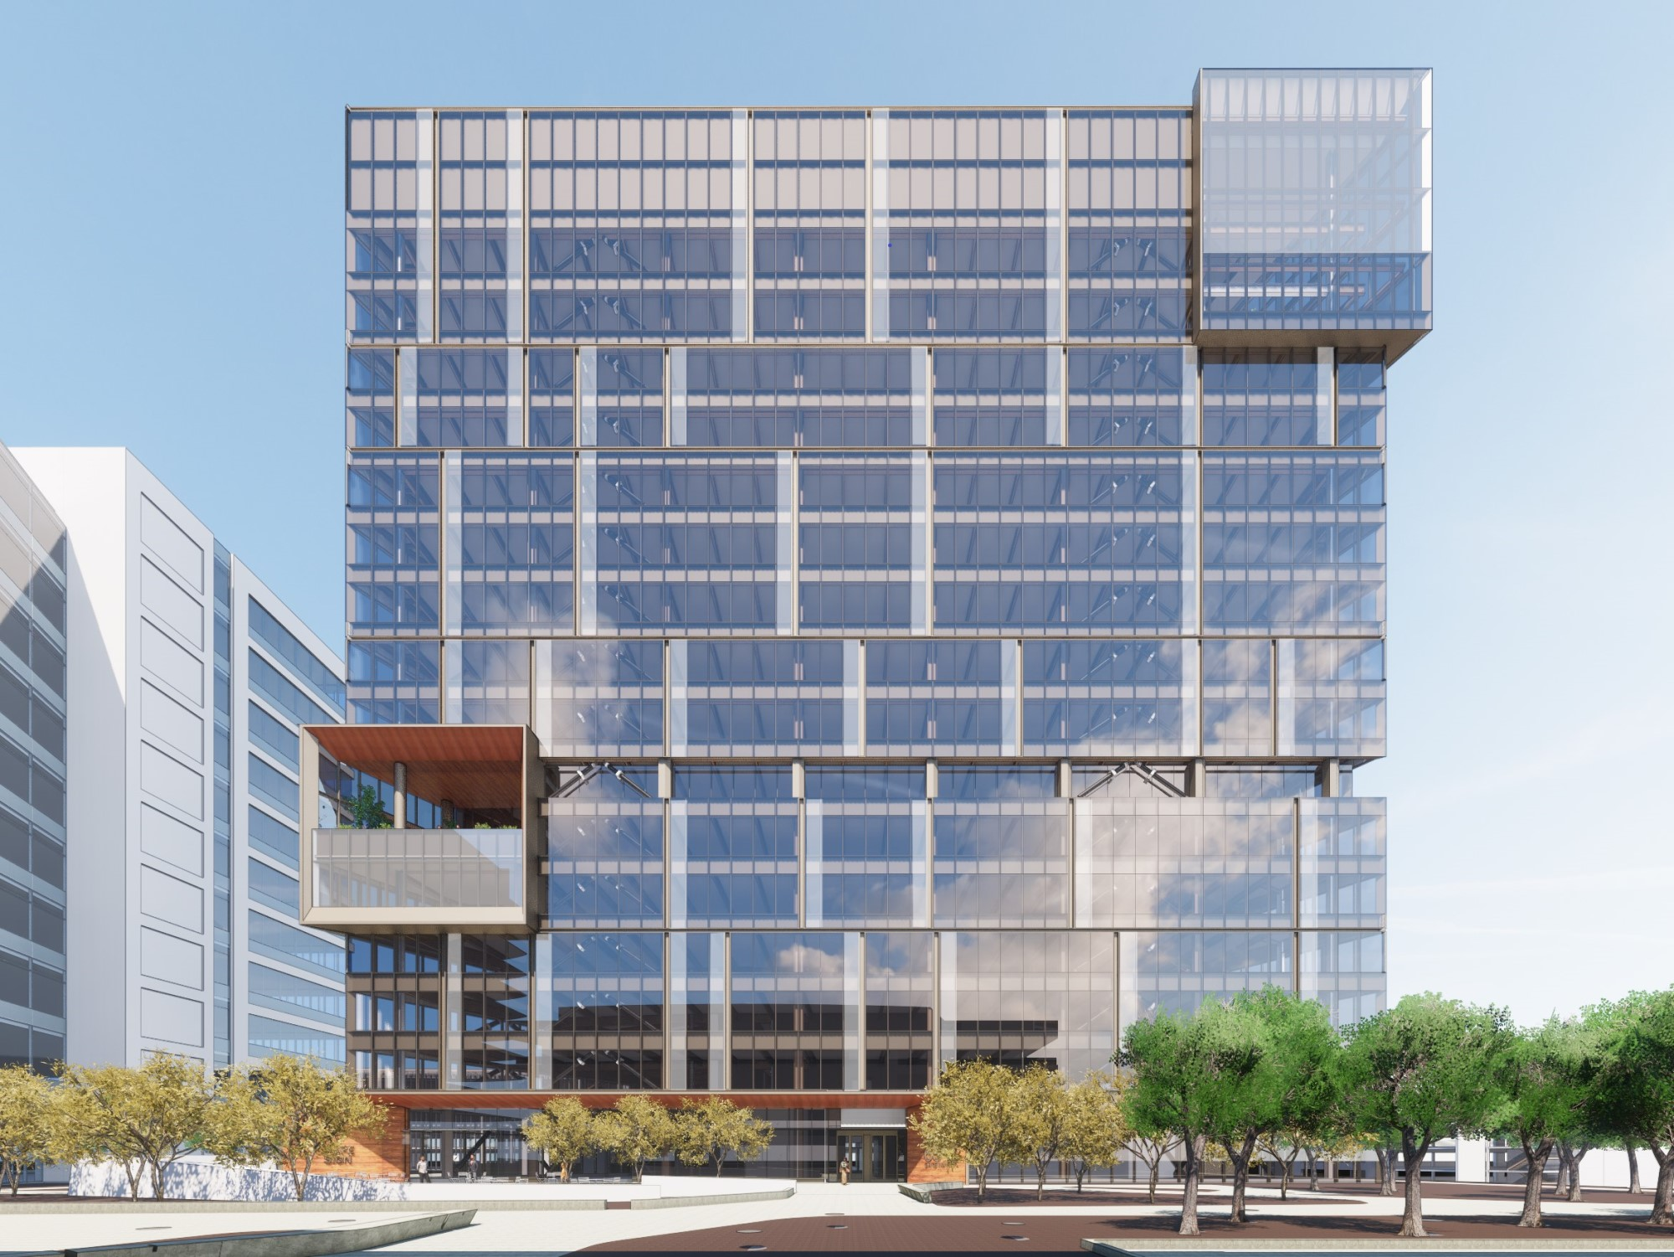 |  |  |  |  |  | 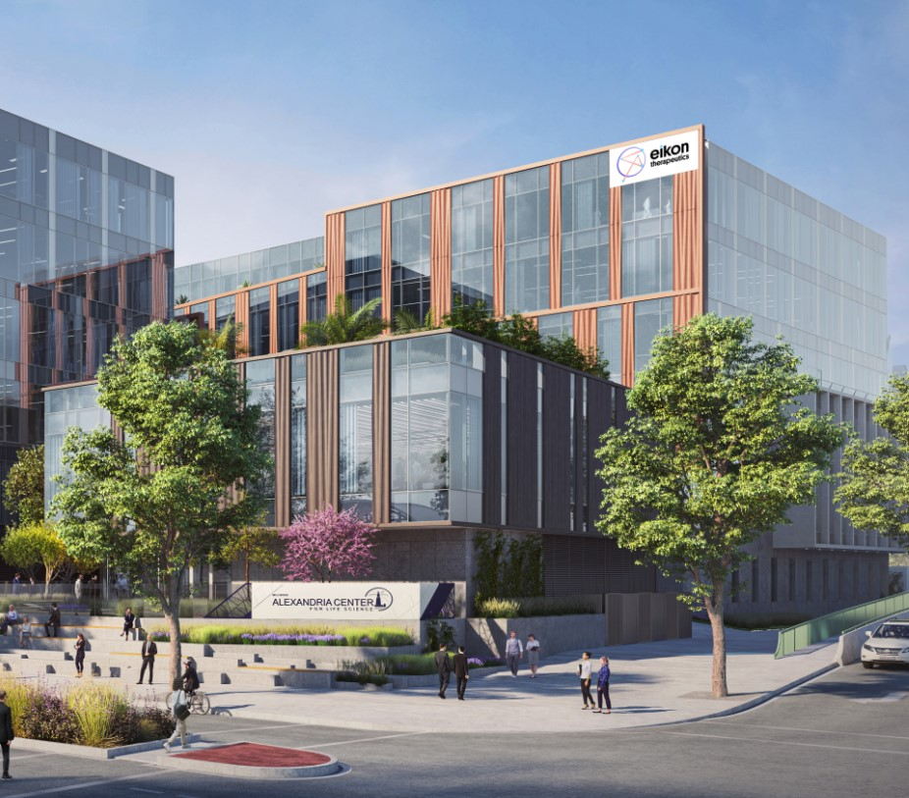

(1)Image represents 500 North Beacon Street on our Arsenal on the Charles mega campus.
(2)Image represents 50 Sylvan Road.

59

New Class A development and redevelopment properties: current projects (continued)
751 Gateway Boulevard |  |  |  |  |  | 1150 Eastlake Avenue East |  |  |  |  |  | Alexandria Center® for Advanced Technologies – Monte Villa Parkway
San Francisco Bay Area/  South San Francisco |  |  |  |  |  | Seattle/Lake Union |  |  |  |  |  | Seattle/Bothell
230,592 RSF |  |  |  |  |  | 311,631 RSF |  |  |  |  |  | 178,129 RSF
100% Leased |  |  |  |  |  | 99% Leased/Negotiating |  |  |  |  |  | 82% Leased/Negotiating
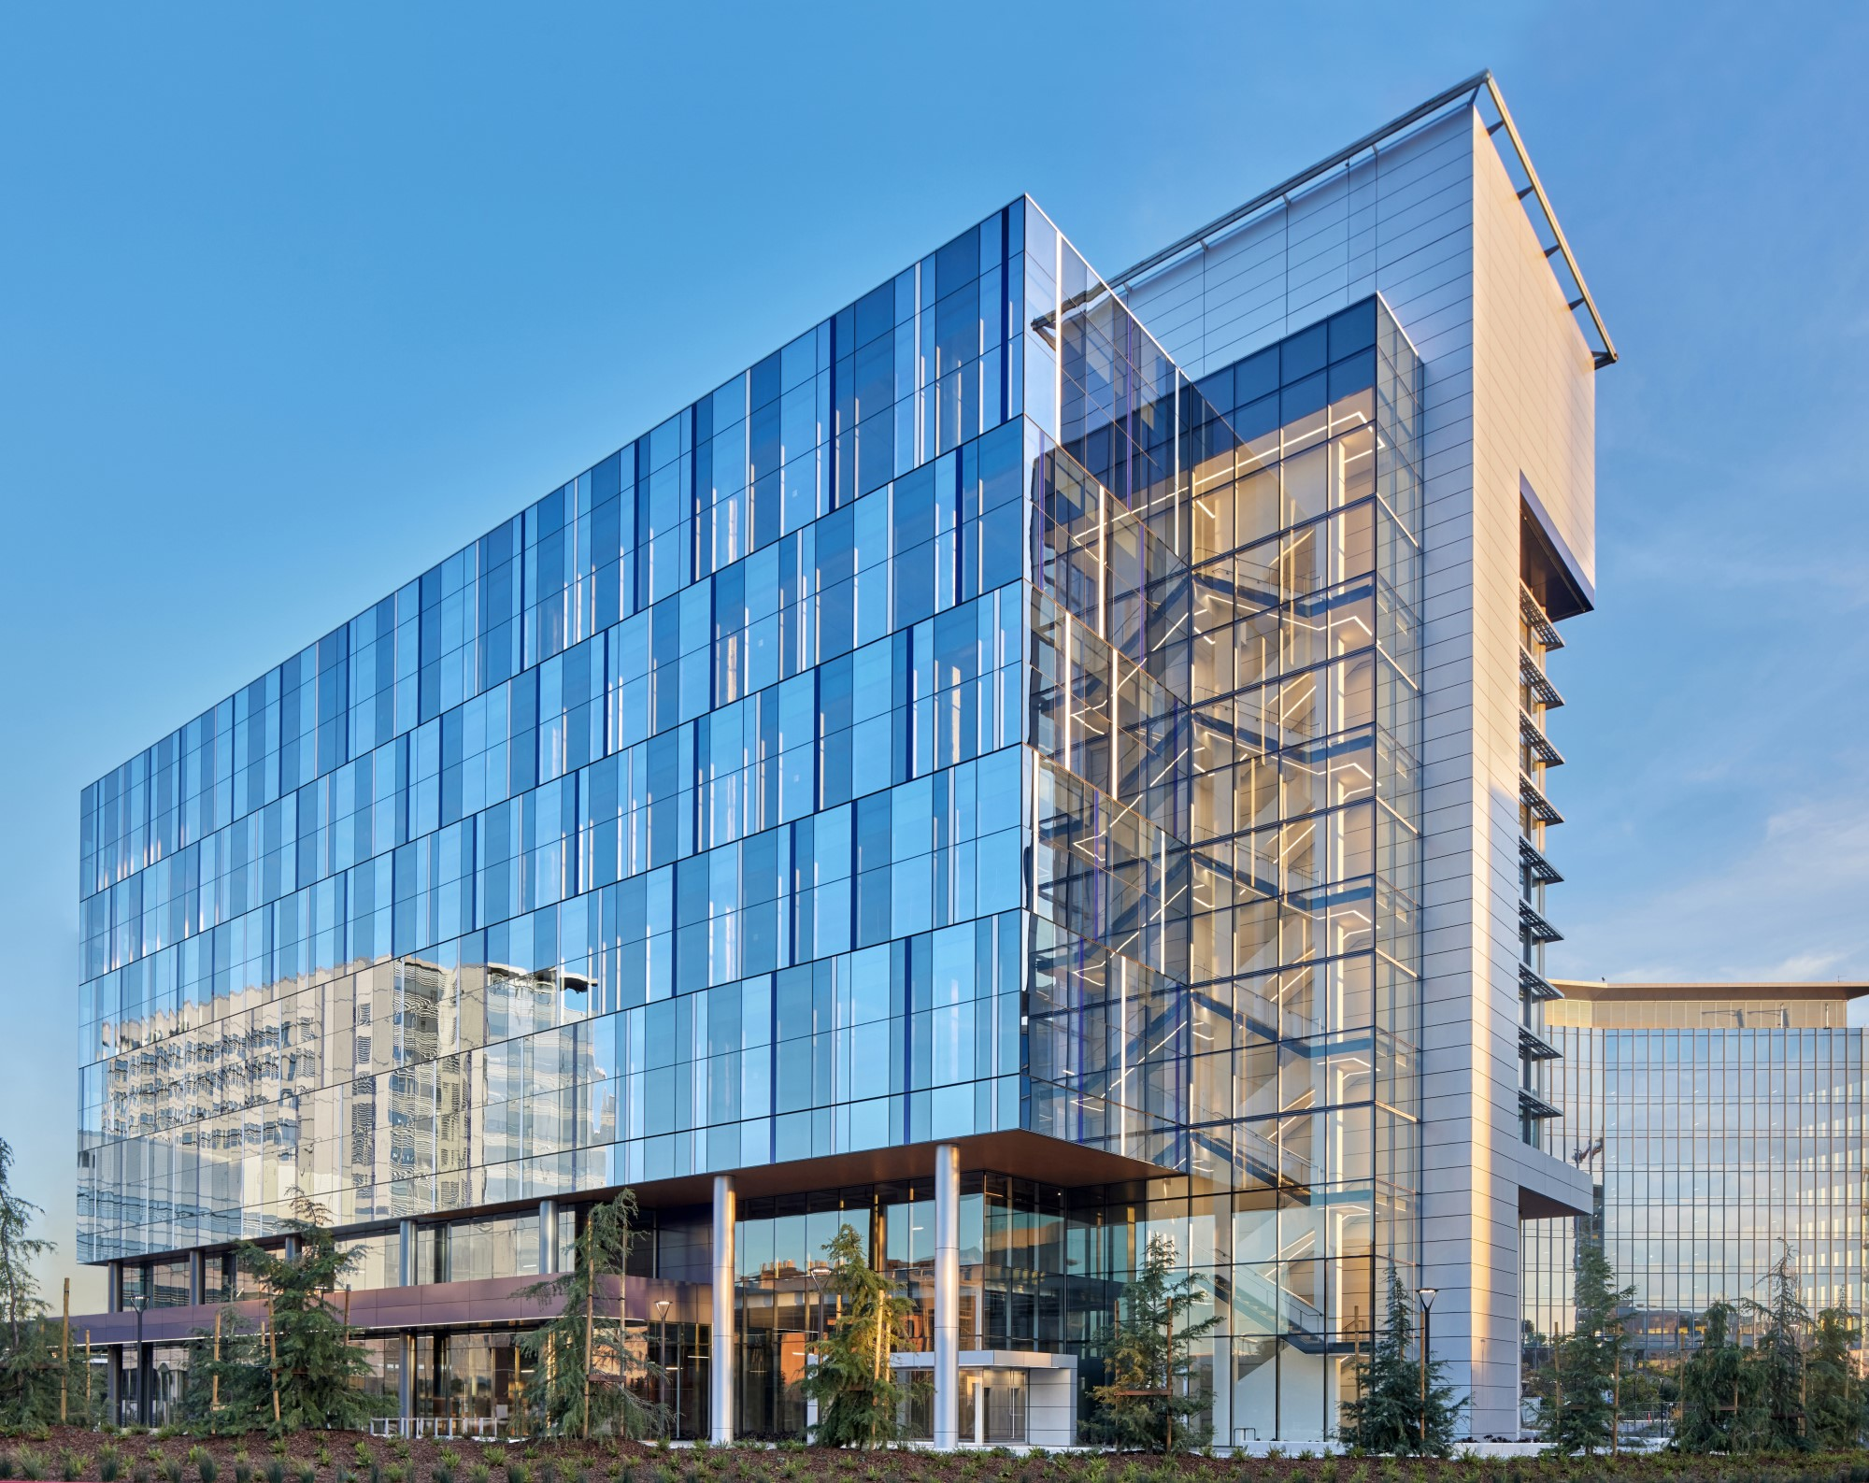 |  |  |  |  |  | 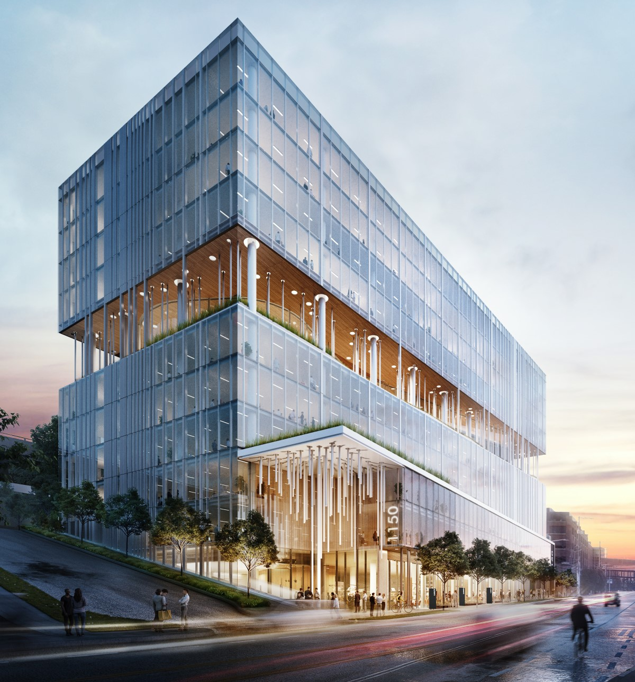

9810 and 9820 Darnestown Road |  |  |  |  |  | 9808 Medical Center Drive |  |  |  |  |  | 9601 and 9603 Medical Center Drive |  |  |  |  |  |  |  |  |  | 6040 George Watts Hill Drive,  Phase II
Maryland/Rockville |  |  |  |  |  | Maryland/Rockville |  |  |  |  |  | Maryland/Rockville |  |  |  |  |  |  |  |  |  | Research Triangle/Research Triangle
442,000 RSF |  |  |  |  |  | 90,000 RSF |  |  |  |  |  | 47,395 RSF |  |  |  |  |  |  |  |  |  | 88,038 RSF
100% Leased |  |  |  |  |  | 47% Leased/Negotiating |  |  |  |  |  | 100% Leased |  |  |  |  |  |  |  |  |  | 100% Leased
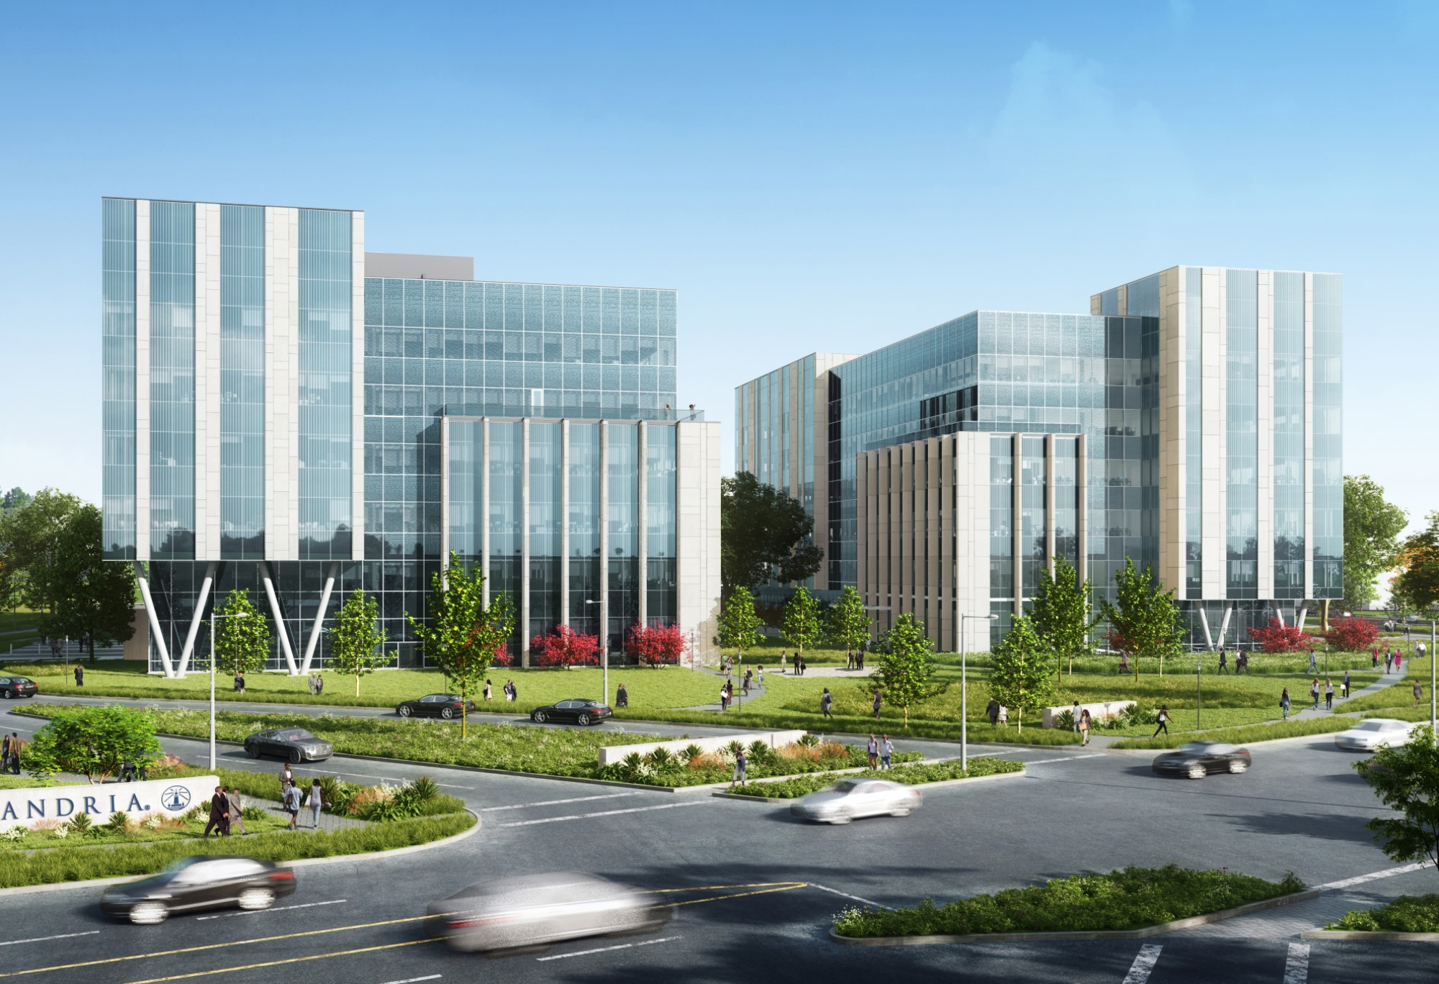 |  |  |  |  |  | 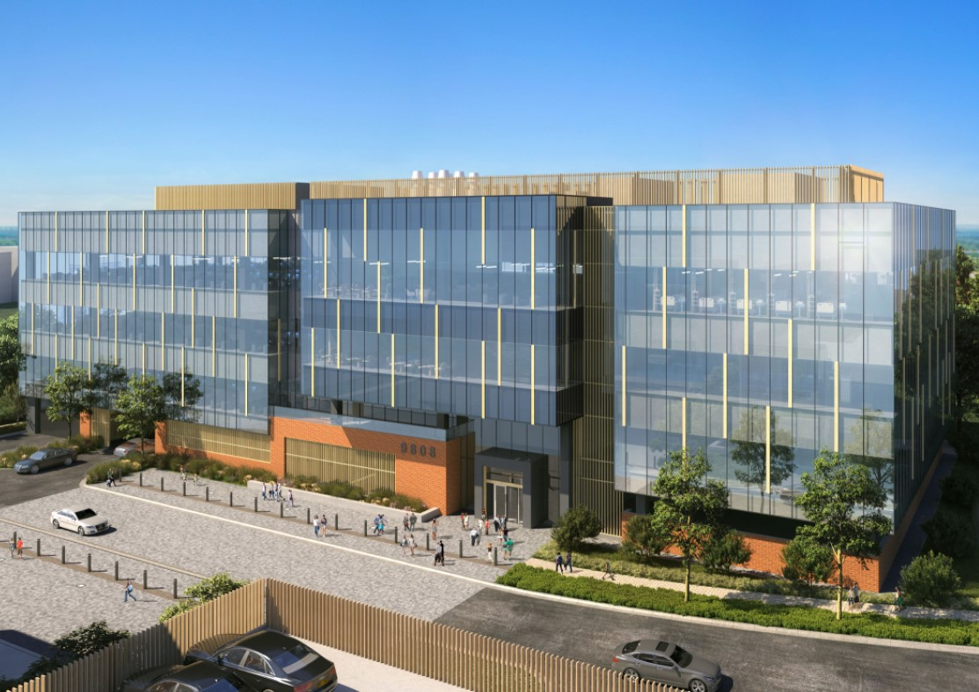 |  |  |  |  |  |  |  |  |  |  |  |  |  |  |  | 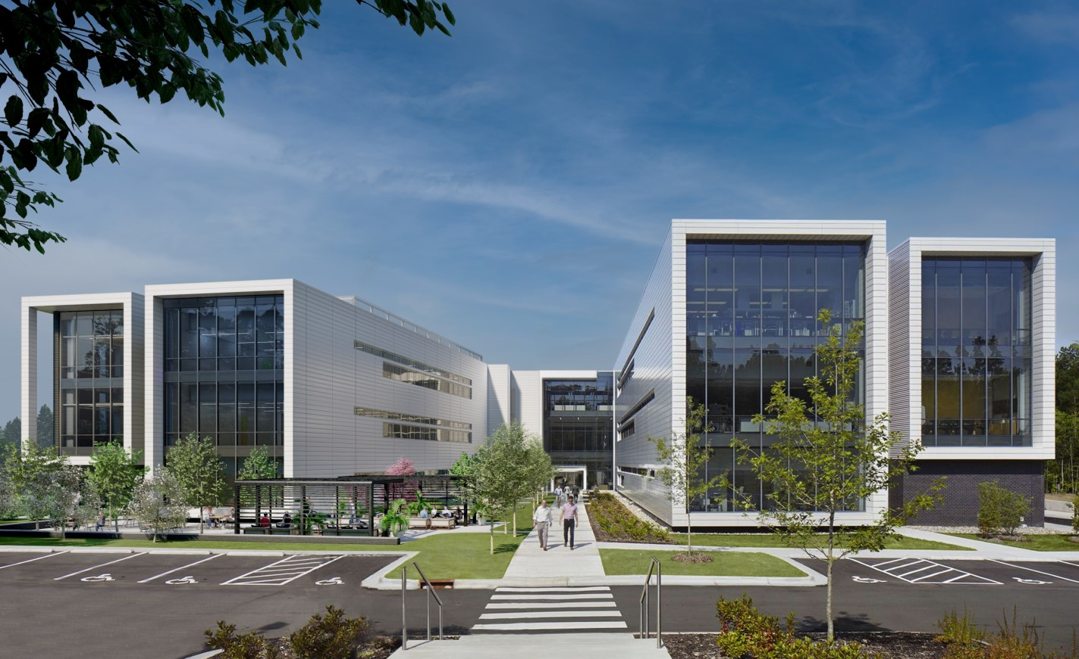

60

New Class A development and redevelopment properties: current projects (continued)

The following tables set forth a summary of our new Class A development and redevelopment properties under construction and pre-leased/negotiating near-term projects as of March 31, 2023 (dollars in thousands):

Market  Property/Submarket |  |  |  |  |  |  |  |  |  |  |  | Square Footage |  |  |  |  |  |  |  |  |  |  |  |  |  |  |  |  |  | Percentage |  |  |  |  |  |  |  |  |  |  |  |  |  |  |  |  |  | Occupancy(1)
 |  |  |  |  |  | Dev/Redev |  |  |  |  |  | In Service |  |  |  |  |  | CIP |  |  |  |  |  | Total |  |  |  |  |  | Leased |  |  |  |  |  |  |  |  | Leased/Negotiating |  |  |  |  |  |  |  |  | Initial |  |  |  |  |  |  |  |  |  |  |  | Stabilized
Under construction
Greater Boston
325 Binney Street/Cambridge/Inner Suburbs |  |  |  |  |  | Dev |  |  |  |  |  | — |  |  |  |  |  | 462,100 |  |  |  |  |  | 462,100 |  |  |  |  |  | 100 |  | % |  |  |  |  |  |  | 100 |  | % |  |  |  |  |  |  |  |  |  | 2023 |  |  |  |  |  |  |  |  | 2024
140 First Street/Cambridge/Inner Suburbs |  |  |  |  |  | Redev |  |  |  |  |  | 4,367 |  |  |  |  |  | 403,892 |  |  |  |  |  | 408,259 |  |  |  |  |  | 100 |  |  |  |  |  |  |  |  | 100 |  |  |  |  |  |  |  |  |  |  |  | 2023 |  |  |  |  |  |  |  |  | 2023
99 Coolidge Avenue/Cambridge/Inner Suburbs |  |  |  |  |  | Dev |  |  |  |  |  | — |  |  |  |  |  | 320,809 |  |  |  |  |  | 320,809 |  |  |  |  |  | 36 |  |  |  |  |  |  |  |  | 36 |  |  |  |  |  |  |  |  |  |  |  | 2024 |  |  |  |  |  |  |  |  | 2025
500 North Beacon Street and 4 Kingsbury Avenue/Cambridge/Inner Suburbs |  |  |  |  |  | Dev |  |  |  |  |  | — |  |  |  |  |  | 248,018 |  |  |  |  |  | 248,018 |  |  |  |  |  | 85 |  |  |  |  |  |  |  |  | 85 |  |  |  |  |  |  |  |  |  |  |  | 2024 |  |  |  |  |  |  |  |  | 2025
201 Brookline Avenue/Fenway |  |  |  |  |  | Dev |  |  |  |  |  | 447,247 |  |  |  |  |  | 62,869 |  |  |  |  |  | 510,116 |  |  |  |  |  | 97 |  |  |  |  |  |  |  |  | 98 |  |  |  |  |  |  |  |  |  |  |  | 3Q22 |  |  |  |  |  |  |  |  | 2023
15 Necco Street/Seaport Innovation District |  |  |  |  |  | Dev |  |  |  |  |  | — |  |  |  |  |  | 345,995 |  |  |  |  |  | 345,995 |  |  |  |  |  | 97 |  |  |  |  |  |  |  |  | 97 |  |  |  |  |  |  |  |  |  |  |  | 2023 |  |  |  |  |  |  |  |  | 2024
40, 50, and 60 Sylvan Road/Route 128 |  |  |  |  |  | Redev |  |  |  |  |  | — |  |  |  |  |  | 515,273 |  |  |  |  |  | 515,273 |  |  |  |  |  | — |  |  |  |  |  |  |  |  | — |  |  | (2) |  |  |  |  |  |  |  |  | 2024 |  |  |  |  |  |  |  |  | 2026
840 Winter Street/Route 128 |  |  |  |  |  | Redev |  |  |  |  |  | 28,230 |  |  |  |  |  | 139,984 |  |  |  |  |  | 168,214 |  |  |  |  |  | 100 |  |  |  |  |  |  |  |  | 100 |  |  |  |  |  |  |  |  |  |  |  | 2024 |  |  |  |  |  |  |  |  | 2024
Other |  |  |  |  |  | Redev |  |  |  |  |  | — |  |  |  |  |  | 453,869 |  |  |  |  |  | 453,869 |  |  |  |  |  | — |  |  |  |  |  |  |  |  | — |  |  | (2) |  |  |  |  |  | 2024 |  |  |  |  |  |  |  |  |  |  |  | 2025
San Francisco Bay Area
1450 Owens Street/Mission Bay |  |  |  |  |  | Dev |  |  |  |  |  | — |  |  |  |  |  | 212,796 |  |  |  |  |  | 212,796 |  |  |  |  |  | — |  |  |  |  |  |  |  |  | — |  |  | (2) |  |  |  |  |  |  |  |  | 2024 |  |  |  |  |  |  |  |  | 2025
651 Gateway Boulevard/South San Francisco |  |  |  |  |  | Redev |  |  |  |  |  | — |  |  |  |  |  | 300,010 |  |  |  |  |  | 300,010 |  |  |  |  |  | 7 |  |  |  |  |  |  |  |  | 22 |  |  |  |  |  |  |  |  |  |  |  | 2023 |  |  |  |  |  |  |  |  | 2025
230 Harriet Tubman Way/South San Francisco |  |  |  |  |  | Dev |  |  |  |  |  | — |  |  |  |  |  | 285,346 |  |  |  |  |  | 285,346 |  |  |  |  |  | 100 |  |  |  |  |  |  |  |  | 100 |  |  |  |  |  |  |  |  |  |  |  | 2024 |  |  |  |  |  |  |  |  | 2024
751 Gateway Boulevard/South San Francisco |  |  |  |  |  | Dev |  |  |  |  |  | — |  |  |  |  |  | 230,592 |  |  |  |  |  | 230,592 |  |  |  |  |  | 100 |  |  |  |  |  |  |  |  | 100 |  |  |  |  |  |  |  |  |  |  |  | 2023 |  |  |  |  |  |  |  |  | 2023
Seattle
1150 Eastlake Avenue East/Lake Union |  |  |  |  |  | Dev |  |  |  |  |  | — |  |  |  |  |  | 311,631 |  |  |  |  |  | 311,631 |  |  |  |  |  | 89 |  |  |  |  |  |  |  |  | 99 |  |  |  |  |  |  |  |  |  |  |  | 2023 |  |  |  |  |  |  |  |  | 2024
Alexandria Center® for Advanced Technologies – Monte Villa Parkway/Bothell |  |  |  |  |  | Redev |  |  |  |  |  | 282,494 |  |  |  |  |  | 178,129 |  |  |  |  |  | 460,623 |  |  |  |  |  | 82 |  |  |  |  |  |  |  |  | 82 |  |  |  |  |  |  |  |  |  |  |  | 1Q23 |  |  |  |  |  |  |  |  | 2024
Maryland
9820 Darnestown Road/Rockville |  |  |  |  |  | Dev |  |  |  |  |  | — |  |  |  |  |  | 250,000 |  |  |  |  |  | 250,000 |  |  |  |  |  | 100 |  |  |  |  |  |  |  |  | 100 |  |  |  |  |  |  |  |  |  |  |  | 2024 |  |  |  |  |  |  |  |  | 2024
9810 Darnestown Road/Rockville |  |  |  |  |  | Dev |  |  |  |  |  | — |  |  |  |  |  | 192,000 |  |  |  |  |  | 192,000 |  |  |  |  |  | 100 |  |  |  |  |  |  |  |  | 100 |  |  |  |  |  |  |  |  |  |  |  | 2024 |  |  |  |  |  |  |  |  | 2024
9808 Medical Center Drive/Rockville |  |  |  |  |  | Dev |  |  |  |  |  | — |  |  |  |  |  | 90,000 |  |  |  |  |  | 90,000 |  |  |  |  |  | 29 |  |  |  |  |  |  |  |  | 47 |  |  |  |  |  |  |  |  |  |  |  | 2023 |  |  |  |  |  |  |  |  | 2024
9601 and 9603 Medical Center Drive/Rockville |  |  |  |  |  | Redev |  |  |  |  |  | 48,516 |  |  |  |  |  | 47,395 |  |  |  |  |  | 95,911 |  |  |  |  |  | 100 |  |  |  |  |  |  |  |  | 100 |  |  |  |  |  |  |  |  |  |  |  | 4Q21 |  |  |  |  |  |  |  |  | 2023
20400 Century Boulevard/Gaithersburg |  |  |  |  |  | Redev |  |  |  |  |  | 70,430 |  |  |  |  |  | 10,120 |  |  |  |  |  | 80,550 |  |  |  |  |  | 100 |  |  |  |  |  |  |  |  | 100 |  |  |  |  |  |  |  |  |  |  |  | 1Q22 |  |  |  |  |  |  |  |  | 2023
Research Triangle
6040 George Watts Hill Drive, Phase II/Research Triangle |  |  |  |  |  | Dev |  |  |  |  |  | — |  |  |  |  |  | 88,038 |  |  |  |  |  | 88,038 |  |  |  |  |  | 100 |  |  |  |  |  |  |  |  | 100 |  |  |  |  |  |  |  |  |  |  |  | 2024 |  |  |  |  |  |  |  |  | 2024
Texas
8800 Technology Forest Place/Greater Houston |  |  |  |  |  | Redev |  |  |  |  |  | — |  |  |  |  |  | 130,765 |  |  |  |  |  | 130,765 |  |  |  |  |  | 36 |  |  |  |  |  |  |  |  | 36 |  |  |  |  |  |  |  |  |  |  |  | 2023 |  |  |  |  |  |  |  |  | 2024
Canada
Canada |  |  |  |  |  | Redev |  |  |  |  |  | 32,992 |  |  |  |  |  | 217,798 |  |  |  |  |  | 250,790 |  |  |  |  |  | 45 |  |  |  |  |  |  |  |  | 73 |  |  |  |  |  |  |  |  |  |  |  | 2023 |  |  |  |  |  |  |  |  | 2025
 |  |  |  |  |  |  |  |  |  |  |  | 914,276 |  |  |  |  |  | 5,497,429 |  |  |  |  |  | 6,411,705 |  |  |  |  |  | 67 |  | % |  |  |  |  |  |  | 69 |  | %
(1)Initial occupancy dates are subject to leasing and/or market conditions. Multi-tenant projects may increase in occupancy over a period of time. Stabilized occupancy may vary depending on single tenancy versus multi-tenancy.
(2)This project is focused on demand from our existing tenants in our adjacent properties/campuses and will also address demand from other non-Alexandria properties/campuses.
61

New Class A development and redevelopment properties: current projects (continued)

Market  Property/Submarket |  |  |  |  |  |  |  |  |  |  |  | Square Footage |  |  |  |  |  |  |  |  |  |  |  |  |  |  |  |  |  | Percentage
 |  |  |  |  |  | Dev/Redev |  |  |  |  |  | In Service |  |  |  |  |  | CIP |  |  |  |  |  | Total |  |  |  |  |  | Leased |  |  |  |  |  |  |  |  | Leased/Negotiating
Near-term projects expected to commence construction in the next four quarters
San Diego
11255 and 11355 North Torrey Pines Road/Torrey Pines |  |  |  |  |  | Dev |  |  |  |  |  | — |  |  |  |  |  | 309,094 |  |  |  |  |  | 309,094 |  |  |  |  |  | 100 |  | % |  |  |  |  |  |  | 100 |  | %
10931 and 10933 North Torrey Pines Road/Torrey Pines |  |  |  |  |  | Dev |  |  |  |  |  | — |  |  |  |  |  | 299,158 |  |  |  |  |  | 299,158 |  |  |  |  |  | 100 |  |  |  |  |  |  |  |  | 100
4135 Campus Point Court/University Town Center |  |  |  |  |  | Dev |  |  |  |  |  | — |  |  |  |  |  | 426,927 |  |  |  |  |  | 426,927 |  |  |  |  |  | 100 |  |  |  |  |  |  |  |  | 100
4155 Campus Point Court/University Town Center |  |  |  |  |  | Dev |  |  |  |  |  | — |  |  |  |  |  | 171,102 |  |  |  |  |  | 171,102 |  |  |  |  |  | 100 |  |  |  |  |  |  |  |  | 100
 |  |  |  |  |  |  |  |  |  |  |  | — |  |  |  |  |  | 1,206,281 |  |  |  |  |  | 1,206,281 |  |  |  |  |  | 100 |  |  |  |  |  |  |  |  | 100
Total |  |  |  |  |  |  |  |  |  |  |  | 914,276 |  |  |  |  |  | 6,703,710 |  |  |  |  |  | 7,617,986 |  |  |  |  |  | 72 |  | % |  |  |  |  |  |  | 74 |  | %

62

New Class A development and redevelopment properties: current projects (continued)

 |  |  |  |  |  | Our Ownership Interest |  |  |  |  |  |  |  |  |  |  |  |  |  |  |  |  |  |  |  |  |  |  |  |  |  |  |  |  |  |  |  |  | Unlevered Yields
Market  Property/Submarket |  |  |  |  |  |  |  |  |  |  |  |  |  |  | In Service |  |  |  |  |  | CIP |  |  |  |  |  | Cost to Complete |  |  |  |  |  | Total at  Completion |  |  |  |  |  | Initial Stabilized |  |  |  |  |  |  |  |  |  |  |  | Initial Stabilized (Cash Basis)
Under construction
Greater Boston
325 Binney Street/Cambridge/Inner Suburbs |  |  |  |  |  | 100 |  | % |  |  |  |  |  |  | $ | — |  |  |  |  | $ | 565,955 |  |  |  |  | $ | 325,045 |  |  |  |  | $ | 891,000 |  |  |  |  |  |  |  | 8.5 |  | % |  |  |  |  |  |  |  |  |  | 7.2 |  | %
140 First Street/Cambridge/Inner Suburbs |  |  |  |  |  | 100 |  | % |  |  |  |  |  |  | 10,820 |  |  |  |  |  | 1,142,677 |  |  |  |  |  | 52,503 |  |  |  |  |  | 1,206,000 |  |  |  |  |  |  |  |  | 5.2 |  | % |  |  |  |  |  |  |  |  |  | 4.2 |  | %
99 Coolidge Avenue/Cambridge/Inner Suburbs |  |  |  |  |  | 75.0 |  | % |  |  |  |  |  |  | — |  |  |  |  |  | 201,961 |  |  |  |  |  | TBD
500 North Beacon Street and 4 Kingsbury Avenue/Cambridge/Inner Suburbs |  |  |  |  |  | 100 |  | % |  |  |  |  |  |  | — |  |  |  |  |  | 193,461 |  |  |  |  |  | 233,539 |  |  |  |  |  | 427,000 |  |  |  |  |  |  |  |  | 6.2 |  | % |  |  |  |  |  |  |  |  |  | 5.5 |  | %
201 Brookline Avenue/Fenway |  |  |  |  |  | 98.8 |  | % |  |  |  |  |  |  | 646,271 |  |  |  |  |  | 78,062 |  |  |  |  |  | 50,667 |  |  |  |  |  | 775,000 |  |  |  |  |  |  |  |  | 7.2 |  | % |  |  |  |  |  |  |  |  |  | 6.5 |  | %
15 Necco Street/Seaport Innovation District |  |  |  |  |  | 90.0 |  | % |  |  |  |  |  |  | — |  |  |  |  |  | 378,472 |  |  |  |  |  | 188,528 |  |  |  |  |  | 567,000 |  |  |  |  |  |  |  |  | 6.7 |  | % |  |  |  |  |  |  |  |  |  | 5.5 |  | %
40, 50, and 60 Sylvan Road/Route 128 |  |  |  |  |  | 100 |  | % |  |  |  |  |  |  | — |  |  |  |  |  | 352,182 |  |  |  |  |  | TBD
840 Winter Street/Route 128 |  |  |  |  |  | 100 |  | % |  |  |  |  |  |  | 13,644 |  |  |  |  |  | 109,835 |  |  |  |  |  | 84,521 |  |  |  |  |  | 208,000 |  |  |  |  |  |  |  |  | 7.5 |  | % |  |  |  |  |  |  |  |  |  | 6.5 |  | %
Other |  |  |  |  |  | 100 |  | % |  |  |  |  |  |  | — |  |  |  |  |  | 132,179 |  |  |  |  |  | TBD
San Francisco Bay Area
1450 Owens Street/Mission Bay |  |  |  |  |  | 54.0 |  | % |  |  |  |  |  |  | — |  |  |  |  |  | 147,041 |  |  |  |  |  | TBD
651 Gateway Boulevard/South San Francisco |  |  |  |  |  | 50.0 |  | % |  |  |  |  |  |  | — |  |  |  |  |  | 214,801
230 Harriet Tubman Way/South San Francisco |  |  |  |  |  | 45.8 |  | % |  |  |  |  |  |  | — |  |  |  |  |  | 136,506 |  |  |  |  |  | 276,494 |  |  |  |  |  | 413,000 |  |  |  |  |  |  |  |  | 7.4 |  | % |  |  |  |  |  |  |  |  |  | 6.2 |  | %
751 Gateway Boulevard/South San Francisco |  |  |  |  |  | 51.0 |  | % |  |  |  |  |  |  | — |  |  |  |  |  | 186,565 |  |  |  |  |  | 103,435 |  |  |  |  |  | 290,000 |  |  |  |  |  |  |  |  | 6.5 |  | % |  |  |  |  |  |  |  |  |  | 6.3 |  | %
Seattle
1150 Eastlake Avenue East/Lake Union |  |  |  |  |  | 100 |  | % |  |  |  |  |  |  | — |  |  |  |  |  | 264,098 |  |  |  |  |  | 140,902 |  |  |  |  |  | 405,000 |  |  |  |  |  |  |  |  | 6.4 |  | % |  |  |  |  |  |  |  |  |  | 6.2 |  | %
Alexandria Center® for Advanced Technologies – Monte Villa Parkway/Bothell |  |  |  |  |  | 100 |  | % |  |  |  |  |  |  | 73,148 |  |  |  |  |  | 89,512 |  |  |  |  |  | 66,340 |  |  |  |  |  | 229,000 |  |  |  |  |  |  |  |  | 6.3 |  | % |  |  |  |  |  |  |  |  |  | 6.2 |  | %
Maryland
9820 Darnestown Road/Rockville |  |  |  |  |  | 100 |  | % |  |  |  |  |  |  | — |  |  |  |  |  | 50,538 |  |  |  |  |  | 126,462 |  |  |  |  |  | 177,000 |  |  |  |  |  |  |  |  | 6.3 |  | % |  |  |  |  |  |  |  |  |  | 5.6 |  | %
9810 Darnestown Road/Rockville |  |  |  |  |  | 100 |  | % |  |  |  |  |  |  | — |  |  |  |  |  | 88,492 |  |  |  |  |  | 44,508 |  |  |  |  |  | 133,000 |  |  |  |  |  |  |  |  | 6.9 |  | % |  |  |  |  |  |  |  |  |  | 6.2 |  | %
9808 Medical Center Drive/Rockville |  |  |  |  |  | 100 |  | % |  |  |  |  |  |  | — |  |  |  |  |  | 66,786 |  |  |  |  |  | TBD
9601 and 9603 Medical Center Drive/Rockville |  |  |  |  |  | 100 |  | % |  |  |  |  |  |  | 31,411 |  |  |  |  |  | 18,760 |  |  |  |  |  | 3,829 |  |  |  |  |  | 54,000 |  |  |  |  |  |  |  |  | 8.4 |  | % |  |  |  |  |  |  |  |  |  | 7.1 |  | %
20400 Century Boulevard/Gaithersburg |  |  |  |  |  | 100 |  | % |  |  |  |  |  |  | 28,413 |  |  |  |  |  | 4,118 |  |  |  |  |  | 2,469 |  |  |  |  |  | 35,000 |  |  |  |  |  |  |  |  | 8.5 |  | % |  |  |  |  |  |  |  |  |  | 8.6 |  | %
Research Triangle
6040 George Watts Hill Drive, Phase II/Research Triangle |  |  |  |  |  | 100 |  | % |  |  |  |  |  |  | — |  |  |  |  |  | 36,543 |  |  |  |  |  | 27,457 |  |  |  |  |  | 64,000 |  |  |  |  |  |  |  |  | 8.0 |  | % |  |  |  |  |  |  |  |  |  | 7.0 |  | %
Texas
8800 Technology Forest Place/Greater Houston |  |  |  |  |  | 100 |  | % |  |  |  |  |  |  | — |  |  |  |  |  | 82,815 |  |  |  |  |  | TBD
Canada
Canada |  |  |  |  |  | 100 |  | % |  |  |  |  |  |  | 4,369 |  |  |  |  |  | 33,342 |  |  |  |  |  | 66,289 |  |  |  |  |  | 104,000 |  |  |  |  |  |  |  |  | 7.0 |  | % |  |  |  |  |  |  |  |  |  | 7.0 |  | %
 |  |  |  |  |  |  |  |  |  |  |  |  |  |  | $ | 808,076 |  |  |  |  | $ | 4,574,701 |  |  |  |  | $ | 3,140,000 |  | (1) |  |  | $ | 8,530,000 |  | (1)
(1) Amounts are rounded to the nearest $10 million and include preliminary estimated amounts for projects listed as TBD.

63

New Class A development and redevelopment properties: current projects (continued)

 |  |  |  |  |  | Our Ownership Interest |  |  |  |  |  |  |  |  | At 100%
Market  Property/Submarket |  |  |  |  |  |  |  |  |  |  |  |  |  |  | In Service |  |  |  |  |  | CIP |  |  |  |  |  | Cost to Complete |  |  |  |  |  | Total at  Completion
Near-term projects expected to commence construction in the next four quarters
San Diego |  |  |  |  |  |  |  |  |  |  |  |  |  |  |  |  |  |  |  |  |  |  |  |  |  |  | TBD
11255 and 11355 North Torrey Pines Road/Torrey Pines |  |  |  |  |  | 100 |  | % |  |  |  |  |  |  | $ | — |  |  |  |  | $ | 130,805
10931 and 10933 North Torrey Pines Road/Torrey Pines |  |  |  |  |  | 100 |  | % |  |  |  |  |  |  | — |  |  |  |  |  | 97,503
4135 Campus Point Court/University Town Center |  |  |  |  |  | 55.0 |  | % |  |  |  |  |  |  | — |  |  |  |  |  | 63,072
4155 Campus Point Court/University Town Center |  |  |  |  |  | 55.0 |  | % |  |  |  |  |  |  | — |  |  |  |  |  | 54,898
 |  |  |  |  |  |  |  |  |  |  |  |  |  |  | — |  |  |  |  |  | 346,278 |  |  |  |  |  | 1,170,000 |  |  | (1) |  |  | 1,510,000 |  |  | (1)
Total |  |  |  |  |  |  |  |  |  |  |  |  |  |  | $ | 808,076 |  |  |  |  | $ | 4,920,979 |  |  |  |  | $ | 4,310,000 |  | (1) |  |  | $ | 10,040,000 |  | (1)
Our share of investment(2) |  |  |  |  |  |  |  |  |  |  |  |  |  |  |  |  |  |  |  |  | $ | 4,440,000 |  | (1) |  |  | $ | 3,620,000 |  | (1) |  |  | $ | 8,860,000 |  | (1)

(1)Amounts are rounded to the nearest $10 million and include preliminary estimated amounts for projects listed as TBD.
(2)Represents our share of investment based on our ownership percentages at the completion of development or redevelopment projects.

64

New Class A development and redevelopment properties: summary of pipeline

The following table summarizes the key information for all our development and redevelopment projects in North America as of March 31, 2023 (dollars in thousands):
Market  Property/Submarket |  |  |  |  |  | Our Ownership Interest |  |  |  |  |  |  |  |  | Book Value |  |  |  |  |  | Square Footage
 |  |  |  |  |  |  |  |  |  |  |  |  |  |  |  |  |  |  |  |  | Development and Redevelopment |  |  |  |  |  |  |  |  |  |  |  |  |  |  |  |  |  |  |  |  |  |  |  |  |  |  |  |  |  | Total(1)
 |  |  |  |  |  |  |  |  |  |  |  |  |  |  |  |  |  |  |  |  | Active and Near-Term Construction |  |  |  |  |  |  |  |  |  |  |  | Future Opportunities Subject to  Market Conditions and Leasing
 |  |  |  |  |  |  |  |  |  |  |  |  |  |  |  |  |  |  |  |  | Under Construction |  |  |  |  |  | Committed Near Term |  |  |  |  |  | Near Term |  |  |  |  |  | Intermediate  Term |  |  |  |  |  | Future
Greater Boston
Mega Campus: Alexandria Center® at One Kendall Square/Cambridge/Inner Suburbs |  |  |  |  |  | 100 |  | % |  |  |  |  |  |  | $ | 565,955 |  |  |  |  | 462,100 |  |  |  |  |  | — |  |  |  |  |  | — |  |  |  |  |  | — |  |  |  |  |  | — |  |  |  |  |  | 462,100
325 Binney Street
Mega Campus: Alexandria Center® at Kendall Square/Cambridge/Inner Suburbs |  |  |  |  |  | 100 |  | % |  |  |  |  |  |  | 1,206,269 |  |  |  |  |  | 403,892 |  |  |  |  |  | — |  |  |  |  |  | 104,500 |  |  |  |  |  | — |  |  |  |  |  | 41,955 |  |  |  |  |  | 550,347
140 First Street and 100 Edwin H. Land Boulevard
99 Coolidge Avenue/Cambridge/Inner Suburbs |  |  |  |  |  | 75.0 |  | % |  |  |  |  |  |  | 201,961 |  |  |  |  |  | 320,809 |  |  |  |  |  | — |  |  |  |  |  | — |  |  |  |  |  | — |  |  |  |  |  | — |  |  |  |  |  | 320,809
Mega Campus: The Arsenal on the Charles/Cambridge/Inner Suburbs |  |  |  |  |  | 100 |  | % |  |  |  |  |  |  | 204,445 |  |  |  |  |  | 248,018 |  |  |  |  |  | — |  |  |  |  |  | — |  |  |  |  |  | — |  |  |  |  |  | 342,603 |  |  |  |  |  | 590,621
311 Arsenal Street, 500 North Beacon Street, and 4 Kingsbury Avenue
Mega Campus: Alexandria Center® for Life Science – Fenway/Fenway |  |  |  |  |  | (2) |  |  |  |  |  |  |  |  | 420,433 |  |  |  |  |  | 62,869 |  |  |  |  |  | — |  |  |  |  |  | 507,997 |  |  |  |  |  | — |  |  |  |  |  | — |  |  |  |  |  | 570,866
201 Brookline Avenue and 421 Park Drive
15 Necco Street/Seaport Innovation District |  |  |  |  |  | 90.0 |  | % |  |  |  |  |  |  | 378,472 |  |  |  |  |  | 345,995 |  |  |  |  |  | — |  |  |  |  |  | — |  |  |  |  |  | — |  |  |  |  |  | — |  |  |  |  |  | 345,995
Mega Campus: 40, 50, and 60 Sylvan Road, 35 Gatehouse Drive, and 840 Winter Street/Route 128 |  |  |  |  |  | 100 |  | % |  |  |  |  |  |  | 519,669 |  |  |  |  |  | 655,257 |  |  |  |  |  | — |  |  |  |  |  | 28,230 |  |  |  |  |  | — |  |  |  |  |  | 515,000 |  |  |  |  |  | 1,198,487
Mega Campus: 480 Arsenal Way and 446, 458, 500, and 550 Arsenal Street/Cambridge/Inner Suburbs |  |  |  |  |  | 100 |  | % |  |  |  |  |  |  | 78,858 |  |  |  |  |  | — |  |  |  |  |  | — |  |  |  |  |  | — |  |  |  |  |  | — |  |  |  |  |  | 902,000 |  |  |  |  |  | 902,000
446, 458, 500, and 550 Arsenal Street
Mega Campus: Alexandria Technology Square®/Cambridge/  Inner Suburbs |  |  |  |  |  | 100 |  | % |  |  |  |  |  |  | 7,881 |  |  |  |  |  | — |  |  |  |  |  | — |  |  |  |  |  | — |  |  |  |  |  | — |  |  |  |  |  | 100,000 |  |  |  |  |  | 100,000
Mega Campus: 380 and 420 E Street/Seaport Innovation District |  |  |  |  |  | 100 |  | % |  |  |  |  |  |  | 127,011 |  |  |  |  |  | — |  |  |  |  |  | — |  |  |  |  |  | — |  |  |  |  |  | — |  |  |  |  |  | 1,000,000 |  |  |  |  |  | 1,000,000
99 A Street/Seaport Innovation District |  |  |  |  |  | 100 |  | % |  |  |  |  |  |  | 50,472 |  |  |  |  |  | — |  |  |  |  |  | — |  |  |  |  |  | — |  |  |  |  |  | — |  |  |  |  |  | 235,000 |  |  |  |  |  | 235,000
10 Necco Street/Seaport Innovation District |  |  |  |  |  | 100 |  | % |  |  |  |  |  |  | 99,649 |  |  |  |  |  | — |  |  |  |  |  | — |  |  |  |  |  | — |  |  |  |  |  | — |  |  |  |  |  | 175,000 |  |  |  |  |  | 175,000
Mega Campus: One Moderna Way/Route 128 |  |  |  |  |  | 100 |  | % |  |  |  |  |  |  | 25,112 |  |  |  |  |  | — |  |  |  |  |  | — |  |  |  |  |  | — |  |  |  |  |  | — |  |  |  |  |  | 1,100,000 |  |  |  |  |  | 1,100,000
215 Presidential Way/Route 128 |  |  |  |  |  | 100 |  | % |  |  |  |  |  |  | 6,808 |  |  |  |  |  | — |  |  |  |  |  | — |  |  |  |  |  | — |  |  |  |  |  | — |  |  |  |  |  | 112,000 |  |  |  |  |  | 112,000
Other value-creation projects |  |  |  |  |  | (3) |  |  |  |  |  |  |  |  | 309,955 |  |  |  |  |  | 453,869 |  |  |  |  |  | — |  |  |  |  |  | 260,992 |  |  |  |  |  | — |  |  |  |  |  | 1,164,549 |  |  |  |  |  | 1,879,410
 |  |  |  |  |  |  |  |  |  |  |  |  |  |  | $ | 4,202,950 |  |  |  |  | 2,952,809 |  |  |  |  |  | — |  |  |  |  |  | 901,719 |  |  |  |  |  | — |  |  |  |  |  | 5,688,107 |  |  |  |  |  | 9,542,635
Refer to the definition of “Mega campus” in the “Definitions and reconciliations” in the “Non-GAAP measures and definitions” section within this Item 2 for additional information.

(1)Represents total square footage upon completion of development or redevelopment of one or more new Class A properties. Square footage presented includes RSF of buildings currently in operation at properties that also have inherent future development or redevelopment opportunities. Upon expiration of existing in-place leases, we have the intent to demolish or redevelop the existing property and commence future construction. Refer to the definition of “Investments in real estate – value-creation square footage currently in rental properties” in the “Non-GAAP measures and definitions” section within this Item 2 for additional information.
(2)We have a 98.8% interest in 201 Brookline Avenue aggregating 62,869 RSF, which is currently under construction, and a 100% interest in the near-term development project at 421 Park Drive aggregating 507,997 SF.
(3)Includes a property in which we own a partial interest through a real estate joint venture. Refer to Note 4 – “Consolidated and unconsolidated real estate joint ventures” to our unaudited consolidated financial statements under Item 1 of this report for additional details.
65

New Class A development and redevelopment properties: summary of pipeline (continued)
Market  Property/Submarket |  |  |  |  |  | Our Ownership Interest |  |  |  |  |  |  |  |  | Book Value |  |  |  |  |  | Square Footage
 |  |  |  |  |  |  |  |  |  |  |  |  |  |  |  |  |  |  |  |  | Development and Redevelopment |  |  |  |  |  |  |  |  |  |  |  |  |  |  |  |  |  |  |  |  |  |  |  |  |  |  |  |  |  | Total(1)
 |  |  |  |  |  |  |  |  |  |  |  |  |  |  |  |  |  |  |  |  | Active and Near-Term Construction |  |  |  |  |  |  |  |  |  |  |  | Future Opportunities Subject to  Market Conditions and Leasing
 |  |  |  |  |  |  |  |  |  |  |  |  |  |  |  |  |  |  |  |  | Under Construction |  |  |  |  |  | Committed Near Term |  |  |  |  |  | Near Term |  |  |  |  |  | Intermediate  Term |  |  |  |  |  | Future
San Francisco Bay Area
Mega Campus: Alexandria Center® for Science and Technology – Mission Bay/Mission Bay |  |  |  |  |  | 54.0 |  | % |  |  |  |  |  |  | $ | 147,041 |  |  |  |  | 212,796 |  |  |  |  |  | — |  |  |  |  |  | — |  |  |  |  |  | — |  |  |  |  |  | — |  |  |  |  |  | 212,796
1450 Owens Street
Mega Campus: Alexandria Technology Center® – Gateway/  South San Francisco |  |  |  |  |  | (2) |  |  |  |  |  |  |  |  | 426,036 |  |  |  |  |  | 530,602 |  |  |  |  |  | — |  |  |  |  |  | — |  |  |  |  |  | — |  |  |  |  |  | 291,000 |  |  |  |  |  | 821,602
651 and 751 Gateway Boulevard
Alexandria Center® for Life Science – Millbrae/South San Francisco |  |  |  |  |  | 45.8 |  | % |  |  |  |  |  |  | 285,392 |  |  |  |  |  | 285,346 |  |  |  |  |  | — |  |  |  |  |  | 198,188 |  |  |  |  |  | 150,213 |  |  |  |  |  | — |  |  |  |  |  | 633,747
230 Harriet Tubman Way, 201 and 231 Adrian Road, and 6 and 30 Rollins Road
Mega Campus: 211(3), 213(3), 249, 259, 269, and 279 East Grand Avenue/South San Francisco |  |  |  |  |  | 100 |  | % |  |  |  |  |  |  | 6,655 |  |  |  |  |  | — |  |  |  |  |  | — |  |  |  |  |  | 107,250 |  |  |  |  |  | — |  |  |  |  |  | 90,000 |  |  |  |  |  | 197,250
211 and 269 East Grand Avenue
Mega Campus: Alexandria Center® for Life Science – San Carlos/Greater Stanford |  |  |  |  |  | 100 |  | % |  |  |  |  |  |  | 404,962 |  |  |  |  |  | — |  |  |  |  |  | — |  |  |  |  |  | 105,000 |  |  |  |  |  | 700,000 |  |  |  |  |  | 692,830 |  |  |  |  |  | 1,497,830
960 Industrial Road, 987 and 1075 Commercial Street, and 888 Bransten Road
901 California Avenue/Greater Stanford |  |  |  |  |  | 100 |  | % |  |  |  |  |  |  | 13,087 |  |  |  |  |  | — |  |  |  |  |  | — |  |  |  |  |  | 56,924 |  |  |  |  |  | — |  |  |  |  |  | — |  |  |  |  |  | 56,924
3825 and 3875 Fabian Way/Greater Stanford |  |  |  |  |  | 100 |  | % |  |  |  |  |  |  | 139,417 |  |  |  |  |  | — |  |  |  |  |  | — |  |  |  |  |  | — |  |  |  |  |  | 250,000 |  |  |  |  |  | 228,000 |  |  |  |  |  | 478,000
Mega Campus: 88 Bluxome Street/SoMa |  |  |  |  |  | 100 |  | % |  |  |  |  |  |  | 352,379 |  |  |  |  |  | — |  |  |  |  |  | — |  |  |  |  |  | — |  |  |  |  |  | 1,070,925 |  |  |  |  |  | — |  |  |  |  |  | 1,070,925
Mega Campus: 1122, 1150, and 1178 El Camino Real/South San Francisco |  |  |  |  |  | 100 |  | % |  |  |  |  |  |  | 361,206 |  |  |  |  |  | — |  |  |  |  |  | — |  |  |  |  |  | — |  |  |  |  |  | — |  |  |  |  |  | 1,930,000 |  |  |  |  |  | 1,930,000
Other value-creation projects |  |  |  |  |  | 100 |  | % |  |  |  |  |  |  | — |  |  |  |  |  | — |  |  |  |  |  | — |  |  |  |  |  | — |  |  |  |  |  | — |  |  |  |  |  | 25,000 |  |  |  |  |  | 25,000
 |  |  |  |  |  |  |  |  |  |  |  |  |  |  | 2,136,175 |  |  |  |  |  | 1,028,744 |  |  |  |  |  | — |  |  |  |  |  | 467,362 |  |  |  |  |  | 2,171,138 |  |  |  |  |  | 3,256,830 |  |  |  |  |  | 6,924,074
New York City
Mega Campus: Alexandria Center® for Life Science – New York City/New York City |  |  |  |  |  | 100 |  | % |  |  |  |  |  |  | 137,953 |  |  |  |  |  | — |  |  |  |  |  | — |  |  |  |  |  | — |  |  |  |  |  | 550,000 |  |  | (4) |  |  | — |  |  |  |  |  | 550,000
219 East 42nd Street/New York City |  |  |  |  |  | 100 |  | % |  |  |  |  |  |  | — |  |  |  |  |  | — |  |  |  |  |  | — |  |  |  |  |  | — |  |  |  |  |  | 579,947 |  |  |  |  |  | — |  |  |  |  |  | 579,947
 |  |  |  |  |  |  |  |  |  |  |  |  |  |  | $ | 137,953 |  |  |  |  | — |  |  |  |  |  | — |  |  |  |  |  | — |  |  |  |  |  | 1,129,947 |  |  |  |  |  | — |  |  |  |  |  | 1,129,947
Refer to the definition of “Mega campus” in the “Definitions and reconciliations” in the “Non-GAAP measures and definitions” section within this Item 2 for additional information.

(1)Represents total square footage upon completion of development or redevelopment of one or more new Class A properties. Square footage presented includes RSF of buildings currently in operation at properties that also have inherent future development or redevelopment opportunities. Upon expiration of existing in-place leases, we have the intent to demolish or redevelop the existing property and commence future construction. Refer to the definition of “Investments in real estate – value-creation square footage currently in rental properties” in the “Non-GAAP measures and definitions” section within this Item 2 for additional information.
(2)We have a 50.0% ownership interest in 651 Gateway Boulevard aggregating 300,010 RSF and a 51.0% ownership interest in 751 Gateway Boulevard aggregating 230,592 RSF.
(3)We own a partial interest in this property through a real estate joint venture. Refer to Note 4 – “Consolidated and unconsolidated real estate joint ventures” to our unaudited consolidated financial statements under Item 1 of this report for additional details.
(4)Pursuant to an option agreement, we are currently negotiating a long-term ground lease with the City of New York for the future site of a new building of approximately 550,000 SF.

66

New Class A development and redevelopment properties: summary of pipeline (continued)
Market  Property/Submarket |  |  |  |  |  | Our Ownership Interest |  |  |  |  |  |  |  |  | Book Value |  |  |  |  |  | Square Footage
 |  |  |  |  |  |  |  |  |  |  |  |  |  |  |  |  |  |  |  |  | Development and Redevelopment |  |  |  |  |  |  |  |  |  |  |  |  |  |  |  |  |  |  |  |  |  |  |  |  |  |  |  |  |  | Total(1)
 |  |  |  |  |  |  |  |  |  |  |  |  |  |  |  |  |  |  |  |  | Active and Near-Term Construction |  |  |  |  |  |  |  |  |  |  |  | Future Opportunities Subject to  Market Conditions and Leasing
 |  |  |  |  |  |  |  |  |  |  |  |  |  |  |  |  |  |  |  |  | Under Construction |  |  |  |  |  | Committed Near Term |  |  |  |  |  | Near Term |  |  |  |  |  | Intermediate  Term |  |  |  |  |  | Future
San Diego
Mega Campus: One Alexandria Square and One Alexandria North/Torrey Pines |  |  |  |  |  | 100 |  | % |  |  |  |  |  |  | $ | 281,313 |  |  |  |  | — |  |  |  |  |  | 608,252 |  |  |  |  |  | — |  |  |  |  |  | 125,280 |  |  |  |  |  | — |  |  |  |  |  | 733,532
10931, 10933, 11255, and 11355 North Torrey Pines Road and 10975 and 10995 Torreyana Road
Mega Campus: Campus Point by Alexandria/University Town Center |  |  |  |  |  | 55.0 |  | % |  |  |  |  |  |  | 283,810 |  |  |  |  |  | — |  |  |  |  |  | 598,029 |  |  |  |  |  | — |  |  |  |  |  | — |  |  |  |  |  | 1,074,445 |  |  |  |  |  | 1,672,474
10010(2), 10140(2), and 10260 Campus Point Drive and 4110, 4135, 4155, 4161, and 4275(2) Campus Point Court
Mega Campus: SD Tech by Alexandria/Sorrento Mesa |  |  |  |  |  | 50.0 |  | % |  |  |  |  |  |  | 144,480 |  |  |  |  |  | — |  |  |  |  |  | — |  |  |  |  |  | 254,771 |  |  |  |  |  | 160,000 |  |  |  |  |  | 333,845 |  |  |  |  |  | 748,616
9805 Scranton Road and 10065 and 10075 Barnes Canyon Road
Mega Campus: Sequence District by Alexandria/Sorrento Mesa |  |  |  |  |  | 100 |  | % |  |  |  |  |  |  | 43,859 |  |  |  |  |  | — |  |  |  |  |  | — |  |  |  |  |  | 200,000 |  |  |  |  |  | 509,000 |  |  |  |  |  | 1,089,915 |  |  |  |  |  | 1,798,915
6260, 6290, 6310, 6340, 6350, and 6450 Sequence Drive
Scripps Science Park by Alexandria/Sorrento Mesa |  |  |  |  |  | 100 |  | % |  |  |  |  |  |  | 71,539 |  |  |  |  |  | — |  |  |  |  |  | — |  |  |  |  |  | 105,000 |  |  |  |  |  | 175,041 |  |  |  |  |  | 164,000 |  |  |  |  |  | 444,041
10048 and 10219 Meanley Drive, and 10277 Scripps Ranch Boulevard
Mega Campus: University District/University Town Center |  |  |  |  |  | 100 |  | % |  |  |  |  |  |  | 147,416 |  |  |  |  |  | — |  |  |  |  |  | — |  |  |  |  |  | — |  |  |  |  |  | 937,000 |  |  |  |  |  | — |  |  |  |  |  | 937,000
9363, 9373, and 9393 Towne Centre Drive, 8410-8750 Genesee Avenue, and 4282 Esplanade Court
Pacific Technology Park/Sorrento Mesa |  |  |  |  |  | 50.0 |  | % |  |  |  |  |  |  | 22,415 |  |  |  |  |  | — |  |  |  |  |  | — |  |  |  |  |  | — |  |  |  |  |  | 149,000 |  |  |  |  |  | — |  |  |  |  |  | 149,000
9444 Waples Street
Mega Campus: 5200 Illumina Way/University Town Center |  |  |  |  |  | 51.0 |  | % |  |  |  |  |  |  | 17,249 |  |  |  |  |  | — |  |  |  |  |  | — |  |  |  |  |  | — |  |  |  |  |  | — |  |  |  |  |  | 451,832 |  |  |  |  |  | 451,832
4025, 4031, 4045, and 4075 Sorrento Valley Boulevard/Sorrento Valley |  |  |  |  |  | 100 |  | % |  |  |  |  |  |  | 21,820 |  |  |  |  |  | — |  |  |  |  |  | — |  |  |  |  |  | — |  |  |  |  |  | — |  |  |  |  |  | 247,000 |  |  |  |  |  | 247,000
Other value-creation projects |  |  |  |  |  | 100 |  | % |  |  |  |  |  |  | 69,678 |  |  |  |  |  | — |  |  |  |  |  | — |  |  |  |  |  | — |  |  |  |  |  | — |  |  |  |  |  | 475,000 |  |  |  |  |  | 475,000
 |  |  |  |  |  |  |  |  |  |  |  |  |  |  | $ | 1,103,579 |  |  |  |  | — |  |  |  |  |  | 1,206,281 |  |  |  |  |  | 559,771 |  |  |  |  |  | 2,055,321 |  |  |  |  |  | 3,836,037 |  |  |  |  |  | 7,657,410
Refer to the definition of “Mega campus” in the “Definitions and reconciliations” in the “Non-GAAP measures and definitions” section within this Item 2 for additional information.

(1)Represents total square footage upon completion of development or redevelopment of one or more new Class A properties. Square footage presented includes RSF of buildings currently in operation at properties that also have inherent future development or redevelopment opportunities. Upon expiration of existing in-place leases, we have the intent to demolish or redevelop the existing property and commence future construction. Refer to the definition of “Investments in real estate – value-creation square footage currently in rental properties” in the “Non-GAAP measures and definitions” section within this Item 2 for additional information.
(2)We have a 100% ownership interest in this property.

67

New Class A development and redevelopment properties: summary of pipeline (continued)
Market  Property/Submarket |  |  |  |  |  | Our Ownership Interest |  |  |  |  |  |  |  |  | Book Value |  |  |  |  |  | Square Footage
 |  |  |  |  |  |  |  |  |  |  |  |  |  |  |  |  |  |  |  |  | Development and Redevelopment |  |  |  |  |  |  |  |  |  |  |  |  |  |  |  |  |  |  |  |  |  |  |  |  |  |  |  |  |  | Total(1)
 |  |  |  |  |  |  |  |  |  |  |  |  |  |  |  |  |  |  |  |  | Active and Near-Term Construction |  |  |  |  |  |  |  |  |  |  |  | Future Opportunities Subject to  Market Conditions and Leasing
 |  |  |  |  |  |  |  |  |  |  |  |  |  |  |  |  |  |  |  |  | Under Construction |  |  |  |  |  | Committed Near Term |  |  |  |  |  | Near Term |  |  |  |  |  | Intermediate  Term |  |  |  |  |  | Future
Seattle
Mega Campus: The Eastlake Life Science Campus by Alexandria/Lake Union |  |  |  |  |  | 100 |  | % |  |  |  |  |  |  | $ | 264,098 |  |  |  |  | 311,631 |  |  |  |  |  | — |  |  |  |  |  | — |  |  |  |  |  | — |  |  |  |  |  | — |  |  |  |  |  | 311,631
1150 Eastlake Avenue East
Alexandria Center® for Advanced Technologies – Monte Villa Parkway/Bothell |  |  |  |  |  | 100 |  | % |  |  |  |  |  |  | 89,512 |  |  |  |  |  | 178,129 |  |  |  |  |  | — |  |  |  |  |  | 50,552 |  |  |  |  |  | — |  |  |  |  |  | — |  |  |  |  |  | 228,681
3301, 3555, and 3755 Monte Villa Parkway
Mega Campus: Alexandria Center® for Life Science – South Lake Union/Lake Union |  |  |  |  |  | (2) |  |  |  |  |  |  |  |  | 397,795 |  |  |  |  |  | — |  |  |  |  |  | — |  |  |  |  |  | 1,095,586 |  |  |  |  |  | — |  |  |  |  |  | 188,400 |  |  |  |  |  | 1,283,986
601 and 701 Dexter Avenue North and 800 Mercer Street
830 and 1010 4th Avenue South/SoDo |  |  |  |  |  | 100 |  | % |  |  |  |  |  |  | 55,385 |  |  |  |  |  | — |  |  |  |  |  | — |  |  |  |  |  | — |  |  |  |  |  | — |  |  |  |  |  | 597,313 |  |  |  |  |  | 597,313
Mega Campus: Alexandria Center® for Advanced Technologies – Canyon Park/Bothell |  |  |  |  |  | 100 |  | % |  |  |  |  |  |  | 14,445 |  |  |  |  |  | — |  |  |  |  |  | — |  |  |  |  |  | — |  |  |  |  |  | — |  |  |  |  |  | 230,000 |  |  |  |  |  | 230,000
21660 20th Avenue Southeast
Other value-creation projects |  |  |  |  |  | 100 |  | % |  |  |  |  |  |  | 86,739 |  |  |  |  |  | — |  |  |  |  |  | — |  |  |  |  |  | — |  |  |  |  |  | — |  |  |  |  |  | 691,000 |  |  |  |  |  | 691,000
 |  |  |  |  |  |  |  |  |  |  |  |  |  |  | 907,974 |  |  |  |  |  | 489,760 |  |  |  |  |  | — |  |  |  |  |  | 1,146,138 |  |  |  |  |  | — |  |  |  |  |  | 1,706,713 |  |  |  |  |  | 3,342,611
Maryland
Mega Campus: Alexandria Center® for Life Science – Shady Grove/Rockville |  |  |  |  |  | 100 |  | % |  |  |  |  |  |  | 243,380 |  |  |  |  |  | 579,395 |  |  |  |  |  | — |  |  |  |  |  | — |  |  |  |  |  | 258,000 |  |  |  |  |  | 38,000 |  |  |  |  |  | 875,395
9603 and 9808 Medical Center Drive and 9810, 9820, and 9830 Darnestown Road
20400 Century Boulevard/Gaithersburg |  |  |  |  |  | 100 |  | % |  |  |  |  |  |  | 4,118 |  |  |  |  |  | 10,120 |  |  |  |  |  | — |  |  |  |  |  | — |  |  |  |  |  | — |  |  |  |  |  | — |  |  |  |  |  | 10,120
 |  |  |  |  |  |  |  |  |  |  |  |  |  |  | $ | 247,498 |  |  |  |  | 589,515 |  |  |  |  |  | — |  |  |  |  |  | — |  |  |  |  |  | 258,000 |  |  |  |  |  | 38,000 |  |  |  |  |  | 885,515
Refer to the definition of “Mega campus” in the “Definitions and reconciliations” in the “Non-GAAP measures and definitions” section within this Item 2 for additional information.

(1)Represents total square footage upon completion of development or redevelopment of one or more new Class A properties. Square footage presented includes RSF of buildings currently in operation at properties that also have inherent future development or redevelopment opportunities. Upon expiration of existing in-place leases, we have the intent to demolish or redevelop the existing property and commence future construction. Refer to the definition of “Investments in real estate – value-creation square footage currently in rental properties” in the “Non-GAAP measures and definitions” section within this Item 2 for additional information.
(2)We have a 100% ownership interest in 601 and 701 Dexter Avenue North aggregating 414,986 SF and a 60% ownership interest in the near-term development project at 800 Mercer Street aggregating 869,000 SF.

68

New Class A development and redevelopment properties: summary of pipeline (continued)
Market  Property/Submarket |  |  |  |  |  | Our Ownership Interest |  |  |  |  |  |  |  |  | Book Value |  |  |  |  |  | Square Footage
 |  |  |  |  |  |  |  |  |  |  |  |  |  |  |  |  |  |  |  |  | Development and Redevelopment |  |  |  |  |  |  |  |  |  |  |  |  |  |  |  |  |  |  |  |  |  |  |  |  |  |  |  |  |  | Total(1)
 |  |  |  |  |  |  |  |  |  |  |  |  |  |  |  |  |  |  |  |  | Active and Near-Term Construction |  |  |  |  |  |  |  |  |  |  |  | Future Opportunities Subject to  Market Conditions and Leasing
 |  |  |  |  |  |  |  |  |  |  |  |  |  |  |  |  |  |  |  |  | Under Construction |  |  |  |  |  | Committed Near Term |  |  |  |  |  | Near Term |  |  |  |  |  | Intermediate  Term |  |  |  |  |  | Future
Research Triangle
6040 George Watts Hill Drive, Phase II/Research Triangle |  |  |  |  |  | 100 |  | % |  |  |  |  |  |  | $ | 36,543 |  |  |  |  | 88,038 |  |  |  |  |  | — |  |  |  |  |  | — |  |  |  |  |  | — |  |  |  |  |  | — |  |  |  |  |  | 88,038
Mega Campus: Alexandria Center® for Advanced Technologies/Research Triangle |  |  |  |  |  | 100 |  | % |  |  |  |  |  |  | 88,407 |  |  |  |  |  | — |  |  |  |  |  | — |  |  |  |  |  | 180,000 |  |  | (2) |  |  | — |  |  |  |  |  | 990,000 |  |  |  |  |  | 1,170,000
4 and 12 Davis Drive
Mega Campus: Alexandria Center® for NextGen Medicines/  Research Triangle |  |  |  |  |  | 100 |  | % |  |  |  |  |  |  | 101,356 |  |  |  |  |  | — |  |  |  |  |  | — |  |  |  |  |  | 100,000 |  |  |  |  |  | 100,000 |  |  |  |  |  | 855,000 |  |  |  |  |  | 1,055,000
3029 East Cornwallis Road
Mega Campus: Alexandria Center® for Life Science – Durham/Research Triangle |  |  |  |  |  | 100 |  | % |  |  |  |  |  |  | 169,576 |  |  |  |  |  | — |  |  |  |  |  | — |  |  |  |  |  | — |  |  |  |  |  | 150,000 |  |  |  |  |  | 2,060,000 |  |  |  |  |  | 2,210,000
41 Moore Drive
120 TW Alexander Drive, 2752 East NC Highway 54, and 10 South Triangle Drive/Research Triangle |  |  |  |  |  | 100 |  | % |  |  |  |  |  |  | 51,569 |  |  |  |  |  | — |  |  |  |  |  | — |  |  |  |  |  | — |  |  |  |  |  | — |  |  |  |  |  | 750,000 |  |  |  |  |  | 750,000
Other value-creation projects |  |  |  |  |  | 100 |  | % |  |  |  |  |  |  | 4,185 |  |  |  |  |  | — |  |  |  |  |  | — |  |  |  |  |  | — |  |  |  |  |  | — |  |  |  |  |  | 76,262 |  |  |  |  |  | 76,262
 |  |  |  |  |  |  |  |  |  |  |  |  |  |  | 451,636 |  |  |  |  |  | 88,038 |  |  |  |  |  | — |  |  |  |  |  | 280,000 |  |  |  |  |  | 250,000 |  |  |  |  |  | 4,731,262 |  |  |  |  |  | 5,349,300
Texas
8800 Technology Forest Place/Greater Houston |  |  |  |  |  | 100 |  | % |  |  |  |  |  |  | 100,300 |  |  |  |  |  | 130,765 |  |  |  |  |  | — |  |  |  |  |  | — |  |  |  |  |  | — |  |  |  |  |  | 116,287 |  |  |  |  |  | 247,052
1020 Red River Street/Austin |  |  |  |  |  | 100 |  | % |  |  |  |  |  |  | 9,304 |  |  |  |  |  | — |  |  |  |  |  | — |  |  |  |  |  | — |  |  |  |  |  | — |  |  |  |  |  | 177,072 |  |  |  |  |  | 177,072
Other value-creation projects |  |  |  |  |  | 100 |  | % |  |  |  |  |  |  | 129,215 |  |  |  |  |  | — |  |  |  |  |  | — |  |  |  |  |  | — |  |  |  |  |  | — |  |  |  |  |  | 1,694,000 |  |  |  |  |  | 1,694,000
 |  |  |  |  |  |  |  |  |  |  |  |  |  |  | 238,819 |  |  |  |  |  | 130,765 |  |  |  |  |  | — |  |  |  |  |  | — |  |  |  |  |  | — |  |  |  |  |  | 1,987,359 |  |  |  |  |  | 2,118,124
Canada |  |  |  |  |  | 100 |  | % |  |  |  |  |  |  | 33,342 |  |  |  |  |  | 217,798 |  |  |  |  |  | — |  |  |  |  |  | — |  |  |  |  |  | — |  |  |  |  |  | 371,743 |  |  |  |  |  | 589,541
Other value-creation projects |  |  |  |  |  | 100 |  | % |  |  |  |  |  |  | 43,494 |  |  |  |  |  | — |  |  |  |  |  | — |  |  |  |  |  | — |  |  |  |  |  | — |  |  |  |  |  | 350,000 |  |  |  |  |  | 350,000
Total pipeline as of March 31, 2023 |  |  |  |  |  |  |  |  |  |  |  |  |  |  | $ | 9,503,420 |  | (3) |  |  | 5,497,429 |  |  |  |  |  | 1,206,281 |  |  |  |  |  | 3,354,990 |  |  |  |  |  | 5,864,406 |  |  |  |  |  | 21,966,051 |  |  |  |  |  | 37,889,157

Refer to the definition of “Mega campus” in the “Definitions and reconciliations” in the “Non-GAAP measures and definitions” section within this Item 2 for additional information.

(1)Total square footage includes 4,227,330 RSF of buildings currently in operation that will be redeveloped or replaced with new development RSF upon commencement of future construction. Refer to the definition of “Investments in real estate – value-creation square footage currently in rental properties” in the “Non-GAAP measures and definitions” section within this Item 2 for additional information.
(2)Represents a ground-up development of one multi-tenant building for which major construction has been temporarily paused as of March 31, 2023. Importantly, should market conditions improve, we maintain the optionality to address demand for this development project.
(3)Total book value includes $4.6 billion of projects currently under construction that are 69% leased/negotiating. We also expect to commence construction on four near-term projects aggregating $346.3 million, which are 100% leased, in the next four quarters after March 31, 2023.

69

Results of operations

Same properties

We supplement an evaluation of our results of operations with an evaluation of operating performance of certain of our properties, referred to as Same Properties. For additional information on the determination of our Same Properties portfolio, refer to the definition of “Same property comparisons” in the “Non-GAAP measures and definitions” section within this Item 2. The following table presents information regarding our Same Properties for the three months ended March 31, 2023:

 |  |  |  |  |  | Three Months Ended March 31, 2023
Percentage change in net operating income over comparable period from prior year |  |  |  |  |  | 3.7%
Percentage change in net operating income (cash basis) over comparable period from prior year |  |  |  |  |  | 9.0%
Operating margin |  |  |  |  |  | 71%
Number of Same Properties |  |  |  |  |  | 314
RSF |  |  |  |  |  | 32,224,933
Occupancy – current-period average |  |  |  |  |  | 94.3%
Occupancy – same-period prior-year average |  |  |  |  |  | 94.9%

The following table reconciles the number of Same Properties to total properties for the three months ended March 31, 2023:

Development – under construction |  |  |  |  |  | Properties
201 Brookline Avenue |  |  |  |  |  | 1
15 Necco Street |  |  |  |  |  | 1
751 Gateway Boulevard |  |  |  |  |  | 1
325 Binney Street |  |  |  |  |  | 1
1150 Eastlake Avenue East |  |  |  |  |  | 1
9810 and 9820 Darnestown Road |  |  |  |  |  | 2
99 Coolidge Avenue |  |  |  |  |  | 1
500 North Beacon Street and 4 Kingsbury Avenue |  |  |  |  |  | 2
9808 Medical Center Drive |  |  |  |  |  | 1
6040 George Watts Hill Drive |  |  |  |  |  | 1
1450 Owens Street |  |  |  |  |  | 1
230 Harriet Tubman Way |  |  |  |  |  | 1
 |  |  |  |  |  | 14
Development – placed into service after January 1, 2022 |  |  |  |  |  | Properties
825 and 835 Industrial Road |  |  |  |  |  | 2
9950 Medical Center Drive |  |  |  |  |  | 1
3115 Merryfield Row |  |  |  |  |  | 1
8 and 10 Davis Drive |  |  |  |  |  | 2
5 and 9 Laboratory Drive |  |  |  |  |  | 2
10055 Barnes Canyon Road |  |  |  |  |  | 1
10102 Hoyt Park Drive |  |  |  |  |  | 1
 |  |  |  |  |  | 10
Redevelopment – under construction |  |  |  |  |  | Properties
840 Winter Street |  |  |  |  |  | 1
20400 Century Boulevard |  |  |  |  |  | 1
9601 and 9603 Medical Center Drive |  |  |  |  |  | 2
140 First Street |  |  |  |  |  | 1
40, 50, and 60 Sylvan Road |  |  |  |  |  | 3
Alexandria Center® for Advanced Technologies – Monte Villa Parkway |  |  |  |  |  | 6
651 Gateway Boulevard |  |  |  |  |  | 1
8800 Technology Forest Place |  |  |  |  |  | 1
Canada |  |  |  |  |  | 4
Other |  |  |  |  |  | 2
 |  |  |  |  |  | 22
Redevelopment – placed into service after  January 1, 2022 |  |  |  |  |  | Properties
3160 Porter Drive |  |  |  |  |  | 1
5505 Morehouse Drive |  |  |  |  |  | 1
The Arsenal on the Charles |  |  |  |  |  | 11
30-02 48th Avenue |  |  |  |  |  | 1
2400 Ellis Road, 40 Moore Drive, and 14 TW Alexander Drive |  |  |  |  |  | 3
 |  |  |  |  |  | 17
Acquisitions after January 1, 2022 |  |  |  |  |  | Properties
3301, 3303, 3305, and 3307 Hillview Avenue |  |  |  |  |  | 4
1150 El Camino Real |  |  |  |  |  | 1
8505 Costa Verde Boulevard and 4260 Nobel Drive |  |  |  |  |  | 2
225 and 235 Presidential Way |  |  |  |  |  | 2
104 TW Alexander Drive |  |  |  |  |  | 4
One Hampshire Street |  |  |  |  |  | 1
Intersection Campus |  |  |  |  |  | 9
100 Edwin H. Land Boulevard |  |  |  |  |  | 1
10010 and 10140 Campus Point Drive and 4275 Campus Point Court |  |  |  |  |  | 3
446 and 458 Arsenal Street |  |  |  |  |  | 2
35 Gatehouse Drive |  |  |  |  |  | 1
1001 Trinity Street and 1020 Red River Street |  |  |  |  |  | 2
Other |  |  |  |  |  | 10
 |  |  |  |  |  | 42
Unconsolidated real estate JVs |  |  |  |  |  | 4
Properties held for sale |  |  |  |  |  | 10
Total properties excluded from Same Properties |  |  |  |  |  | 119
Same Properties |  |  |  |  |  | 314
Total properties in North America as of March 31, 2023 |  |  |  |  |  | 433

70

Comparison of results for the three months ended March 31, 2023 to the three months ended March 31, 2022

The following table presents a comparison of the components of net operating income for our Same Properties and Non-Same Properties for the three months ended March 31, 2023, compared to the three months ended March 31, 2022. Refer to the “Non-GAAP measures and definitions” section within this Item 2 for definitions of “Tenant recoveries” and “Net operating income” and their reconciliations from the most directly comparable financial measures presented in accordance with GAAP, income from rentals and net income, respectively.

 |  |  |  |  |  | Three Months Ended March 31,
(Dollars in thousands) |  |  |  |  |  | 2023 |  |  |  |  |  | 2022 |  |  |  |  |  | $ Change |  |  |  |  |  | % Change
Income from rentals:
Same Properties |  |  |  |  |  | $ | 413,673 |  |  |  |  | $ | 397,258 |  |  |  |  | $ | 16,415 |  |  |  |  | 4.1 |  | %
Non-Same Properties |  |  |  |  |  | 104,629 |  |  |  |  |  | 72,279 |  |  |  |  |  | 32,350 |  |  |  |  |  | 44.8
Rental revenues |  |  |  |  |  | 518,302 |  |  |  |  |  | 469,537 |  |  |  |  |  | 48,765 |  |  |  |  |  | 10.4
Same Properties |  |  |  |  |  | 137,093 |  |  |  |  |  | 124,086 |  |  |  |  |  | 13,007 |  |  |  |  |  | 10.5
Non-Same Properties |  |  |  |  |  | 32,554 |  |  |  |  |  | 18,931 |  |  |  |  |  | 13,623 |  |  |  |  |  | 72.0
Tenant recoveries |  |  |  |  |  | 169,647 |  |  |  |  |  | 143,017 |  |  |  |  |  | 26,630 |  |  |  |  |  | 18.6
Income from rentals |  |  |  |  |  | 687,949 |  |  |  |  |  | 612,554 |  |  |  |  |  | 75,395 |  |  |  |  |  | 12.3
Same Properties |  |  |  |  |  | 177 |  |  |  |  |  | 225 |  |  |  |  |  | (48) |  |  |  |  |  | (21.3)
Non-Same Properties |  |  |  |  |  | 12,669 |  |  |  |  |  | 2,286 |  |  |  |  |  | 10,383 |  |  |  |  |  | 454.2
Other income |  |  |  |  |  | 12,846 |  |  |  |  |  | 2,511 |  |  |  |  |  | 10,335 |  |  |  |  |  | 411.6
Same Properties |  |  |  |  |  | 550,943 |  |  |  |  |  | 521,569 |  |  |  |  |  | 29,374 |  |  |  |  |  | 5.6
Non-Same Properties |  |  |  |  |  | 149,852 |  |  |  |  |  | 93,496 |  |  |  |  |  | 56,356 |  |  |  |  |  | 60.3
Total revenues |  |  |  |  |  | 700,795 |  |  |  |  |  | 615,065 |  |  |  |  |  | 85,730 |  |  |  |  |  | 13.9
Same Properties |  |  |  |  |  | 161,805 |  |  |  |  |  | 146,453 |  |  |  |  |  | 15,352 |  |  |  |  |  | 10.5
Non-Same Properties |  |  |  |  |  | 45,128 |  |  |  |  |  | 34,875 |  |  |  |  |  | 10,253 |  |  |  |  |  | 29.4
Rental operations |  |  |  |  |  | 206,933 |  |  |  |  |  | 181,328 |  |  |  |  |  | 25,605 |  |  |  |  |  | 14.1
Same Properties |  |  |  |  |  | 389,138 |  |  |  |  |  | 375,116 |  |  |  |  |  | 14,022 |  |  |  |  |  | 3.7
Non-Same Properties |  |  |  |  |  | 104,724 |  |  |  |  |  | 58,621 |  |  |  |  |  | 46,103 |  |  |  |  |  | 78.6
Net operating income |  |  |  |  |  | $ | 493,862 |  |  |  |  | $ | 433,737 |  |  |  |  | $ | 60,125 |  |  |  |  | 13.9 |  | %
Net operating income – Same Properties |  |  |  |  |  | $ | 389,138 |  |  |  |  | $ | 375,116 |  |  |  |  | $ | 14,022 |  |  |  |  | 3.7 |  | %
Straight-line rent revenue |  |  |  |  |  | (20,132) |  |  |  |  |  | (32,912) |  |  |  |  |  | 12,780 |  |  |  |  |  | (38.8)
Amortization of acquired below-market leases |  |  |  |  |  | (8,032) |  |  |  |  |  | (10,959) |  |  |  |  |  | 2,927 |  |  |  |  |  | (26.7)
Net operating income – Same Properties (cash basis) |  |  |  |  |  | $ | 360,974 |  |  |  |  | $ | 331,245 |  |  |  |  | $ | 29,729 |  |  |  |  | 9.0 |  | %

71

Income from rentals

Total income from rentals for the three months ended March 31, 2023 increased by $75.4 million, or 12.3%, to $687.9 million, compared to $612.6 million for the three months ended March 31, 2022, as a result of an increase in rental revenues and tenant recoveries, as discussed below.

Rental revenues

Total rental revenues for the three months ended March 31, 2023 increased by $48.8 million, or 10.4%, to $518.3 million, compared to $469.5 million for the three months ended March 31, 2022. The increase was primarily due to an increase in rental revenues from our Non-Same Properties related to 3.6 million RSF of development and redevelopment projects placed into service subsequent to January 1, 2022 and 42 operating properties aggregating 4.2 million RSF acquired subsequent to January 1, 2022.

Rental revenues from our Same Properties for the three months ended March 31, 2023 increased by $16.4 million, or 4.1%, to $413.7 million, compared to $397.3 million for the three months ended March 31, 2022. The increase was primarily due to rental rate increases on lease renewals and re-leasing of space since January 1, 2022.

Tenant recoveries

Tenant recoveries for the three months ended March 31, 2023 increased by $26.6 million, or 18.6%, to $169.6 million, compared to $143.0 million for the three months ended March 31, 2022. The increase was due to our Non-Same Properties related to our development and redevelopment projects placed into service and properties acquired subsequent to January 1, 2022, as discussed above under “Rental revenues,” and also from our Same Properties related to tenant recoveries from higher operating expenses, as described below.

Same Properties’ tenant recoveries for the three months ended March 31, 2023 increased by $13.0 million, or 10.5%, primarily due to higher operating expenses during the three months ended March 31, 2023, as discussed under “Rental operations” below. As of March 31, 2023, 93% of our leases (on an annual rental revenue basis) were triple net leases, which require tenants to pay substantially all real estate taxes, insurance, utilities, repairs and maintenance, common area expenses, and other operating expenses (including increases thereto) in addition to base rent.

Other income

Other income for the three months ended March 31, 2023 increased by $10.3 million, or 411.6%, to $12.8 million, compared to $2.5 million for the three months ended March 31, 2022. The increase in other income was primarily due to a $5.3 million leasing fee related to a joint venture in our Seattle market and an increase in interest income resulting from an increase in average interest rates earned by our money market accounts to over 4.0% during the three months ended March 31, 2023 from less than 0.1% during the three months ended March 31, 2022.

Rental operations

Total rental operating expenses for the three months ended March 31, 2023 increased by $25.6 million, or 14.1%, to $206.9 million, compared to $181.3 million for the three months ended March 31, 2022. The increase was partially due to incremental expenses related to our Non-Same Properties, which consist of development and redevelopment projects placed into service and acquired properties, as discussed above under “Rental revenues.”

Same Properties’ rental operating expenses increased by $15.4 million, or 10.5%, to $161.8 million during the three months ended March 31, 2023, compared to $146.5 million for the three months ended March 31, 2022. The increase was primarily the result of an increase in (i) utilities expenses aggregating $2.9 million, primarily due to higher rates and usage; (ii) repair and maintenance expenses aggregating $2.3 million, primarily due to an increase in usage of facilities at our properties; and (iii) higher contract services costs aggregating $2.1 million, primarily due to increases in security services.

General and administrative expenses

General and administrative expenses for the three months ended March 31, 2023 increased by $7.3 million, or 17.7%, to $48.2 million, compared to $40.9 million for the three months ended March 31, 2022. The increase was primarily due to costs related to the continued growth in the depth and breadth of our operations in multiple markets, including development and redevelopment projects placed into service and properties acquired, as discussed above under “Rental revenues.” As a percentage of net operating income, our general and administrative expenses for the trailing twelve months ended March 31, 2023 and 2022 were 9.9% and 10.0%, respectively.

72

Interest expense

Interest expense for the three months ended March 31, 2023 and 2022 consisted of the following (dollars in thousands):
 |  |  |  |  |  | Three Months Ended March 31,
Component |  |  |  |  |  | 2023 |  |  |  |  |  | 2022 |  |  |  |  |  | Change
Gross interest |  |  |  |  |  | $ | 100,824 |  |  |  |  | $ | 87,203 |  |  |  |  | $ | 13,621
Capitalized interest |  |  |  |  |  | (87,070) |  |  |  |  |  | (57,763) |  |  |  |  |  | (29,307)
Interest expense |  |  |  |  |  | $ | 13,754 |  |  |  |  | $ | 29,440 |  |  |  |  | $ | (15,686)
Average debt balance outstanding(1) |  |  |  |  |  | $ | 10,791,039 |  |  |  |  | $ | 10,104,928 |  |  |  |  | $ | 686,111
Weighted-average annual interest rate(2) |  |  |  |  |  | 3.7 |  | % |  |  |  | 3.5 |  | % |  |  |  | 0.2 |  | %
(1)Represents the average debt balance outstanding during the respective periods.
(2)Represents total interest incurred divided by the average debt balance outstanding during the respective periods.

The net change in interest expense during the three months ended March 31, 2023, compared to the three months ended March 31, 2022, resulted from the following (dollars in thousands):
Component |  |  |  |  |  | Interest Rate(1) |  |  |  |  |  |  |  |  |  |  |  | Effective Date |  |  |  |  |  | Change
Increases in interest incurred due to:
Issuances of debt:
$1.0 billion unsecured senior notes payable due 2052 |  |  |  |  |  |  |  |  | 3.63 |  | % |  |  |  |  |  |  | February 2022 |  |  |  |  |  | $ | 4,449
$800 million unsecured senior notes payable due 2034 – green bond |  |  |  |  |  |  |  |  | 3.07 |  | % |  |  |  |  |  |  | February 2022 |  |  |  |  |  | 2,973
$500 million unsecured senior notes payable due 2053 |  |  |  |  |  |  |  |  | 5.26 |  | % |  |  |  |  |  |  | February 2023 |  |  |  |  |  | 3,224
$500 million unsecured senior notes payable due 2035 – green bond |  |  |  |  |  |  |  |  | 4.88 |  | % |  |  |  |  |  |  | February 2023 |  |  |  |  |  | 2,979
Rate increases on borrowings under commercial paper program and from unsecured senior line of credit |  |  |  |  |  |  |  |  |  |  |  |  |  |  |  |  |  |  |  |  |  |  |  | 956
Other increase in interest |  |  |  |  |  |  |  |  |  |  |  |  |  |  |  |  |  |  |  |  |  |  |  | 1,930
Total increases |  |  |  |  |  |  |  |  |  |  |  |  |  |  |  |  |  |  |  |  |  |  |  | 16,511
Decreases in interest incurred due to:
Repayments of debt:
Secured notes payable |  |  |  |  |  |  |  |  | 3.40 |  | % |  |  |  |  |  |  | April 2022 |  |  |  |  |  | (1,634)
Lower average outstanding balances under commercial paper program and unsecured senior line of credit |  |  |  |  |  |  |  |  |  |  |  |  |  |  |  |  |  |  |  |  |  |  |  | (1,256)
Total decreases |  |  |  |  |  |  |  |  |  |  |  |  |  |  |  |  |  |  |  |  |  |  |  | (2,890)
Change in gross interest |  |  |  |  |  |  |  |  |  |  |  |  |  |  |  |  |  |  |  |  |  |  |  | 13,621
Increase in capitalized interest |  |  |  |  |  |  |  |  |  |  |  |  |  |  |  |  |  |  |  |  |  |  |  | (29,307)
Total change in interest expense |  |  |  |  |  |  |  |  |  |  |  |  |  |  |  |  |  |  |  |  |  |  |  | $ | (15,686)
(1)Represents the weighted-average interest rate as of the end of the applicable period, including amortization of loan fees, amortization of debt premiums (discounts), and other bank fees.

Depreciation and amortization

Depreciation and amortization expense for the three months ended March 31, 2023 increased by $24.6 million, or 10.2%, to $265.3 million, compared to $240.7 million for the three months ended March 31, 2022. The increase was primarily due to additional depreciation from development and redevelopment projects placed into service and properties acquired, as discussed above under “Rental revenues.”

Investment loss

During the three months ended March 31, 2023, we recognized investment loss aggregating $45.1 million, which consisted of $65.9 million of unrealized losses and $20.7 million of realized gains. Unrealized losses of $65.9 million primarily consisted of decreases in fair values of our investments in publicly traded companies and investments in privately held entities that report NAV. Realized gains were primarily related to sales of investments and distributions received.

During the three months ended March 31, 2022, we recognized investment loss aggregating $240.3 million, which consisted of $263.4 million of unrealized losses and $23.1 million of realized gains. For more information about our investments, refer to Note 7 – “Investments” to our unaudited consolidated financial statements under Item 1 of this report.

Other comprehensive income

Total other comprehensive income for the three months ended March 31, 2023 decreased by $1.3 million to aggregate net unrealized gains of $276 thousand, compared to net unrealized gains of $1.6 million for the three months ended March 31, 2022.

73

Summary of capital expenditures

Our construction spending for the three months ended March 31, 2023 and projected spending for the remainder of the year ending December 31, 2023 consisted of the following (in thousands):

 |  |  |  |  |  | Three Months Ended March 31, 2023 |  |  |  |  |  |  |  |  |  |  |  | Projected Year Ending  December 31, 2023
Construction spending(1) |  |  |  |  |  | $ |  |  | 927,903 |  |  |  |  |  |  |  |  | $ |  |  | 3,471,000 |  |  |  |  |  | (2)
Contributions from real estate joint venture partners:
Existing real estate joint ventures |  |  |  |  |  |  |  |  | (80,375) |  |  |  |  |  |  |  |  |  |  |  | (543,000) |  |  |  |  |  | (3)
Additional targeted real estate joint ventures in 2023 |  |  |  |  |  |  |  |  | — |  |  |  |  |  |  |  |  |  |  |  | (203,000)
 |  |  |  |  |  |  |  |  | (80,375) |  |  |  |  |  |  |  |  |  |  |  | (746,000)
Total construction spending |  |  |  |  |  | $ |  |  | 847,528 |  |  |  |  |  |  |  |  | $ |  |  | 2,725,000
Guidance range |  |  |  |  |  |  |  |  |  |  |  |  |  |  |  |  |  | $2,575,000 – $2,875,000
(1)Includes our contributions into unconsolidated real estate joint ventures related to construction.
(2)Includes projected revenue-enhancing/repositioning capital expenditures and non-revenue-enhancing capital expenditures of $147 million and $60 million, respectively.
(3)Includes commitments from our new real estate joint venture partner related to the partial interest sale of 15 Necco Street completed in April 2023. Refer to Note 16 – “Subsequent events” to our unaudited consolidated financial statements under Item 1 of this report for additional information.

Projected capital contributions from partners in consolidated real estate joint ventures to fund construction

The following table summarizes projected capital contributions from partners in our consolidated joint ventures to fund construction through 2026 (in thousands):
Capital Contributions from Partners in Our Consolidated Real Estate Joint Ventures |  |  |  |  |  | Projected Contributions From Partners to Fund Construction(1)
 |  |  |  |  |  | Nine Months Ending December 31, 2023 |  |  |  |  |  | 2024 Through 2026 |  |  |  |  |  | Total
Existing real estate joint ventures as of December 31, 2022 |  |  |  |  |  | $ | 355,000 |  |  |  |  | $ | 923,000 |  |  |  |  | $ | 1,278,000
Real estate joint venture formed in April 2023(2) |  |  |  |  |  | 108,000 |  |  |  |  |  | 11,000 |  |  |  |  |  | 119,000
 |  |  |  |  |  | 463,000 |  |  |  |  |  | 934,000 |  |  |  |  |  | 1,397,000
Additional targeted real estate joint ventures in 2023 |  |  |  |  |  | 203,000 |  |  |  |  |  | — |  |  |  |  |  | 203,000
Total |  |  |  |  |  | $ | 666,000 |  |  |  |  | $ | 934,000 |  |  |  |  | $ | 1,600,000
(1)Amounts represent reductions to our consolidated construction spending. Excludes initial proceeds from sales of partial interests upon formation of these consolidated joint ventures.
(2)Represents projected capital contributions from our new real estate joint venture partner following the completion of our partial interest sale at 15 Necco Street. Refer to Note 16 – “Subsequent events” to our unaudited consolidated financial statements under Item 1 of this report for additional information.

74

Projected results

We present updated guidance for EPS attributable to Alexandria’s common stockholders – diluted, funds from operations per share attributable to Alexandria’s common stockholders – diluted, and funds from operations per share attributable to Alexandria’s common stockholders – diluted, as adjusted, based on our current view of existing market conditions and other assumptions for the year ending December 31, 2023 as set forth in the tables below. The tables below also provide a reconciliation of EPS attributable to Alexandria’s common stockholders – diluted, the most directly comparable financial measure presented in accordance with GAAP, to funds from operations per share, a non-GAAP measure, and other key assumptions included in our updated guidance for the year ending December 31, 2023. There can be no assurance that actual amounts will not be materially higher or lower than these expectations. Refer to our discussion of “Forward-looking statements” within this Item 2.

Projected 2023 Earnings per Share and Funds From Operations per Share Attributable to Alexandria’s Common Stockholders – Diluted |  |  |  |  |  | As of 4/24/23 |  |  |  |  |  |  |  |  |  |  |  | As of 1/30/23 |  |  |  |  |  |  |  |  |  |  |  | Key Changes
Earnings per share(1) |  |  |  |  |  | $2.21 to $2.31 |  |  |  |  |  |  |  |  |  |  |  | $3.41 to $3.61
Depreciation and amortization of real estate assets |  |  |  |  |  |  |  |  | 5.55 |  |  |  |  |  |  |  |  |  |  |  | 5.50 |  |  |  |  |  |  |  |  | 5-cent increase
Impairment of real estate – rental properties |  |  |  |  |  |  |  |  | 0.81 |  |  |  |  |  |  |  |  |  |  |  | — |  |  |  |  |  |  |  |  | (2)
Allocation of unvested restricted stock awards |  |  |  |  |  |  |  |  | (0.04) |  |  |  |  |  |  |  |  |  |  |  | (0.05)
Funds from operations per share(3) |  |  |  |  |  | $8.53 to $8.63 |  |  |  |  |  |  |  |  |  |  |  | $8.86 to $9.06
Unrealized losses on non-real estate investments |  |  |  |  |  |  |  |  | 0.39 |  |  |  |  |  |  |  |  |  |  |  | —
Allocation of unvested restricted stock awards |  |  |  |  |  |  |  |  | (0.01) |  |  |  |  |  |  |  |  |  |  |  | —
Funds from operations per share, as adjusted(2) |  |  |  |  |  | $8.91 to $9.01 |  |  |  |  |  |  |  |  |  |  |  | $8.86 to $9.06 |  |  |  |  |  |  |  |  |  |  |  | No change to midpoint; narrowed range by 10 cents
Midpoint |  |  |  |  |  |  |  |  | $8.96 |  |  |  |  |  |  |  |  |  |  |  | $8.96
(1)Excludes unrealized gains or losses after March 31, 2023 that are required to be recognized in earnings and are excluded from funds from operations per share, as adjusted.
(2)Refer to Note 16 – “Subsequent events” to our unaudited consolidated financial statement under Item 1 of this report for additional information.
(3)Refer to the definition of “Funds from operations and funds from operations, as adjusted, attributable to Alexandria Real Estate Equities, Inc.’s common stockholders” in the “Non-GAAP measures and definitions” section within this Item 2 for additional information.

Key Assumptions(1)  (Dollars in millions) |  |  |  |  |  | As of 4/24/23 |  |  |  |  |  |  |  |  |  |  |  | As of 1/30/23
 |  |  |  |  |  | Low |  |  |  |  |  | High |  |  |  |  |  | Low |  |  |  |  |  | High |  |  |  |  |  | Key Changes
Occupancy percentage for operating properties in North America as of December 31, 2023 |  |  |  |  |  | 94.6% |  |  |  |  |  | 95.6% |  |  |  |  |  | 94.8% |  |  |  |  |  | 95.8% |  |  |  |  |  | 20 bps decline(2)
Lease renewals and re-leasing of space:
Rental rate increases |  |  |  |  |  | 28.0% |  |  |  |  |  | 33.0% |  |  |  |  |  | 27.0% |  |  |  |  |  | 32.0% |  |  |  |  |  | 1.0% increase
Rental rate increases (cash basis) |  |  |  |  |  | 12.0% |  |  |  |  |  | 17.0% |  |  |  |  |  | 11.0% |  |  |  |  |  | 16.0%
Same property performance:
Net operating income increases |  |  |  |  |  | 2.0% |  |  |  |  |  | 4.0% |  |  |  |  |  | 2.0% |  |  |  |  |  | 4.0% |  |  |  |  |  | No change
Net operating income increases (cash basis) |  |  |  |  |  | 4.0% |  |  |  |  |  | 6.0% |  |  |  |  |  | 4.0% |  |  |  |  |  | 6.0%
Straight-line rent revenue |  |  |  |  |  | $ | 130 |  |  |  |  | $ | 145 |  |  |  |  | $ | 130 |  |  |  |  | $ | 145
General and administrative expenses |  |  |  |  |  | $ | 183 |  |  |  |  | $ | 193 |  |  |  |  | $ | 183 |  |  |  |  | $ | 193
Capitalization of interest |  |  |  |  |  | $ | 342 |  |  |  |  | $ | 362 |  |  |  |  | $ | 342 |  |  |  |  | $ | 362
Interest expense |  |  |  |  |  | $ | 74 |  |  |  |  | $ | 94 |  |  |  |  | $ | 74 |  |  |  |  | $ | 94
(1)Our assumptions presented in the table above are subject to a number of variables and uncertainties, including those discussed as “Forward-looking statements” under Part I; and “Item 1A. Risk factors” and “Item 7. Management’s discussion and analysis of financial condition and results of operations” of our annual report on Form 10-K for the year ended December 31, 2022, as well as in “Item 1A. Risk factors” within “Part II – Other information” of this quarterly report on Form 10-Q.
(2)The decline of 20 basis points in our 2023 guidance range for occupancy percentage in North America as of December 31, 2023 relates to a two-building value-creation project aggregating 201,499 RSF in our Greater Houston submarket to convert office space to office/laboratory space through redevelopment. One building aggregates 130,765 RSF and is 36% leased, with initial occupancy expected to commence in 2023. In connection with our strategic review of projected 2023 construction spending, we temporarily paused construction work on the second building, which aggregates 70,734 RSF, until further lease-up of the 130,765 RSF building. As of March 31, 2023, the vacant 70,734 RSF building was classified as an operating property.

Key Credit Metrics |  |  |  |  |  | As of 4/24/23 |  |  |  |  |  | As of 1/30/23 |  |  |  |  |  | Key Changes
Net debt and preferred stock to Adjusted EBITDA – fourth quarter of 2023 annualized |  |  |  |  |  | Less than or equal to 5.1x |  |  |  |  |  | Less than or equal to 5.1x |  |  |  |  |  | No change
Fixed-charge coverage ratio – fourth quarter of 2023 annualized |  |  |  |  |  | 4.5x to 5.0x |  |  |  |  |  | 4.5x to 5.0x

75

Consolidated and unconsolidated real estate joint ventures

We present components of balance sheet and operating results information for the noncontrolling interest share of our consolidated real estate joint ventures and for our share of investments in unconsolidated real estate joint ventures to help investors estimate balance sheet and operating results information related to our partially owned entities. These amounts are estimated by computing, for each joint venture that we consolidate in our financial statements, the noncontrolling interest percentage of each financial item to arrive at the cumulative noncontrolling interest share of each component presented. In addition, for our real estate joint ventures that we do not control and do not consolidate, we apply our economic ownership percentage to the unconsolidated real estate joint ventures to arrive at our proportionate share of each component presented. Refer to Note 4 – “Consolidated and unconsolidated real estate joint ventures” to our unaudited consolidated financial statements under Item 1 of this report for further discussion.
Consolidated Real Estate Joint Ventures
Property/Market/Submarket |  |  |  |  |  | Noncontrolling(1)  Interest Share |  |  |  |  |  |  |  |  |  |  |  | Operating RSF  at 100%
50 and 60 Binney Street/Greater Boston/Cambridge/Inner Suburbs |  |  |  |  |  |  |  |  | 66.0 |  | % |  |  |  |  |  |  |  |  |  | 532,395
75/125 Binney Street/Greater Boston/Cambridge/Inner Suburbs |  |  |  |  |  |  |  |  | 60.0 |  | % |  |  |  |  |  |  |  |  |  | 388,270
100 and 225 Binney Street and 300 Third Street/Greater Boston/Cambridge/Inner Suburbs |  |  |  |  |  |  |  |  | 70.0 |  | % |  |  |  |  |  |  |  |  |  | 870,106
99 Coolidge Avenue/Greater Boston/Cambridge/Inner Suburbs |  |  |  |  |  |  |  |  | 25.0 |  | % |  |  |  |  |  |  |  |  |  | — |  |  | (2)
15 Necco Street/Greater Boston/Seaport Innovation District |  |  |  |  |  |  |  |  | 10.0 |  | % | (3) |  |  |  |  |  |  |  |  | — |  |  | (2)
Other joint venture/Greater Boston |  |  |  |  |  |  |  |  | 39.3 |  | % |  |  |  |  |  |  |  |  |  | — |  |  | (2)
Alexandria Center® for Science and Technology – Mission Bay/San Francisco Bay Area/  Mission Bay(4) |  |  |  |  |  |  |  |  | 75.0 |  | % |  |  |  |  |  |  |  |  |  | 1,005,879
1450 Owens Street/San Francisco Bay Area/Mission Bay |  |  |  |  |  |  |  |  | 46.0 |  | % | (5) |  |  |  |  |  |  |  |  | — |  |  | (2)
601, 611, 651, 681, 685, and 701 Gateway Boulevard/San Francisco Bay Area/  South San Francisco |  |  |  |  |  |  |  |  | 50.0 |  | % |  |  |  |  |  |  |  |  |  | 789,567
751 Gateway Boulevard/San Francisco Bay Area/South San Francisco |  |  |  |  |  |  |  |  | 49.0 |  | % |  |  |  |  |  |  |  |  |  | — |  |  | (2)
211(2) and 213 East Grand Avenue/San Francisco Bay Area/South San Francisco |  |  |  |  |  |  |  |  | 70.0 |  | % |  |  |  |  |  |  |  |  |  | 300,930
500 Forbes Boulevard/San Francisco Bay Area/South San Francisco |  |  |  |  |  |  |  |  | 90.0 |  | % |  |  |  |  |  |  |  |  |  | 155,685
Alexandria Center® for Life Science – Millbrae/San Francisco Bay Area/South San Francisco |  |  |  |  |  |  |  |  | 54.2 |  | % |  |  |  |  |  |  |  |  |  | — |  |  | (2)
3215 Merryfield Row/San Diego/Torrey Pines |  |  |  |  |  |  |  |  | 70.0 |  | % |  |  |  |  |  |  |  |  |  | 170,523
Campus Point by Alexandria/San Diego/University Town Center(6) |  |  |  |  |  |  |  |  | 45.0 |  | % |  |  |  |  |  |  |  |  |  | 1,337,916
5200 Illumina Way/San Diego/University Town Center |  |  |  |  |  |  |  |  | 49.0 |  | % |  |  |  |  |  |  |  |  |  | 792,687
9625 Towne Centre Drive/San Diego/University Town Center |  |  |  |  |  |  |  |  | 49.9 |  | % |  |  |  |  |  |  |  |  |  | 163,648
SD Tech by Alexandria/San Diego/Sorrento Mesa(7) |  |  |  |  |  |  |  |  | 50.0 |  | % |  |  |  |  |  |  |  |  |  | 876,869
Pacific Technology Park/San Diego/Sorrento Mesa |  |  |  |  |  |  |  |  | 50.0 |  | % |  |  |  |  |  |  |  |  |  | 544,352
Summers Ridge Science Park/San Diego/Sorrento Mesa(8) |  |  |  |  |  |  |  |  | 70.0 |  | % |  |  |  |  |  |  |  |  |  | 316,531
1201 and 1208 Eastlake Avenue East and 199 East Blaine Street /Seattle/Lake Union |  |  |  |  |  |  |  |  | 70.0 |  | % |  |  |  |  |  |  |  |  |  | 321,218
400 Dexter Avenue North/Seattle/Lake Union |  |  |  |  |  |  |  |  | 70.0 |  | % |  |  |  |  |  |  |  |  |  | 290,754
800 Mercer Street/Seattle/Lake Union |  |  |  |  |  |  |  |  | 40.0 |  | % |  |  |  |  |  |  |  |  |  | — |  |  | (2)
Unconsolidated Real Estate Joint Ventures
Property/Market/Submarket |  |  |  |  |  | Our Ownership Share(9) |  |  |  |  |  |  |  |  |  |  |  | Operating RSF  at 100%
1655 and 1725 Third Street/San Francisco Bay Area/Mission Bay |  |  |  |  |  |  |  |  | 10.0 |  | % |  |  |  |  |  |  |  |  |  | 586,208
1401/1413 Research Boulevard/Maryland/Rockville |  |  |  |  |  |  |  |  | 65.0 |  | % | (10) |  |  |  |  |  |  |  |  | (11)
1450 Research Boulevard/Maryland/Rockville |  |  |  |  |  |  |  |  | 73.2 |  | % | (10) |  |  |  |  |  |  |  |  | 42,679
101 West Dickman Street/Maryland/Beltsville |  |  |  |  |  |  |  |  | 57.9 |  | % | (10) |  |  |  |  |  |  |  |  | 135,423
(1)In addition to the consolidated real estate joint ventures listed, various partners hold insignificant noncontrolling interests in two other real estate joint ventures in North America.
(2)Represents a property currently under construction or in our value-creation pipeline. Refer to the sections under “New Class A development and redevelopment properties” within this Item 2 for additional details.
(3)Refer to Note 16 – “Subsequent events” to our unaudited consolidated financial statements under Item 1 of this report for additional information.
(4)Includes 409 and 499 Illinois Street, 1500 and 1700 Owens Street, and 455 Mission Bay Boulevard South.
(5)The noncontrolling interest share of our joint venture partner is anticipated to increase to 75% as our partner contributes the remaining cost to complete the project over time.
(6)Includes 10210, 10260, 10290, and 10300 Campus Point Drive and 4110, 4135, 4155, 4161, 4224, and 4242 Campus Point Court.
(7)Includes 9605, 9645, 9675, 9685, 9725, 9735, 9808, 9855, and 9868 Scranton Road and 10055, 10065, and 10075 Barnes Canyon Road.
(8)Includes 9965, 9975, 9985, and 9995 Summers Ridge Road.
(9)In addition to the unconsolidated real estate joint ventures listed, we hold an interest in one other insignificant unconsolidated real estate joint venture in North America.
(10)Represents a joint venture with a local real estate operator in which our partner manages the day-to-day activities that significantly affect the economic performance of the joint venture.
(11)Represents a joint venture with a distinguished retail real estate developer for a retail shopping center aggregating 84,837 RSF.

76

The following table presents key terms related to our unconsolidated real estate joint ventures’ secured loans as of March 31, 2023 (dollars in thousands):
 |  |  |  |  |  | Maturity Date |  |  |  |  |  |  |  |  |  |  |  | Stated Rate |  |  |  |  |  | Interest Rate(1) |  |  |  |  |  | At 100% |  |  |  |  |  |  |  |  |  |  |  | Our Share
Unconsolidated Joint Venture |  |  |  |  |  |  |  |  |  |  |  |  |  |  |  |  |  |  |  |  |  |  |  |  |  |  |  |  |  | Aggregate Commitment |  |  |  |  |  | Debt Balance(2)
1401/1413 Research Boulevard |  |  |  |  |  |  |  |  | 12/23/24 |  |  |  |  |  |  |  |  | 2.70% |  |  |  |  |  | 3.31 |  | % |  |  |  | $ | 28,500 |  |  |  |  | $ | 28,201 |  |  |  |  | 65.0%
1655 and 1725 Third Street |  |  |  |  |  |  |  |  | 3/10/25 |  |  |  |  |  |  |  |  | 4.50% |  |  |  |  |  | 4.57 |  | % |  |  |  | 600,000 |  |  |  |  |  | 599,187 |  |  |  |  |  | 10.0%
101 West Dickman Street |  |  |  |  |  |  |  |  | 11/10/26 |  |  |  |  |  |  |  |  | SOFR+1.95% |  |  | (3) |  |  | 6.61 |  | % |  |  |  | 26,750 |  |  |  |  |  | 12,648 |  |  |  |  |  | 57.9%
1450 Research Boulevard |  |  |  |  |  |  |  |  | 12/10/26 |  |  |  |  |  |  |  |  | SOFR+1.95% |  |  | (3) |  |  | 6.67 |  | % |  |  |  | 13,000 |  |  |  |  |  | 5,245 |  |  |  |  |  | 73.2%
 |  |  |  |  |  |  |  |  |  |  |  |  |  |  |  |  |  |  |  |  |  |  |  |  |  |  |  |  |  | $ | 668,250 |  |  |  |  | $ | 645,281
(1)Includes interest expense and amortization of loan fees.
(2)Represents outstanding principal, net of unamortized deferred financing costs, as of March 31, 2023.
(3)This loan is subject to a fixed SOFR floor rate of 0.75%.

The following tables present information related to the operating results and financial positions of our consolidated and unconsolidated real estate joint ventures as of and for the three months ended March 31, 2023 (in thousands):
 |  |  | Three Months Ended March 31, 2023
 |  |  | Noncontrolling Interest Share of Consolidated Real Estate Joint Ventures |  |  |  | Our Share of Unconsolidated  Real Estate Joint Ventures
Total revenues |  |  | $ | 101,968 |  |  |  |  |  |  | $ | 2,717
Rental operations |  |  | (29,688) |  |  |  |  |  |  |  | (782)
 |  |  | 72,280 |  |  |  |  |  |  |  | 1,935
General and administrative |  |  | (467) |  |  |  |  |  |  |  | (32)
Interest |  |  | (5) |  |  |  |  |  |  |  | (850)
Depreciation and amortization of real estate assets |  |  | (28,178) |  |  |  |  |  |  |  | (859)
Fixed returns allocated to redeemable noncontrolling interests(1) |  |  | 201 |  |  |  |  |  |  |  | —
 |  |  | $ | 43,831 |  |  |  |  |  |  | $ | 194
Straight-line rent and below-market lease revenue |  |  | $ | 4,701 |  |  |  |  |  |  | $ | 286
Funds from operations(2) |  |  | $ | 72,009 |  |  |  |  |  |  | $ | 1,053

(1)Represents an allocation of joint venture earnings to redeemable noncontrolling interests primarily in one property in our South San Francisco submarket. These redeemable noncontrolling interests earn a fixed return on their investment rather than participate in the operating results of the property.
(2)Refer to the definition of “Funds from operations and funds from operations, as adjusted, attributable to Alexandria Real Estate Equities, Inc.’s common stockholders” in the “Non-GAAP measures and definitions” section within this Item 2 for the definition and the reconciliation from the most directly comparable financial measure, presented in accordance with GAAP.
 |  |  | As of March 31, 2023
 |  |  | Noncontrolling Interest Share of Consolidated  Real Estate Joint Ventures |  |  |  |  |  | Our Share of Unconsolidated  Real Estate Joint Ventures
Investments in real estate |  |  | $ | 3,503,302 |  |  |  |  | $ | 116,645
Cash, cash equivalents, and restricted cash |  |  | 130,582 |  |  |  |  |  | 5,001
Other assets |  |  | 390,096 |  |  |  |  |  | 11,368
Secured notes payable |  |  | (18,249) |  |  |  |  |  | (89,419)
Other liabilities |  |  | (202,958) |  |  |  |  |  | (5,240)
Redeemable noncontrolling interests |  |  | (44,862) |  |  |  |  |  | —
 |  |  | $ | 3,757,911 |  |  |  |  | $ | 38,355

During the three months ended March 31, 2023 and 2022, our consolidated real estate joint ventures distributed an aggregate of $63.2 million and $30.5 million, respectively, to our joint venture partners. Refer to our consolidated statements of cash flows and Note 4 – “Consolidated and unconsolidated real estate joint ventures” to our unaudited consolidated financial statements under Item 1 of this report for additional information.

77

Investments

We hold investments in publicly traded companies and privately held entities primarily involved in the life science, agtech, and technology industries. The tables below summarize components of our non-real estate investments and investment income. For additional information, refer to Note 7 – “Investments” to our unaudited consolidated financial statements under Item 1 of this report (dollars in thousands).
 |  |  |  |  |  | Three Months Ended March 31, 2023 |  |  |  |  |  |  |  |  | Year Ended December 31, 2022
Realized gains |  |  |  |  |  | $ | 20,744 |  |  |  |  |  |  |  |  |  |  | $ | 80,435
Unrealized losses |  |  |  |  |  | (65,855) |  |  |  |  |  |  |  |  |  |  |  | (412,193)
Investment loss |  |  |  |  |  | $ | (45,111) |  |  |  |  |  |  |  |  |  |  | $ | (331,758)
 |  |  |  |  |  | March 31, 2023 |  |  |  |  |  |  |  |  |  |  |  |  |  |  |  |  |  |  |  |  |  |  |  | December 31, 2022
Investments |  |  |  |  |  | Cost |  |  |  |  |  | Unrealized Gains |  |  |  |  |  | Unrealized Losses |  |  |  |  |  | Carrying Amount |  |  |  |  |  | Carrying Amount
Publicly traded companies |  |  |  |  |  | $ | 200,833 |  |  |  |  | $ | 63,308 |  |  |  |  | $ | (110,800) |  |  |  |  | $ | 153,341 |  |  |  |  | $ | 207,139
Entities that report NAV |  |  |  |  |  | 469,863 |  |  |  |  |  | 299,235 |  |  |  |  |  | (10,144) |  |  |  |  |  | 758,954 |  |  |  |  |  | 759,752
Entities that do not report NAV:
Entities with observable price changes |  |  |  |  |  | 101,703 |  |  |  |  |  | 96,728 |  |  |  |  |  | (1,574) |  |  |  |  |  | 196,857 |  |  |  |  |  | 193,784
Entities without observable price changes |  |  |  |  |  | 401,350 |  |  |  |  |  | — |  |  |  |  |  | — |  |  |  |  |  | 401,350 |  |  |  |  |  | 388,940
Investments accounted for under the equity method of accounting |  |  |  |  |  | N/A |  |  |  |  |  | N/A |  |  |  |  |  | N/A |  |  |  |  |  | 62,516 |  |  |  |  |  | 65,459
March 31, 2023 |  |  |  |  |  | $ | 1,173,749 |  | (1) |  |  | $ | 459,271 |  |  |  |  | $ | (122,518) |  |  |  |  | $ | 1,573,018 |  |  |  |  | $ | 1,615,074
December 31, 2022 |  |  |  |  |  | $ | 1,152,613 |  |  |  |  | $ | 506,404 |  |  |  |  | $ | (109,402) |  |  |  |  | $ | 1,615,074
(1)Represents 2.8% of gross assets as of March 31, 2023.

Public/Private  Mix (Cost) |  |  |  |  |  | Tenant/Non-Tenant  Mix (Cost)
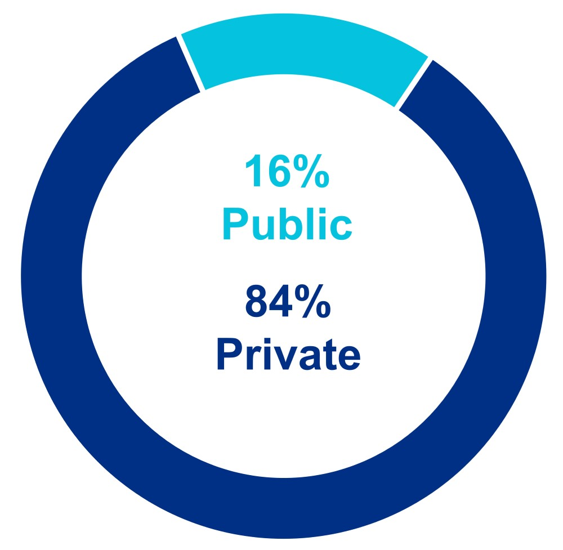 |  |  |  |  |  | 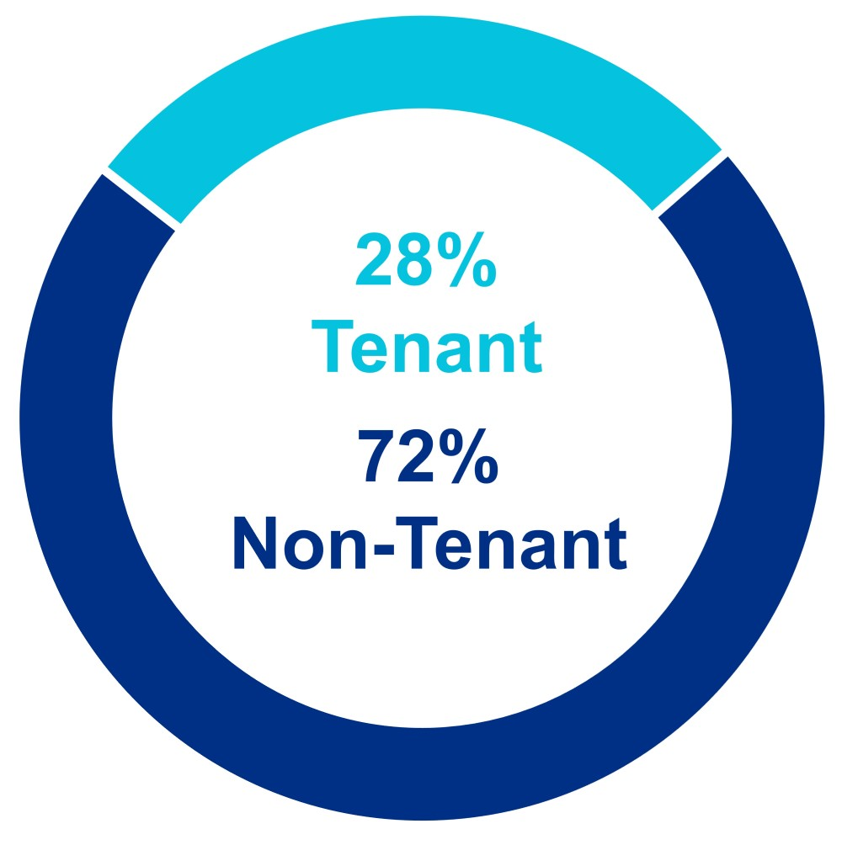

78

Liquidity
Liquidity |  |  |  |  |  |  |  |  | Minimal Outstanding Borrowings and Significant Availability on  Unsecured Senior Line of Credit
$5.3B |  |  |  |  |  |  |  |  | (in millions)
 |  |  |  |  |  |  |  |  | 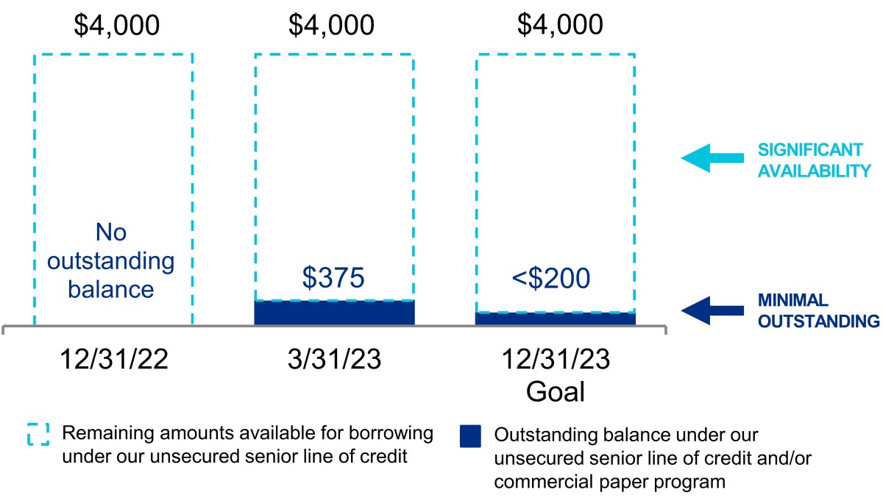
(In millions)
Availability under our unsecured senior line of credit, net of amounts outstanding under our commercial paper program |  |  | $ | 3,625
Outstanding forward equity sales agreements(1) |  |  | 103
Cash, cash equivalents, and restricted cash |  |  | 1,298
Remaining construction loan commitments |  |  | 121
Investments in publicly traded companies |  |  | 153
Liquidity as of March 31, 2023 |  |  | $ | 5,300
(1)Represents expected net proceeds from the future settlement of 699 thousand shares of common stock under forward equity sales agreements after underwriter discounts.

We expect to meet certain long-term liquidity requirements, such as requirements for development, redevelopment, other construction projects, capital improvements, tenant improvements, property acquisitions, leasing costs, non-revenue-enhancing capital expenditures, scheduled debt maturities, distributions to noncontrolling interests, and payment of dividends through net cash provided by operating activities, periodic asset sales, strategic real estate joint ventures, long-term secured and unsecured indebtedness, borrowings under our unsecured senior line of credit, issuances under our commercial paper program, and issuances of additional debt and/or equity securities.

We also expect to continue meeting our short-term liquidity and capital requirements, as further detailed in this section, generally through our working capital and net cash provided by operating activities. We believe that the net cash provided by operating activities will continue to be sufficient to enable us to make the distributions necessary to continue qualifying as a REIT.

For additional information on our liquidity requirements related to our contractual obligations and commitments, refer to Note 5 – “Leases” and Note 10 – “Secured and unsecured senior debt” to our unaudited consolidated financial statements under Item 1 of this report.

Over the next several years, our balance sheet, capital structure, and liquidity objectives are as follows:

•Retain positive cash flows from operating activities after payment of dividends and distributions to noncontrolling interests for investment in development and redevelopment projects and/or acquisitions;
•Maintain significant balance sheet liquidity;
•Improve credit profile and relative long-term cost of capital;
•Maintain diverse sources of capital, including sources from net cash provided by operating activities, unsecured debt, secured debt, selective real estate asset sales, strategic real estate joint ventures, non-real estate investment sales, and common stock;
•Maintain commitment to long-term capital to fund growth;
•Maintain prudent laddering of debt maturities;
•Maintain solid credit metrics;
•Prudently manage variable-rate debt exposure through the reduction of short-term and medium-term variable-rate debt;
•Maintain a large, unencumbered asset pool to provide financial flexibility;
•Fund common stock dividends and distributions to noncontrolling interests from net cash provided by operating activities;
•Manage a disciplined level of value-creation projects as a percentage of our gross real estate assets.
•Maintain high levels of pre-leasing and percentage leased in value-creation projects.

79

The following table presents the availability under our unsecured senior line of credit, net of amounts outstanding under our commercial paper program; outstanding forward equity sales agreements; cash, cash equivalents, and restricted cash; availability under our secured construction loan; and investments in publicly traded companies as of March 31, 2023 (dollars in thousands):
Description |  |  |  |  |  | Stated Rate |  |  |  |  |  | Aggregate  Commitments |  |  |  |  |  | Outstanding  Balance(1) |  |  |  |  |  | Remaining Commitments/Liquidity
Availability under our unsecured senior line of credit, net of amounts outstanding under our commercial paper program |  |  |  |  |  | SOFR+0.835% |  |  |  |  |  | $ | 4,000,000 |  |  |  |  | $ | 374,536 |  |  |  |  | $ | 3,625,000
Outstanding forward equity sales agreements(2) |  |  |  |  |  |  |  |  |  |  |  |  |  |  |  |  |  |  |  |  |  |  |  | 102,547
Cash, cash equivalents, and restricted cash |  |  |  |  |  |  |  |  |  |  |  |  |  |  |  |  |  |  |  |  |  |  |  | 1,298,384
Remaining construction loan commitments |  |  |  |  |  | SOFR+2.70% |  |  |  |  |  | $ | 195,300 |  |  |  |  | $ | 72,996 |  |  |  |  | 121,156
Investments in publicly traded companies |  |  |  |  |  |  |  |  |  |  |  |  |  |  |  |  |  |  |  |  |  |  |  | 153,341
Liquidity as of March 31, 2023 |  |  |  |  |  |  |  |  |  |  |  |  |  |  |  |  |  |  |  |  |  |  |  | $ | 5,300,428

(1)Represents outstanding principal, net of unamortized deferred financing costs, as of March 31, 2023.
(2)Represents expected net proceeds from the future settlement of 699 thousand shares of common stock under forward equity sales agreements after underwriter discounts.

Cash, cash equivalents, and restricted cash

As of March 31, 2023 and December 31, 2022, we had $1.3 billion and $858.0 million, respectively, of cash, cash equivalents, and restricted cash. We expect existing cash, cash equivalents, and restricted cash, net cash provided by operating activities, proceeds from real estate asset sales, sales of partial interests, strategic real estate joint ventures, non-real estate investment sales, borrowings under our unsecured senior line of credit, issuances under our commercial paper program, issuances of unsecured senior notes payable, borrowings under our secured construction loans, and issuances of common stock to continue to be sufficient to fund our operating activities and cash commitments for investing and financing activities, such as regular quarterly dividends, distributions to noncontrolling interests, scheduled debt repayments, acquisitions, and certain capital expenditures, including expenditures related to construction activities.

Cash flows

We report and analyze our cash flows based on operating activities, investing activities, and financing activities. The following table summarizes changes in our cash flows for the three months ended March 31, 2023 and 2022 (in thousands):
 |  |  | Three Months Ended March 31,
 |  |  | 2023 |  |  |  |  |  | 2022 |  |  |  |  |  | Change
Net cash provided by operating activities |  |  | $ | 305,570 |  |  |  |  | $ | 191,086 |  |  |  |  | $ | 114,484
Net cash used in investing activities |  |  | $ | (1,039,665) |  |  |  |  | $ | (2,488,798) |  |  |  |  | $ | 1,449,133
Net cash provided by financing activities |  |  | $ | 1,174,810 |  |  |  |  | $ | 2,752,570 |  |  |  |  | $ | (1,577,760)

Operating activities

Cash flows provided by operating activities are primarily dependent upon the occupancy level of our asset base, the rental rates of our leases, the collectibility of rent and recovery of operating expenses from our tenants, the timing of completion of development and redevelopment projects, and the timing of acquisitions and dispositions of operating properties. Net cash provided by operating activities for the three months ended March 31, 2023 increased by $114.5 million to $305.6 million, compared to $191.1 million for the three months ended March 31, 2022. The increase was primarily attributable to the following since January 1, 2022: (i) cash flows generated from our highly leased development and redevelopment projects recently placed into service, (ii) income-producing acquisitions, and (iii) increases in rental rates on lease renewals and re-leasing of space.

80

Investing activities

Cash used in investing activities for the three months ended March 31, 2023 and 2022 consisted of the following (in thousands):
 |  |  | Three Months Ended March 31, |  |  |  |  |  |  |  |  |  |  |  | Increase (Decrease)
 |  |  | 2023 |  |  |  |  |  | 2022
Sources of cash from investing activities:
Sales of and distributions from non-real estate investments |  |  | $ | 49,385 |  |  |  |  | $ | 44,842 |  |  |  |  | $ | 4,543
Change in escrow deposits |  |  | 9,366 |  |  |  |  |  | 100,635 |  |  |  |  |  | (91,269)
Return of capital from unconsolidated real estate joint ventures |  |  | — |  |  |  |  |  | 471 |  |  |  |  |  | (471)
 |  |  | 58,751 |  |  |  |  |  | 145,948 |  |  |  |  |  | (87,197)
Uses of cash for investing activities:
Purchases of real estate |  |  | 177,543 |  |  |  |  |  | 1,903,800 |  |  |  |  |  | (1,726,257)
Additions to real estate |  |  | 873,366 |  |  |  |  |  | 666,364 |  |  |  |  |  | 207,002
Investments in unconsolidated real estate joint ventures |  |  | 106 |  |  |  |  |  | 335 |  |  |  |  |  | (229)
Additions to non-real estate investments |  |  | 47,401 |  |  |  |  |  | 64,247 |  |  |  |  |  | (16,846)
 |  |  | 1,098,416 |  |  |  |  |  | 2,634,746 |  |  |  |  |  | (1,536,330)
Net cash used in investing activities |  |  | $ | 1,039,665 |  |  |  |  | $ | 2,488,798 |  |  |  |  | $ | (1,449,133)

The decrease in net cash used in investing activities for the three months ended March 31, 2023 when compared to the three months ended March 31, 2022 was primarily due to a decreased use of cash for purchases of real estate, partially offset by increased use of cash for additions to real estate. Refer to Note 3 – “Investments in real estate” to our unaudited consolidated financial statements under Item 1 of this report for additional information.

Financing activities

Cash flows provided by financing activities for the three months ended March 31, 2023 and 2022 consisted of the following (in thousands):
 |  |  | Three Months Ended March 31,
 |  |  | 2023 |  |  |  |  |  | 2022 |  |  |  |  |  | Change
Borrowings from secured notes payable |  |  | $ | 14,428 |  |  |  |  | $ | 5,082 |  |  |  |  | $ | 9,346
Repayments of borrowings from secured notes payable |  |  | — |  |  |  |  |  | (906) |  |  |  |  |  | 906
Proceeds from issuance of unsecured senior notes payable |  |  | 996,205 |  |  |  |  |  | 1,793,318 |  |  |  |  |  | (797,113)
Borrowings from unsecured senior line of credit |  |  | 375,000 |  |  |  |  |  | 1,180,000 |  |  |  |  |  | (805,000)
Repayments of borrowings from unsecured senior line of credit |  |  | (375,000) |  |  |  |  |  | (1,180,000) |  |  |  |  |  | 805,000
Proceeds from issuances under commercial paper program |  |  | 775,000 |  |  |  |  |  | 6,120,000 |  |  |  |  |  | (5,345,000)
Repayments of borrowings under commercial paper program |  |  | (400,000) |  |  |  |  |  | (6,390,000) |  |  |  |  |  | 5,990,000
Payments of loan fees |  |  | (9,989) |  |  |  |  |  | (17,596) |  |  |  |  |  | 7,607
Changes related to debt |  |  | 1,375,644 |  |  |  |  |  | 1,509,898 |  |  |  |  |  | (134,254)
Contributions from and sales of noncontrolling interests |  |  | 79,337 |  |  |  |  |  | 819,610 |  |  |  |  |  | (740,273)
Distributions to and purchases of noncontrolling interests |  |  | (63,186) |  |  |  |  |  | (30,501) |  |  |  |  |  | (32,685)
Proceeds from issuance of common stock |  |  | — |  |  |  |  |  | 646,316 |  |  |  |  |  | (646,316)
Dividends on common stock |  |  | (209,131) |  |  |  |  |  | (183,847) |  |  |  |  |  | (25,284)
Taxes paid related to net settlement of equity awards |  |  | (7,854) |  |  |  |  |  | (8,906) |  |  |  |  |  | 1,052
Net cash provided by financing activities |  |  | $ | 1,174,810 |  |  |  |  | $ | 2,752,570 |  |  |  |  | $ | (1,577,760)

81

Capital resources

We expect that our principal liquidity needs for the year ending December 31, 2023 will be satisfied by the multiple sources of capital shown in the table below. There can be no assurance that our sources and uses of capital will not be materially higher or lower than these expectations. Guidance for 2023 has been updated to reflect our current view of existing market conditions and assumptions for the year ending December 31, 2023. Key updates to our 2023 guidance include the following changes to the midpoints of our guidance ranges for our 2023 key sources and uses of capital:
•$325 million reduction in total uses of capital to $2.95 billion.
•$325 million reduction in sources of capital to $2.95 billion.
•$950 million in net incremental debt for 2023 ($1.0 billion of unsecured senior notes payable issued in February 2023).
•$375 million in net cash provided by operating activities after dividends.
•$1.625 billion in dispositions, sales of partial interests, and future settlement of forward equity sales agreements that were outstanding as of December 31, 2022.
•$965.4 million, or 59%, completed or subject to executed letters of intent or purchase and sale agreements, including $865.4 million from dispositions and sales of partial interests and approximately $100 million from forward equity sales agreements that were outstanding as of December 31, 2022.
•$659.6 million of targeted dispositions and sales of partial interests.
•$275 million of excess bond offering proceeds to reduce debt capital for 2024.
Key Sources and Uses of Capital  (In millions) |  |  |  |  |  | Midpoint |  |  |  |  |  |  |  |  |  |  |  |  |  |  |  |  |  | 2023 Guidance
 |  |  |  |  |  | As of 1/30/23 |  |  |  |  |  | Key Changes |  |  |  |  |  | As of 4/24/23 |  |  |  |  |  | Range |  |  |  |  |  |  |  |  |  |  |  | Midpoint
Sources of capital:
Incremental debt |  |  |  |  |  | $ | 700 |  |  |  |  | $ | (50) |  |  |  |  | $ | 650 |  |  |  |  | $ | 575 |  |  |  |  | $ | 725 |  |  |  |  | $ | 650
Excess 2022 bond capital held as cash at  December 31, 2022 |  |  |  |  |  | 300 |  |  |  |  |  | — |  |  |  |  |  | 300 |  |  |  |  |  | 300 |  |  |  |  |  | 300 |  |  |  |  |  | 300 |  |  | (1)
Net cash provided by operating activities after dividends |  |  |  |  |  | 375 |  |  |  |  |  | $ | — |  |  |  |  | 375 |  |  |  |  |  | 350 |  |  |  |  |  | 400 |  |  |  |  |  | 375
Dispositions and sales of partial interests |  |  |  |  |  | 1,900 |  |  |  |  |  | (275) |  |  |  |  |  | 1,525 |  |  |  |  |  | 1,425 |  |  |  |  |  | 1,625 |  |  |  |  |  | 1,525 |  |  | (2)
Future settlement of forward equity sales agreements outstanding as of December 31, 2022 |  |  |  |  |  |  |  |  |  |  |  |  |  |  |  |  |  | 100 |  |  |  |  |  | 100 |  |  |  |  |  | 100 |  |  |  |  |  | 100 |  |  | (3)
Total sources of capital before excess cash expected to be held at December 31, 2023 |  |  |  |  |  | $ | 3,275 |  |  |  |  | $ | (325) |  |  |  |  | $ | 2,950 |  |  |  |  | $ | 2,750 |  |  |  |  | $ | 3,150 |  |  |  |  | $ | 2,950
Cash expected to be held at December 31, 2023(4) |  |  |  |  |  | $ | — |  |  |  |  | $ | 275 |  |  |  |  | 275 |  |  |  |  |  | 125 |  |  |  |  |  | 425 |  |  |  |  |  | 275
Total sources of capital |  |  |  |  |  |  |  |  |  |  |  |  |  |  |  |  |  |  |  |  |  |  |  | $ | 2,875 |  |  |  |  | $ | 3,575 |  |  |  |  | $ | 3,225
Uses of capital:
Construction |  |  |  |  |  | $ | 2,975 |  |  |  |  | $ | (250) |  |  |  |  | $ | 2,725 |  |  |  |  | $ | 2,575 |  |  |  |  | $ | 2,875 |  |  |  |  | $ | 2,725
Acquisitions |  |  |  |  |  | 300 |  |  |  |  |  | (75) |  |  |  |  |  | 225 |  |  |  |  |  | 175 |  |  |  |  |  | 275 |  |  |  |  |  | 225 |  |  | (5)
Total uses of capital |  |  |  |  |  | $ | 3,275 |  |  |  |  | $ | (325) |  |  |  |  | $ | 2,950 |  |  |  |  | $ | 2,750 |  |  |  |  | $ | 3,150 |  |  |  |  | $ | 2,950
Incremental debt (included above):
Issuance of unsecured senior notes payable |  |  |  |  |  |  |  |  |  |  |  |  |  |  |  |  |  |  |  |  |  |  |  | $ | 1,000 |  |  |  |  | $ | 1,000 |  |  |  |  | $ | 1,000 |  | (6)
Unsecured senior line of credit, commercial paper, and other |  |  |  |  |  |  |  |  |  |  |  |  |  |  |  |  |  |  |  |  |  |  |  | (425) |  |  |  |  |  | (275) |  |  |  |  |  | (350)
Net incremental debt |  |  |  |  |  |  |  |  |  |  |  |  |  |  |  |  |  |  |  |  |  |  |  | $ | 575 |  |  |  |  | $ | 725 |  |  |  |  | $ | 650
(1)Represents $300.0 million of excess 2022 bond capital proceeds held as cash at December 31, 2022 that was used to reduce our 2023 debt capital needs.
(2)As of the date of this report, we have completed dispositions and pending transactions subject to signed letters of intent or purchase and sale agreements aggregating $865.4 million.
(3)Represents outstanding forward equity sales agreements entered into during the three months ended December 31, 2022 to sell 699 thousand shares of common stock under our ATM program. Refer to Note 13 – “Stockholders’ equity” to our unaudited consolidated financial statements under Item 1 of this report for additional information.
(4)Represents estimated excess 2023 bond capital proceeds expected to be held as cash at December 31, 2023, which reduces our 2024 debt capital needs.
(5)As of March 31, 2023, we have completed acquisitions aggregating $171.9 million. Refer to “Acquisitions” within this Item 2 for additional information.
(6)Represents $1.0 billion of unsecured senior notes payable issued in February 2023. Refer to Note 10 – “Secured and unsecured senior debt” to our unaudited consolidated financial statements under Item 1 of this report for additional information.

The key assumptions behind the sources and uses of capital in the table above include a favorable capital market environment, performance of our core operating properties, lease-up and delivery of current and future development and redevelopment projects, and leasing activity. Our expected sources and uses of capital are subject to a number of variables and uncertainties, including those discussed as “Forward-looking statements” under Part I; and “Item 1A. Risk factors” and “Item 7. Management’s discussion and analysis of financial condition and results of operations” of our annual report on Form 10-K for the year ended December 31, 2022; as well as “Item 1A. Risk factors” within “Part II – Other information” of this quarterly report on Form 10-Q. We expect to update our forecast for sources and uses of capital on a quarterly basis.

82

Sources of capital

Net cash provided by operating activities after dividends

We expect to retain $350.0 million to $400.0 million of net cash flows from operating activities after payment of common stock dividends, and distributions to noncontrolling interests for the year ending December 31, 2023. For purposes of this calculation, changes in operating assets and liabilities are excluded as they represent timing differences. For the year ending December 31, 2023, we expect our recently delivered projects, our highly pre-leased value-creation projects expected to be delivered, and contributions from Same Properties and recently acquired properties to contribute increases in income from rentals, net operating income, and cash flows. We anticipate contractual near-term growth in annual net operating income (cash basis) of $41 million related to the commencement of contractual rents on the projects recently placed into service that are near the end of their initial free rent period. Refer to the “Cash flows” subsection of the “Liquidity” section within this Item 2 for a discussion of cash flows provided by operating activities for the three months ended March 31, 2023.

Debt

We expect to fund a portion of our capital needs for the remainder of 2023 from real estate dispositions, sales of partial interests, strategic real estate joint ventures, settlement of our outstanding forward equity sales agreements, cash on hand, issuances under our commercial paper program, borrowings under our unsecured senior line of credit, and borrowings under our secured construction loans.
Our unsecured senior line of credit has aggregate commitments of $4.0 billion and bears an interest rate of SOFR plus 0.835%. In addition to the cost of borrowing, the unsecured senior line of credit is subject to an annual facility fee of 0.14% based on the aggregate commitments outstanding. Based upon our ability to achieve certain annual sustainability targets, the interest rate and facility fee rate are also subject to upward or downward adjustments of up to four basis points with respect to the interest rate and up to one basis point with respect to the facility fee rate.

During the three months ended March 31, 2023, we achieved certain annual sustainability targets, as described in our unsecured senior line of credit agreement, which reduced the borrowing rate by four basis points for a one-year period to SOFR plus 0.835%, from SOFR plus 0.875%, and reduced the facility fee by one basis point to 0.14% from 0.15%. As of March 31, 2023, we had no outstanding balance on our unsecured senior line of credit.

We established a commercial paper program that provides us with the ability to issue up to $2.0 billion of commercial paper notes with a maturity of generally 30 days or less and with a maximum maturity of 397 days from the date of issuance. Our commercial paper program is backed by our unsecured senior line of credit, and at all times we expect to retain a minimum undrawn amount of borrowing capacity under our unsecured senior line of credit equal to any outstanding balance under our commercial paper program. We use borrowings under the program to fund short-term capital needs. The notes issued under our commercial paper program are sold under customary terms in the commercial paper market. They are typically issued at a discount to par, representing a yield to maturity dictated by market conditions at the time of issuance. In the event we are unable to issue commercial paper notes or refinance outstanding commercial paper notes under terms equal to or more favorable than those under the unsecured senior line of credit, we expect to borrow under the unsecured senior line of credit. The commercial paper notes sold during the three months ended March 31, 2023 were issued at a weighted-average yield to maturity of 5.08%. As of March 31, 2023, we had $374.5 million outstanding balance under our commercial paper program.

In February 2023, we opportunistically issued $1.0 billion of unsecured senior notes payable with a weighted-average interest rate of 4.95% and a weighted-average maturity of 21.2 years. The unsecured senior notes consisted of $500.0 million of 4.75% green unsecured senior notes due 2035 and $500.0 million of 5.15% unsecured senior notes due 2053.

The following table presents our average debt outstanding and weighted-average interest rate during the three months ended March 31, 2023:
 |  |  |  |  |  | Three Months Ended March 31, 2023
 |  |  |  |  |  | Average Debt Outstanding |  |  |  | Weighted-Average Interest Rate
Long-term fixed-rate debt |  |  |  |  |  | $ | 10,673,206 |  |  |  |  |  |  | 3.57 |  | %
Short-term variable-rate unsecured senior line of credit and commercial paper program debt |  |  |  |  |  | 86,314 |  |  |  |  |  |  |  | 5.39
Blended average interest rate |  |  |  |  |  | 10,759,520 |  |  |  |  |  |  |  | 3.58
Loan fee amortization and annual facility fee related to unsecured senior line of credit |  |  |  |  |  | N/A |  |  |  |  |  |  |  | 0.11
Total/weighted average |  |  |  |  |  | $ | 10,759,520 |  |  |  |  |  |  | 3.69 |  | %

83

Real estate dispositions, sales of partial interests, and issuances of common equity

We expect to continue to focus on the disciplined execution of select sales of operating assets. Future sales will provide an important source of capital to fund a portion of pending and recently completed opportunistic acquisitions and our highly leased value-creation development and redevelopment projects, and also provide significant capital for growth. We may also consider additional sales of partial interests in core Class A properties and/or development projects. For 2023, we expect real estate dispositions, sales of partial interests, and issuances of common equity ranging from $1.5 billion to $1.7 billion. The amount of asset sales necessary to meet our forecasted sources of capital will vary depending upon the amount of EBITDA associated with the assets sold.

As a REIT, we are generally subject to a 100% tax on the net income from real estate asset sales that the IRS characterizes as “prohibited transactions.” We do not expect our sales will be categorized as prohibited transactions. However, unless we meet certain “safe harbor” requirements, whether a real estate asset sale is a “prohibited transaction” will be based on the facts and circumstances of the sale. Our real estate asset sales may not always meet such “safe harbor” requirements. Refer to “Item 1A. Risk factors” of our annual report on Form 10-K for the year ended December 31, 2022 for additional information about the “prohibited transaction” tax.

Common equity transactions

During the three months ended March 31, 2023, we did not issue shares to settle our outstanding forward equity agreements. We expect to issue an aggregate of 699 thousand shares of common stock to settle all our outstanding forward equity sales agreements, and to receive net proceeds of $102.5 million. In addition, the remaining amount available under our ATM program for future sales of common stock aggregated $141.9 million as of March 31, 2023.

Other sources

Under our current shelf registration statement filed with the SEC, we may offer common stock, preferred stock, debt, and other securities. These securities may be issued, from time to time, at our discretion based on our needs and market conditions, including, as necessary, to balance our use of incremental debt capital.

Additionally, we, together with joint venture partners, hold interests in real estate joint ventures that we consolidate in our financial statements. These existing joint ventures provide significant equity capital to fund a portion of our future construction spend, and our joint venture partners may also contribute equity into these entities for financing-related activities. From April 1, 2023 to December 31, 2026, we expect to receive capital contributions of $1.4 billion from existing real estate joint venture partners to fund construction. During the year ending December 31, 2023, contributions from noncontrolling interests are expected to aggregate $746.0 million, of which approximately 73% represents expected funding from our existing joint venture partners and the remaining amount represents expected funding from partners in future real estate joint ventures.

84

Uses of capital

Summary of capital expenditures

One of our primary uses of capital relates to the development, redevelopment, pre-construction, and construction of properties. We currently have projects in our value-creation pipeline aggregating 5.5 million RSF of Class A properties undergoing construction, 9.7 million RSF of near-term and intermediate-term development and redevelopment projects, and 18.5 million SF of future development projects in North America. We incur capitalized construction costs related to development, redevelopment, pre-construction, and other construction activities. We also incur additional capitalized project costs, including interest, property taxes, insurance, and other costs directly related and essential to the development, redevelopment, pre-construction, or construction of a project, during periods when activities necessary to prepare an asset for its intended use are in progress. Refer to “New Class A development and redevelopment properties: current projects” and “Summary of capital expenditures” subsections of the “Investments in real estate” section within this Item 2 for more information on our capital expenditures.

We capitalize interest cost as a cost of the project only during the period in which activities necessary to prepare an asset for its intended use are ongoing, provided that expenditures for the asset have been made and interest cost has been incurred. Capitalized interest for the three months ended March 31, 2023 and 2022 of $87.1 million and $57.8 million, respectively, was classified in investments in real estate in our consolidated balance sheets.

Property taxes, insurance on real estate, and indirect project costs, such as construction administration, legal fees, and office costs that clearly relate to projects under development or construction, are capitalized as incurred during the period an asset is undergoing activities to prepare it for its intended use. We capitalized payroll and other indirect costs related to development, redevelopment, pre-construction, and construction projects, aggregating $23.6 million and $20.4 million, and property taxes, insurance on real estate and indirect project costs aggregating $29.8 million and $21.8 million during the three months ended March 31, 2023 and 2022, respectively.

The increase in capitalized costs for the three months ended March 31, 2023, compared to the same period in 2022, was primarily due to an increase in our value-creation pipeline projects undergoing construction and pre-construction activities in 2023 over 2022. Pre-construction activities include entitlements, permitting, design, site work, and other activities preceding commencement of construction of aboveground building improvements. The advancement of pre-construction efforts is focused on reducing the time required to deliver projects to prospective tenants. These critical activities add significant value for future ground-up development and are required for the vertical construction of buildings. Should we cease activities necessary to prepare an asset for its intended use, the interest, taxes, insurance, and certain other direct and indirect project costs related to the asset would be expensed as incurred. Expenditures for repairs and maintenance are expensed as incurred.

Fluctuations in our development, redevelopment, and construction activities could result in significant changes to total expenses and net income. For example, had we experienced a 10% reduction in development, redevelopment, and construction activities without a corresponding decrease in indirect project costs, including interest and payroll, total expenses would have increased by approximately $11.1 million for the three months ended March 31, 2023.

We use third-party brokers to assist in our leasing activity, who are paid on a contingent basis upon successful leasing. We are required to capitalize initial direct costs related to successful leasing transactions that result directly from and are essential to the lease transaction and would not have been incurred had that lease transaction not been successfully executed. During the three months ended March 31, 2023, we capitalized total initial direct leasing costs of $28.7 million. Costs that we incur to negotiate or arrange a lease regardless of its outcome, such as fixed employee compensation, tax, or legal advice to negotiate lease terms, and other costs, are expensed as incurred.

Acquisitions

Refer to the “Acquisitions” section in Note 3 – “Investments in real estate” and to Note 4 – “Consolidated and unconsolidated real estate joint ventures” to our unaudited consolidated financial statements under Item 1 of this report, and the “Acquisitions” subsection of the “Investments in real estate” section within this Item 2 for information on our acquisitions.

85

Dividends

During the three months ended March 31, 2023 and 2022, we paid common stock dividends of $209.1 million and $183.8 million, respectively. The increase of $25.3 million in dividends paid on our common stock during the three months ended March 31, 2023, compared to the three months ended March 31, 2022, was primarily due to an increase in the number of common shares outstanding subsequent to January 1, 2022 as a result of issuances of common stock under our ATM program and settlement of forward equity sales agreements, and partially due to the increase in the related dividends to $1.21 per common share paid during the three months ended March 31, 2023 from $1.15 per common share paid during the three months ended March 31, 2022.

Secured notes payable

Secured notes payable as of March 31, 2023 consisted of three notes secured by two properties. Our secured notes payable typically require monthly payments of principal and interest and had a weighted-average interest rate of approximately 7.56%. As of March 31, 2023, the total book value of our investments in real estate securing debt was approximately $243.0 million. As of March 31, 2023, our secured notes payable, including unamortized discounts and deferred financing costs, comprised approximately $649 thousand and $73.0 million of fixed-rate debt and unhedged variable-rate debt, respectively.

Unsecured senior notes payable and unsecured senior line of credit

The requirements of, and our actual performance with respect to, the key financial covenants under our unsecured senior notes payable as of March 31, 2023 were as follows:

Covenant Ratios(1) |  |  |  |  |  | Requirement |  |  |  |  |  | March 31, 2023
Total Debt to Total Assets |  |  |  |  |  | Less than or equal to 60% |  |  |  |  |  | 29%
Secured Debt to Total Assets |  |  |  |  |  | Less than or equal to 40% |  |  |  |  |  | 0.2%
Consolidated EBITDA(2) to Interest Expense |  |  |  |  |  | Greater than or equal to 1.5x |  |  |  |  |  | 20.8x
Unencumbered Total Asset Value to Unsecured Debt |  |  |  |  |  | Greater than or equal to 150% |  |  |  |  |  | 334%

(1)All covenant ratio titles utilize terms as defined in the respective debt agreements.
(2)The calculation of consolidated EBITDA is based on the definitions contained in our loan agreements and is not directly comparable to the computation of EBITDA as described in Exchange Act Release No. 47226.

In addition, the terms of the indentures, among other things, limit the ability of the Company, Alexandria Real Estate Equities, L.P., and the Company’s subsidiaries to (i) consummate a merger, or consolidate or sell all or substantially all of the Company’s assets, and (ii) incur certain secured or unsecured indebtedness.

The requirements of, and our actual performance with respect to, the key financial covenants under our unsecured senior line of credit as of March 31, 2023 were as follows:
Covenant Ratios(1) |  |  |  |  |  | Requirement |  |  |  |  |  | March 31, 2023
Leverage Ratio |  |  |  |  |  | Less than or equal to 60.0% |  |  |  |  |  | 27.3%
Secured Debt Ratio |  |  |  |  |  | Less than or equal to 45.0% |  |  |  |  |  | 0.1%
Fixed-Charge Coverage Ratio |  |  |  |  |  | Greater than or equal to 1.50x |  |  |  |  |  | 4.31x
Unsecured Interest Coverage Ratio |  |  |  |  |  | Greater than or equal to 1.75x |  |  |  |  |  | 24.51x
(1)All covenant ratio titles utilize terms as defined in the credit agreement.

Estimated interest payments

Estimated interest payments on our fixed-rate debt are calculated based upon contractual interest rates, including interest payment dates and scheduled maturity dates. As of March 31, 2023, 96.1% of our debt was fixed-rate debt. For additional information regarding our debt, refer to Note 10 – “Secured and unsecured senior debt” to our unaudited consolidated financial statements under Item 1 of this report.

86

Ground lease obligations

Operating lease agreements

Ground lease obligations as of March 31, 2023 included leases for 41 of our properties, which accounted for approximately 9% of our total number of properties. Excluding one ground lease that expires in 2036 related to one operating property with a net book value of $6.2 million as of March 31, 2023, our ground lease obligations have remaining lease terms ranging from approximately 31 to 99 years, including available extension options that we are reasonably certain to exercise.

As of March 31, 2023, the remaining contractual payments under ground and office lease agreements in which we are the lessee aggregated $865.3 million and $33.1 million, respectively. We are required to recognize a right-of-use asset and a related liability to account for our future obligations under operating lease arrangements in which we are the lessee. The operating lease liability is measured based on the present value of the remaining lease payments, including payments during the term under our extension options that we are reasonably certain to exercise. The right-of-use asset is equal to the corresponding operating lease liability, adjusted for the initial direct leasing cost and any other consideration exchanged with the landlord prior to the commencement of the lease, as well as adjustments to reflect favorable or unfavorable terms of an acquired lease when compared with market terms at the time of acquisition. As of March 31, 2023, the present value of the remaining contractual payments aggregating $898.5 million under our operating lease agreements, including our extension options that we are reasonably certain to exercise, was $405.2 million, which was classified in accounts payable, accrued expenses, and other liabilities in our consolidated balance sheets. As of March 31, 2023, the weighted-average remaining lease term of operating leases in which we are the lessee was approximately 42 years, and the weighted-average discount rate was 4.6%. Our corresponding operating lease right-of-use assets, adjusted for initial direct leasing costs and other consideration exchanged with the landlord prior to the commencement of the lease, aggregated $554.9 million. We classify the right-of-use asset in other assets in our consolidated balance sheets. Refer to the “Lease accounting” section in Note 2 – “Summary of significant accounting policies” to our unaudited consolidated financial statements under Item 1 in this report for additional information.

Commitments

As of March 31, 2023, remaining aggregate costs under contract for the construction of properties undergoing development, redevelopment, and improvements under the terms of leases approximated $2.9 billion. In addition, we may be required to incur construction costs associated with our future development projects aggregating 643,331 RSF in our Greater Boston market pursuant to an agreement whereby our counterparty may elect to execute future lease agreements on mutually agreeable terms.

We expect payments for these obligations to occur over one to three years, subject to capital planning adjustments from time to time. We may have the ability to cease the construction of certain projects, which would result in the reduction of our commitments. In addition, we have letters of credit and performance obligations aggregating $22.4 million primarily related to construction projects and an anticipated acquisition.

We are committed to funding approximately $419.2 million related to our non-real estate investments. These funding commitments are primarily associated with our investments in privately held entities that report NAV and expire at various dates over the next 12 years, with a weighted-average expiration of 8.5 years as of March 31, 2023.

Exposure to environmental liabilities

In connection with the acquisition of all of our properties, we have obtained Phase I environmental assessments to ascertain the existence of any environmental liabilities or other issues. The Phase I environmental assessments of our properties have not revealed any environmental liabilities that we believe would have a material adverse effect on our financial condition or results of operations taken as a whole, nor are we aware of any material environmental liabilities that have occurred since the Phase I environmental assessments were completed. In addition, we carry a policy of pollution legal liability insurance covering exposure to certain environmental losses at substantially all of our properties.

87

Foreign currency translation gains and losses

The following table presents the change in accumulated other comprehensive loss attributable to Alexandria Real Estate Equities, Inc.’s stockholders during the three months ended March 31, 2023 due to the changes in the foreign exchange rates for our real estate investments in Canada and Asia. We reclassify unrealized foreign currency translation gains and losses into net income as we dispose of these holdings.
(In thousands) |  |  |  |  |  | Total
Balance as of December 31, 2022 |  |  |  |  |  | $ | (20,812)
Other comprehensive income before reclassifications |  |  |  |  |  | 276
Net other comprehensive income |  |  |  |  |  | 276
Balance as of March 31, 2023 |  |  |  |  |  | $ | (20,536)

Inflation

As of March 31, 2023, approximately 93% of our leases (on an annual rental revenue basis) were triple net leases, which require tenants to pay substantially all real estate taxes, insurance, utilities, repairs and maintenance, common area expenses, and other operating expenses (including increases thereto) in addition to base rent. Approximately 95% of our leases (on an annual rental revenue basis) contained effective annual rent escalations that were either fixed (generally ranging from 3.0% to 3.5%) or indexed based on a consumer price index or other indices. Accordingly, we do not believe that our cash flows or earnings from real estate operations are subject to significant risks from inflation. A period of inflation, however, could cause an increase in the cost of our variable-rate borrowings, including borrowings under our unsecured senior line of credit and commercial paper program, issuances of unsecured senior notes payable, and borrowings under our secured construction loans, and secured loans held by our unconsolidated real estate joint ventures.

In addition, refer to “Item 1A. Risk factors” within “Part II – Other information” in this quarterly report on Form 10-Q for a discussion about risks that inflation directly or indirectly may pose to our business.

88

Issuer and guarantor subsidiary summarized financial information

Alexandria Real Estate Equities, Inc. (the “Issuer”) has sold certain debt securities registered under the Securities Act of 1933, as amended, that are fully and unconditionally guaranteed by Alexandria Real Estate Equities, L.P. (the “LP” or the “Guarantor Subsidiary”), an indirectly 100% owned subsidiary of the Issuer. The Issuer’s other subsidiaries, including, but not limited to, the subsidiaries that own substantially all of its real estate (collectively, the “Combined Non-Guarantor Subsidiaries”), will not provide a guarantee of such securities, including the subsidiaries that are partially or 100% owned by the LP. The following summarized financial information presents, on a combined basis, balance sheet information as of March 31, 2023 and December 31, 2022, and results of operations and comprehensive income for the three months ended March 31, 2023 and year ended December 31, 2022 for the Issuer and the Guarantor Subsidiary. The information presented below excludes eliminations necessary to arrive at the information on a consolidated basis. In presenting the summarized financial statements, the equity method of accounting has been applied to (i) the Issuer’s interests in the Guarantor Subsidiary, (ii) the Guarantor Subsidiary’s interests in the Combined Non-Guarantor Subsidiaries, and (iii) the Combined Non-Guarantor Subsidiaries’ interests in the Guarantor Subsidiary, where applicable, even though all such subsidiaries meet the requirements to be consolidated under GAAP. All assets and liabilities have been allocated to the Issuer and the Guarantor Subsidiary generally based on legal entity ownership.

The following tables present combined summarized financial information as of March 31, 2023 and December 31, 2022, for the three months ended March 31, 2023, and for the year ended December 31, 2022 for the Issuer and Guarantor Subsidiary. Amounts provided do not represent our total consolidated amounts (in thousands):
(in thousands) |  |  |  |  |  | March 31, 2023 |  |  |  |  |  | December 31, 2022
Assets:
Cash, cash equivalents, and restricted cash |  |  |  |  |  | $ | 940,093 |  |  |  |  | $ | 465,707
Other assets |  |  |  |  |  | 108,875 |  |  |  |  |  | 107,287
Total assets |  |  |  |  |  | $ | 1,048,968 |  |  |  |  | $ | 572,994
Liabilities:
Unsecured senior notes payable |  |  |  |  |  | $ | 11,089,124 |  |  |  |  | $ | 10,100,717
Unsecured senior line of credit and commercial paper |  |  |  |  |  | 374,536 |  |  |  |  |  | —
Other liabilities |  |  |  |  |  | 424,481 |  |  |  |  |  | 466,369
Total liabilities |  |  |  |  |  | $ | 11,888,141 |  |  |  |  | $ | 10,567,086

(in thousands) |  |  |  |  |  | Three Months Ended March 31, 2023 |  |  |  |  |  | Year Ended December 31, 2022
Total revenues |  |  |  |  |  | $ | 12,296 |  |  |  |  | $ | 33,052
Total expenses |  |  |  |  |  | (62,452) |  |  |  |  |  | (277,647)
Net loss |  |  |  |  |  | (50,156) |  |  |  |  |  | (244,595)
Net income attributable to unvested restricted stock awards |  |  |  |  |  | (2,606) |  |  |  |  |  | (8,392)
Net loss attributable to Alexandria Real Estate Equities, Inc.’s common stockholders |  |  |  |  |  | $ | (52,762) |  |  |  |  | $ | (252,987)

As of March 31, 2023, 421 of our 433 properties were held indirectly by the REIT’s wholly owned consolidated subsidiary, Alexandria Real Estate Equities, L.P.

Critical accounting estimates

Refer to our annual report on Form 10-K for the year ended December 31, 2022 for a discussion of our critical accounting estimates related to recognition of real estate acquired, impairment of long-lived assets, monitoring of tenant credit quality, and allowance for credit losses.

89

Non-GAAP measures and definitions

This section contains additional information of certain non-GAAP financial measures and the reasons why we use these supplemental measures of performance and believe they provide useful information to investors, as well as the definitions of other terms used in this report.

Funds from operations and funds from operations, as adjusted, attributable to Alexandria Real Estate Equities, Inc.’s common stockholders

GAAP-basis accounting for real estate assets utilizes historical cost accounting and assumes that real estate values diminish over time. In an effort to overcome the difference between real estate values and historical cost accounting for real estate assets, the Nareit Board of Governors established funds from operations as an improved measurement tool. Since its introduction, funds from operations has become a widely used non-GAAP financial measure among equity REITs. We believe that funds from operations is helpful to investors as an additional measure of the performance of an equity REIT. Moreover, we believe that funds from operations, as adjusted, allows investors to compare our performance to the performance of other real estate companies on a consistent basis, without having to account for differences recognized because of real estate acquisition and disposition decisions, financing decisions, capital structure, capital market transactions, variances resulting from the volatility of market conditions outside of our control, or other corporate activities that may not be representative of the operating performance of our properties.

The 2018 White Paper published by the Nareit Board of Governors (the “Nareit White Paper”) defines funds from operations as net income (computed in accordance with GAAP), excluding gains or losses on sales of real estate, and impairments of real estate, plus depreciation and amortization of operating real estate assets, and after adjustments for our share of consolidated and unconsolidated partnerships and real estate joint ventures. Impairments represent the write-down of assets when fair value over the recoverability period is less than the carrying value due to changes in general market conditions and do not necessarily reflect the operating performance of the properties during the corresponding period.

We compute funds from operations, as adjusted, as funds from operations calculated in accordance with the Nareit White Paper, excluding significant gains, losses, and impairments realized on non-real estate investments, unrealized gains or losses on non-real estate investments, gains or losses on early extinguishment of debt, significant termination fees, acceleration of stock compensation expense due to the resignation of an executive officer, deal costs, the income tax effect related to such items, and the amount of such items that is allocable to our unvested restricted stock awards. We compute the amount that is allocable to our unvested restricted stock awards using the two-class method. Under the two-class method, we allocate net income (after amounts attributable to noncontrolling interests) to common stockholders and to unvested restricted stock awards by applying the respective weighted-average shares outstanding during each quarter-to-date and year-to-date period. This may result in a difference of the summation of the quarter-to-date and year-to-date amounts. Neither funds from operations nor funds from operations, as adjusted, should be considered as alternatives to net income (determined in accordance with GAAP) as indications of financial performance, or to cash flows from operating activities (determined in accordance with GAAP) as measures of liquidity, nor are they indicative of the availability of funds for our cash needs, including our ability to make distributions.

The following table reconciles net income to funds from operations for the share of consolidated real estate joint ventures attributable to noncontrolling interests and our share of unconsolidated real estate joint ventures for the three months ended March 31, 2023 (in thousands):

 |  |  | Three Months Ended March 31, 2023
 |  |  | Noncontrolling Interest Share of Consolidated Real Estate Joint Ventures |  |  |  | Our Share of Unconsolidated  Real Estate Joint Ventures
Net income |  |  | $ | 43,831 |  |  |  |  |  |  | $ | 194
Depreciation and amortization of real estate assets |  |  | 28,178 |  |  |  |  |  |  |  | 859
Funds from operations |  |  | $ | 72,009 |  |  |  |  |  |  | $ | 1,053

90

The following tables present a reconciliation of net income (loss) attributable to Alexandria Real Estate Equities, Inc.’s common stockholders, the most directly comparable financial measure presented in accordance with GAAP, including our share of amounts from consolidated and unconsolidated real estate joint ventures, to funds from operations attributable to Alexandria Real Estate Equities, Inc.’s common stockholders – diluted, and funds from operations attributable to Alexandria Real Estate Equities, Inc.’s common stockholders – diluted, as adjusted, and the related per share amounts for the three months ended March 31, 2023 and 2022. Per share amounts may not add due to rounding.

 |  |  |  |  |  | Three Months Ended March 31,
(In thousands) |  |  |  |  |  | 2023 |  |  |  |  |  | 2022
Net income (loss) attributable to Alexandria Real Estate Equities, Inc.’s common stockholders – basic and diluted |  |  |  |  |  | $ | 75,256 |  |  |  |  | $ | (151,650)
Depreciation and amortization of real estate assets |  |  |  |  |  | 262,124 |  |  |  |  |  | 237,160
Noncontrolling share of depreciation and amortization from consolidated real estate JVs |  |  |  |  |  | (28,178) |  |  |  |  |  | (23,681)
Our share of depreciation and amortization from unconsolidated real estate JVs |  |  |  |  |  | 859 |  |  |  |  |  | 955
Allocation to unvested restricted stock awards |  |  |  |  |  | (1,359) |  |  |  |  |  | —
Funds from operations attributable to Alexandria Real Estate Equities, Inc.’s common stockholders – diluted(1) |  |  |  |  |  | 308,702 |  |  |  |  |  | 62,784
Unrealized losses on non-real estate investments |  |  |  |  |  | 65,855 |  |  |  |  |  | 263,433
Allocation to unvested restricted stock awards |  |  |  |  |  | (867) |  |  |  |  |  | (1,604)
Funds from operations attributable to Alexandria Real Estate Equities, Inc.’s common stockholders – diluted, as adjusted |  |  |  |  |  | $ | 373,690 |  |  |  |  | $ | 324,613

(1)Calculated in accordance with standards established by the Nareit Board of Governors.

 |  |  |  |  |  | Three Months Ended March 31,
(Per share) |  |  |  |  |  | 2023 |  |  |  |  |  | 2022
Net income (loss) per share attributable to Alexandria Real Estate Equities, Inc.’s common stockholders – diluted |  |  |  |  |  | $ | 0.44 |  |  |  |  | $ | (0.96)
Depreciation and amortization of real estate assets |  |  |  |  |  | 1.38 |  |  |  |  |  | 1.36
Allocation to unvested restricted stock awards |  |  |  |  |  | (0.01) |  |  |  |  |  | —
Funds from operations per share attributable to Alexandria Real Estate Equities, Inc.’s common stockholders – diluted |  |  |  |  |  | 1.81 |  |  |  |  |  | 0.40
Unrealized losses on non-real estate investments |  |  |  |  |  | 0.39 |  |  |  |  |  | 1.67
Allocation to unvested restricted stock awards |  |  |  |  |  | (0.01) |  |  |  |  |  | (0.02)
Funds from operations per share attributable to Alexandria Real Estate Equities, Inc.’s common stockholders – diluted, as adjusted |  |  |  |  |  | $ | 2.19 |  |  |  |  | $ | 2.05
Weighted-average shares of common stock outstanding for calculation of:
EPS – diluted |  |  |  |  |  | 170,784 |  |  |  |  |  | 158,198
Funds from operations – diluted, per share |  |  |  |  |  | 170,784 |  |  |  |  |  | 158,209
Funds from operations – diluted, as adjusted, per share |  |  |  |  |  | 170,784 |  |  |  |  |  | 158,209

91

Adjusted EBITDA and Adjusted EBITDA margin

We use Adjusted EBITDA as a supplemental performance measure of our operations, for financial and operational decision-making, and as a supplemental means of evaluating period-to-period comparisons on a consistent basis. Adjusted EBITDA is calculated as earnings before interest, taxes, depreciation, and amortization (“EBITDA”), excluding stock compensation expense, gains or losses on early extinguishment of debt, gains or losses on sales of real estate, impairments of real estate, and significant termination fees. Adjusted EBITDA also excludes unrealized gains or losses and significant realized gains or losses and impairments that result from our non-real estate investments. These non-real estate investment amounts are classified in our consolidated statements of operations outside of total revenues.

We believe Adjusted EBITDA provides investors with relevant and useful information as it allows investors to evaluate the operating performance of our business activities without having to account for differences recognized because of investing and financing decisions related to our real estate and non-real estate investments, our capital structure, capital market transactions, and variances resulting from the volatility of market conditions outside of our control. For example, we exclude gains or losses on the early extinguishment of debt to allow investors to measure our performance independent of our indebtedness and capital structure. We believe that adjusting for the effects of impairments and gains or losses on sales of real estate, significant impairments and realized gains or losses on non-real estate investments, and significant termination fees allows investors to evaluate performance from period to period on a consistent basis without having to account for differences recognized because of investing and financing decisions related to our real estate and non-real estate investments or other corporate activities that may not be representative of the operating performance of our properties.

In addition, we believe that excluding charges related to stock compensation and unrealized gains or losses facilitates for investors a comparison of our business activities across periods without the volatility resulting from market forces outside of our control. Adjusted EBITDA has limitations as a measure of our performance. Adjusted EBITDA does not reflect our historical expenditures or future requirements for capital expenditures or contractual commitments. While Adjusted EBITDA is a relevant measure of performance, it does not represent net income (loss) or cash flows from operations calculated and presented in accordance with GAAP, and it should not be considered as an alternative to those indicators in evaluating performance or liquidity.

In order to calculate the Adjusted EBITDA margin, we divide Adjusted EBITDA by total revenues as presented in our consolidated statements of operations. We believe that this supplemental performance measure provides investors with additional useful information regarding the profitability of our operating activities.

The following table reconciles net income (loss), the most directly comparable financial measure calculated and presented in accordance with GAAP, to Adjusted EBITDA and calculates the Adjusted EBITDA margin for the three months ended March 31, 2023 and 2022 (dollars in thousands):
 |  |  | Three Months Ended March 31,
 |  |  | 2023 |  |  |  |  |  | 2022
Net income (loss) |  |  | $ | 121,693 |  |  |  |  | $ | (117,392)
Interest expense |  |  | 13,754 |  |  |  |  |  | 29,440
Income taxes |  |  | 1,131 |  |  |  |  |  | 3,571
Depreciation and amortization |  |  | 265,302 |  |  |  |  |  | 240,659
Stock compensation expense |  |  | 16,486 |  |  |  |  |  | 14,028
Unrealized losses on non-real estate investments |  |  | 65,855 |  |  |  |  |  | 263,433
Adjusted EBITDA |  |  | $ | 484,221 |  |  |  |  | $ | 433,739
Total revenues |  |  | $ | 700,795 |  |  |  |  | $ | 615,065
Adjusted EBITDA margin |  |  | 69% |  |  |  |  |  | 71%

92

Annual rental revenue

Annual rental revenue represents the annualized fixed base rental obligations, calculated in accordance with GAAP, for leases in effect as of the end of the period, related to our operating RSF. Annual rental revenue is presented using 100% of the annual rental revenue from our consolidated properties and our share of annual rental revenue for our unconsolidated real estate joint ventures. Annual rental revenue per RSF is computed by dividing annual rental revenue by the sum of 100% of the RSF of our consolidated properties and our share of the RSF of properties held in unconsolidated real estate joint ventures. As of March 31, 2023, approximately 93% of our leases (on an annual rental revenue basis) were triple net leases, which require tenants to pay substantially all real estate taxes, insurance, utilities, repairs and maintenance, common area expenses, and other operating expenses (including increases thereto) in addition to base rent. Annual rental revenue excludes these operating expenses recovered from our tenants. Amounts recovered from our tenants related to these operating expenses, along with base rent, are classified in income from rentals in our consolidated statements of operations.

Capitalization rates

Capitalization rates are calculated based on net operating income and net operating income (cash basis) annualized for the quarter preceding the date on which the property is sold, or near-term prospective net operating income.

Cash interest

Cash interest is equal to interest expense calculated in accordance with GAAP plus capitalized interest, less amortization of loan fees and debt premiums (discounts). Refer to the definition of “Fixed-charge coverage ratio” in this section within this Item 2 for a reconciliation of interest expense, the most directly comparable financial measure calculated and presented in accordance with GAAP, to cash interest.

Class A properties and AAA locations

Class A properties are properties clustered in AAA locations that provide innovative tenants with highly dynamic and collaborative environments that enhance their ability to successfully recruit and retain world-class talent and inspire productivity, efficiency, creativity, and success. Class A properties generally command higher annual rental rates than other classes of similar properties.

AAA locations are in close proximity to concentrations of specialized skills, knowledge, institutions, and related businesses. Such locations are generally characterized by high barriers to entry for new landlords, high barriers to exit for tenants, and a limited supply of available space.

Construction costs related to active development and redevelopment projects under contract

Includes (i) costs incurred to date, (ii) remaining costs to complete under a general contractor’s guaranteed maximum price (“GMP”) construction contract or other fixed contracts, and (iii) our maximum committed tenant improvement allowances under our executed leases. The general contractor’s GMP contract or other fixed contracts reduce our exposure to costs of construction materials, labor, and services from third-party contractors and suppliers, unless the overruns result from, among other things, a force majeure event or a change in the scope of work covered by the contract.

93

Development, redevelopment, and pre-construction

A key component of our business model is our disciplined allocation of capital to the development and redevelopment of new Class A properties, and property enhancements identified during the underwriting of certain acquired properties, located in collaborative life science, agtech, and advanced technology campuses in AAA innovation clusters. These projects are generally focused on providing high-quality, generic, and reusable spaces that meet the real estate requirements of, and are reusable by, a wide range of tenants. Upon completion, each value-creation project is expected to generate increases in rental income, net operating income, and cash flows. Our development and redevelopment projects are generally in locations that are highly desirable to high-quality entities, which we believe results in higher occupancy levels, longer lease terms, higher rental income, higher returns, and greater long-term asset value.

Development projects generally consist of the ground-up development of generic and reusable facilities. Redevelopment projects consist of the permanent change in use of office, warehouse, and shell space into office/laboratory, agtech, or tech space. We generally will not commence new development projects for aboveground construction of new Class A office/laboratory, agtech, and tech space without first securing significant pre-leasing for such space, except when there is solid market demand for high-quality Class A properties.

Pre-construction activities include entitlements, permitting, design, site work, and other activities preceding commencement of construction of aboveground building improvements. The advancement of pre-construction efforts is focused on reducing the time required to deliver projects to prospective tenants. These critical activities add significant value for future ground-up development and are required for the vertical construction of buildings. Ultimately, these projects will provide high-quality facilities and are expected to generate significant revenue and cash flows.

Development, redevelopment, and pre-construction spending also includes the following costs: (i) amounts to bring certain acquired properties up to market standard and/or other costs identified during the acquisition process (generally within two years of acquisition) and (ii) permanent conversion of space for highly flexible, move-in-ready office/laboratory space to foster the growth of promising early- and growth-stage life science companies.

Revenue-enhancing and repositioning capital expenditures represent spending to reposition or significantly change the use of a property, including through improvement in the asset quality from Class B to Class A.

Non-revenue-enhancing capital expenditures represent costs required to maintain the current revenues of a stabilized property, including the associated costs for renewed and re-leased space.

Fixed-charge coverage ratio

Fixed-charge coverage ratio is a non-GAAP financial measure representing the ratio of Adjusted EBITDA to fixed charges. We believe that this ratio is useful to investors as a supplemental measure of our ability to satisfy fixed financing obligations and preferred stock dividends. Cash interest is equal to interest expense calculated in accordance with GAAP plus capitalized interest, less amortization of loan fees and debt premiums (discounts).

The following table reconciles interest expense, the most directly comparable financial measure calculated and presented in accordance with GAAP, to cash interest and fixed charges and computes the fixed-charge coverage ratio for the three months ended March 31, 2023 and 2022 (dollars in thousands):
 |  |  |  |  |  | Three Months Ended March 31,
 |  |  |  |  |  | 2023 |  |  |  |  |  | 2022
Adjusted EBITDA |  |  |  |  |  | $ | 484,221 |  |  |  |  | $ | 433,739
Interest expense |  |  |  |  |  | $ | 13,754 |  |  |  |  | $ | 29,440
Capitalized interest |  |  |  |  |  | 87,070 |  |  |  |  |  | 57,763
Amortization of loan fees |  |  |  |  |  | (3,639) |  |  |  |  |  | (3,103)
Amortization of debt (discounts) premiums |  |  |  |  |  | (288) |  |  |  |  |  | 424
Cash interest and fixed charges |  |  |  |  |  | $ | 96,897 |  |  |  |  | $ | 84,524
Fixed-charge coverage ratio:
– period annualized |  |  |  |  |  | 5.0x |  |  |  |  |  | 5.1x
– trailing 12 months |  |  |  |  |  | 5.0x |  |  |  |  |  | 5.1x

94

Gross assets

Gross assets are calculated as total assets plus accumulated depreciation as of March 31, 2023 and December 31, 2022 (in thousands):
 |  |  | March 31, 2023 |  |  |  |  |  | December 31, 2022
Total assets |  |  | $ | 36,912,465 |  |  |  |  | $ | 35,523,399
Accumulated depreciation |  |  | 4,561,854 |  |  |  |  |  | 4,354,063
Gross assets |  |  | $ | 41,474,319 |  |  |  |  | $ | 39,877,462

Initial stabilized yield (unlevered)

Initial stabilized yield is calculated as the estimated amounts of net operating income at stabilization divided by our investment in the property. Our initial stabilized yield excludes the benefit of leverage. Our cash rents related to our value-creation projects are generally expected to increase over time due to contractual annual rent escalations. Our estimates for initial stabilized yields, initial stabilized yields (cash basis), and total costs at completion represent our initial estimates at the commencement of the project. We expect to update this information upon completion of the project, or sooner if there are significant changes to the expected project yields or costs.
•Initial stabilized yield reflects rental income, including contractual rent escalations and any rent concessions over the term(s) of the lease(s), calculated on a straight-line basis.
•Initial stabilized yield (cash basis) reflects cash rents at the stabilization date after initial rental concessions, if any, have elapsed and our total cash investment in the property.

Investment-grade or publicly traded large cap tenants

Investment-grade or publicly traded large cap tenants represent tenants that are investment-grade rated or publicly traded companies with an average daily market capitalization greater than $10 billion for the twelve months ended March 31, 2023, as reported by Bloomberg Professional Services. Credit ratings from Moody’s Investors Service and S&P Global Ratings reflect credit ratings of the tenant’s parent entity, and there can be no assurance that a tenant’s parent entity will satisfy the tenant’s lease obligation upon such tenant’s default. We monitor the credit quality and related material changes of our tenants. Material changes that cause a tenant’s market capitalization to decrease below $10 billion, which are not immediately reflected in the twelve-month average, may result in their exclusion from this measure.

Investments in real estate – our value-creation pipeline of new Class A development and redevelopment projects as a percentage of gross assets

The following table presents our value-creation pipeline of new Class A development and redevelopment projects as a percentage of gross assets as of March 31, 2023:
Percentage of
Gross Assets
Under construction projects 69% leased/negotiating |  |  |  |  |  |  |  |  | 11%
Near-term projects expected to commence construction in the next four quarters 100% leased |  |  |  |  |  |  |  |  | 1%
Income-producing/potential cash flows/covered land play(1) |  |  |  |  |  |  |  |  | 8%
Land |  |  |  |  |  |  |  |  | 3%
(1)Includes projects with existing buildings that are generating or can generate operating cash flows. Also includes development rights associated with existing operating campuses. These projects aggregated 1.1% of total annual rental revenue as of March 31, 2023 and are included in our industry mix chart as targeted for a future change in use. Refer to “High-quality and diverse client base in AAA locations” section within this Item 2 for additional information.

95

Investments in real estate – value-creation square footage currently in rental properties

The square footage presented in the table below includes RSF of buildings in operation as of March 31, 2023, primarily representing lease expirations or vacant space at recently acquired properties and projects that have an opportunity for first-time conversion from non-laboratory space to laboratory space that also have inherent future development or redevelopment opportunities and for which we have the intent to, subject to market conditions, demolish or redevelop upon expiration of the existing in-place leases and commencement of future construction:
 |  |  |  |  |  | Dev/Redev |  |  |  |  |  | RSF of Lease Expirations Targeted for  Development and Redevelopment
Property/Submarket |  |  |  |  |  |  |  |  |  |  |  | 2023 |  |  |  |  |  | 2024 |  |  |  |  |  | Thereafter(1) |  |  |  |  |  | Total
Near-term projects:
100 Edwin H. Land Boulevard/Cambridge/Inner Suburbs |  |  |  |  |  | Redev |  |  |  |  |  | — |  |  |  |  |  | 104,500 |  |  |  |  |  | — |  |  |  |  |  | 104,500
840 Winter Street/Route 128 |  |  |  |  |  | Redev |  |  |  |  |  | 10,265 |  |  |  |  |  | 17,965 |  |  |  |  |  | — |  |  |  |  |  | 28,230
269 East Grand Avenue/South San Francisco |  |  |  |  |  | Redev |  |  |  |  |  | — |  |  |  |  |  | 107,250 |  |  |  |  |  | — |  |  |  |  |  | 107,250
3301 Monte Villa Parkway/Bothell |  |  |  |  |  | Redev |  |  |  |  |  | — |  |  |  |  |  | 50,552 |  |  |  |  |  | — |  |  |  |  |  | 50,552
 |  |  |  |  |  |  |  |  |  |  |  | 10,265 |  |  |  |  |  | 280,267 |  |  |  |  |  | — |  |  |  |  |  | 290,532
Intermediate-term projects:
219 East 42nd Street/New York City |  |  |  |  |  | Dev |  |  |  |  |  | — |  |  |  |  |  | 349,947 |  |  |  |  |  | — |  |  |  |  |  | 349,947
10975 and 10995 Torreyana Road/Torrey Pines |  |  |  |  |  | Dev |  |  |  |  |  | — |  |  |  |  |  | 84,829 |  |  |  |  |  | — |  |  |  |  |  | 84,829
 |  |  |  |  |  |  |  |  |  |  |  | — |  |  |  |  |  | 434,776 |  |  |  |  |  | — |  |  |  |  |  | 434,776
Future projects:
311 Arsenal Street/Cambridge/Inner Suburbs |  |  |  |  |  | Redev |  |  |  |  |  | — |  |  |  |  |  | — |  |  |  |  |  | 308,446 |  |  |  |  |  | 308,446
446, 458, 500, and 550 Arsenal Street/Cambridge/Inner Suburbs |  |  |  |  |  | Dev |  |  |  |  |  | — |  |  |  |  |  | — |  |  |  |  |  | 392,583 |  |  |  |  |  | 392,583
380 and 420 E Street/Seaport Innovation District |  |  |  |  |  | Dev |  |  |  |  |  | — |  |  |  |  |  | — |  |  |  |  |  | 195,506 |  |  |  |  |  | 195,506
Other/Greater Boston |  |  |  |  |  | Redev |  |  |  |  |  | — |  |  |  |  |  | — |  |  |  |  |  | 167,549 |  |  |  |  |  | 167,549
1122 and 1150 El Camino Real/South San Francisco |  |  |  |  |  | Dev |  |  |  |  |  | — |  |  |  |  |  | — |  |  |  |  |  | 375,232 |  |  |  |  |  | 375,232
3875 Fabian Way/Greater Stanford |  |  |  |  |  | Dev |  |  |  |  |  | — |  |  |  |  |  | — |  |  |  |  |  | 228,000 |  |  |  |  |  | 228,000
960 Industrial Road/Greater Stanford |  |  |  |  |  | Dev |  |  |  |  |  | — |  |  |  |  |  | — |  |  |  |  |  | 110,000 |  |  |  |  |  | 110,000
Campus Point by Alexandria/University Town Center |  |  |  |  |  | Dev |  |  |  |  |  | — |  |  |  |  |  | 495,192 |  |  |  |  |  | — |  |  |  |  |  | 495,192
Sequence District by Alexandria/Sorrento Mesa |  |  |  |  |  | Dev/Redev |  |  |  |  |  | — |  |  |  |  |  | — |  |  |  |  |  | 688,034 |  |  |  |  |  | 688,034
4025 and 4045 Sorrento Valley Boulevard/Sorrento Valley |  |  |  |  |  | Dev |  |  |  |  |  | — |  |  |  |  |  | — |  |  |  |  |  | 22,886 |  |  |  |  |  | 22,886
830 4th Avenue South/SoDo |  |  |  |  |  | Dev |  |  |  |  |  | — |  |  |  |  |  | — |  |  |  |  |  | 42,380 |  |  |  |  |  | 42,380
Other/Seattle |  |  |  |  |  | Dev |  |  |  |  |  | — |  |  |  |  |  | — |  |  |  |  |  | 102,437 |  |  |  |  |  | 102,437
1020 Red River Street/Austin |  |  |  |  |  | Redev |  |  |  |  |  | — |  |  |  |  |  | 126,034 |  |  |  |  |  | — |  |  |  |  |  | 126,034
Canada |  |  |  |  |  | Redev |  |  |  |  |  | — |  |  |  |  |  | — |  |  |  |  |  | 247,743 |  |  |  |  |  | 247,743
 |  |  |  |  |  |  |  |  |  |  |  | — |  |  |  |  |  | 621,226 |  |  |  |  |  | 2,880,796 |  |  |  |  |  | 3,502,022
 |  |  |  |  |  |  |  |  |  |  |  | 10,265 |  |  |  |  |  | 1,336,269 |  |  |  |  |  | 2,880,796 |  |  |  |  |  | 4,227,330
(1)Includes vacant square footage as of March 31, 2023.

96

Joint venture financial information

We present components of balance sheet and operating results information related to our real estate joint ventures, which are not presented, or intended to be presented, in accordance with GAAP. We present the proportionate share of certain financial line items as follows: (i) for each real estate joint venture that we consolidate in our financial statements, which are controlled by us through contractual rights or majority voting rights, but of which we own less than 100%, we apply the noncontrolling interest economic ownership percentage to each financial item to arrive at the amount of such cumulative noncontrolling interest share of each component presented; and (ii) for each real estate joint venture that we do not control and do not consolidate, and are instead controlled jointly or by our joint venture partners through contractual rights or majority voting rights, we apply our economic ownership percentage to each financial item to arrive at our proportionate share of each component presented.

The components of balance sheet and operating results information related to our real estate joint ventures do not represent our legal claim to those items. For each entity that we do not wholly own, the joint venture agreement generally determines what equity holders can receive upon capital events, such as sales or refinancing, or in the event of a liquidation. Equity holders are normally entitled to their respective legal ownership of any residual cash from a joint venture only after all liabilities, priority distributions, and claims have been repaid or satisfied.

We believe that this information can help investors estimate the balance sheet and operating results information related to our partially owned entities. Presenting this information provides a perspective not immediately available from consolidated financial statements and one that can supplement an understanding of the joint venture assets, liabilities, revenues, and expenses included in our consolidated results.

The components of balance sheet and operating results information related to our real estate joint ventures are limited as an analytical tool as the overall economic ownership interest does not represent our legal claim to each of our joint ventures’ assets, liabilities, or results of operations. In addition, joint venture financial information may include financial information related to the unconsolidated real estate joint ventures that we do not control. We believe that in order to facilitate for investors a clear understanding of our operating results and our total assets and liabilities, joint venture financial information should be examined in conjunction with our consolidated statements of operations and balance sheets. Joint venture financial information should not be considered an alternative to our consolidated financial statements, which are presented and prepared in accordance with GAAP.

Mega campus

Mega campuses are cluster campuses that consist of approximately 1 million RSF or more, including operating, active development/redevelopment, and land RSF less operating RSF expected to be demolished. The following table reconciles our operating RSF as of March 31, 2023:

 |  |  |  |  |  | Operating RSF
Mega campus |  |  |  |  |  | 28,341,978
Non-mega campus |  |  |  |  |  | 13,603,787
Total |  |  |  |  |  | 41,945,765
Mega campus RSF as a percentage of total operating property RSF |  |  |  |  |  | 68 |  | %

Net cash provided by operating activities after dividends

Net cash provided by operating activities after dividends includes the deduction for distributions to noncontrolling interests. For purposes of this calculation, changes in operating assets and liabilities are excluded as they represent timing differences.

Net debt and preferred stock to Adjusted EBITDA

Net debt and preferred stock to Adjusted EBITDA is a non-GAAP financial measure that we believe is useful to investors as a supplemental measure of evaluating our balance sheet leverage. Net debt and preferred stock is equal to the sum of total consolidated debt less cash, cash equivalents, and restricted cash, plus preferred stock outstanding as of the end of the period. Refer to the definition of “Adjusted EBITDA and Adjusted EBITDA margin” within this section of this Item 2 for further information on the calculation of Adjusted EBITDA.

97

The following table reconciles debt to net debt and preferred stock and computes the ratio to Adjusted EBITDA as of March 31, 2023 and December 31, 2022 (dollars in thousands):
 |  |  | March 31, 2023 |  |  |  |  |  | December 31, 2022
Secured notes payable |  |  | $ | 73,645 |  |  |  |  | $ | 59,045
Unsecured senior notes payable |  |  | 11,089,124 |  |  |  |  |  | 10,100,717
Unsecured senior line of credit and commercial paper |  |  | 374,536 |  |  |  |  |  | —
Unamortized deferred financing costs |  |  | 82,831 |  |  |  |  |  | 74,918
Cash and cash equivalents |  |  | (1,263,452) |  |  |  |  |  | (825,193)
Restricted cash |  |  | (34,932) |  |  |  |  |  | (32,782)
Preferred stock |  |  | — |  |  |  |  |  | —
Net debt and preferred stock |  |  | $ | 10,321,752 |  |  |  |  | $ | 9,376,705
Adjusted EBITDA:
– quarter annualized |  |  | $ | 1,936,884 |  |  |  |  | $ | 1,846,936
– trailing 12 months |  |  | $ | 1,848,018 |  |  |  |  | $ | 1,797,536
Net debt and preferred stock to Adjusted EBITDA:
– quarter annualized |  |  | 5.3 |  | x |  |  |  | 5.1 |  | x
– trailing 12 months |  |  | 5.6 |  | x |  |  |  | 5.2 |  | x

Net operating income, net operating income (cash basis), and operating margin

The following table reconciles net income (loss) to net operating income and net operating income (cash basis) and computes operating margin for the three months ended March 31, 2023 and 2022 (dollars in thousands):
 |  |  |  |  |  | Three Months Ended March 31,
 |  |  |  |  |  | 2023 |  |  |  |  |  | 2022
Net income (loss) |  |  |  |  |  | $ | 121,693 |  |  |  |  | $ | (117,392)
Equity in earnings of unconsolidated real estate joint ventures |  |  |  |  |  | (194) |  |  |  |  |  | (220)
General and administrative expenses |  |  |  |  |  | 48,196 |  |  |  |  |  | 40,931
Interest expense |  |  |  |  |  | 13,754 |  |  |  |  |  | 29,440
Depreciation and amortization |  |  |  |  |  | 265,302 |  |  |  |  |  | 240,659
Investment loss |  |  |  |  |  | 45,111 |  |  |  |  |  | 240,319
Net operating income |  |  |  |  |  | 493,862 |  |  |  |  |  | 433,737
Straight-line rent revenue |  |  |  |  |  | (33,191) |  |  |  |  |  | (42,025)
Amortization of acquired below-market leases |  |  |  |  |  | (21,636) |  |  |  |  |  | (13,915)
Net operating income (cash basis) |  |  |  |  |  | $ | 439,035 |  |  |  |  | $ | 377,797
Net operating income (cash basis) – annualized |  |  |  |  |  | $ | 1,756,140 |  |  |  |  | $ | 1,511,188
Net operating income (from above) |  |  |  |  |  | $ | 493,862 |  |  |  |  | $ | 433,737
Total revenues |  |  |  |  |  | $ | 700,795 |  |  |  |  | $ | 615,065
Operating margin |  |  |  |  |  | 70% |  |  |  |  |  | 71%

98

Net operating income is a non-GAAP financial measure calculated as net income, the most directly comparable financial measure calculated and presented in accordance with GAAP, excluding equity in the earnings of our unconsolidated real estate joint ventures, general and administrative expenses, interest expense, depreciation and amortization, impairments of real estate, gains or losses on early extinguishment of debt, gains or losses on sales of real estate, and investment income or loss. We believe net operating income provides useful information to investors regarding our financial condition and results of operations because it primarily reflects those income and expense items that are incurred at the property level. Therefore, we believe net operating income is a useful measure for investors to evaluate the operating performance of our consolidated real estate assets. Net operating income on a cash basis is net operating income adjusted to exclude the effect of straight-line rent and amortization of acquired above- and below-market lease revenue adjustments required by GAAP. We believe that net operating income on a cash basis is helpful to investors as an additional measure of operating performance because it eliminates straight-line rent revenue and the amortization of acquired above- and below-market leases.

Furthermore, we believe net operating income is useful to investors as a performance measure of our consolidated properties because, when compared across periods, net operating income reflects trends in occupancy rates, rental rates, and operating costs, which provide a perspective not immediately apparent from net income or loss. Net operating income can be used to measure the initial stabilized yields of our properties by calculating net operating income generated by a property divided by our investment in the property. Net operating income excludes certain components from net income in order to provide results that are more closely related to the results of operations of our properties. For example, interest expense is not necessarily linked to the operating performance of a real estate asset and is often incurred at the corporate level rather than at the property level. In addition, depreciation and amortization, because of historical cost accounting and useful life estimates, may distort comparability of operating performance at the property level. Impairments of real estate have been excluded in deriving net operating income because we do not consider impairments of real estate to be property-level operating expenses. Impairments of real estate relate to changes in the values of our assets and do not reflect the current operating performance with respect to related revenues or expenses. Our impairments of real estate represent the write-down in the value of the assets to the estimated fair value less cost to sell. These impairments result from investing decisions or a deterioration in market conditions. We also exclude realized and unrealized investment gain or loss, which results from investment decisions that occur at the corporate level related to non-real estate investments in publicly traded companies and certain privately held entities. Therefore, we do not consider these activities to be an indication of operating performance of our real estate assets at the property level. Our calculation of net operating income also excludes charges incurred from changes in certain financing decisions, such as losses on early extinguishment of debt, as these charges often relate to corporate strategy. Property operating expenses included in determining net operating income primarily consist of costs that are related to our operating properties, such as utilities, repairs, and maintenance; rental expense related to ground leases; contracted services, such as janitorial, engineering, and landscaping; property taxes and insurance; and property-level salaries. General and administrative expenses consist primarily of accounting and corporate compensation, corporate insurance, professional fees, office rent, and office supplies that are incurred as part of corporate office management. We calculate operating margin as net operating income divided by total revenues.

We believe that in order to facilitate for investors a clear understanding of our operating results, net operating income should be examined in conjunction with net income or loss as presented in our consolidated statements of operations. Net operating income should not be considered as an alternative to net income or loss as an indication of our performance, nor as an alternative to cash flows as a measure of our liquidity or our ability to make distributions.

Operating statistics

We present certain operating statistics related to our properties, including number of properties, RSF, occupancy percentage, leasing activity, and contractual lease expirations as of the end of the period. We believe these measures are useful to investors because they facilitate an understanding of certain trends for our properties. We compute the number of properties, RSF, occupancy percentage, leasing activity, and contractual lease expirations at 100% for all properties in which we have an investment, including properties owned by our consolidated and unconsolidated real estate joint ventures. For operating metrics based on annual rental revenue, refer to the definition of “Annual rental revenue” in this “Non-GAAP measures and definitions” section within this Item 2.

99

Same property comparisons

As a result of changes within our total property portfolio during the comparative periods presented, including changes from assets acquired or sold, properties placed into development or redevelopment, and development or redevelopment properties recently placed into service, the consolidated total income from rentals, as well as rental operating expenses in our operating results, can show significant changes from period to period. In order to supplement an evaluation of our results of operations over a given quarterly or annual period, we analyze the operating performance for all consolidated properties that were fully operating for the entirety of the comparative periods presented, referred to as same properties. We separately present quarterly and year-to-date same property results to align with the interim financial information required by the SEC in our management’s discussion and analysis of our financial condition and results of operations. These same properties are analyzed separately from properties acquired subsequent to the first day in the earliest comparable quarterly or year-to-date period presented, properties that underwent development or redevelopment at any time during the comparative periods, unconsolidated real estate joint ventures, properties classified as held for sale, and corporate entities (legal entities performing general and administrative functions), which are excluded from same property results. Additionally, termination fees, if any, are excluded from the results of same properties. Refer to the “Same properties” subsection in the “Results of operations” section within this Item 2 for additional information.

Stabilized occupancy date

The stabilized occupancy date represents the estimated date on which the project is expected to reach occupancy of 95% or greater.

Tenant recoveries

Tenant recoveries represent revenues comprising reimbursement of real estate taxes, insurance, utilities, repairs and maintenance, common area expenses, and other operating expenses and earned in the period during which the applicable expenses are incurred and the tenant’s obligation to reimburse us arises.

We classify rental revenues and tenant recoveries generated through the leasing of real estate assets within revenues in income from rentals in our consolidated statements of operations. We provide investors with a separate presentation of rental revenues and tenant recoveries in the “Comparison of results for the three months ended March 31, 2023 to the three months ended March 31, 2022” subsection of the “Results of operations” section within this Item 2 because we believe it promotes investors’ understanding of our operating results. We believe that the presentation of tenant recoveries is useful to investors as a supplemental measure of our ability to recover operating expenses under our triple net leases, including recoveries of utilities, repairs and maintenance, insurance, property taxes, common area expenses, and other operating expenses, and of our ability to mitigate the effect to net income for any significant variability to components of our operating expenses.

The following table reconciles income from rentals to tenant recoveries for the three months ended March 31, 2023 and 2022 (in thousands):
 |  |  |  |  |  | Three Months Ended March 31,
 |  |  |  |  |  | 2023 |  |  |  |  |  | 2022
Income from rentals |  |  |  |  |  | $ | 687,949 |  |  |  |  | $ | 612,554
Rental revenues |  |  |  |  |  | (518,302) |  |  |  |  |  | (469,537)
Tenant recoveries |  |  |  |  |  | $ | 169,647 |  |  |  |  | $ | 143,017

Total equity capitalization

Total equity capitalization is equal to the outstanding shares of common stock multiplied by the closing price on the last trading day at the end of each period presented.

Total market capitalization

Total market capitalization is equal to the sum of total equity capitalization and total debt.

Unencumbered net operating income as a percentage of total net operating income

Unencumbered net operating income as a percentage of total net operating income is a non-GAAP financial measure that we believe is useful to investors as a performance measure of the results of operations of our unencumbered real estate assets as it reflects those income and expense items that are incurred at the unencumbered property level. Unencumbered net operating income is derived from assets classified in continuing operations, which are not subject to any mortgage, deed of trust, lien, or other security interest, as of the period for which income is presented.

100

The following table summarizes unencumbered net operating income as a percentage of total net operating income for the three months ended March 31, 2023 and 2022 (dollars in thousands):
 |  |  | Three Months Ended March 31,
 |  |  | 2023 |  |  |  |  |  | 2022
Unencumbered net operating income |  |  | $ | 492,860 |  |  |  |  | $ | 420,960
Encumbered net operating income |  |  | 1,002 |  |  |  |  |  | 12,777
Total net operating income |  |  | $ | 493,862 |  |  |  |  | $ | 433,737
Unencumbered net operating income as a percentage of total net operating income |  |  | 100% |  |  |  |  |  | 97%

Weighted-average shares of common stock outstanding – diluted

From time to time, we enter into capital market transactions, including forward equity sales agreements (“Forward Agreements”), to fund acquisitions, to fund construction of our highly leased development and redevelopment projects, and for general working capital purposes. We are required to consider the potential dilutive effect of our Forward Agreements under the treasury stock method while the Forward Agreements are outstanding. As of March 31, 2023, we had Forward Agreements outstanding to sell an aggregate of 699 thousand shares of common stock. Refer to Note 13 – “Stockholders’ equity” to our unaudited consolidated financial statements under Item 1 of this report for additional information.

The weighted-average shares of common stock outstanding used in calculating EPS – diluted, funds from operations per share – diluted, and funds from operations per share – diluted, as adjusted, for the three months ended March 31, 2023 and 2022 are calculated as follows. Also shown are the weighted-average unvested shares associated with restricted stock awards used in calculating the amounts allocable to unvested stock award holders for each of the respective periods presented below (in thousands):

 |  |  | Three Months Ended March 31,
 |  |  | 2023 |  |  |  |  |  | 2022
Basic shares for earnings per share |  |  | 170,784 |  |  |  |  |  | 158,198
Forward Agreements |  |  | — |  |  |  |  |  | —
Diluted shares for earnings per share |  |  | 170,784 |  |  |  |  |  | 158,198
Basic shares for funds from operations per share and funds from operations per share, as adjusted |  |  | 170,784 |  |  |  |  |  | 158,198
Forward Agreements |  |  | — |  |  |  |  |  | 11
Diluted shares for funds from operations per share and funds from operations per share, as adjusted |  |  | 170,784 |  |  |  |  |  | 158,209
Weighted-average unvested restricted shares used in the allocations of net income, funds from operations, and funds from operations, as adjusted |  |  | 2,277 |  |  |  |  |  | 1,826

101

ITEM 3. QUANTITATIVE AND QUALITATIVE DISCLOSURES ABOUT MARKET RISK

Interest rate risk

The primary market risk to which we believe we may be exposed is interest rate risk, which may result from many factors, including government monetary and tax policies, domestic and international economic and political considerations, and other factors that are beyond our control.

In order to modify and manage the interest rate characteristics of our outstanding debt and to limit the effects of interest rate risks on our operations, we may utilize a variety of financial instruments, including interest rate hedge agreements, caps, floors, and other interest rate exchange contracts. The use of these types of instruments to hedge a portion of our exposure to changes in interest rates may carry additional risks, such as counterparty credit risk and the legal enforceability of hedge agreements. As of March 31, 2023, we did not have any outstanding interest rate hedge agreements.

Our future earnings and fair values relating to our outstanding debt are primarily dependent upon prevalent market rates of interest. The following tables illustrate the effect of a 1% change in interest rates, assuming a zero percent interest rate floor, on our fixed- and variable-rate debt as of March 31, 2023 (in thousands):
Annualized effect on future earnings due to variable-rate debt:
Rate increase of 1% |  |  | $ | (261)
Rate decrease of 1% |  |  | $ | 261
Effect on fair value of total consolidated debt:
Rate increase of 1% |  |  | $ | (748,819)
Rate decrease of 1% |  |  | $ | 855,008
These amounts are determined by considering the effect of the hypothetical interest rates on our borrowings as of March 31, 2023. These analyses do not consider the effects of the reduced level of overall economic activity that could exist in such an environment. Furthermore, in the event of a change of such magnitude, we would consider taking actions to further mitigate our exposure to the change. Because of the uncertainty of the specific actions that would be taken and their possible effects, the sensitivity analyses assume no changes in our capital structure.

Equity price risk

We have exposure to equity price market risk because we hold equity investments in publicly traded companies and privately held entities. All of our investments in actively traded public companies are reflected in our consolidated balance sheets at fair value. Our investments in privately held entities that report NAV per share are measured at fair value using NAV as a practical expedient to fair value. Our equity investments in privately held entities that do not report NAV per share are measured at cost less impairments, adjusted for observable price changes during the period. Changes in fair value of public investments, changes in NAV per share reported by privately held entities, and observable price changes of privately held entities that do not report NAV per share are classified as investment income in our consolidated statements of operations. There is no assurance that future declines in value will not have a material adverse effect on our future results of operations. The following table illustrates the effect that a 10% change in the value of our equity investments would have on earnings as of March 31, 2023 (in thousands):
Equity price risk:
Fair value increase of 10% |  |  | $ | 157,302
Fair value decrease of 10% |  |  | $ | (157,302)

102

Foreign currency exchange rate risk

We have exposure to foreign currency exchange rate risk related to our subsidiaries operating in Canada and Asia. The functional currencies of our foreign subsidiaries are the local currencies in each respective country. Gains or losses resulting from the translation of our foreign subsidiaries’ balance sheets and statements of operations are classified in accumulated other comprehensive income (loss) as a separate component of total equity and are excluded from net income (loss). Gains or losses will be reflected in our consolidated statements of operations when there is a sale or partial sale of our investment in these operations or upon a complete or substantially complete liquidation of the investment. The following tables illustrate the effect that a 10% change in foreign currency rates relative to the U.S. dollar would have on our potential future earnings and on the fair value of our net investment in foreign subsidiaries based on our current operating assets outside the U.S. as of March 31, 2023 (in thousands):
Effect on potential future earnings due to foreign currency exchange rate:
Rate increase of 10% |  |  | $ | 100
Rate decrease of 10% |  |  | $ | (100)
Effect on the fair value of net investment in foreign subsidiaries due to foreign currency exchange rate:
Rate increase of 10% |  |  | $ | 30,937
Rate decrease of 10% |  |  | $ | (30,937)
The sensitivity analyses assume a parallel shift of all foreign currency exchange rates with respect to the U.S. dollar; however, foreign currency exchange rates do not typically move in such a manner, and actual results may differ materially.

Our exposure to market risk elements for the three months ended March 31, 2023 was consistent with the risk elements presented above, including the effects of changes in interest rates, equity prices, and foreign currency exchange rates.

ITEM 4. CONTROLS AND PROCEDURES

Evaluation of disclosure controls and procedures

As of March 31, 2023, we had performed an evaluation, under the supervision of our principal executive officers and principal financial officer, of the effectiveness of the design and operation of our disclosure controls and procedures. These controls and procedures have been designed to ensure that information required for disclosure is recorded, processed, summarized, and reported within the requisite time periods. Based on our evaluation, the principal executive officers and principal financial officer concluded that our disclosure controls and procedures were effective as of March 31, 2023.

Changes in internal control over financial reporting

There has not been any change in our internal control over financial reporting during the three months ended March 31, 2023 that has materially affected, or is reasonably likely to materially affect, our internal control over financial reporting.

103

PART II – OTHER INFORMATION

ITEM 1A. RISK FACTORS

In addition to the information set forth in this quarterly report on Form 10-Q, one should also carefully review and consider the information contained in the other reports and periodic filings that we make with the SEC, including, without limitation, the information contained under the caption “Item 1A. Risk factors” in our annual report on Form 10-K for the year ended December 31, 2022. Those risk factors could materially affect our business, financial condition, and results of operations. The risks that we describe in our public filings are not the only risks that we face. Additional risks and uncertainties not currently known to us, or that we presently deem to be immaterial, also may materially adversely affect our business, financial condition, and results of operations.

There have been no material changes in our risk factors from those disclosed under the caption “Item 1A. Risk factors” in our annual report on Form 10-K for the year ended December 31, 2022, except for the following updates:

Operating factors

The price per share of our stock may fluctuate significantly.

The market price per share of our common stock may fluctuate significantly in response to a variety of factors, many of which are beyond our control, including, but not limited to:

•The availability and cost of debt and/or equity capital;
•The condition of our balance sheet;
•Actual or anticipated capital requirements;
•The condition of the financial and banking industries;
•Actual or anticipated variations in our quarterly operating results or dividends;
•The amount and timing of debt maturities and other contractual obligations;
•Changes in our net income, funds from operations, or guidance;
•The publication of research reports and articles about us, our tenants, the real estate industry, or the life science, agtech, and technology industries;
•The general reputation of REITs and the attractiveness of their equity securities in comparison to other debt or equity securities (including securities issued by other real estate-based companies);
•General stock and bond market conditions, including changes in interest rates on fixed-income securities, that may lead prospective stockholders to demand a higher annual yield from future dividends;
•Changes in our analyst ratings;
•Changes in our corporate credit ratings or credit ratings of our debt or other securities;
•Changes in market valuations of similar companies;
•Adverse market reaction to any additional debt we incur or equity we raise in the future;
•Additions, departures, or other announcements regarding board of directors and/or our key management personnel;
•Actions by institutional stockholders;
•Speculation in the press or investment community;
•Terrorist activity adversely affecting the markets in which our securities trade, possibly increasing market volatility and causing the further erosion of business and consumer confidence and spending;
•Government regulatory action and changes in tax laws;
•Fiscal policies or inaction at the U.S. federal government level that may lead to federal government shutdowns or negative impacts on the U.S. economy;
•Fluctuations due to general market volatility;
•Disruptions in the banking sector or failures of financial institutions, that we may or may not have business relationships with;
•Global market factors adversely affecting the U.S. economic and political environment;
•The realization of any of the other risk factors included in our annual report on Form 10-K; and
•General market and economic conditions.

These factors may cause the market price of shares of our common stock to decline, regardless of our financial condition, results of operations, business, or prospects.

104

We are subject to risks and liabilities in connection with properties owned through partnerships, limited liability companies, and joint ventures.

Our organizational documents do not limit the amount of funds that we may invest in non–wholly owned partnerships, limited liability companies, or joint ventures. Partnership, limited liability company, or joint venture investments involve certain risks, including, but not limited to, the following:

•Upon bankruptcy of non–wholly owned partnerships, limited liability companies, or joint venture entities, we may become liable for the liabilities of the partnership, limited liability company, or joint venture;
•We may share certain approval rights over major decisions with third parties;
•Our partners may file for bankruptcy protection or otherwise fail to fund their share of required capital contributions;
•Our partners, co-members, or joint venture partners might have economic or other business interests or goals that are inconsistent with our business interests or goals and that could affect our ability to lease or re-lease the property, operate the property, or maintain our qualification as a REIT;
•Our partners, co-members, or joint venture partners may have banking or financial relationships with institutions that become insolvent or otherwise fail that could affect our access to capital;
•Our ability to sell the interest on advantageous terms when we so desire may be limited or restricted under the terms of our agreements with our partners; and
•We may not continue to own or operate the interests or assets underlying such relationships or may need to purchase such interests or assets at an above-market price to continue ownership.

The risks noted above could negatively impact us or require us to:

•Contribute additional capital if our partners fail to fund their share of any required capital contributions or are unable to access capital as a result of disruptions in the banking sector;
•Experience substantial unanticipated delays that could hinder either the initiation or completion of redevelopment activities or new construction;
•Incur additional expenses that could prevent the achievement of yields or returns that were initially anticipated;
•Become engaged in a dispute with our joint venture partner that could lead to the sale of either party’s ownership interest or the property at a price below estimated fair market value;
•Initiate litigation or settle disagreements with our partners through litigation or arbitration; and
•Suffer losses or less than optimal returns as a result of actions taken by our partners with respect to our joint venture investments.

We generally seek to maintain control of our partnerships, limited liability companies, and joint venture investments in a manner sufficient to permit us to achieve our business objectives. However, we may not be able to do so, and the occurrence of one or more of the events described above could adversely affect our financial condition, results of operations, and cash flows, our ability to make distributions to our stockholders, and the market price of our common stock.

Our tenants and venture investments are primarily in the life science, agtech, and technology industries, and changes within these industries may adversely impact our revenues from lease payments, the value of our non-real estate investments, and our operating results.

In general, our business strategy is to invest primarily in properties used by tenants in the life science, agtech, and technology industries. Through our venture investment portfolio, we also hold investments in companies that, similar to our tenant base, are concentrated in the life science, agtech, and technology industries. Our business could be adversely affected if the life science, agtech, or technology industries are impacted by an economic, financial, or banking crisis, or if these industries migrate from the U.S. to other countries. Because of our industry focus, events within these industries may have a more pronounced effect on our results of operations and ability to make distributions to our stockholders than if we had more diversified tenants and investments. Also, some of our properties may be better suited for a particular life science, agtech, or technology industry tenant and could require significant modification before we are able to re-lease space to a tenant that does not operate in one of these industries. Generally, our properties may not be suitable for lease to traditional office tenants without significant expenditures on renovations.

Our ability to negotiate contractual rent escalations on future leases and to achieve increases in rental rates will depend upon market conditions and the demand for office/laboratory, agtech, and tech space at the time the leases are negotiated and the increases are proposed.

It is common for businesses in the life science, agtech, and technology industries to undergo mergers, acquisitions, or other consolidations. Mergers, acquisitions, or consolidations of life science, agtech, and technology entities in the future could reduce the RSF requirements of our tenants and prospective tenants, which may adversely impact the demand for office/laboratory, agtech, and tech space and our future revenue from lease payments and our results of operations.

105

It is also possible that our tenants or venture investments within these industries may be adversely affected by crises involving financial institutions with which they have business relationships. On March 10, 2023, Silicon Valley Bank (“SVB”), the 16th largest bank in the U.S. and headquartered in California, was closed by the California Department of Financial Protection and Innovation, which appointed the FDIC as receiver. The closure represents the second-largest bank failure in the history of the U.S. as SVB became the largest bank to fail since the 2008 financial crisis. SVB was a provider of commercial and private banking products and services to industries including life science, technology, and healthcare. SVB is now a division of First Citizens Bank.

Additionally, on March 12, 2023, the New York State Department of Financial Services announced that it had closed New York-based Signature Bank and appointed the FDIC as a receiver. We have not identified any direct exposure to Signature Bank.

The Federal Reserve, FDIC, and the U.S. Department of the Treasury (the “Treasury”), jointly announced that all deposits at what was formerly SVB, both insured and uninsured, would be fully protected and subsequently also announced that all deposits at Signature Bank, both insured and uninsured, would be fully protected.

Although we do not have bank accounts, loans to or from, or investments in any venture funds led by SVB, Signature Bank, or any other recently failed financial institution, some of our tenants and venture investments may have banking or other business relationships with these entities. Despite protections implemented by the Federal Reserve, the FDIC, and the Treasury, if our tenants or venture investments are unable to access cash or other capital from these institutions, their liquidity, ability to meet operating expense obligations, and financial performance may be adversely affected. Accordingly, such tenants may be unable to pay us rent, or our venture investments may decline in value, which may negatively impact our financial results.

In addition, some of our operating leases require tenants to provide security deposits to cover certain lease obligations. If a tenant fulfills its lease obligations through the term of its lease, the security deposit will be returned to the tenant. A portion of these security deposits take the form of letters of credit, some of which were issued by SVB and/or its affiliates. While First Citizens Bank has indicated it will continue to uphold letters of credit issued by the former SVB, we are working with such tenants to replace such letters of credit with other acceptable security deposits as required under their respective lease agreements. However, there is no guarantee that we will be able to replace letters of credit successfully or in a timely manner should similar banking crises occur in the future, which may subject us to additional risk if our tenants are unable to fulfill their lease obligations.

Some of our current or future tenants may also include technology companies in their startup or growth phases of their life cycle. Fluctuations in market confidence in these companies or adverse changes in economic, financial, or banking conditions, such as the failure of financial institutions, including the events discussed above, may have a disproportionate effect on the operations of such companies. Deterioration of our tenants’ financial condition may result in our inability to collect lease payments from them and therefore may negatively impact our operating results.

We hold a portion of our cash and cash equivalents in deposit accounts that could be adversely affected if the financial institutions holding such deposits fail.

We maintain our cash and cash equivalents at insured financial institutions. The combined account balances at each institution periodically exceed the FDIC insurance coverage of $250,000, and, as a result, there is a concentration of credit risk related to amounts in excess of FDIC insurance coverage. We do not have any bank accounts, loans to or from, or any other amounts due to or from SVB (now a division of First Citizens Bank), Signature Bank, or any other recently failed financial institution, nor have we experienced any losses to date on our cash and cash equivalents held in bank accounts. However, there is no assurance that financial institutions in which we hold our cash and cash equivalents will not fail, in which case we may be subject to a risk of loss or delay in accessing all or a portion of our funds exceeding the FDIC insurance coverage, which could adversely impact our short-term liquidity, ability to operate our business, and financial performance.

Any or all of the foregoing could have a material adverse effect on our financial condition, results of operations, and cash flows, or the market price of our common stock. Additional risks and uncertainties not currently known to us, or that we presently deem to be immaterial, may also have potential to materially adversely affect our business, financial condition, and results of operations.

106

ITEM 6. EXHIBITS

Exhibit  Number |  |  |  |  |  | Exhibit Title |  |  |  |  |  | Incorporated by Reference to: |  |  |  |  |  | Date Filed
3.1* |  |  |  |  |  | Articles of Amendment and Restatement of the Company, dated May 21, 1997 |  |  |  |  |  | Form 10-Q |  |  |  |  |  | August 14, 1997
3.2* |  |  |  |  |  | Certificate of Correction of the Company, dated June 20, 1997 |  |  |  |  |  | Form 10-Q |  |  |  |  |  | August 14, 1997
3.3* |  |  |  |  |  | Articles of Amendment of the Company, effective as of May 10, 2017 |  |  |  |  |  | Form 8-K |  |  |  |  |  | May 12, 2017
3.4* |  |  |  |  |  | Articles of Amendment of the Company, effective as of May 18, 2022 |  |  |  |  |  | Form 8-K |  |  |  |  |  | May 19, 2022
3.5* |  |  |  |  |  | Articles Supplementary, dated June 9, 1999, relating to the 9.50% Series A Cumulative Redeemable Preferred Stock |  |  |  |  |  | Form 10-Q |  |  |  |  |  | August 13, 1999
3.6* |  |  |  |  |  | Articles Supplementary, dated February 10, 2000, relating to the election to be subject to Subtitle 8 of Title 3 of the Maryland General Corporation Law |  |  |  |  |  | Form 8-K |  |  |  |  |  | February 10, 2000
3.7* |  |  |  |  |  | Articles Supplementary, dated February 10, 2000, relating to the Series A Junior Participating Preferred Stock |  |  |  |  |  | Form 8-K |  |  |  |  |  | February 10, 2000
3.8* |  |  |  |  |  | Articles Supplementary, dated January 18, 2002, relating to the 9.10% Series B Cumulative Redeemable Preferred Stock |  |  |  |  |  | Form 8-A |  |  |  |  |  | January 18, 2002
3.9* |  |  |  |  |  | Articles Supplementary, dated June 22, 2004, relating to the 8.375% Series C Cumulative Redeemable Preferred Stock |  |  |  |  |  | Form 8-A |  |  |  |  |  | June 28, 2004
3.10* |  |  |  |  |  | Articles Supplementary, dated March 25, 2008, relating to the 7.00% Series D Cumulative Convertible Preferred Stock |  |  |  |  |  | Form 8-K |  |  |  |  |  | March 25, 2008
3.11* |  |  |  |  |  | Articles Supplementary, dated March 12, 2012, relating to the 6.45% Series E Cumulative Redeemable Preferred Stock |  |  |  |  |  | Form 8-K |  |  |  |  |  | March 14, 2012
3.12* |  |  |  |  |  | Articles Supplementary, effective as of May 10, 2017, relating to Reclassified Preferred Stock |  |  |  |  |  | Form 8-K |  |  |  |  |  | May 12, 2017
3.13* |  |  |  |  |  | Amended and Restated Bylaws of the Company (Amended July 27, 2018) |  |  |  |  |  | Form 8-K |  |  |  |  |  | August 2, 2018
4.1* |  |  |  |  |  | Indenture, dated as of March 3, 2017, by and among the Company, as Issuer, Alexandria Real Estate Equities, L.P., as Guarantor, and Truist Bank (formerly known as Branch Banking and Trust Company), as Trustee |  |  |  |  |  | Form 8-K |  |  |  |  |  | March 3, 2017
4.2* |  |  |  |  |  | Supplemental Indenture No. 18, dated as of February 16, 2023, by and among the Company, as Issuer, Alexandria Real Estate Equities, L.P., as Guarantor, and Truist Bank, as Trustee |  |  |  |  |  | Form 8-K |  |  |  |  |  | February 16, 2023
4.3* |  |  |  |  |  | Form of 4.750% Senior Notes due 2035 (included in Exhibit 4.2 above) |  |  |  |  |  | Form 8-K |  |  |  |  |  | February 16, 2023
4.4* |  |  |  |  |  | Supplemental Indenture No. 19, dated as of February 16, 2023, by and among the Company, as Issuer, Alexandria Real Estate Equities, L.P., as Guarantor, and Truist Bank, as Trustee |  |  |  |  |  | Form 8-K |  |  |  |  |  | February 16, 2023
4.5* |  |  |  |  |  | Form of 5.150% Senior Notes due 2053 (included in Exhibit 4.4 above) |  |  |  |  |  | Form 8-K |  |  |  |  |  | February 16, 2023
22.1 |  |  |  |  |  | List of Guarantor Subsidiaries of the Company |  |  |  |  |  | N/A |  |  |  |  |  | Filed herewith
31.1 |  |  |  |  |  | Certification of Principal Executive Officer Pursuant to Section 302 of the Sarbanes-Oxley Act of 2002 |  |  |  |  |  | N/A |  |  |  |  |  | Filed herewith
31.2 |  |  |  |  |  | Certification of Principal Executive Officer Pursuant to Section 302 of the Sarbanes-Oxley Act of 2002 |  |  |  |  |  | N/A |  |  |  |  |  | Filed herewith
31.3 |  |  |  |  |  | Certification of Principal Financial Officer Pursuant to Section 302 of the Sarbanes-Oxley Act of 2002 |  |  |  |  |  | N/A |  |  |  |  |  | Filed herewith
32.0 |  |  |  |  |  | Certification of Principal Executive Officers and Principal Financial Officer Pursuant to 18 U.S.C. Section 1350, as Adopted Pursuant to Section 906 of the Sarbanes-Oxley Act of 2002 |  |  |  |  |  | N/A |  |  |  |  |  | Filed herewith
101.1 |  |  |  |  |  | The following materials from the Company’s quarterly report on Form 10-Q for the quarterly period ended March 31, 2023, formatted in iXBRL (Inline eXtensible Business Reporting Language): (i) Consolidated Balance Sheets as of March 31, 2023 and December 31, 2022 (unaudited), (ii) Consolidated Statements of Operations for the three months ended March 31, 2023 and 2022 (unaudited), (iii) Consolidated Statements of Comprehensive Income for the three months ended March 31, 2023 and 2022 (unaudited), (iv) Consolidated Statements of Changes in Stockholders’ Equity and Noncontrolling Interests for the three months ended March 31, 2023 and 2022 (unaudited), (v) Consolidated Statements of Cash Flows for the three months ended March 31, 2023 and 2022 (unaudited), and (vi) Notes to Consolidated Financial Statements (unaudited) |  |  |  |  |  | N/A |  |  |  |  |  | Filed herewith
104 |  |  |  |  |  | Cover Page Interactive Data File – the cover page from this Quarterly Report on Form 10-Q for the quarter ended March 31, 2023 is formatted in Inline XBRL and contained in Exhibit 101.1 |  |  |  |  |  | N/A |  |  |  |  |  | Filed herewith
(*) Incorporated by reference.

107

SIGNATURES

Pursuant to the requirements of the Securities Exchange Act of 1934, the registrant has duly caused this report to be signed on its behalf by the undersigned, thereunto duly authorized, on April 24, 2023.
ALEXANDRIA REAL ESTATE EQUITIES, INC.
/s/ Joel S. Marcus
Joel S. Marcus
Executive Chairman
(Principal Executive Officer)
/s/ Peter M. Moglia
Peter M. Moglia
Chief Executive Officer and Co-Chief Investment Officer
(Principal Executive Officer)
/s/ Dean A. Shigenaga
Dean A. Shigenaga
President and Chief Financial Officer
(Principal Financial Officer)

108
EXHIBIT 22.1

List of Guarantor Subsidiaries of Alexandria Real Estate Equities, Inc.

The following subsidiary was, as of March 31, 2023, a guarantor of the registrant's 3.45% Senior Notes due 2025, 4.30% Senior Notes due 2026, 3.80% Senior Notes due 2026, 3.95% Senior Notes due 2027, 3.95% Senior Notes due 2028, 4.50% Senior Notes due 2029, 2.75% Senior Notes due 2029, 4.70% Senior Notes due 2030, 4.90% Senior Notes due 2030, 3.375% Senior Notes due 2031, 2.00% Senior Notes due 2032, 1.875% Senior Notes due 2033, 2.95% Senior Notes due 2034, 4.75% Senior Notes due 2035, 4.85% Senior Notes due 2049, 4.00% Senior Notes due 2050, 3.00% Senior Notes due 2051, 3.55% Senior Notes due 2052, and 5.15% Senior Notes due 2053.

Name of Subsidiary |  |  |  |  |  | Jurisdiction of Organization
Alexandria Real Estate Equities, L.P. |  |  |  |  |  | Delaware

EXHIBIT 31.1

CERTIFICATION OF PRINCIPAL EXECUTIVE OFFICER

PURSUANT TO

SECTION 302 OF THE SARBANES-OXLEY ACT OF 2002

I, Joel S. Marcus, certify that:

1. I have reviewed this Quarterly Report on Form 10-Q of Alexandria Real Estate Equities, Inc.;

2. Based on my knowledge, this report does not contain any untrue statement of a material fact or omit to state a material fact necessary to make the statements made, in light of the circumstances under which such statements were made, not misleading with respect to the period covered by this report;

3. Based on my knowledge, the financial statements, and other financial information included in this report, fairly present in all material respects the financial condition, results of operations, and cash flows of the registrant as of, and for, the periods presented in this report;

4. The registrant’s other certifying officers and I are responsible for establishing and maintaining disclosure controls and procedures (as defined in Exchange Act Rules 13a-15(e) and 15d-15(e)) and internal control over financial reporting (as defined in Exchange Act Rules 13a-15(f) and 15d-15(f)) for the registrant and have:

a. Designed such disclosure controls and procedures, or caused such disclosure controls and procedures to be designed under our supervision, to ensure that material information relating to the registrant, including its consolidated subsidiaries, is made known to us by others within those entities, particularly during the period in which this report is being prepared;

b. Designed such internal control over financial reporting, or caused such internal control over financial reporting to be designed under our supervision, to provide reasonable assurance regarding the reliability of financial reporting and the preparation of financial statements for external purposes in accordance with generally accepted accounting principles;

c. Evaluated the effectiveness of the registrant’s disclosure controls and procedures and presented in this report our conclusions about the effectiveness of the disclosure controls and procedures, as of the end of the period covered by this report based on such evaluation; and

d. Disclosed in this report any change in the registrant’s internal control over financial reporting that occurred during the registrant’s most recent fiscal quarter (the registrant’s fourth fiscal quarter in the case of an annual report) that has materially affected, or is reasonably likely to materially affect, the registrant’s internal control over financial reporting; and

5. The registrant’s other certifying officers and I have disclosed, based on our most recent evaluation of internal control over financial reporting, to the registrant’s auditors and the audit committee of the registrant’s board of directors (or persons performing the equivalent functions):

a. All significant deficiencies and material weaknesses in the design or operation of internal control over financial reporting which are reasonably likely to adversely affect the registrant’s ability to record, process, summarize, and report financial information; and

b. Any fraud, whether or not material, that involves management or other employees who have a significant role in the registrant’s internal control over financial reporting.

Date: April 24, 2023

/s/ Joel S. Marcus
Joel S. Marcus
Executive Chairman

EXHIBIT 31.2

CERTIFICATION OF PRINCIPAL EXECUTIVE OFFICER

PURSUANT TO

SECTION 302 OF THE SARBANES-OXLEY ACT OF 2002

I, Peter M. Moglia, certify that:

1. I have reviewed this Quarterly Report on Form 10-Q of Alexandria Real Estate Equities, Inc.;

2. Based on my knowledge, this report does not contain any untrue statement of a material fact or omit to state a material fact necessary to make the statements made, in light of the circumstances under which such statements were made, not misleading with respect to the period covered by this report;

3. Based on my knowledge, the financial statements, and other financial information included in this report, fairly present in all material respects the financial condition, results of operations, and cash flows of the registrant as of, and for, the periods presented in this report;

4. The registrant’s other certifying officers and I are responsible for establishing and maintaining disclosure controls and procedures (as defined in Exchange Act Rules 13a-15(e) and 15d-15(e)) and internal control over financial reporting (as defined in Exchange Act Rules 13a-15(f) and 15d-15(f)) for the registrant and have:

a. Designed such disclosure controls and procedures, or caused such disclosure controls and procedures to be designed under our supervision, to ensure that material information relating to the registrant, including its consolidated subsidiaries, is made known to us by others within those entities, particularly during the period in which this report is being prepared;

b. Designed such internal control over financial reporting, or caused such internal control over financial reporting to be designed under our supervision, to provide reasonable assurance regarding the reliability of financial reporting and the preparation of financial statements for external purposes in accordance with generally accepted accounting principles;

c. Evaluated the effectiveness of the registrant’s disclosure controls and procedures and presented in this report our conclusions about the effectiveness of the disclosure controls and procedures, as of the end of the period covered by this report based on such evaluation; and

d. Disclosed in this report any change in the registrant’s internal control over financial reporting that occurred during the registrant’s most recent fiscal quarter (the registrant’s fourth fiscal quarter in the case of an annual report) that has materially affected, or is reasonably likely to materially affect, the registrant’s internal control over financial reporting; and

5. The registrant’s other certifying officers and I have disclosed, based on our most recent evaluation of internal control over financial reporting, to the registrant’s auditors and the audit committee of the registrant’s board of directors (or persons performing the equivalent functions):

a. All significant deficiencies and material weaknesses in the design or operation of internal control over financial reporting which are reasonably likely to adversely affect the registrant’s ability to record, process, summarize, and report financial information; and

b. Any fraud, whether or not material, that involves management or other employees who have a significant role in the registrant’s internal control over financial reporting.

Date: April 24, 2023

/s/ Peter M. Moglia
Peter M. Moglia
Chief Executive Officer and Co-Chief Investment Officer

EXHIBIT 31.3

CERTIFICATION OF PRINCIPAL FINANCIAL OFFICER

PURSUANT TO

SECTION 302 OF THE SARBANES-OXLEY ACT OF 2002

I, Dean A. Shigenaga, certify that:

1. I have reviewed this Quarterly Report on Form 10-Q of Alexandria Real Estate Equities, Inc.;

2. Based on my knowledge, this report does not contain any untrue statement of a material fact or omit to state a material fact necessary to make the statements made, in light of the circumstances under which such statements were made, not misleading with respect to the period covered by this report;

3. Based on my knowledge, the financial statements, and other financial information included in this report, fairly present in all material respects the financial condition, results of operations, and cash flows of the registrant as of, and for, the periods presented in this report;

4. The registrant’s other certifying officers and I are responsible for establishing and maintaining disclosure controls and procedures (as defined in Exchange Act Rules 13a-15(e) and 15d-15(e)) and internal control over financial reporting (as defined in Exchange Act Rules 13a-15(f) and 15d-15(f)) for the registrant and have:

a. Designed such disclosure controls and procedures, or caused such disclosure controls and procedures to be designed under our supervision, to ensure that material information relating to the registrant, including its consolidated subsidiaries, is made known to us by others within those entities, particularly during the period in which this report is being prepared;

b. Designed such internal control over financial reporting, or caused such internal control over financial reporting to be designed under our supervision, to provide reasonable assurance regarding the reliability of financial reporting and the preparation of financial statements for external purposes in accordance with generally accepted accounting principles;

c. Evaluated the effectiveness of the registrant’s disclosure controls and procedures and presented in this report our conclusions about the effectiveness of the disclosure controls and procedures, as of the end of the period covered by this report based on such evaluation; and

d. Disclosed in this report any change in the registrant’s internal control over financial reporting that occurred during the registrant’s most recent fiscal quarter (the registrant’s fourth fiscal quarter in the case of an annual report) that has materially affected, or is reasonably likely to materially affect, the registrant’s internal control over financial reporting; and

5. The registrant’s other certifying officers and I have disclosed, based on our most recent evaluation of internal control over financial reporting, to the registrant’s auditors and the audit committee of the registrant’s board of directors (or persons performing the equivalent functions):

a. All significant deficiencies and material weaknesses in the design or operation of internal control over financial reporting which are reasonably likely to adversely affect the registrant’s ability to record, process, summarize, and report financial information; and

b. Any fraud, whether or not material, that involves management or other employees who have a significant role in the registrant’s internal control over financial reporting.

Date: April 24, 2023

/s/ Dean A. Shigenaga
Dean A. Shigenaga
President and Chief Financial Officer

EXHIBIT 32.0

CERTIFICATION OF PRINCIPAL EXECUTIVE OFFICERS AND PRINCIPAL FINANCIAL OFFICER

PURSUANT TO

18 U.S.C. SECTION 1350.

AS ADOPTED PURSUANT TO

SECTION 906 OF THE SARBANES-OXLEY ACT OF 2002

I, Joel S. Marcus, certify, pursuant to 18 U.S.C. Section 1350, as adopted pursuant to Section 906 of the Sarbanes-Oxley Act of 2002, that the Quarterly Report on Form 10-Q of Alexandria Real Estate Equities, Inc. for the quarter ended March 31, 2023, fully complies with the requirements of Section 13(a) or 15(d) of the Securities Exchange Act of 1934, as amended, and that the information contained in such report fairly presents, in all material respects, the financial condition and results of operations of Alexandria Real Estate Equities, Inc.

Date: April 24, 2023
/s/ Joel S. Marcus
Joel S. Marcus
Executive Chairman

I, Peter M. Moglia, certify, pursuant to 18 U.S.C. Section 1350, as adopted pursuant to Section 906 of the Sarbanes-Oxley Act of 2002, that the Quarterly Report on Form 10-Q of Alexandria Real Estate Equities, Inc. for the quarter ended March 31, 2023, fully complies with the requirements of Section 13(a) or 15(d) of the Securities Exchange Act of 1934, as amended, and that the information contained in such report fairly presents, in all material respects, the financial condition and results of operations of Alexandria Real Estate Equities, Inc.

Date: April 24, 2023
/s/ Peter M. Moglia
Peter M. Moglia
Chief Executive Officer and Co-Chief Investment Officer

I, Dean A. Shigenaga, certify, pursuant to 18 U.S.C. Section 1350, as adopted pursuant to Section 906 of the Sarbanes-Oxley Act of 2002, that the Quarterly Report on Form 10-Q of Alexandria Real Estate Equities, Inc. for the quarter ended March 31, 2023, fully complies with the requirements of Section 13(a) or 15(d) of the Securities Exchange Act of 1934, as amended, and that the information contained in such report fairly presents, in all material respects, the financial condition and results of operations of Alexandria Real Estate Equities, Inc.

Date: April 24, 2023
/s/ Dean A. Shigenaga
Dean A. Shigenaga
President and Chief Financial Officer

